Software Requirement Specification

Version No. : 0.1
Date: 05-07-2016
Project Name: FERIHA
(Feature Engineering Rich in Handling Automation)
Project Code:

This document contains proprietary information of NEC Technologies India Pvt. Ltd. Unauthorized access, copying and replication are prohibited. This document must not be copied in whole or part by any means, without the written authorization of NEC Technologies India Pvt. Ltd, Noida, India.

Revision History
Version | Date | Author | Reviewer | Significant Changes
0.1 | 05-07-2016 | Dr. Aankita Kaur |  | Initial Draft
0.2 | 25-08-2016 | Dr. Aankita Kaur |  | Initial Creation

Table of Contents

Definitions, Acronyms, and Abbreviations 5
1 Introduction 6
1.1 Purpose 6
1.2 Scope 6
2 Overall System Description 7
2.1 System / Sub-system (and boundaries) overview 7
2.2 Product Perspective 7
2.2.1 Deployment perspective 7
2.2.2 Site Adaptation Requirements 8
2.3 User Characteristics 8
2.4 Product Functions / Operational concepts and Scenarios 8
2.4.1 Business scenarios 8
2.4.2 Operating Modes 9
2.4.3 Operations 9
2.4.4 Boundary Handling 9
2.5 Standards, Protocol and Conformance Requirements 9
2.6 Constraints 9
2.6.1 Memory (& other system) Constraints 10
2.6.2 <Constraint Types> 10
2.7 Technical Assumptions and Dependencies 10
3 Requirements Specifications 11
3.1 Functional Requirements / System Features Specifications 11
3.1.1 System/Component Feature 1 11
3.1.2 Use Cases of Features/Functionalities 11
3.2 External Interface Requirements Specification 13
3.2.1 User Interface Specifications 13
3.2.2 Sub-system / Modules level interfaces Specifications 13
3.2.3 Hardware Interface Specifications 13
3.2.4 Software Interface Specifications 13
3.2.5 Communication Interface Specifications 13
3.2.6 Use Case Screen Mapping 13
3.3 Non Functional Requirements 14
3.3.1 Performance Requirements 14
3.3.2 Logical Database Requirements 14
3.3.3 Exception Handling 14
3.3.4 Logging / Debugging requirements 14
3.3.5 Software System Attributes 14
3.4 Testing Requirements 15
3.5 Other Requirements 15
4 Requirements Handling 16
4.1 Apportioning of Requirements 16
4.2 Requirement Validation Methodology 16
4.3 Change Management Process 16
5 References 18

Definitions, Acronyms, and Abbreviations

DFS: Deep Feature Synthesis
DSE: Data Science Endeavors
GC: Gaussian Copula
RFEAT: Relational Features
EFEAT: Entity Features
DFEAT: Direct Features
ER: Entity Relationship
EB: Backward Relationships
EF: Forward Relationships

Introduction
In recent times, data science is the emerging field because of availability of huge data. But the pipeline to solve the data science problems is ad-hoc in its nature. One of the most important part of FERIHA is to process the raw data and convert into valuable features by automating one of the data science module. Hence, this project is an initiative to automate that part in the data science pipeline i,e feature engineering.
Feature engineering for relational and human behavioral data remains iterative, human-intuition driven, and challenging, and hence, time consuming any replacement for a human must be able
to engineer them acceptably well.

Purpose
The general purpose of any Data Science Process Flow is to Build Predictive Models in the following manner:
Here the Input will be RDBMS (relational data) with schema and the output would be Predictive model solving the business problem. The approximate estimation of time taken in each of the modules is also mentioned below:

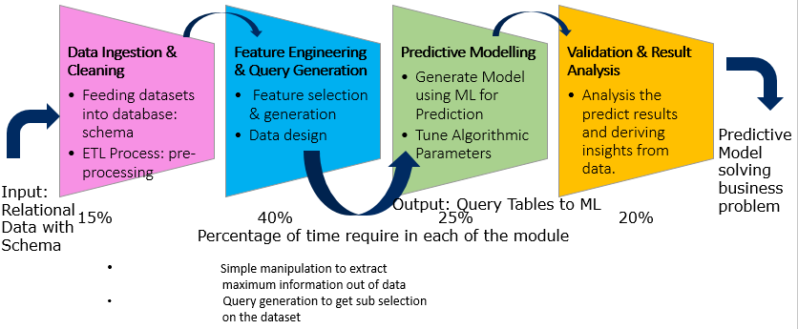

1. Data Ingestion & Cleaning (15% Time)
1.1 Feeding datasets into database: schema
1.2 ETL Process: pre-processing

2. Feature Engineering & Query Generation (40% Time)
2.1 Feature selection & generation
2.2 Data design3. Predictive Modelling (25% Time)
3.1 Generate Model using ML for Prediction
3.2 Tune Algorithmic Parameters

4. Validation & Result Analysis (20% Time)
4.1 Analysis the predict results and deriving insights from data.

Scope
- Automating Feature Engineering & Query Generation Process:
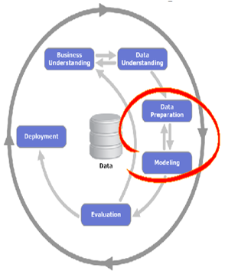

- Data Selection
- Data Cleaning & Pre-Processing
- Feature Engineering: Scaling, Decomposition, Aggregation & Transformation

- Crafting three types of Features via Deep Feature Synthesis Algorithm (DFS):

- EFEAT: Entity Features (establishing tabular relationships)
- RFEAT: Relational Features (establishing backward relationships)
- DFEAT: Direct Features (establishing forward relationships)
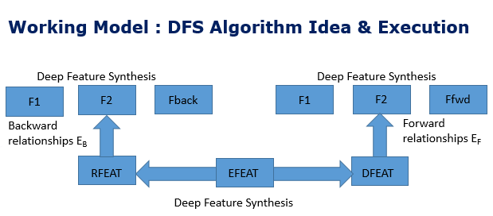

Overall System Description

System / Sub-system (and boundaries) overview

Product Perspective

2.2.1 Existing architecture

FERIHA has a command line interface. The source files to be analyzed are supplied on command line, along with verification and configuration options.

The basic description of the technical approach used in any Machine learning problem is described below:

Stage 1: Data Storage & Cleaning: In this stage the raw data is gathered in the Tabular/CSV form and further stored in Psql. The data is preprocessed with the help of Python Utilities via ETL process. Here the relational multi tabular data is stored in Psql.

Stage 2: Feature Engineering: The process of feature engineering consists of feature selection, feature transformation, feature generation, feature combination. In this stage we will extract three categories of features: Entity Features, Relational Features, Direct features.
We will used Graphlab, NetworkX library for the representation of the data and SQL Queries to generate features. The database will be formed with a single table view containing features.

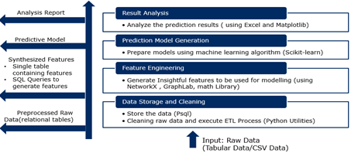

Stage 3: Prediction Model Generation: In this stage predictive model is generated using various machine learning algorithm from Scikit-learn.

Stage 4: Result Analysis: In this stage the results are evaluated using excel and Matplotlib. Various analysis reports are formed.

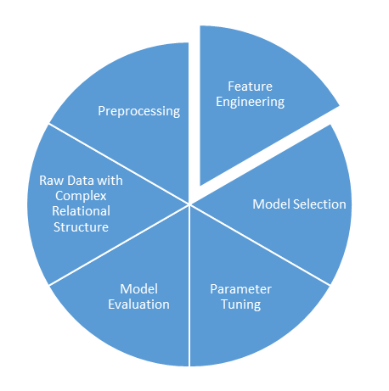

- In the above stages of setting up a machine learning pipeline we emphasis on automation of stage 2 i,e Feature Engineering module and named our product as FERIHA.In this module of feature engineering we have few sub modules crafting three types of Features via Deep Feature Synthesis Algorithm (DFS):

Module 2: Feature Engineering
Module 2.1:
EFEAT
Module 2.2:
RFEAT
Module 2.3:
DFEAT

- Module 2.1 : EFEAT: Entity Features (establishing tabular relationships)

- Module 2.2 : RFEAT: Relational Features (establishing backward relationships)

- Module 2.3 : DFEAT: Direct Features ( establishing forward relationships)

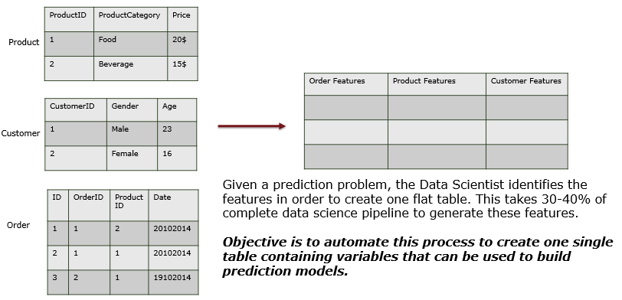

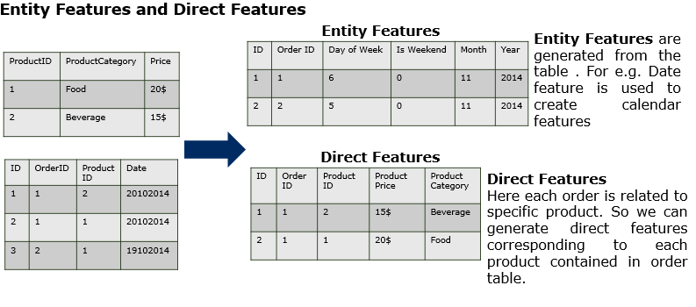

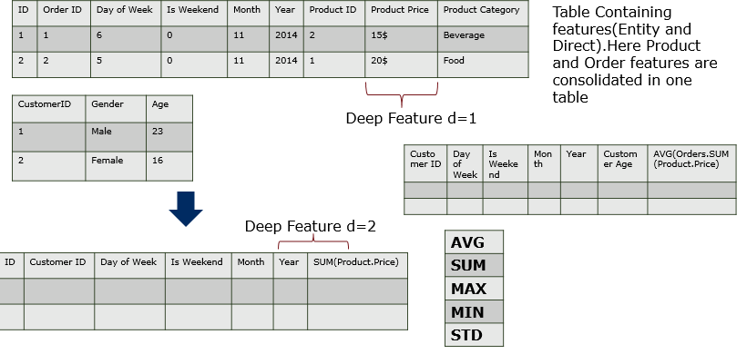
Relations
Primary Key

Foreign Key

As an input to the feature engineering module we introduce Pacakager that contains:

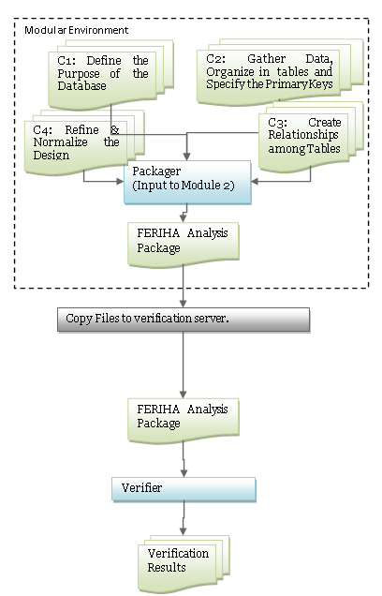

Figure 1: Flow in existing architecture
In environments involved in the above figure are explained below:

Sno. | Machine | Description
1 | Build environment | The environment on which the target source is compliable.
2 | Verification environment | The environment on which FERIHA will perform verification.

Table 1 Environments involved in using FERIHA

Deployment perspective
Logical Entities, Physical entities, Installation approach, Update approach, remote monitoring

Hardware Interface
None

Software Interfaces
<Describe the connections between this product and other specific software components (name and version), including databases, operating systems, tools, libraries, and integrated commercial components. Do not include development environment and software.. >

Communication Interfaces (Standards & Protocols)
No specific communication interface specified.

Site Adaptation Requirements
No site adaptation required.

User Characteristics
This functionality cannot be controlled by the end user. Therefore no specific user characteristics is required to use this functionality.

Product Functions / Operational concepts and Scenarios
<Provide a summary of the major functions that the software will perform. This section describes the functionality/major functions of the system/components being produced in the language of the customer. Operational concepts and scenarios applicable for the system as well as components listed in section 1.2 should be listed using use cases.>
<Explanation of Operational Modes>

<Events / State Machines> => To be elaborated in HLD

RFEAT: Relational Features

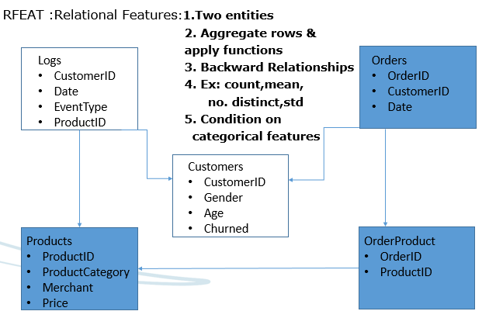

DFEAT : Direct Features

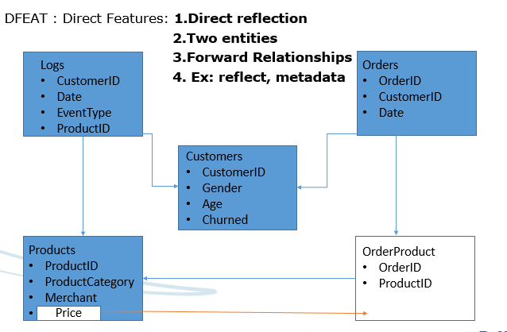

EFEAT : Entity Features

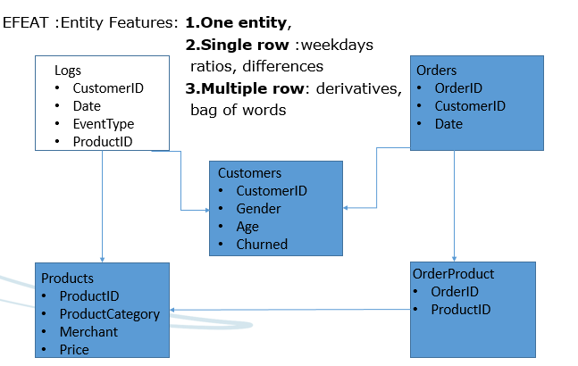

Business scenarios

System Entities/Masters
< section defines the basic system entities used as a backbone of system>

Business Flow
< section defines the business flow with examples and real-time scenarios of all the functionalities used as a backbone of system>

Activity Diagrams
< section defines activity diagrams of major functionalities of system depicting the flow of system.>

Operating Modes
The operating mode would be through command line interface only.

Operations
<Specify the normal and special operations required by the user which common to entire system such as:

- The various modes of operations in the user organization
- Periods of interactive operations and periods of unattended operations
- Data processing support functions
- Backup and recovery operations

Every product component mentioned in section 1.2 can have its own normal and special operations. If this is the case then provide the component specific operations as well.>

Backup and recovery operations
No backup flow would be implemented in this version

Boundary Handling
No specific requirement.

Standards, Protocol and Conformance Requirements

None.

Constraints
- Algorithm used here only supports RDBMS structure
- The system supports numerical data ( no text data)
- The system supports multi tabular entities
- Modelling can be done via machine learning separately
- Tuning of model can be taken care by already built/different module
- New algorithm development
- Data creation – Wherever not available

Memory (& other system) Constraints
No specific memory constraints.

Technical Assumptions and Dependencies
<List each of the factors that affect the requirements stated in the SRS. These factors are not design constraints on the software but are, rather, any changes to them that can affect the requirements in the SRS.
This section is catch-all for everything else that might influence the design of the system/components and that did not fit in any of the categories above.

Every product component mentioned in section 1.2 can have its specific assumptions and dependencies as well. If this is the case then provide the component specific assumption and dependencies as well.>

<Development environment hardware and software can be described here>

Requirements Specifications
<Contains sort of Formal functional and non functional requirements specifications that should be tracked to closure, May include the conceptualized component/block diagram>

Functional Requirements / System Features Specifications
<This template illustrates organizing the functional requirements for the product by system features, the major services provided by the product. You may prefer to organize this section by use case, mode of operation, functional hierarchy, or combinations of these, whatever makes the most logical sense for your product.

Every product component mentioned in section 1.2 will have its specific functional requirements as well. Therefore provide the component specific functional requirements as well.>

System/Component Feature 1
< State the Component/feature name in just a few words.>

<Provide a short description and purpose of the feature >

Stimulus/Response Sequences
<List the sequences of user actions and system responses that stimulate the behavior defined for this feature. >

Functional Requirements
<Itemize the detailed functional requirements associated with this feature. These are the software capabilities that must be present in order for the user to carry out the services provided by the feature, or to execute the use case. Include how the product should respond to anticipated error conditions or invalid inputs. Requirements should be concise, complete, unambiguous, verifiable, and necessary. Use “TBD” as a placeholder to indicate when necessary information is not yet available.>

<Each requirement should be uniquely identified with a sequence number or a meaningful tag of some kind.>

REQ-1:
REQ-2:

Use Cases of Features/Functionalities
<This section illustrates the use cases of all the components. Use case is a methodology used in system analysis to identify, clarify, and organize system requirements. The use case is made up of a set of possible sequences of interactions between systems and users in a particular environment and related to a particular goal. It consists of a group of elements that can be used together in a way that will have an effect larger than the sum of the separate elements combined. The use case should contain all system activities that have significance to the users. A use case can be thought of as a collection of possible scenarios related to a particular goal, indeed, the use case and goal are sometimes considered to be synonymous >

< Features/Functionalities 1> Use Case

Use Case Diagram

<Use Case Diagram at its simplest is a representation of a user's interaction with the system that shows the relationship between the user and the different use cases in which the user is involved. A use case diagram can identify the different types of users of a system and the different use cases and will often be accompanied by other types of diagrams as well>

Use Case
<Format of Use Case as example given below>
Use Case Name | View Logs
Use Case ID | UC_XX_001
Overview | View logs generated by application
Actors/ Use Case Diagram | 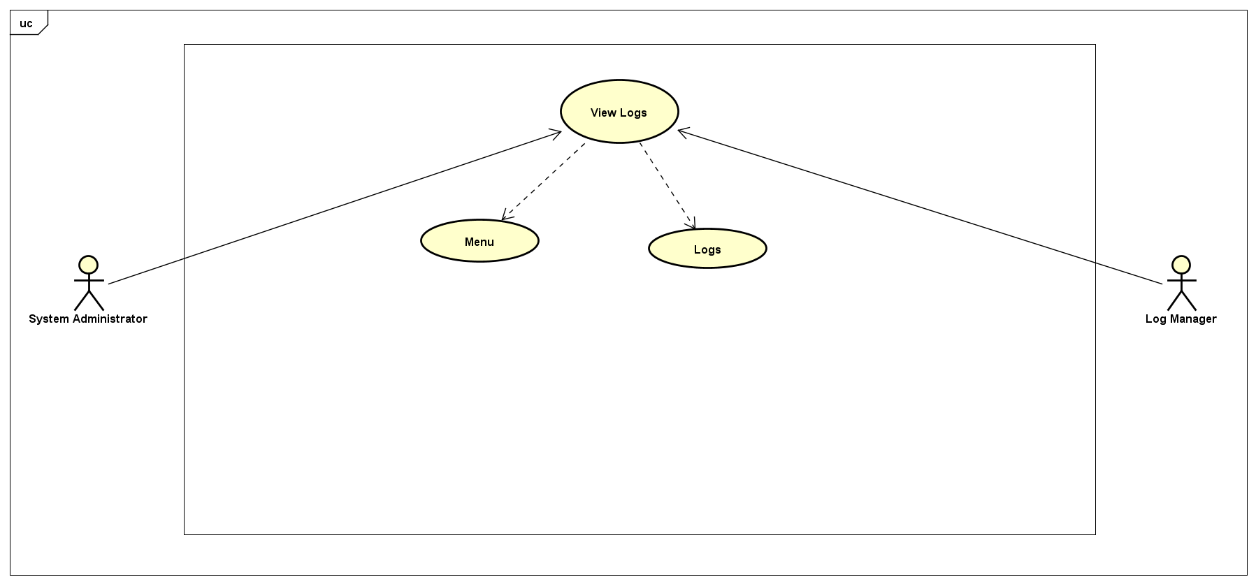  Actor Name: System Administrator, Sub-Actor Name: Log Manager
Preconditions | - Media player should be installed on the System.
Outcome | Logs generated will be displayed
Exception(s)
Notes | -
Steps
- Open Application.
- Click the “Setting” button and click “Logs” Menu.

< Features/Functionalities 2> Use Case and so on

External Interface Requirements Specification
<This section is meant for giving specification for the interfaces overview / description covered in brief in section 2.2.2>

User Interface Specifications
<GUI Specification>
<CLI Specification>
<Web Services Specification>
<XML-RPC Specification>
<Message Specification> => to be elaborated in HLD

This section may describe sample screen images, any GUI standards or product family style guides that are to be followed, screen layout constraints, standard buttons and functions (e.g., help) that will appear on every screen, keyboard shortcuts, error message display standards, and so on.

For Non GUI system, user interface could be the commands that user can execute using the software/components being built

Sub-system / Modules level interfaces Specifications
None

Hardware Interface Specifications
None

Software Interface Specifications
???

Communication Interface Specifications
None

Use Case Screen Mapping

S.No. | Use Case ID | Reference Use Case Step | Screen Name/ID

Non Functional Requirements
<List the Non functional requirements common to the entire system.

Every product component mentioned in section 1.2 can have its specific nonfunctional requirements as well. If this is the case, provide the component specific non functional requirements as well in all the subsections of section 3.4>

Performance Requirements
<This subsection specifies both the static and the dynamic numerical requirements placed on the software or on human interaction with the software, as a whole. Static numerical requirements may include:
(a) The number of terminals to be supported
(b) The number of simultaneous users to be supported
(c) Amount and type of information to be handled
Static numerical requirements are sometimes identified under a separate section entitled capacity.

Dynamic numerical requirements may include, for example, the numbers of transactions and tasks and the amount of data to be processed within certain time periods for both normal and peak workload conditions.

All of these requirements should be stated in measurable terms.>

Logical Database Requirements
None

Exception Handling
<This section specifies the exceptional handling strategy for overall product and for individual product components as applicable. >

Logging / Debugging requirements
None

Software System Attributes
<These are characteristics the system must possess, but that pervade (or cross-cut) the design. These requirements have to be testable just like the functional requirements. >

Reliability
<Specify the factors required to establish the required reliability of the software system at time of delivery.>

Availability
< Specify the factors required to guarantee a defined availability level for the entire system such as checkpoint, recovery, and restart. This is somewhat related to reliability>

Security
None

Maintainability
All functionality would be modular and modeled using Python Libraries

Portability
Each Module should work for all environments supported in FERIHA

Installability
Present Installation mechanism of FERIHA should remain the same.

Testing Requirements
<List the testing requirements common to the entire system as well as for all the product components mentioned in section 1.2>

Other Requirements
None

Requirements Handling

Apportioning of Requirements
All requirements mentioned in this document are mandatory

Requirement Validation Methodology
Prototyping would be used to validate the requirements.

Change Management Process
Change Management Process of NTI would be followed.
References

- Data Science Foundry for MOOCs : Sebastien Boyer, Ben U. Gelman, Benjamin Schreck, Kalyan Veeramachaneni. Accepted, IEEE/ACM Data Science and Advance Analytics Conference.
- Transfer Learning for Predictive Models in Massive Open Online Courses : Sebastien Boyer, Kalyan Veeramachaneni. Accepted, 17th International Conference on Artificial Intelligence in Education.
- Collaborative Embedding Features and Diversified Ensemble for E-Commerce Repeat Buyer Prediction Zhanpeng Fang∗ , Zhilin Yang∗ and Yutao Zhang
- Repeat Buyer Prediction for E-Commerce Guimei Liu⋆ , Tam T. Nguyen⋆ , Gang Zhao#, Wei Zha⋆ , Jianbo Yang§ Jianneng Cao⋆ , Min Wu⋆ , Peilin Zhao⋆ , Wei Chen, Institute for Infocomm Research
- Deep Feature Synthesis: Torwards Automating Data Science Endeavors : James Max Kanter, Kalyan Veeramachaneni. Accepted, IEEE/ACM Data Science and Advance Analytics Conference
The Data Science Machine is an end-to-end software system that is able to automatically develop predictive models from relational data. The Machine was created by Max Kanter and Kalyan Verramachaneni at the Computer Science and Artificial Intelligence Laboratory (CSAIL) at MIT.
- https://www.csail.mit.edu/data_science_machine

