High Level Design
Project Name: FERIHA
Version No.:
Date: 18 April 2017

This document contains proprietary information of NEC Technologies India Pvt. Ltd. Unauthorized access, copying and replication are prohibited. This document must not be copied in whole or part by any means, without the written authorization of NEC Technologies India Pvt. Ltd, Noida, India.

Revision History
V. No. | Date | Prepared by / Modified by | Significant Changes
1 | 18 April 2017 | Dr Aankita Kaur
2 | 18 April 2017 | Anugraha Sinha

Table of Contents
1 Introduction 5
1.1 Scope 5
1.2 Out of Scope 5
1.3 Intended Audience 5
1.4 Abbreviation 5
2 System Environment 6
2.1 Hardware and Software Platforms 6
2.1.1 Hardware 6
2.1.2 Software 7
2.2 System Input and Output 8
3 Architecture 10
3.1 Architecture diagram 10
3.2 Technical Overview 11
3.3 Deployment Model 12
3.4 Data sizing and Performance 14
3.5 Interfaces 14
3.5.1 External Interfaces 15
3.5.2 Internal Interfaces 15
4 Design Description 15
4.1 Static Model 15
4.2 Behavioral Description (This is an optional section, can be removed if not required) 16
4.3 Process Model 16
4.4 Synchronization / threading model 17
4.5 Exception & Signal Handling 18
4.6 Logging & debugging mechanism 18
4.7 Design for Software System Attributes/ Quality Attributes 18
4.8 Design for Performance Requirements 19
4.8.1 List of Time Critical and Periodic Functions 19
5 Design Considerations 19
5.1 Design Constraints 19
5.2 Design Assumptions 19
5.3 Design Limitations 19
5.4 Design Issues 19
5.5 Design Risks 20
5.6 Alternate Design Methods Considered 20
6 Design for special requirements 20
7 Appendix 20
7.1 Standards 20
7.2 References 20
7.3 Construction Strategy 21
7.4 Existing Architecture 21
7.4.1 Architecture diagram 21
7.4.2 Technical Overview 21
7.5 Anticipated Changes 21
7.6 Detailed Decomposition 21
7.6.1 Entity, attributes and their relationships 21

Introduction

In recent times, data science is the emerging field because of availability of huge data. But the pipeline to solve the data science problems is ad-hoc in its nature. One of the most important part of FERIHA is to process the raw data and convert into valuable features by automating one of the data science module. Hence, this project is an initiative to automate that part in the data science pipeline i,e feature engineering.
Feature engineering for relational and human behavioral data remains iterative, human-intuition driven, and challenging, and hence, time consuming any replacement for a human must be able to engineer them acceptably well.
The general purpose of any Data Science Process Flow is to Build Predictive Models in the following manner:
Here the Input will be RDBMS (relational data) with schema and the output would be Predictive model solving the business problem.

1. Data Ingestion & Cleaning (15% Time)
1.1 Feeding datasets into database: schema
1.2 ETL Process: pre-processing

2. Feature Engineering & Query Generation (40% Time)
2.1 Feature selection & generation
2.2 Data design

3. Predictive Modelling (25% Time)
3.1 Generate Model using ML for Prediction
3.2 Tune Algorithmic Parameters

4. Validation & Result Analysis (20% Time)
4.1 Analysis the predict results and deriving insights from data.

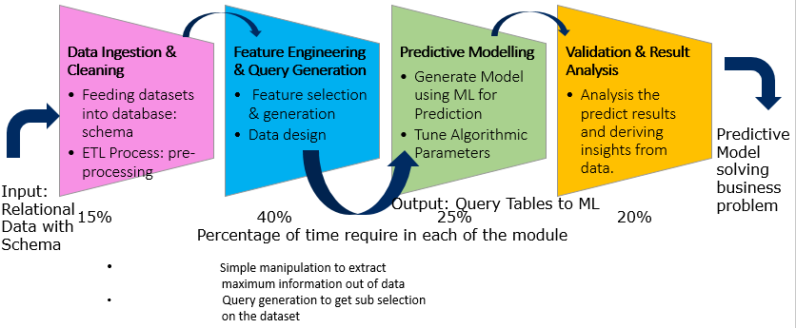

Deep Feature Synthesis is an algorithm capable of automatically creating features between sets of relational data to synthesize automatic learning processes. It is implemented using MySQL and Python databases.

“ Deep Feature Synthesis helps in this task because it is an algorithm that automates automatic learning”

It is an algorithm capable of automatically creating features between sets of relational data to synthesize automatic learning processes. The algorithm applies mathematical functions to the data sets in the source field and transforms them into new groups with new and deeper features.
In this process of evolution of the source data, one can begin with some information variables referring to the gender or age and at the end of the process applied by Deep Feature Synthesis have features that will make it possible to make other deeper calculations as percentages.

The three processes of Deep Feature Synthesis:

The Data Science based on Deep Feature Synthesis uses the three usual processes with the data to prepare predictive models:
● Data pre-processing: the preliminary work with the data is essential before considering automatic learning work. The parameters need to be reviewed in order to reject, for example, null values.
● Selection of features and reduction of dimensionality: the algorithm generates a large amount of features for each entity and a preliminary selection and reduction task is necessary.
● Modeling: decision trees are used for data modeling.

Deep Feature Synthesis Key Ideas:

- Features are often derived using relationships in the dataset
- Across datasets, many features are derived using similar mathematical operations
- New features are often composed using previously derived features
- With candidate features for given prediction, there are effective feature selection techniques.

Database:

The data necessary to run analysis may come from many disparate sources. Those sources could
be different types of existing databases, log _les, or third party data providers.The Data Science machine assumes that this data has been processed and put into a standard schema.

Example :

Student Dropout (KDD 2015) Using student interaction with resources on an online course, predict if they will dropout in next 10 days.

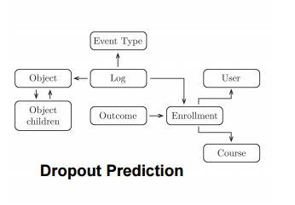

Business Goals: FERIHA

- Translate the business need to problem prediction: The process of deciding what to predict -- or “Prediction Engineering” -- is the most significant factor in data science expectations. Companies frequently build predictive models that cannot be operationalized for the use case they were designed to address. The Question should be : “How will a prediction be used?”
- Experiment with new predictive models: Prediction Engineering frequently uncovers many approaches to address a business’ needs. You should pick one to get underway, but you will find down the road that other ideas have value. The key to extracting the most from your data is to find untapped opportunities first rather than fine-tuning every last improvement in an existing model.
- Get the right people involved in the process: Placing tools into the hands of the right people makes a significant difference in the return on investment from data science investments. So that they can built predictive models can solve real business problems using new technology -- and do it both simply and efficiently

Scope
- Automating Feature Engineering & Query Generation Process:
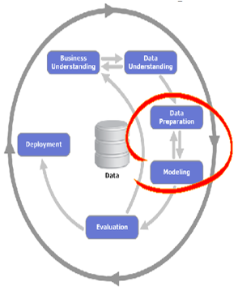

- Data Selection
- Data Cleaning & Pre-Processing
- Feature Engineering: Scaling, Decomposition, Aggregation & Transformation

- Crafting three types of Features via Deep Feature Synthesis Algorithm (DFS):
- EFEAT: Entity Features (establishing tabular relationships)
- RFEAT: Relational Features (establishing backward relationships)
- DFEAT: Direct Features (establishing forward relationships)

FERIHA feature engineering module, is strictly for relational datasets, and is used to automate the identification and generation of insight-eliciting features. This Feature Engineering module takes relational tables as input, and is able to process the various types of data held within such a data structure. To be successful, the feature engineering module aims to think like a data scientist, looking to turn insightful questions into input features.
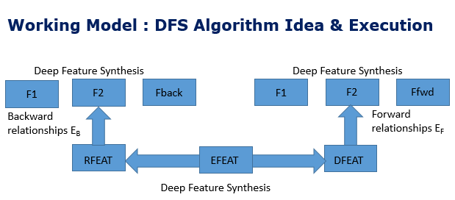

Out of Scope

Following things are out of scope of this document:

- Design and modifications required in modules other than Module #2 (Feature Engineering) does not come under the scope of this document.
- Design and modifications for the scenarios other than the scenarios mentioned in the Software Requirements Specification document does not come under the scope of this document.
- Model development phase related to Gaussian Copula/ Tuning Parameters Module: The auto-tuning capability is intended as a machine-learning pathway used to extract value from synthesized features, starting with such variables as age or gender. The resulting new features can be used to create new measurements such as the percentage of certain feature, they explained.
The algorithm follows relationships in the datasets to a base field, and then sequentially applies mathematical functions along that path to create a final feature. Then a machine learning is implemented and tuned using a probably theory called Gaussian Copula.

Intended Audience

This document will be an input for implementation. This document will be referred by developer(s).

Abbreviation

Abbreviation | Description
DFS | Deep Feature Synthesis
DSE | Data Science Endeavors
GC | Gaussian Copula
RFEAT | Relational Features
EFEAT | Entity Features
DFEAT | Direct Features
EB/EF | Backward/Forward Relationships

System Environment

The Deep Feature Synthesis algorithm has its own set of parameters that affect the resulting synthesized features. Future worked aimed at “empowering” data scientists could focus on selecting these parameters to improve performance and overall system performance.
The Data Science Machine and accompanying Deep Feature Synthesis algorithm were built on top of a MySQL database using the InnoDB storage engine for tables. The researchers said raw datasets were manually converted to a MySQL schema for processing by the Data Science Machine.
The Python programming language was used to implement the logic for calculating, managing and manipulating the synthesized features.

Deep Feature Synthesis use a relational database like MySQL because the algorithm's requirements and the way in which the data in this type of database are sorted are similar. The Data Science machine used by the algorithm's creators implements AVG (), MAX (), MIN (), SUM (), STD () and COUNT () type functions. It also adds others for another type of operations with the data, such as length () or WEEKDAY () and MONTH () to convert the dates into the days of the week and the month when they occurred.

The use of functions, plus the creation of filters, enable the algorithm to address two really important matters in predictive models:

- Application of functions only to the cases in which a given condition is taken to be true. Without data filtering it is impossible.
- Construction of time interval values, with limits above and also below, based on a time date.
- This makes it much easier to optimize database queries.

Hardware and Software Platforms

FERIHA supports 32-bit and 64-bit machine architecture. Below are the specifications of each type of machine (for Linux platform):

- For 32-bit machine:
Machine h/w name | i686
Processor | i686
H/w Platform | i386
Table 1
- For 64-bit machine:
Machine h/w name | x86_64
Processor | x86_64
H/w Platform | x86_64
Table 2

Software

The following system requirements:
Python 2.4 or later.
SciPy (http://www.scipy.org/)
NumPy (http://www.numpy.org/)
matplotlib library (http://matplotlib.org/)
SQLAlchemy: www.sqlalchemy.org
sqlacodegen: https://bitbucket.org/agronholm/sqlacodegen

System Input and Output
<Each software system exists because it is used to process a certain amount of information i.e. the input data. The data items, which are used by the system, shall be described to a level of detail that the functional system needs to know. The data item names should be consistent with the data flows of the Design Flow diagram.
Each software system transforms the input data to output data according to the operations of the system. The data items, which are outputs from the system, shall be described. The data item names shall be consistent with the data flows of the DFDs.
For UI based system, outputs should be specified screen wise.>

Architecture

FERIHA has a command line interface. The source files to be analyzed are supplied on command line, along with verification and configuration options.

Architecture diagram

The basic description of the technical approach used in any Machine learning problem is described below:

Stage 1: Data Storage & Cleaning: In this stage the raw data is gathered in the Tabular/CSV form and further stored in Psql. The data is preprocessed with the help of Python Utilities via ETL process. Here the relational multi tabular data is stored in Psql.
In relational database there are three types of relationships. One-to-one, one-to-many, many-to-many. Using existing software libraries (SQLalchemy and sqlacodegen ), The DSM can extract these relationships between tables in the database. All objects in a table will be of the same type. If an object is the \one" in a relationship or has no relationship to other objects, then it is classi_ed as an entity. If an object is the \many" in a relationship, then it is a transaction.

Stage 2: Feature Engineering: The process of feature engineering consists of feature selection, feature transformation, feature generation, feature combination. In this stage we will extract three categories of features: Entity Features, Relational Features, Direct features.
We will used different Python libraries as mentioned in the Introduction section for the representation of the data and SQL Queries to generate features. The database will be formed with a single table view containing features.

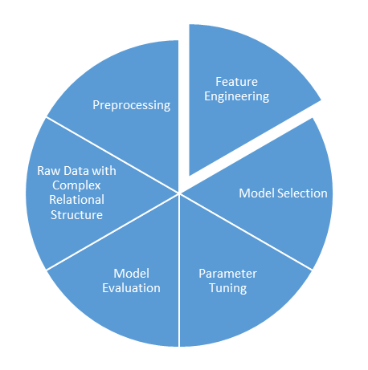
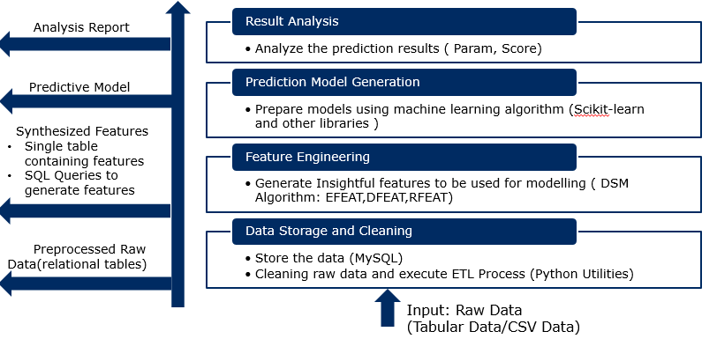

Stage 3: Prediction Model Generation: In this stage predictive model is generated using various machine learning algorithm from Scikit-learn.

Stage 4: Result Analysis: In this stage the results are evaluated using excel and Matplotlib. Various analysis reports are formed.

- In the above stages of setting up a machine learning pipeline we emphasis on automation of stage 2 i,e Feature Engineering module and named our product as FERIHA.In this module of feature engineering we have few sub modules crafting three types of Features via Deep Feature Synthesis Algorithm (DFS):

- Module 2.1 : EFEAT: Entity Features (establishing tabular relationships)

- Module 2.2 : RFEAT: Relational Features (establishing backward relationships)

- Module 2.3 : DFEAT: Direct Features ( establishing forward relationships)

Module 2: Feature Engineering
Module 2.1:
EFEAT
Module 2.2:
RFEAT
Module 2.3:
DFEAT

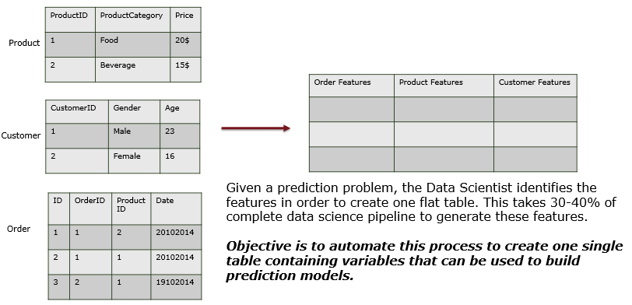

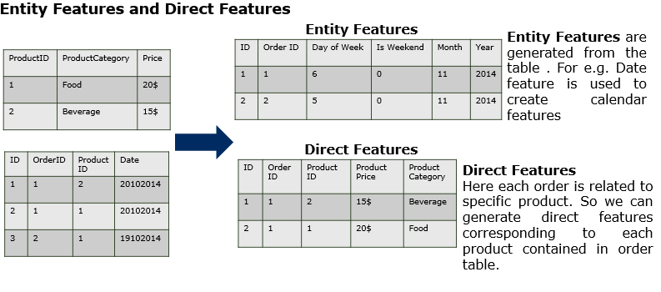

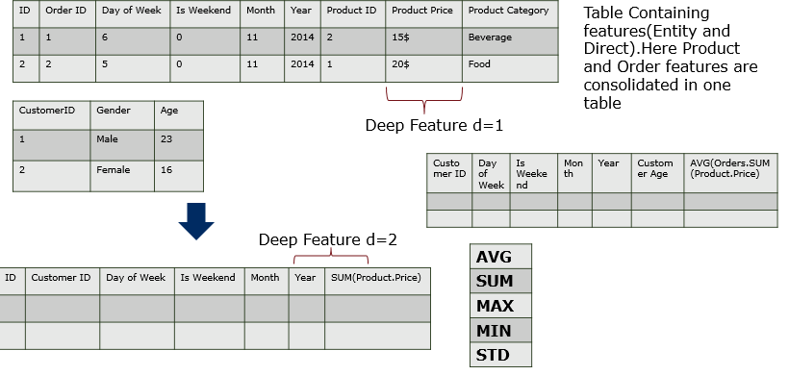
Relations
Primary Key

Foreign Key

As an input to the feature engineering module we introduce Packager that contains:
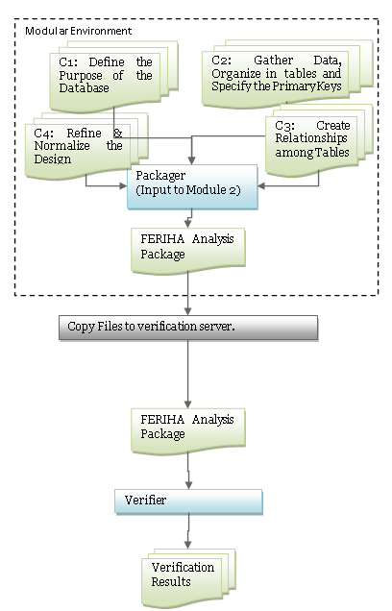

Figure 1: Flow in existing architecture

In environments involved in the above figure are explained below:
Sno. | Machine | Description
1 | Build environment | The environment on which the target source is compliable.
2 | Verification environment | The environment on which FERIHA will perform verification.

Table 1 Environments involved in using FERIHA

FERIHA : Integrated Architecture

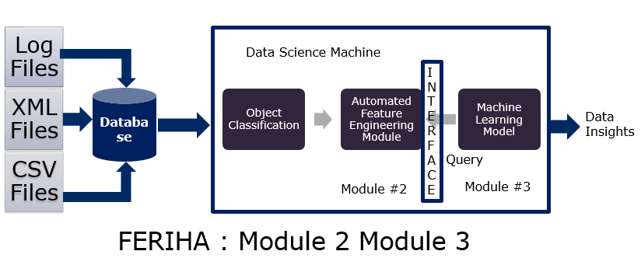

1. Identify entities and transactions relationships in a database
2. Construct new candidate features to describe and summarize the data
3. Provide end user data insights using machine learning methods.

The goal of FERIHA is to automatically generate data insights from data. There are four guiding design ideas that make the system unique from past work :

1. Allow exibility on how data gets into the system The DSM expect data to enter the
system in the form of a relational database.
2. Use as all data available for analysis This means not only using the values of the data, but the relationships between values.
3. Reusable feature engineering The DSM generates a large set of candidate features from predefined recipes. It assumes the machine learning model will handle the feature selection.
4. Provide actionable insights to the end user The DSM will go beyond just summarizing
the data and providing basic statistics.

Innovative companies use their data to stay ahead of the competition. Predictive modeling with Feature Labs enables developers, analysts, managers, and executives to build and deliver intelligent products tailored to their unique needs.

- Solving business problems with "Prediction Engineering“ :FERIHA offers a flexible interface to define and predict any future "event" of interest to an organization
- Automated Feature Engineering: This enables users to obtain the accuracy levels of human data scientists in 1/10th of the time.
- Easy Model Deployment :Data on its own doesn’t do much; it must be used and used well. And to do it effortlessly. It's easy to retrain using new data, to adjust modeling parameters.

Benefits of data science automation:

- Solve What Matters Most: With data science automation, you can focus on what to solve rather than how to solve it.
- Improve Data Science Accessibility :You'll increase involvement from product and domain experts in the data science process.
- Scale Your Productivity: Cultivating your data science capabilities allows you to avoid tedious tasks and lets you focus on growth.

In order to successfully integrate data science into an organization, a platform that flexibly addresses the wide range of prediction problems encountered is needed. Many companies offer pre-built applications for specific data science use cases. However, data doesn't appear the same between organizations, hindering the path to implementation. FERIHA has proven itself across a variety of industries as a robust data science solution for your organization.

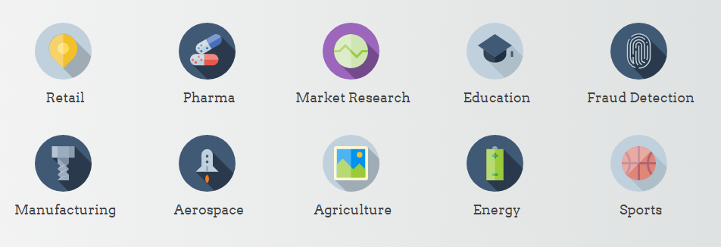

FERIHA : Module Wise Architecture:
Module # 2 Feature Engineering :

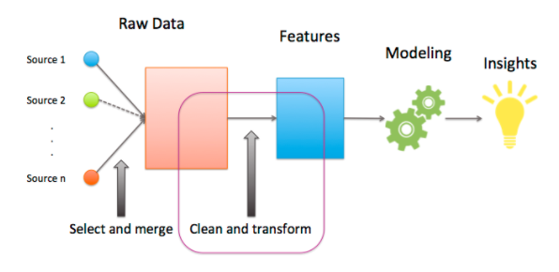

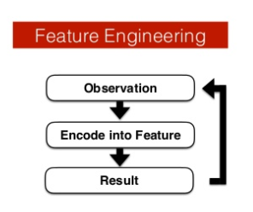

Feature Engineering is the art/science of representing data is the best way possible. Feature Engineering involves an elegant blend of domain knowledge, intuition, and basic mathematical abilities.
Feature Engineering, is pre-process your data so that your model/learning algorithm has to spend minimum effort on wading through noise. What I mean by ‘noise’ here, is any information that is not relevant to learning/predicting your ultimate goal. In fact, using good features can even let you use considerably simpler models since you are doing a part of the thinking yourself.

“Good features allow a simple model to beat a complex model”
Good feature engineering involves intuition, domain knowledge (human experience) and basic math skills.

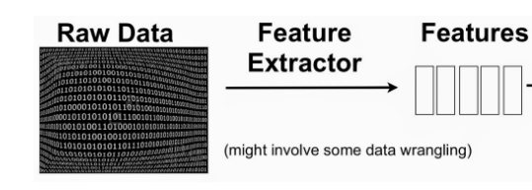

- Representing Timestamp : Time-stamp attributes are usually denoted by the EPOCH time or split up into multiple dimensions such as (Year, Month, Date, Hours, Minutes, Seconds).
- Decomposing Categorical Attributes : Some attributes come as categories instead of numbers. A simple example would be a ‘color’ attribute that is (say) one of {Red, Green, Blue}. The most common way to go about representing this, is to convert each category into a binary attribute that takes one value out of {0, 1}. So you basically end up with a number of added attributes equal to the number of categories possible. And for each instance in your dataset, only one of them is 1 (with the others being 0). This is a form of one-hot encoding.
- Binning/Bucketing : Sometimes, it makes more sense to represent a numerical attribute as a categorical one. The idea is to reduce the noise endured by the learning algorithm, by assigning certain ranges of a numerical attribute to distinct ‘buckets’. Consider the problem of predicting whether a person owns a certain item of clothing or not. Age might definitely be a factor here. What is actually more pertinent, is the Age Group. So what you could do, is have ranges such as 1-10, 11-18, 19-25, 26-40, etc.

Bucketing makes sense when the domain of your attribute can be divided into neat ranges, where all numbers falling in a range imply a common characteristic. It reduces overfitting in certain applications, where you don’t want your model to try and distinguish between values that are too close by.

Binning also reduces the effect of tiny errors, by ’rounding off’ a given value to the nearest representative. Binning does not make sense if the number of your ranges is comparable to the total possible values, or if precision is very important to you.

- Feature Crosses: Feature crosses are a unique way to combine two or more categorical attributes into a single one. This is extremely useful a technique, when certain features together denote a property better than individually by themselves. Mathematically speaking, you are doing a cross product between all possible values of the categorical features.

Consider a feature A, with two possible values {A1, A2}. Let B be a feature with possibilities {B1, B2}. Then, a feature-cross between A & B (lets call it AB) would take one of the following values: {(A1, B1), (A1, B2), (A2, B1), (A2, B2)}. You can basically give these ‘combinations’ any names you like. Just remember that every combination denotes a synergy between the information contained by the corresponding values of A and B.

The process usually involves the creation of new features (feature engineering) and identifying the most essential ones (feature selection).

Feature Selection : Using certain algorithms to automatically select a subset of your original features, for your final model. Here, you are not creating/modifying your current features, but rather pruning them to reduce noise/redundancy.

In the machine-learning literature there are three commonly used methods for feature selection:

- Domain experts can manually pick out features. It’s not hard to find examples of problems where domain expertise is insufficient, and this approach isn’t particularly practical when underlying data sets are massive.
- There are variable ranking procedures that use metrics like correlation, information criteria, etc. They scale to large data sets but can easily lead to strange
- Techniques that take a vast feature space and reduce it to a lower-dimensional one (clustering, principal component analysis, matrix factorization).

Feature Selection Checklist

Isabelle Guyon and Andre Elisseeff the authors of “An Introduction to Variable and Feature Selection” (PDF) provide an excellent checklist that you can use the next time you need to select data features for you predictive modeling problem.

The salient parts of Feature Selection checklist are :

- Do you have domain knowledge? If yes, construct a better set of ad hoc”” features
- Are your features commensurate? If no, consider normalizing them.
- Do you suspect interdependence of features? If yes, expand your feature set by constructing conjunctive features or products of features, as much as your computer resources allow you.
- Do you need to prune the input variables (e.g. for cost, speed or data understanding reasons)? If no, construct disjunctive features or weighted sums of feature
- Do you need to assess features individually (e.g. to understand their influence on the system or because their number is so large that you need to do a first filtering)? If yes, use a variable ranking method; else, do it anyway to get baseline results.
- Do you need a predictor? If no, stop
- Do you suspect your data is “dirty” (has a few meaningless input patterns and/or noisy outputs or wrong class labels)? If yes, detect the outlier examples using the top ranking variables obtained in step 5 as representation; check and/or discard them.
- Do you know what to try first? If no, use a linear predictor. Use a forward selection method with the “probe” method as a stopping criterion or use the 0-norm embedded method for comparison, following the ranking of step 5, construct a sequence of predictors of same nature using increasing subsets of features. Can you match or improve performance with a smaller subset? If yes, try a non-linear predictor with that subset.
- Do you have new ideas, time, computational resources, and enough examples? If yes, compare several feature selection methods, including your new idea, correlation coefficients, backward selection and embedded methods. Use linear and non-linear predictors. Select the best approach with model selection

Example : feature subset selection methods:

- Wrappers utilize the learning machine of interest as a black box to score subsets of variable according to their predictive power.
- Filters select subsets of variables as a pre-processing step, independently of the chosen predictor.
- Embedded methods perform variable selection in the process of training and are usually specific to given learning machines.

- Do you want a stable solution (to improve performance and/or understanding)? If yes, subsample your data and redo your analysis for several “bootstrap”.
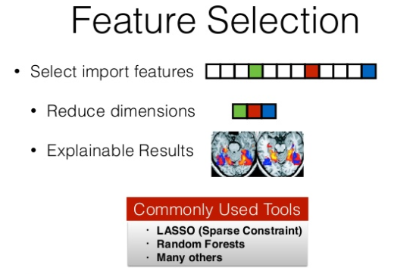

Feature Scaling : Sometimes, you may notice that certain attributes have a higher ‘magnitude’ than others. An example might be a person’s income – as compared to his age. In such cases, for certain models (such as Ridge Regression), it is infact necessary that you scale all your attributes to comparable/equivalent ranges. This prevents your model from giving greater weightage to certain attributes as compared to others.

Feature Extraction : Feature extraction involves a host of algorithms that automatically generate a new set of features from your raw attributes. Dimensionality reduction falls under this category.

Featured composition : FERIHA uses a couple of tricks to manufacture candidate features for data analyses. One is to exploit structural relationships inherent in database design. Databases typically store different types of data in different tables, indicating the correlations between them using numerical identifiers. The Data Science Machine tracks these correlations, using them as a cue to feature construction. Example : one table might list retail items and their costs; another might list items included in individual customers’ purchases. The Data Science Machine would begin by importing costs from the first table into the second. Then, taking its cue from the association of several different items in the second table with the same purchase number, it would execute a suite of operations to generate candidate features: total cost per order, average cost per order, minimum cost per order, and so on. As numerical identifiers proliferate across tables, the Data Science Machine layers operations on top of each other, finding minima of averages, averages of sums, and so on.
Depending on the input data types, a number of mathematical functions are applied at 2 distinct levels in the FERIHA (make_feature.py) : entity and relational. Entity level features focus on conversion and translation functions, such as changing data representations, rounding numbers, and extracting existing generalized attributes into more numerous and concise attributes. Relational level features are concerned with the relationships between entities in tables (think about your primary and foreign keys). These feature functions are then able to extract related data from other tables to associate with a given feature (for example, finding the max item price or item count associated with an order), data which could potentially be exploited as a useful feature to feed into a model.

- It also looks for so-called categorical data, which appear to be restricted to a limited range of values, such as days of the week or brand names. It then generates further feature candidates by dividing up existing features across categories.
- Once it’s produced an array of candidates, it reduces their number by identifying those whose values seem to be correlated. Then it starts testing its reduced set of features on sample data, recombining them in different ways to optimize the accuracy of the predictions they yield.
- “The Data Science Machine is one of those unbelievable projects where applying cutting-edge research to solve practical problems opens an entirely new way of looking at the problem,” says Margo Seltzer, a professor of computer science at Harvard University who was not involved in the work. “I think what they’ve done is going to become the standard quickly — very quickly.”

FERIHA uses combinatorics in what amounts to brute force feature engineering, to apply iterative feature subsets to sample data while recombining them for optimization until the best possible solution is found.

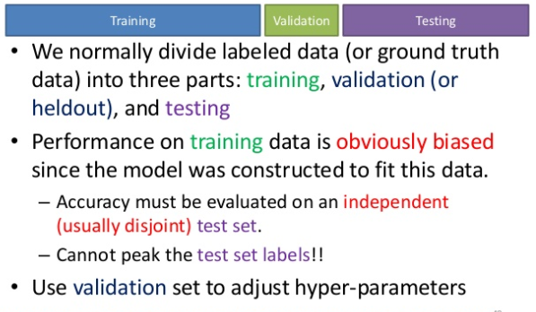

Technical Overview
<Give technical overview of the proposed software architecture:
- n-tier architecture components
- database Layer
- client layer
- browser Interface
- Portal Interface
- CRM Package Interface
- message Interface> etc>
Function Decomposition diagram should be provided. Each logical overview should be described in separate sections. Portion of this section can be customized as per the need of the systems.

RFEAT: Relational Features

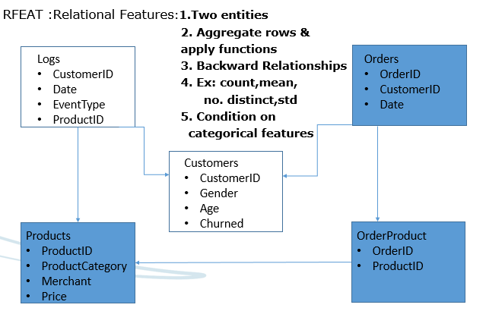

DFEAT : Direct Features
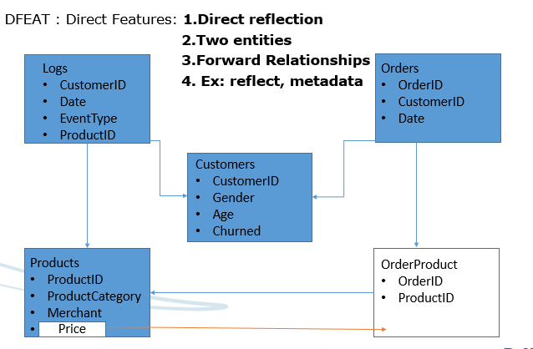

EFEAT : Entity Features
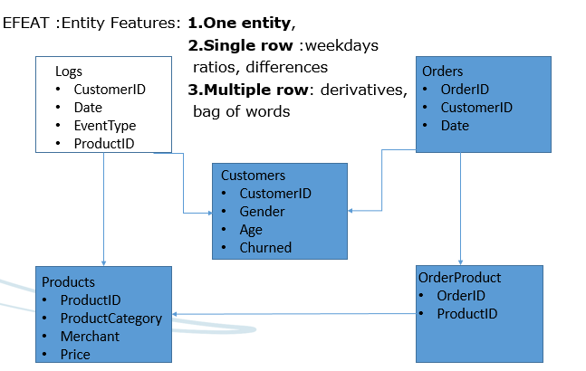

Example 1

Deployment Model
<If applicable, show the deployment perspective of systems showing positioning of various modules / components at various physical entities. Along with the diagram, description of each components description should also be written and mapped against the deployment model. For better understanding the model can also describe of scope context which is part of total deployment model.>
Example of deployment model
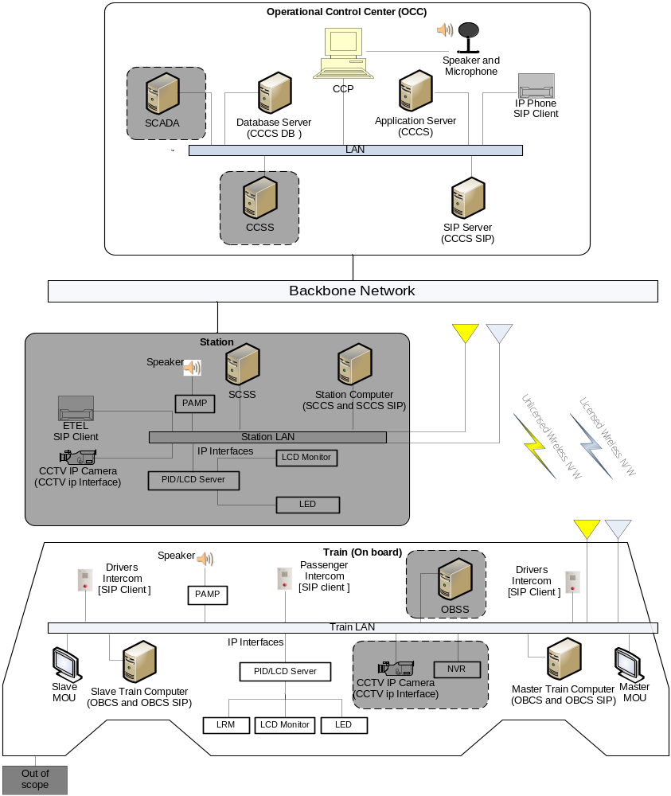
Figure 1 : <Diagram 1>
<This header can be used while inserting a figure. Update field function should be used when there are multiple figures in the document>

<Mapping of component with deployment model must be done.>
Component | Description
Communication Control Panel (CCP) | Provides GUI interface to operator or maintenance officer for doing PA, intercom, and remote management operations.
Central Communication Control System Database Server (CCCS DB) | Provides permanent storage for configuration settings and master data at CCCS system.
Central Communication Control System Application Server (CCCS) | Required for deployment of CCCS software components.  The components are CCCS I/F and OBCS I/F.  CCCS Core: It deals with the communication controls, admin controls and On-board equipment management controls etc.  CCSS I/F: It deals with request and responses for various operations to/from signaling system i.e. CCSS  OBCS I/F: It deals with request and responses for various operations to/from OBCS.

Data sizing and Performance
<This section should list the transaction entries, the growth in the data pattern for the entities/data stores of the software system.
Other critical performance factors like network traffic, usage of hardware devices like juke boxes; optical devices etc. should also be listed.
This section should also specify how the derived timings and performance requirements for the unit processes and the software system are handled as a whole.

Interfaces
<This section lists the interfaces that will be exposed/used by the system which is being built. Interface specification must describe. >
All data from and to the interfaces shall be defined for the whole range of values defined by the type of the data, including the ranges which are not used when processed by the functions:
a) Definition and description of all equivalence classes for all specified data and each software function using them,
b) Definition of unused or forbidden equivalence classes.
NOTE: The data type includes the following:
- Input parameters and output results of functions and/or procedures;
- Data specified in telegrams or communication packets;
- Data from the hardware.

External Interfaces
<This section lists following type of interfaces:
- Interfaces which will be exposed by the system being built so that external applications/modules can use this system.
- External Interfaces which will be used by the system being built for its functionality.
- Describe interfaces of pre-existing software also
- Boundary conditions >

Internal Interfaces
<This section lists the interfaces required by the internal components of system to work with each other.
If internal interfaces are not given here, then reference to LLD document should be given here to refer the internal interfaces.>

Design Description

Static Model
<Static model represents initial static composition modules / components of system.
Figure out relevant macro level patterns being used, e.g. layering model, MVC, client server architecture etc.>

Behavioral Description (This is an optional section, can be removed if not required)
<State Chart, This section describes the system/module state table, if any. All the states, their transitions and associated events may be detailed here
- State
- Transitions
- Events
The event list is a simple textual listing of the events in the environment to which the system must respond.
Another way to represent the behavior is given in the table below.>
Event Name | Response To Event | Function

Process Model
<Process model consists of the following items:
- Data / Signal Flow Diagram (DFD): The data flow diagram is a modeling tool that allows us to picture a system as a network of functional processes. The data flow diagram (DFD) is a statement of user requirements, which portrays the system in terms of its component pieces with all the interfaces indicated. This diagram consists of terminators, data flows, control flows, data stores and process bubbles.
- Flow charts : Any process specific flow chart may be detailed here
- Context Diagram: Context Diagram defines all the inputs to and the outputs from the software system. This diagram consists of terminators, data flows, control flows, data stores and a single process bubble representing the entire system.>
Example:
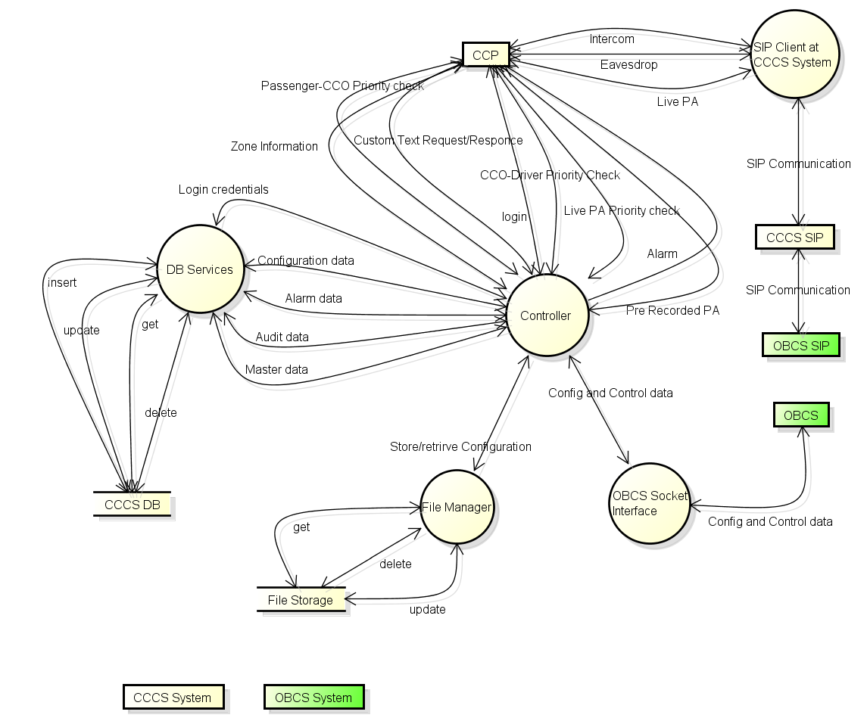
Figure 2 : <Diagram 1>
<This header can be used while inserting a figure. Update field function should be used when there are multiple figures in the document>

Synchronization / threading model
<Explain the strategy for designing multiple components / modules / structures for optimal utilization of system resources and corresponding synchronization strategy.
List of threads can be described as per below reference for more description. Table gives the detailed list of the threads which are running on the system. Description of each column is as follows:
- Component Name– Lists the name of the module of the system
- Total Threads – Signifies total threads that are present in the system including permanent and connection based threads.
- Always running – signifies the permanent running threads.
- Number of Times in system – This column signifies that whether thread will run on each interface of the SDC or only on one interface.
Thread List Table
S. No | Reference section | Component Name | Total Threads | Always running | Number of Times in system | Total on SDC
1 |  | XYZ | 1 | 1 | 2 | 2

Details of the components thread should be detailed down in subsection of 4.4 which will be referred in above table.

Exception & Signal Handling
This section has information about all the errors which will be displayed on the Web Client UI. All the Error messages will be referred from properties file. All the errors received from the external system will be logged and the Dashboard specific errors mentioned in the below table will be thrown depending upon the error received.
Table which can be used for describing exception & Signal Handling are as give below.
S.no | Error Code | Error Message | Remark
1 | DAS_ERR_350001 | User is not found in Database.
2 | DAS_ERR_350002 | Session is not Created

If details of exceptional & Signal handling are defined in LLD this section can be removed. If required high level of detailing can be described here.

Logging & debugging mechanism
Logging: This section will describe about logging approach into the system. It can be explained through diagram too. e.g. “Different components will be sending their log request to log server which will log the info using the syslog service. OBCS will be using syslog service for logging purpose. All the components of OBCS will be sending their log info to log server.
OBCS will be using different log levels for different components and corresponding action of sending audit info to CCCS, will also be determined by evaluating the log level.

Design for Software System Attributes/ Quality Attributes
<This section adds the details w.r.t. technical design required to meet the software system attributes (like availability, reliability etc.) identified in SRS document. Following are the key quality attributes which can be detailed out.
- High Availability and scalability
- Security
- Maintainability
- Portability
- Safety
- Efficiency
- Usability.
Each key attribute can be detailed out in a separate sub sections.>

Design for Performance Requirements
<This section adds the details w.r.t. to technical design required to meet the performance requirements identified in SRS document.>

List of Time Critical and Periodic Functions
<In this section, list out all the time critical and periodic functions for the entire application.>

Design Considerations

Design Constraints
<This section specifies the design constraints on the software being developed. These constraints may include physical memory limitations or the necessity for a specialized external interface, may dictate special requirements for assembling or packaging of software portability, use of system calls, use of specific data structure etc. >

Design Assumptions
<This sections lists down if any assumptions considered by design.>

Design Limitations
<This sections lists down if any limitations are there in the chosen design.>

Design Issues
<This sections lists down if any issues are still there in the chosen design for current/future implementation. These issues should be tracked in PMP too>

Design Risks
<This sections lists down if any risks are associated with the chosen design for current/future implementation. These risks should be tracked in PMP too.>

Alternate Design Methods Considered
<Give the details of the alternate design method considered, evaluation method adopted, rating criteria used and rationale used for selection of chosen design. You can also attach DAR sheet here. If DAR sheet is not followed, refer process and mandatory information (Selected alternatives, critical factors etc.) should be given in project specific template.>

Design for special requirements

Few systems may have some special requirements like installation, system backup/recovery procedure etc. Related design considerations / strategy should be captured in this section.
- Install Procedures
- Backup and Recovery Procedures
<The scope should clearly define whether it is within the purview of the proposed application.
If the client wants something specific to be developed in this regard and it falls within the scope of the application, the details and the specifications for that should be documented.>
- Operating Modes
- Data / object persistence

Appendix

Standards
<All coding standards and GUI standards should be attached as an appendix. If standards are not given here, then reference to LLD document or standards document should be given here to refer the internal interfaces.>

References

- Data Science Foundry for MOOCs : Sebastien Boyer, Ben U. Gelman, Benjamin Schreck, Kalyan Veeramachaneni. Accepted, IEEE/ACM Data Science and Advance Analytics Conference.
- Transfer Learning for Predictive Models in Massive Open Online Courses : Sebastien Boyer, Kalyan Veeramachaneni. Accepted, 17th International Conference on Artificial Intelligence in Education.
- Collaborative Embedding Features and Diversified Ensemble for E-Commerce Repeat Buyer Prediction Zhanpeng Fang∗ , Zhilin Yang∗ and Yutao Zhang
- Repeat Buyer Prediction for E-Commerce Guimei Liu⋆ , Tam T. Nguyen⋆ , Gang Zhao#, Wei Zha⋆ , Jianbo Yang§ Jianneng Cao⋆ , Min Wu⋆ , Peilin Zhao⋆ , Wei Chen, Institute for Infocomm Research
- Deep Feature Synthesis: Torwards Automating Data Science Endeavors : James Max Kanter, Kalyan Veeramachaneni. Accepted, IEEE/ACM Data Science and Advance Analytics Conference
The Data Science Machine is an end-to-end software system that is able to automatically develop predictive models from relational data. The Machine was created by Max Kanter and Kalyan Verramachaneni at the Computer Science and Artificial Intelligence Laboratory (CSAIL) at MIT
https://www.csail.mit.edu/data_science_machine

S.no | Document Name | Version/Release Date | Remark

Construction Strategy
<In this section, please mention if any of the identified modules / functions will be re-used from the database or bought as third party component. Also mention the verification and validation requirements of such items. These verification and validation should also support PMP>
S. No | Module / Function | Buy / Re-use | Verification / Validation | Remarks

Existing Architecture
<Mention about the existing architecture, if applicable>

Architecture diagram
<For the existing architecture, give a block diagram depicting the hardware, software, network components such as servers, connectivity, OS etc. >

Technical Overview
<As guided above in section 3.2>

Anticipated Changes
<This section specifies the anticipated changes that may occur in the software. Future enhancements from design perspective can also be described here.>

Detailed Decomposition

Entity, attributes and their relationships

<This section is relevant when OOPs (Object Oriented Programming) based design is created for building the prototype.>
<This section should list all the entities, a verbose description of what that entity pertains to and list of all its attributes. Specify For each of the attributes, the data type, the data size, specific constraints and a verbose description for each of the attribute should be specified.>

