ICT ACADEMY OF KERALA
Capstone Project Report

StrideGrid

MERN Stack Running Territory Game



Anugrah K S
Sahrdaya College of Engineering and Technology, Kodakara
20 October 2026

EXECUTIVE SUMMARY
StrideGrid is a MERN stack capstone developed for the ICT Academy of Kerala skill enhancement course. It turns a recorded outdoor run into progress on a shared territory map. A runner can claim unowned ground, challenge another runner, defend an owned cell, and compare current ownership on a leaderboard. The project aims to make local route exploration more engaging while demonstrating full stack application design.
The current application includes account registration and sign-in, a signed-in dashboard, a public map, foreground GPS tracking, server-side route validation, territory rules, run history, live activity updates, and responsive views. Five automated rule tests and the React production build pass. The source repository is public and the application is hosted over HTTPS with MongoDB Atlas. A complete outdoor GPS trial and the two-runner territory flow still require verification before final submission.

INTRODUCTION
Most run trackers summarize distance, pace, and time after an activity. StrideGrid adds a shared spatial objective: a completed route can change ownership of small areas on a city map. The idea is designed for recreational runners who want a reason to explore different streets and revisit familiar routes.
The application is a browser-based system with a React client, Node.js and Express API, and MongoDB data store. A mobile browser collects location samples only after the runner starts a run and grants permission. The server checks the route before it can affect territory. The first version is intentionally limited to foreground tracking and a small local playing area; it is an academic demonstration rather than a verified sporting competition.
The Software Requirements Specification in the project repository defines the core user stories, acceptance criteria, data entities, privacy requirements, and known constraints. The report follows those requirements and documents the functionality that is currently present in the code.

OBJECTIVES
The project objectives combined a usable running game with practical MERN development skills:
- Develop a responsive React interface with a public introduction, registration and sign-in, dashboard, territory map, leaderboard, and run history.
- Design Express APIs and MongoDB models for users, private GPS runs, and territory ownership, with protected account routes.
- Record foreground browser location samples and validate a run on the server for distance, duration, accuracy, ordering, and plausible movement.
- Implement the claim, challenge, defense, and capture rules and show their results on a shared map with current leaderboard standings.
- Verify core rules with tests, build the client for production, deploy the MERN application, and document privacy limits and the outdoor verification still required.

SCOPE AND DELIVERABLES
The implemented scope covers one runner account per user, browser-based run recording while the page remains open, a shared map of territory cells, private run history, and public leaderboard and activity views. The map and dashboard update after a completed run through a server event stream, with periodic refresh as a fallback.
Deliverables include the React client, Express API, Mongoose schemas, pure route and territory-rule functions, five automated tests, the Software Requirements Specification, README setup guide, and this report. The report Appendix contains screenshots of the main local views.
Native background tracking, teams, badges, notifications, verified anti-spoofing, and large-scale geographic querying are outside this version. The HTTPS application and public GitHub repository are available; outdoor gameplay verification remains pending.

METHODOLOGY
Development began with user stories for account creation, run capture, fair scoring, territory ownership, map exploration, and privacy. These were translated into three core data models: User, Run, and Territory. The React client uses Vite, React Router, and React Leaflet; the server uses Express and Mongoose. JSON APIs connect the client to MongoDB.
A runner starts tracking from the Explore page. The browser records latitude, longitude, accuracy, and timestamp. On Finish, the client sends the samples to the API. The server requires at least five usable samples, eight minutes, one kilometer, and GPS accuracy within 50 metres for enough points. It rejects invalid time order and repeated implausible jumps. Exact duplicate route submissions are identified with a hash.
Accepted samples map to projected cells approximately 150 metres across. At least 35 metres of measured travel must be attributed to a cell, and one run affects at most 30 cells. The calculation scores measured sample locations instead of filling a straight line across unsampled gaps; this reduces false territory across water when a route crosses a bridge. A pure transition function applies claim, seven-day challenge, capture, and defense rules.
Passwords are hashed with bcrypt. Authentication uses a seven-day JWT in an HttpOnly cookie, and account routes are rate limited. Raw GPS samples remain on private Run records; public map responses expose cell bounds, owner names, and coarser marker positions. The implementation was checked with unit tests, local browser exercises, API responses, and a production client build.

PROJECT ACTIVITIES
Requirements and design. I prepared the SRS and separated the application into client pages, API routes, models, and pure game-rule modules. This made route validation and territory transitions testable without a browser.
Account and interface work. I built the public landing page, registration and sign-in screens, session restoration, protected dashboard and My Runs pages, sign-out, error feedback, and responsive navigation. The dashboard presents owned cells, distance, defense state, rank, map, recent runs, and activity.
Tracking and map work. I integrated browser Geolocation with visible point count, elapsed time, distance, and accuracy feedback. The Explore page uses a Leaflet map and run controls. A route is drawn only from accepted points; the server decides whether a finished run qualifies and which cells it affects.
Game and live data work. I implemented MongoDB territory updates for claim, challenge, capture, and defense. The leaderboard counts currently owned cells. Completed runs announce a server event so open pages can refresh, with a 30-second polling fallback.
Problem solving. An early map implementation visually extended territory across water because sparse samples were treated as a continuous path. I changed scoring to use measured sample locations instead of painting intermediate cells. I also refined the public landing page and moved personal statistics to the signed-in dashboard.

RESULTS & FINDINGS
The first playable version is implemented locally and hosted over HTTPS. A new user can register, sign in, reach a private dashboard, open the territory map, and start a foreground GPS session. The API can validate a submitted run and apply the territory rules. Public visitors can view the overview, map, and leaderboard without seeing another runner’s precise route.
Verification on 18 October 2026: all five automated tests passed. They cover cell conversion, sampled route coverage without filling gaps, plausible and implausible GPS data, and claim/challenge/defense/capture transitions. The Vite production build also completed successfully. Local browser and API checks exercised registration, duplicate email handling, invalid and valid sign-in, session restoration, protected routes, and sign-out. On 20 October 2026, the hosted landing page, health endpoint, and public leaderboard endpoint responded successfully. Hosted account and outdoor-run flows still need testing.
The screenshots in the Appendix document the real local interface. The dashboard, leaderboard, and My Runs screenshots use a disposable demo account and show empty states because no qualifying outdoor run was submitted. They are evidence of the interface and its empty-state handling, not evidence of a completed outdoor run.
The most important finding is that sparse GPS data must not be assumed to trace every point between samples; doing so can award ground across a river. The revised cell-scoring approach avoids that specific false fill. It cannot prove that a user physically ran, and foreground browser tracking can stop when a phone suspends the page.

CONCLUSION
StrideGrid meets the core capstone goal of connecting a React experience to Express APIs and MongoDB-backed game data. It demonstrates authentication, geolocation capture, server validation, persistent territory state, a responsive dashboard, and live update behaviour. The SRS, tests, and project structure make the implementation reviewable.
The application is deployed over HTTPS with a MongoDB Atlas connection, and the source repository is public. Before final submission, a real phone-based outdoor run and a two-runner challenge/defense scenario should be verified on the hosted site. For a larger launch, territory scoring should be transactional and the public map should query by area instead of returning a fixed capped set.

APPENDIX
Project artifacts. The source repository contains client/src for React views, server/src/routes for APIs, server/src/models for data schemas, server/src/lib for route and territory logic, docs/SRS.md for requirements, and README.md for setup and API details.
Local run commands: open a terminal in the project folder, run npm install, then npm run dev. The client opens at http://localhost:5173 and the API runs on port 5000. MongoDB can start locally for development when MONGODB_URI is not set. Run npm test and npm run build for the automated checks.
Submission links: GitHub repository https://github.com/anugrahks19/StrideGrid; hosted application https://stridegrid.onrender.com/. The screenshots below were captured from the local application on 18 October 2026. They do not include a live run result because an outdoor qualifying run has not yet been completed.

Figure 1 Public overview and entry point
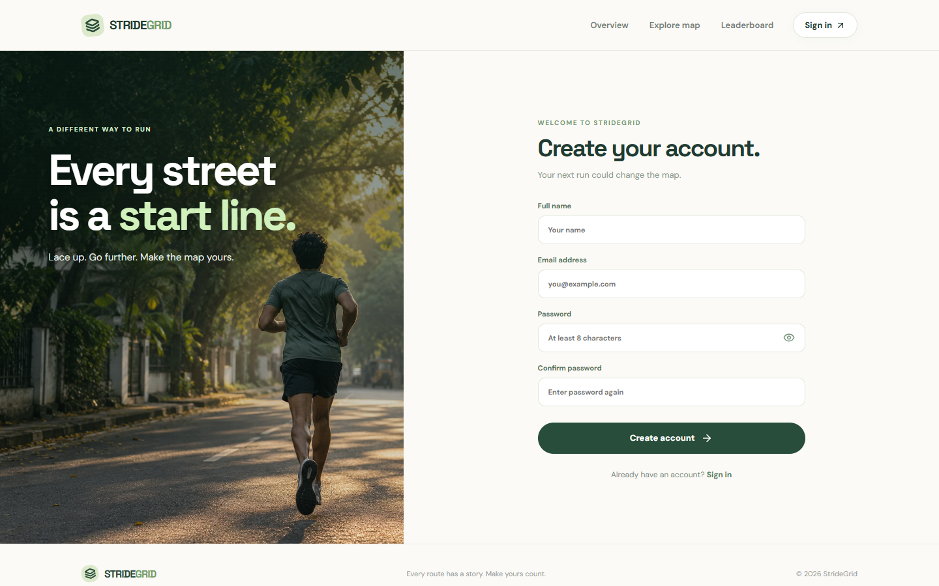
Figure 2 Account registration
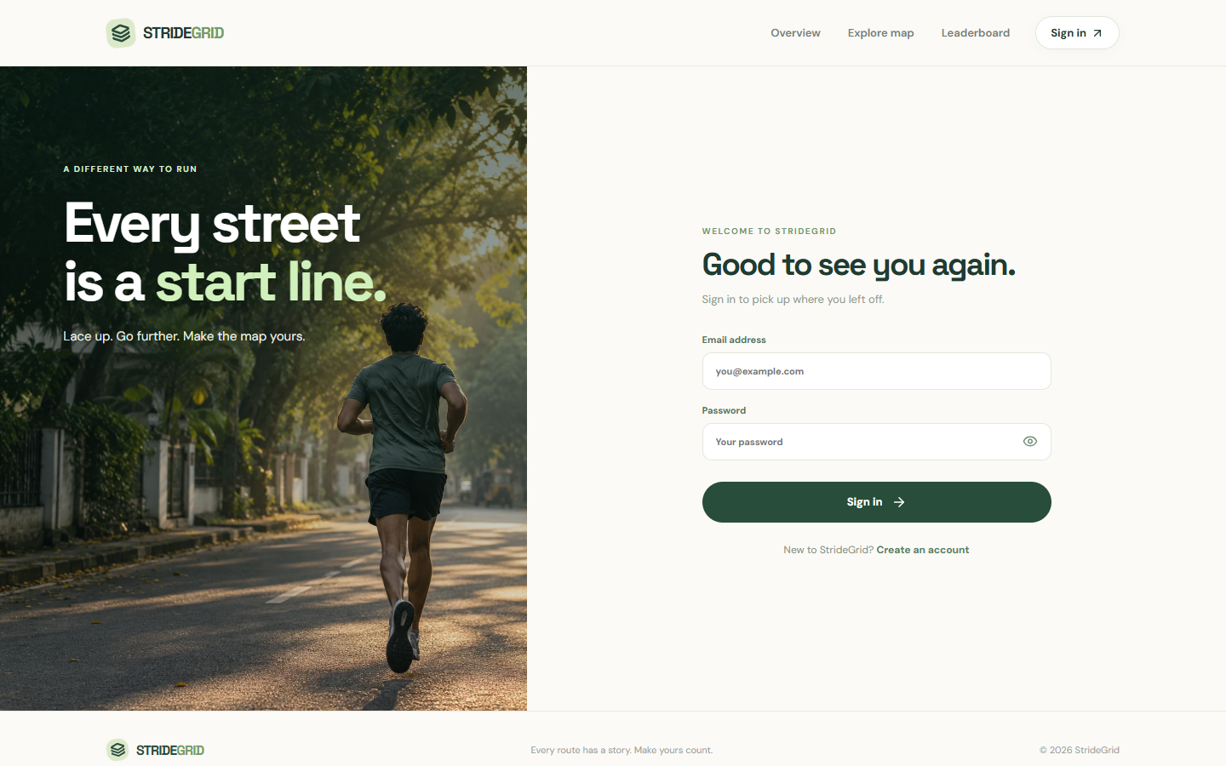
Figure 3 Returning runner sign-in
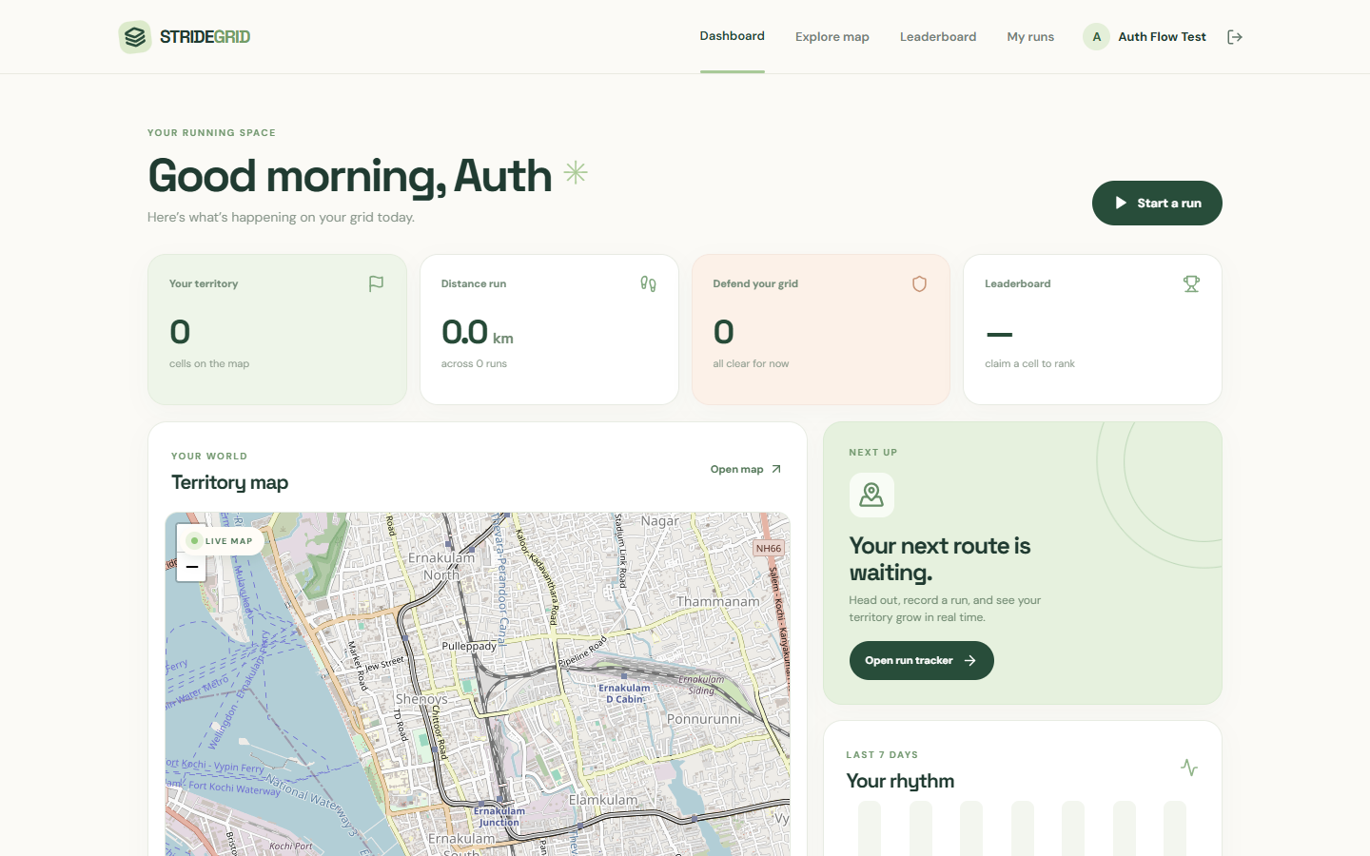
Figure 4 Signed-in dashboard using a demo account
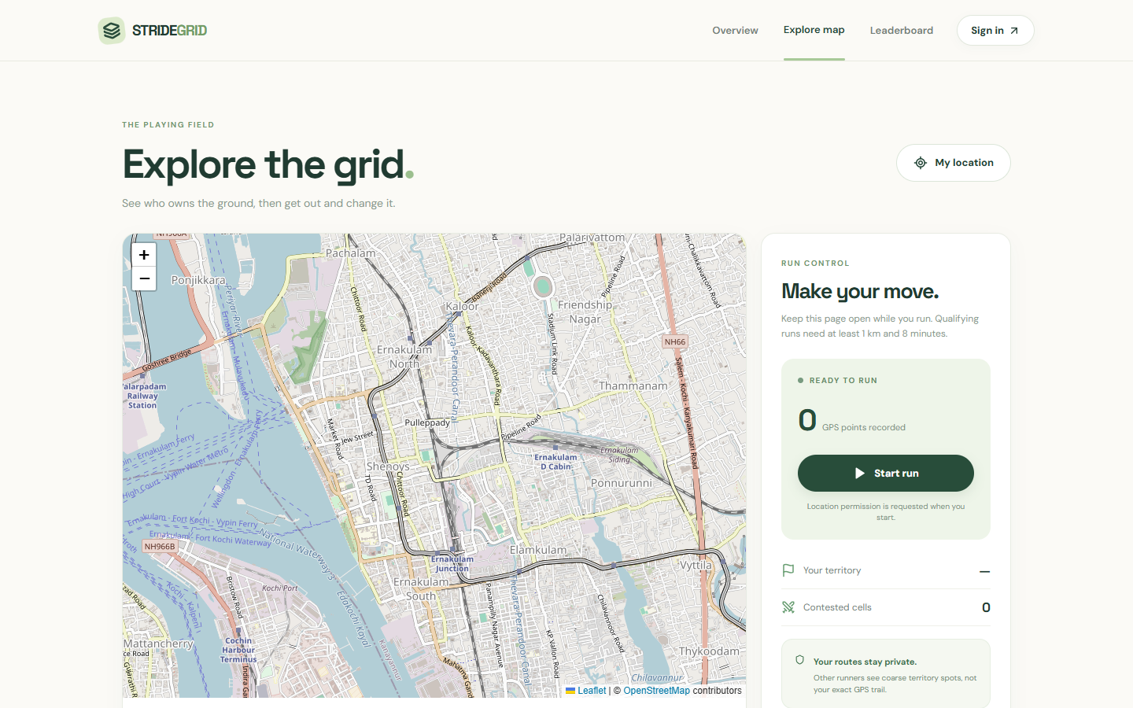
Figure 5 Territory map and run controls

Figure 6 Leaderboard empty state before a qualifying run
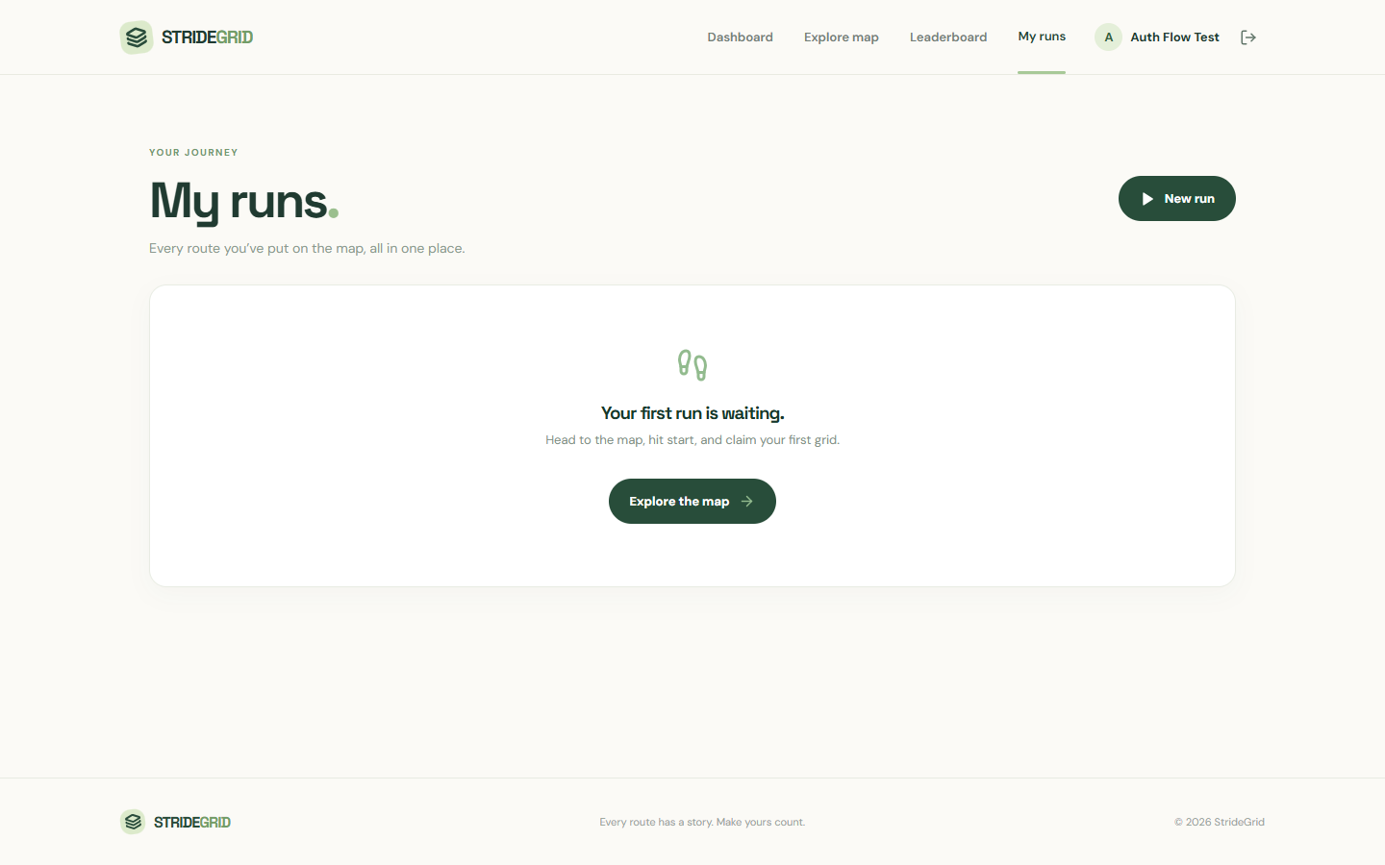
Figure 7 Private run-history empty state

