**Instructions**

* The duration of this challenge is **120 Minutes**.
* Programming questions have a **Compile and Run** option where you can run your solution against sample test cases before submitting it.
* Click **Evaluate** button only if your code compiles successfully.
* This challenge covers the following topic(s).
* Conditional constructs
* Looping
* Arrays
* Generic Collections
* List<object>

**Problem: Logistics Management System**

Create a console application to add and view the logistic details of customers.

Create a class called **Shipments** in which the following properties should be defined.

|  |  |
| --- | --- |
| **Property Name** | **Data Type** |
| ShipmentId | string |
| CustomerName | string |
| StartLocation | string |
| EndLocation | string |
| ExpectedStartDate | datetime |
| ActualStartDate | datetime |
| ExpectedEndDate | datetime |
| ActualEndDate | datetime |

Create a class called **DataAccessLayer** in which the following functions should be defined.

|  |  |  |  |
| --- | --- | --- | --- |
| **Method Name** | **Input Arguments** | **Return Type** | **Description** |
| InsertShipmentDetails | Shipments | int | This is a static function which accepts a shipment object, inserts data into database and returns the count of rows inserted. |
| ViewShipments | N/A | DataTable | This is a static function which accepts nothing but returns the shipment details of all shipments as a data table |
| ViewShipmentsByCustomerName | string | DataTable | This is a static function which accepts a customer name and returns his shipment details as a data table |

Create a class called **BusinessLogicLayer** in which the following functions should be defined.

|  |  |  |  |
| --- | --- | --- | --- |
| **Method Name** | **Input Arguments** | **Return Type** | **Description** |
| InsertShipmentDetails | Shipment | int | This is a static function which accepts a shipment object and calls InsertShipmentDetails function of the data access layer |
| ViewShipments | N/A | List<Shipments> | This is a static function which accepts nothing but returns the shipment details of all shipments as a List by calling the ViewShipments function of the data access layer |
| ViewShipmentsByCustomerName | String | List<Shipment> | This is a static function which accepts a customer name and returns his shipment details in the form of a list by calling ViewShipmentsByCustomerName function of the data access layer |

Call the functions of the Business logic layer from the Main method of the program class.

**Input & Output**

Input consists of a menu as given below.

Enter Your Choice

1. Insert Logistics Details
2. View All Logistics Details
3. View Logistics details of a customer
4. Exit

On choosing option 1, Invoke the method InsertShipmentDetails of Business Logic Layer for inserting the logistics details and if the number of rows affected is greater than 0 then display the message **‘Shipment Items inserted successfully’**. If the count of rows returned is less than 0 then display the message **‘An error occurred’**.

On choosing option 2, invoke the method ViewShipments method of the business logic layer for displaying the details of all the logistics.

On choosing the option 3, invoke the method ViewShipmentsByCustomerName of the business logic layer by passing the customer name and display the logistics details of that particular customer.

On choosing option 4 application should exit by printing the message ‘**Exiting the application**’.

If an invalid option is entered then display the message **‘Please enter a valid choice’**.

Based on the menu chosen display the appropriate message or data as mentioned above.

**Sample Input1 & Output 1**

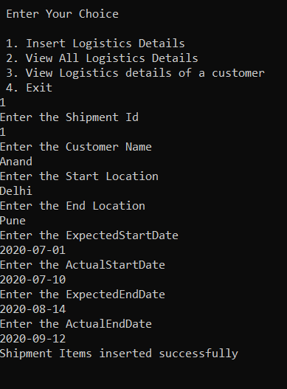

**Sample Input 2 & Output2**

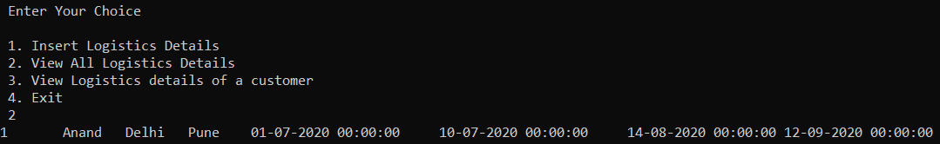

**Sample Input3 & Output 3**

