Synycs Group

AI-Powered Resume Builder
Project

An Intelligent Resume Generation System

Automating Professional Resume Creation using Artificial Intelligence

Details:
Anugu Hruthik Reddy
anuguhruthikreddy@gmail.com
mob: 8688270781
Aspiring AI engineer

1. Introduction
The AI Resume Builder is a full-stack web application designed to simplify and automate the process of creating professional resumes using Artificial Intelligence. In today’s competitive job market, students and fresh graduates often face challenges in creating resumes that meet industry standards and attract recruiters. This system addresses those challenges by providing an intelligent platform that generates high-quality resumes based on user input.
The application allows users to enter their academic background, skills, projects, certifications, and work experience through an interactive interface. Based on a selected job role or job description, the system generates a structured and optimized resume.
The system leverages AI models to analyze user data, enhance content, and ensure ATS (Applicant Tracking System) compatibility. It also provides features like skill gap analysis, resume editing, and multiple templates.
Overall, this project demonstrates how AI can be effectively integrated with web technologies to automate resume creation and improve job readiness.

Problem Statement
Creating a professional resume is a time-consuming and complex task, especially for students and freshers who lack experience in resume writing. Many users are unaware of proper formatting standards, keyword optimization, and industry expectations.
Traditional methods result in generic resumes that are not tailored to specific job roles. Additionally, many resumes fail to pass ATS systems due to poor structure and missing keywords.
Another challenge is the lack of awareness about skill gaps. Users often do not know which skills are required for specific job roles, leading to weak applications.
There is also a lack of tools that provide real-time feedback, intelligent suggestions, and automation. Hence, there is a need for an AI-based system that can generate optimized, personalized, and job-ready resumes efficiently.

Objectives
The main objective of this project is to develop an AI-powered system that automates the resume creation process. It aims to reduce manual effort and improve resume quality using intelligent algorithms.
The system focuses on generating ATS-friendly resumes that meet industry standards and increase the chances of selection. It also enables job-specific optimization by analyzing job descriptions and aligning user profiles accordingly.
Another objective is to identify skill gaps and provide suggestions for improvement. The system also provides multiple templates for customization and better presentation.
Additionally, it allows users to preview, edit, and download resumes in formats such as PDF and DOCX. The overall goal is to create a user-friendly and efficient platform for resume building.

Proposed System
The proposed system is an AI-powered platform that automates resume generation and optimization. It provides an intuitive interface for users to input their details such as skills, education, projects, and experience.
The system uses Groq to analyze input data and generate professional, structured, and ATS-friendly resume content.
It performs skill gap analysis, identifies missing skills, and suggests improvements. The platform supports multiple templates and provides real-time preview and editing capabilities.
The backend processes user data and interacts with AI models, while the frontend ensures a smooth user experience. The final output is a job-ready resume that can be downloaded instantly.
System Architecture
The system architecture follows a modular approach consisting of frontend, backend, and AI components. The frontend is developed using Streamlit, which provides an interactive interface for user input and resume preview.
The backend is built using FastAPI, which handles API requests, data processing, and communication between components.
The AI module uses Groq to generate and optimize resume content based on user input and job descriptions.
The data flows from the frontend to the backend, then to the AI module, and finally back to the frontend as a structured resume.
This architecture ensures scalability, real-time processing, and efficient integration of all components.

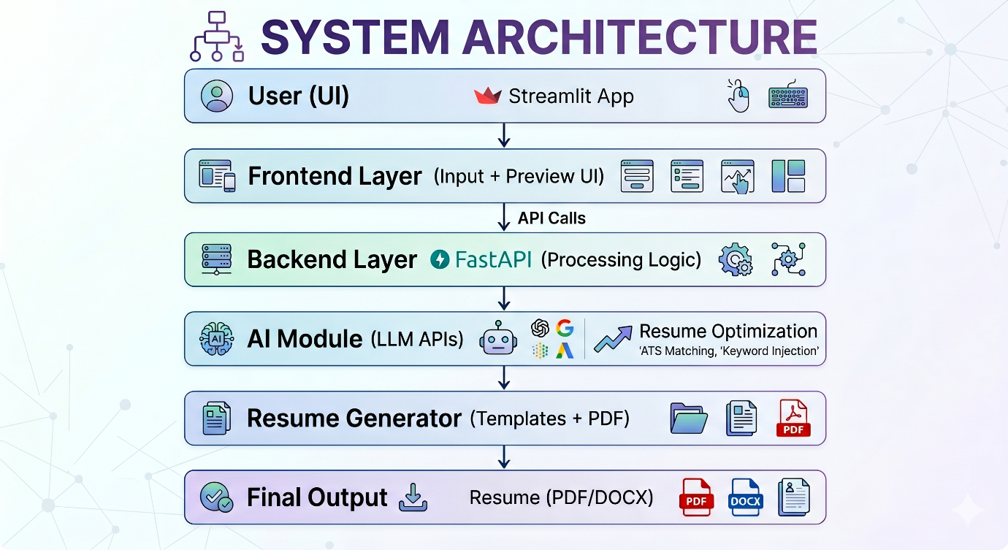
6. Technology Stack
The project uses modern technologies to ensure efficiency and scalability. The frontend is developed using Streamlit for building interactive web applications.
The backend is implemented using FastAPI, which provides high performance and fast API handling.
Python is used as the core programming language due to its simplicity and strong support for AI and web development.
The AI functionality is powered by Groq , which generates and optimizes resume content, performs skill analysis, and enhances quality.
Additional tools such as SQLAlchemy, LLM, WeasyPrint, and PDF generators and template engines are used to create downloadable resumes.
This combination of technologies creates a robust and scalable system.

Modules Description
The system is divided into multiple modules for better organization and functionality. The User Input Module collects user data such as skills, education, projects, and experience.
The AI Module uses Groq to generate optimized resume content and perform skill analysis.
The Resume Optimization Module organizes content into structured sections and ensures ATS compatibility.
The Template Module applies formatting and provides multiple resume layouts.
The Resume Editor Module allows users to edit and customize resumes in real time.
The PDF Generation Module converts resumes into downloadable formats.
The Resume History Module stores previous resumes for reuse.
All modules work together to provide a seamless and efficient system.
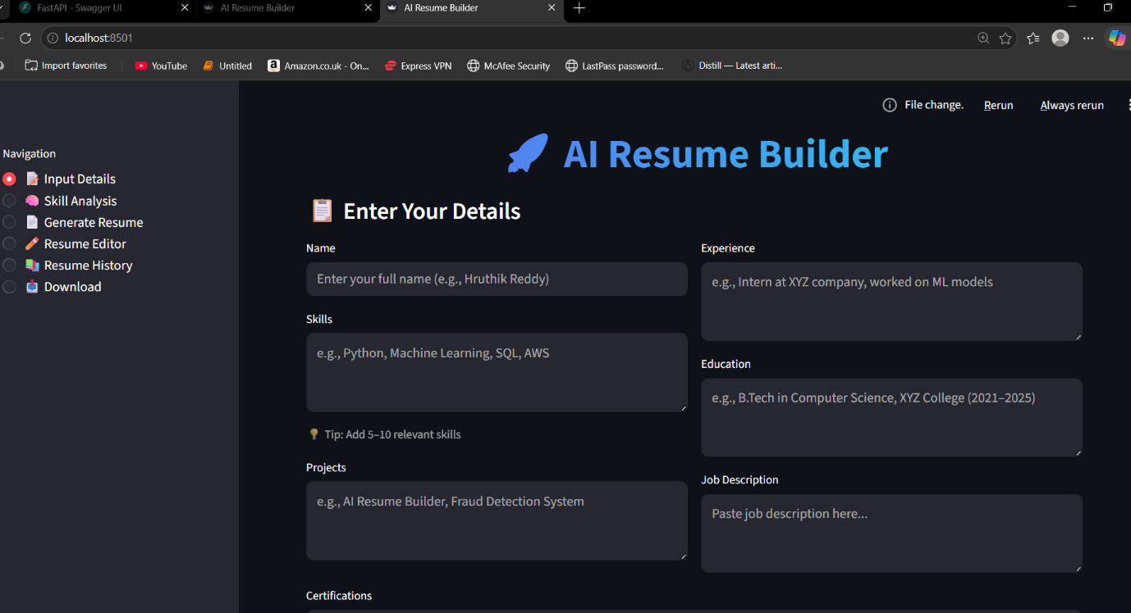
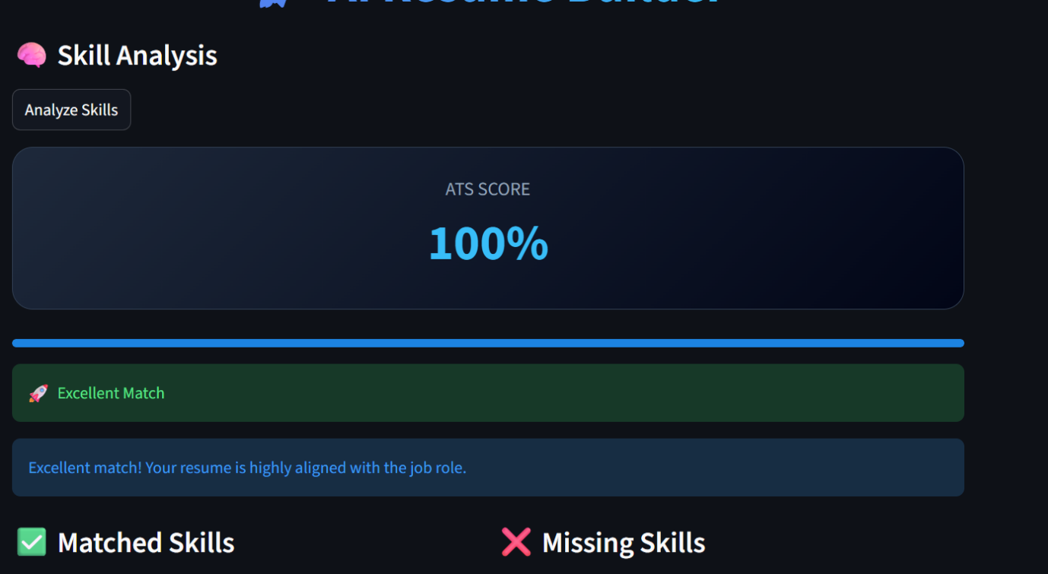
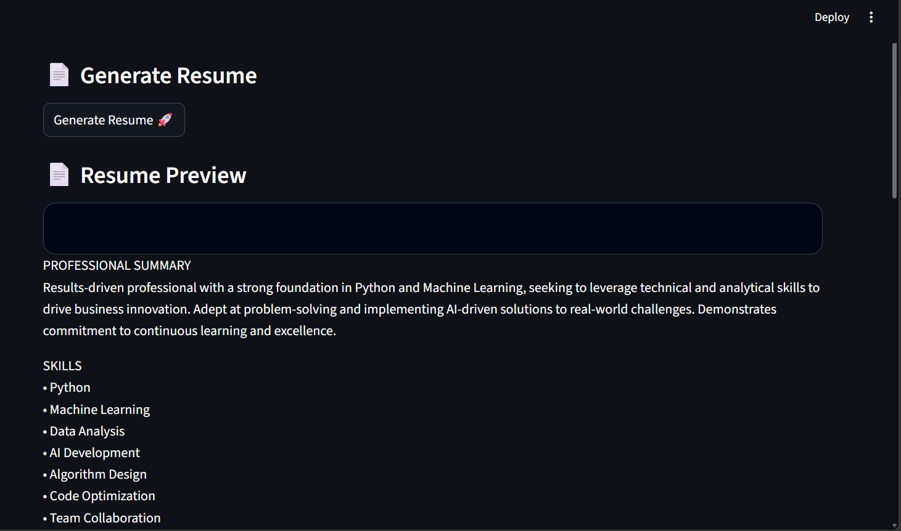
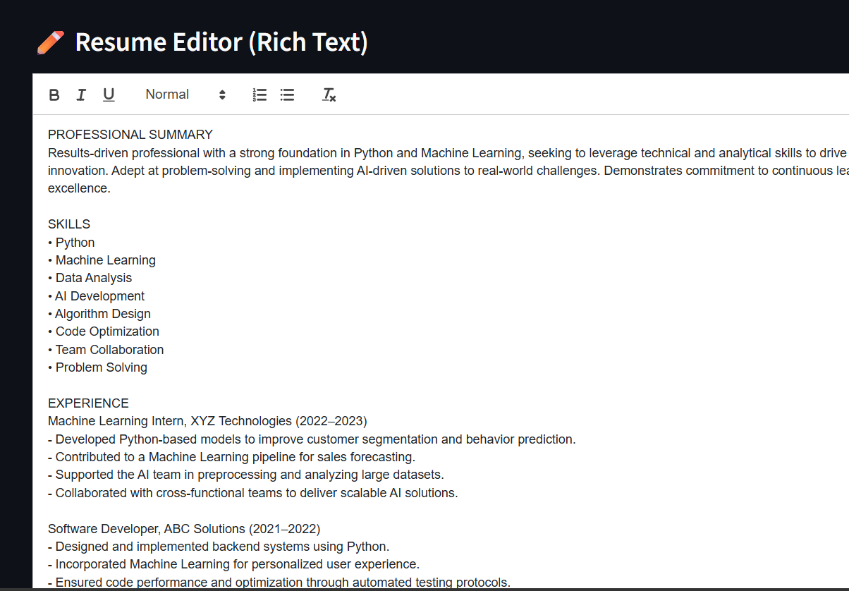

Working of the System
The system begins with the user entering their details through the frontend interface. The data is sent to the backend for processing and validation.
The backend forwards the data to the AI module, where Groq analyzes the input and generates optimized resume content.
The content is then structured using templates and displayed to the user. Users can edit and refine the resume using the editor.
The system also performs skill analysis and provides an ATS score.
Finally, the resume is generated in PDF/DOCX format and made available for download.
This process ensures quick and efficient resume creation.

Challenges & Issues Faced (Updated with Real Issues)
During the development of the AI Resume Builder, several practical challenges and system-level issues were encountered, particularly in backend integration and AI processing. These challenges helped in improving the robustness and reliability of the system.
One major issue was related to the Skill Analysis Module, where the system occasionally produced incorrect or inconsistent outputs. In some cases, the same skill was repeatedly classified, or irrelevant text was identified as missing skills. This occurred due to improper parsing of AI responses and lack of structured output handling.
Another significant issue was the occurrence of backend errors such as “Internal Server Error” and “Invalid response from backend” while fetching resume history. These errors were mainly caused by improper API responses, missing data validation, or incorrect handling of JSON responses between the frontend and backend.
The system also faced challenges in handling AI-generated responses, as Groq sometimes returned unstructured or verbose outputs. This required additional processing and filtering to extract meaningful information such as matched and missing skills.
In the skill analysis feature, inconsistencies occurred when comparing user skills with job descriptions due to string matching limitations and lack of normalization techniques (e.g., “machine learning” vs “ML”).
Another challenge was ensuring real-time synchronization between frontend (Streamlit) and backend (FastAPI). Delays or improper API handling sometimes caused UI errors or incomplete data rendering.
Handling resume history storage and retrieval was also difficult, especially when dealing with empty or corrupted records, leading to backend failures.
Additionally, maintaining consistent formatting during PDF/DOCX generation was challenging, as slight variations in content affected layout and structure.
All these issues were resolved through debugging, improving API validation, refining AI prompts, and implementing better error handling mechanisms. These improvements enhanced the system’s stability, accuracy, and user experience.
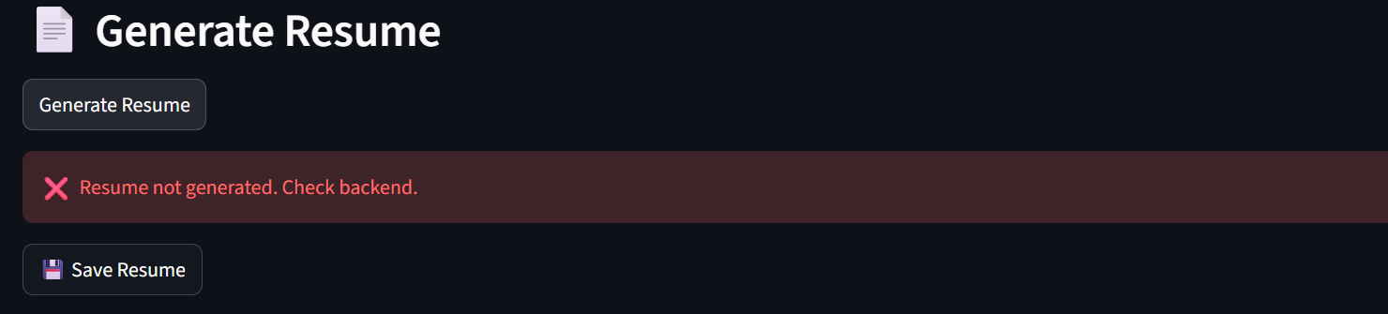
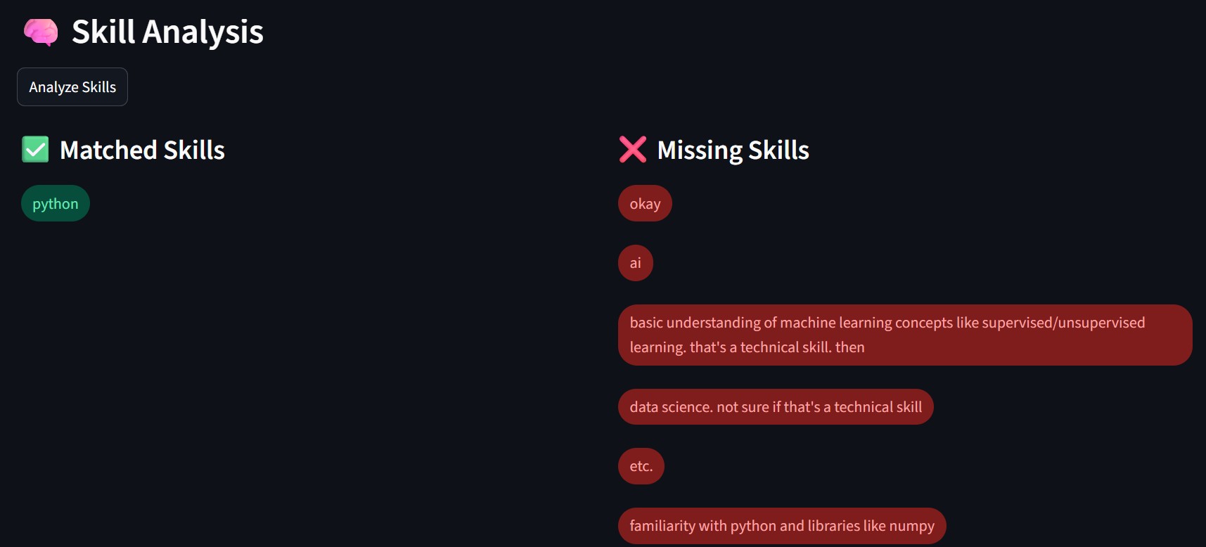

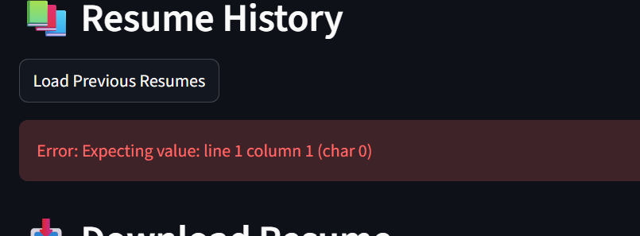

Files Structure
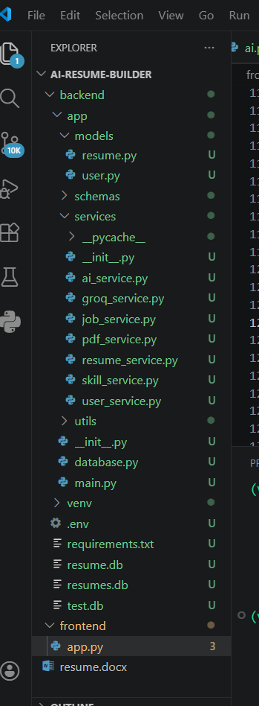

Features and Advantages
The system offers features such as AI-powered resume generation, ATS-friendly formatting, job-specific optimization, and skill gap analysis.
It provides a rich text editor for customization, multiple templates, and resume history management.
Users can download resumes in PDF/DOCX formats.
Advantages include saving time, improving resume quality, increasing job selection chances, and providing a beginner-friendly interface.
The system also helps users identify missing skills and improve their profiles.
Future Scope
The system can be enhanced by adding a job recommendation system that suggests roles based on user profiles.
A resume scoring system can provide detailed feedback and ratings.
Integration with LinkedIn can allow automatic data import.
AI-based interview preparation can be added for mock interviews.
Multi-language support can expand usability.
Cloud deployment can improve scalability for large users.

Conclusion
The AI Resume Builder is an intelligent system that simplifies and enhances resume creation using Artificial Intelligence. It combines frontend, backend, and AI technologies to provide a seamless user experience.
The system generates professional, ATS-friendly resumes and helps users improve their profiles through skill analysis.
It reduces manual effort and increases efficiency, making it highly beneficial for students and job seekers.
Overall, the project demonstrates the potential of AI in transforming traditional processes into intelligent solutions.

