

**The British College**

Kathmandu

Student ID: **77263669**

Module Tutor: Pratik Shrestha

Module Name: Advance web engineering

1. Evidences: - Laravel Installation - Laravel Routing - Version Control - View Templates - HTTP Requests (GET / POST/ 'PATCH or PUT' / DELETE). This formative checkpoint will provide an opportunity for early feedback on your usage of routing, view templates and Blade.

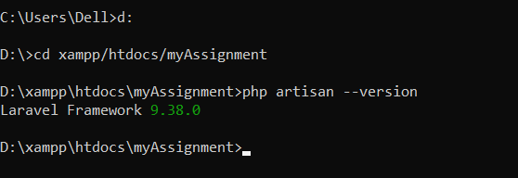

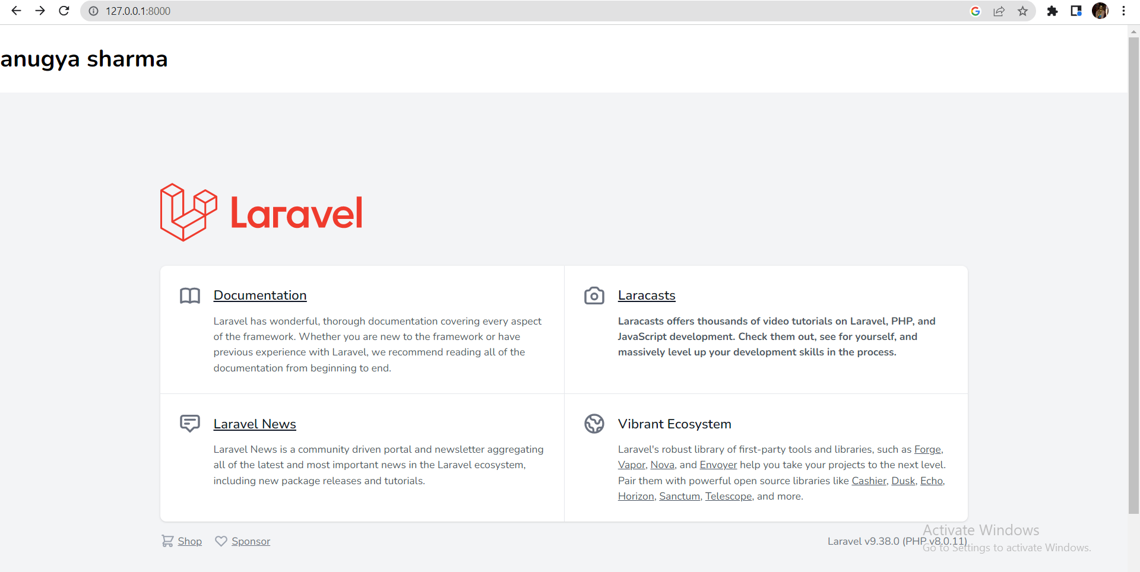

This is the web page of laravel which is running in my local host

So my laravel is successfully installed

1. **ROUTING: this feature allows us to route all the application demands to authorized controller**

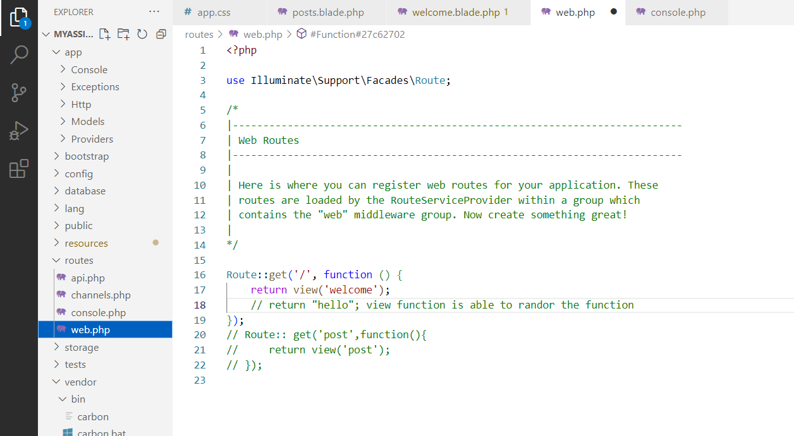

1. **Version control**

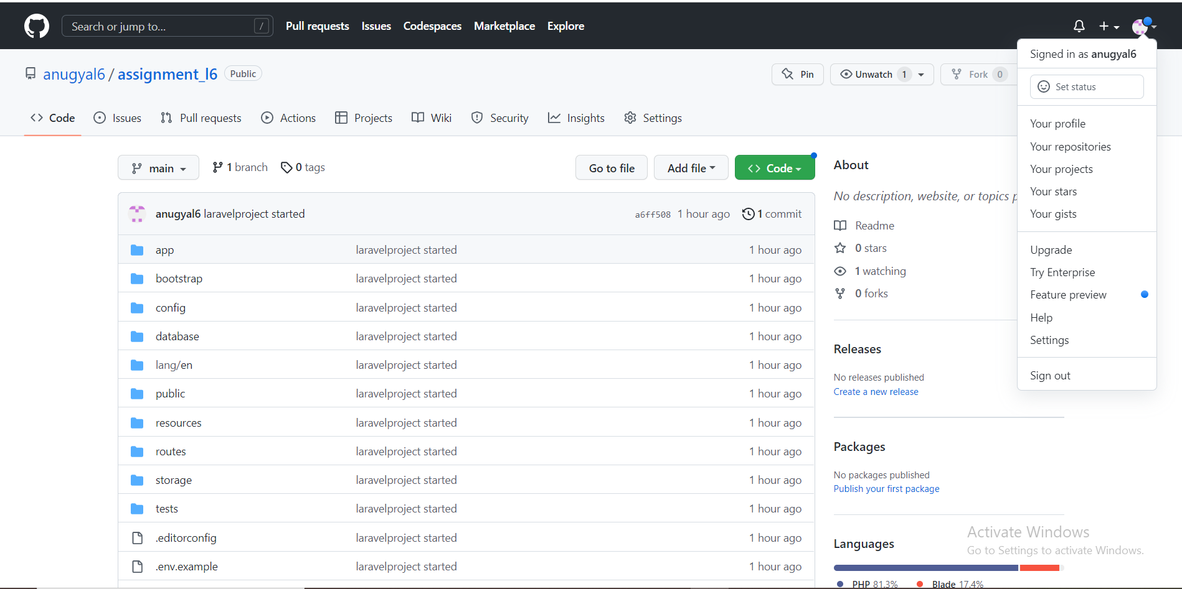

If we make any updates in our repo file , changes of history will be made in each file

**View templates**

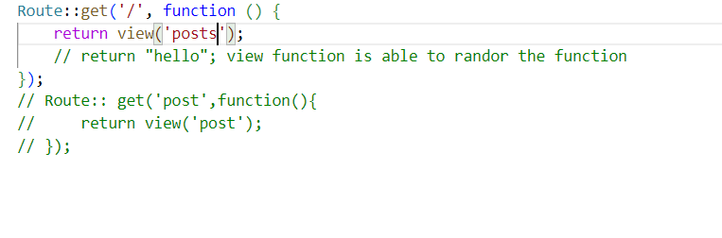

As you can see here above I have change name from welcome to posts now this is showing the content which is present inside the posts

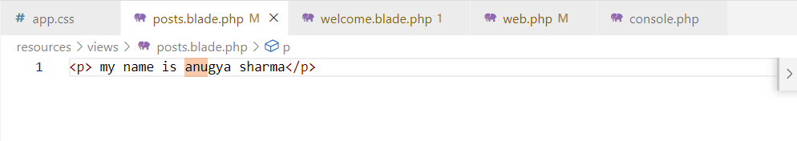

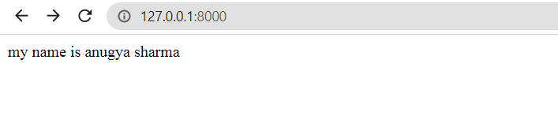

And now after changing and adding some information in posts.blade.php the input information are presented on webpage

1. HTTP Requests (GET / POST/ 'PATCH or PUT' / DELETE).

Https verbs

Get: when user is asking for data//read

Post: sending a data//c

Put/patch: any updates users want to make to data//update-------------------interchangeable

Delete: which should be delete//delete

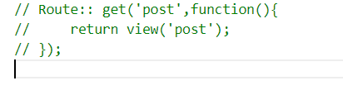

Here as we can see route: get(), route will try to access the real route object and then call get method.