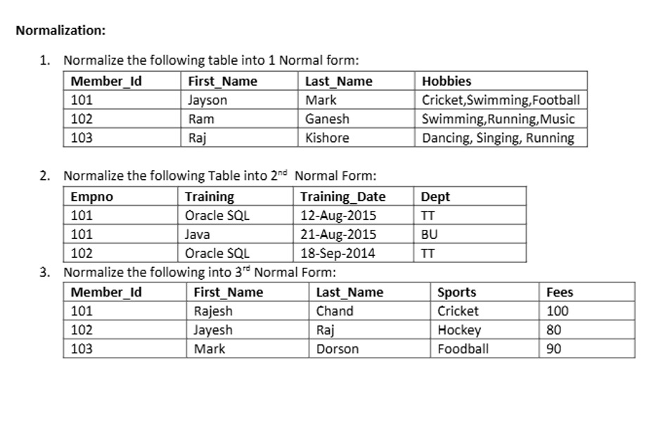

CREATE TABLE Member_Hobby (
Member_Id INT,
First_Name VARCHAR(50),
Last_Name VARCHAR(50),
Hobby VARCHAR(50)
);

INSERT INTO Member_Hobby VALUES
(101, 'Jayson', 'Mark', 'Cricket'),
(101, 'Jayson', 'Mark', 'Swimming'),
(101, 'Jayson', 'Mark', 'Football'),
(102, 'Ram', 'Ganesh', 'Swimming'),
(102, 'Ram', 'Ganesh', 'Running'),
(102, 'Ram', 'Ganesh', 'Music'),
(103, 'Raj', 'Kishore', 'Dancing'),
(103, 'Raj', 'Kishore', 'Singing'),
(103, 'Raj', 'Kishore', 'Running');


CREATE TABLE EMPLOYEE (
Empno INT PRIMARY KEY,
Dept VARCHAR(10)
);

CREATE TABLE EMP_TRAINING (
Empno INT,
Training VARCHAR(50),
Training_Date DATE,
PRIMARY KEY (Empno, Training),
FOREIGN KEY (Empno) REFERENCES EMPLOYEE(Empno)
);

INSERT INTO EMPLOYEE VALUES
(101, 'TT'),
(102, 'TT');

INSERT INTO EMP_TRAINING VALUES
(101, 'Oracle SQL', '2015-08-12'),
(101, 'Java', '2015-08-21'),
(102, 'Oracle SQL', '2014-09-18');


CREATE TABLE MEMBER (
Member_Id INT PRIMARY KEY,
First_Name VARCHAR(50),
Last_Name VARCHAR(50),
Sports VARCHAR(50)
);

CREATE TABLE SPORTS_FEES (
Sports VARCHAR(50) PRIMARY KEY,
Fees INT
);

INSERT INTO MEMBER VALUES
(101, 'Rajesh', 'Chand', 'Cricket'),
(102, 'Jayesh', 'Raj', 'Hockey'),
(103, 'Mark', 'Dorson', 'Football');

INSERT INTO SPORTS_FEES VALUES
('Cricket', 100),
('Hockey', 80),
('Football', 90);

