**1.Project Title:**

Jungle Run

**2.Game Description:**

It is an 3D endless runner game built with ThreeJS Library or API on top of WebGL and HTML 5 technologies. It can be played on different browsers.

Jungle Run aims to implement game of type infinite runner, in which the player appears to infinitely run through constant stream of obstacles

The graphic features implemented involve the elements necessary for a basic scene in a game. In order to provide some appearance of a game, various models and textures had to be imported and mapped.

**3.Goals:**

To create a game where player is running continuously to earn the coins having limited lives. Initially player will be having only two lives,once he will earn 10k coins in his bucket then life will increase by one.

**4. Requirement Specification:**

Here is a list of the minimum Hardware and Software requirements for playing this game:-

(i)Operating System:

* Windows 7

* Windows 8

* Windows 10

(ii) Hardware:

* Processor (CPU) with 2 gigahertz (GHz) frequency or above

* A minimum of 2 GB of RAM

* Monitor Resolution 1024 X 768 or higher

* Internet Connection Broadband (high-speed) with a speed of 4 Mbps or more

* Keyboard and a Microsoft Mouse or some other compatible pointing device

* Sound card

* Speakers or headphones

(iii) Browsers:

* Chrome 36+

* Edge 20+

* Mozilla Firefox 31+

* Internet Explorer 11+ (Windows only)

**5. Functional Requirements:**

1. Player can jump and slide to cross the hurdles.
2. Hurdles will come continuously but random,
3. Similarly coins will appear in screen and player have to collect these.
4. If player contacts any hurdles then it will prompt the messages to use his lives.
5. If life is used then game will resume not restart.
6. Game will be over if no lives in account.
7. Game should have 3 levels.
8. Every level will increase speed of the game and will count of hurdles
9. Apply jungle theme in background.

**6. Technology Used:**

1. Three JS
2. HTML5
3. CSS3
4. Javascript
5. Bootstrap
6. Tween JS

**7.User Interface:**

(i)Home Page

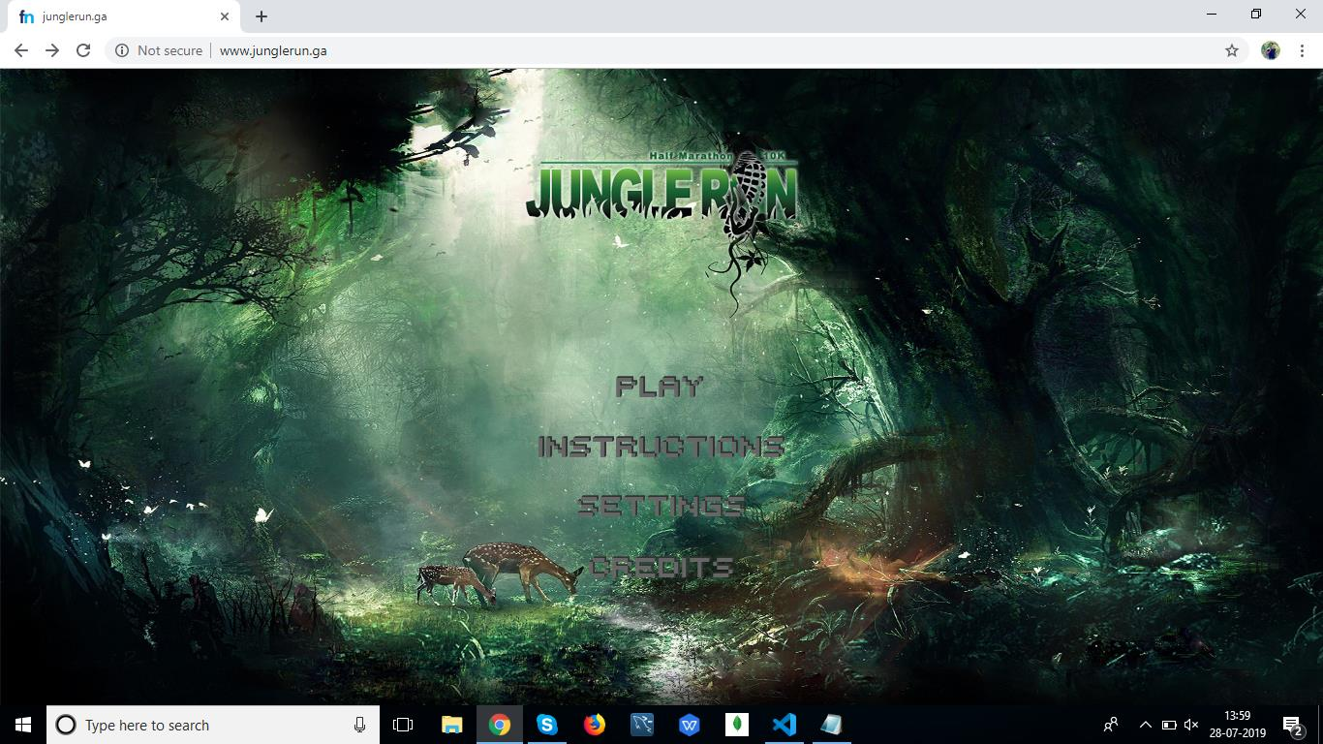

(ii)Storyline

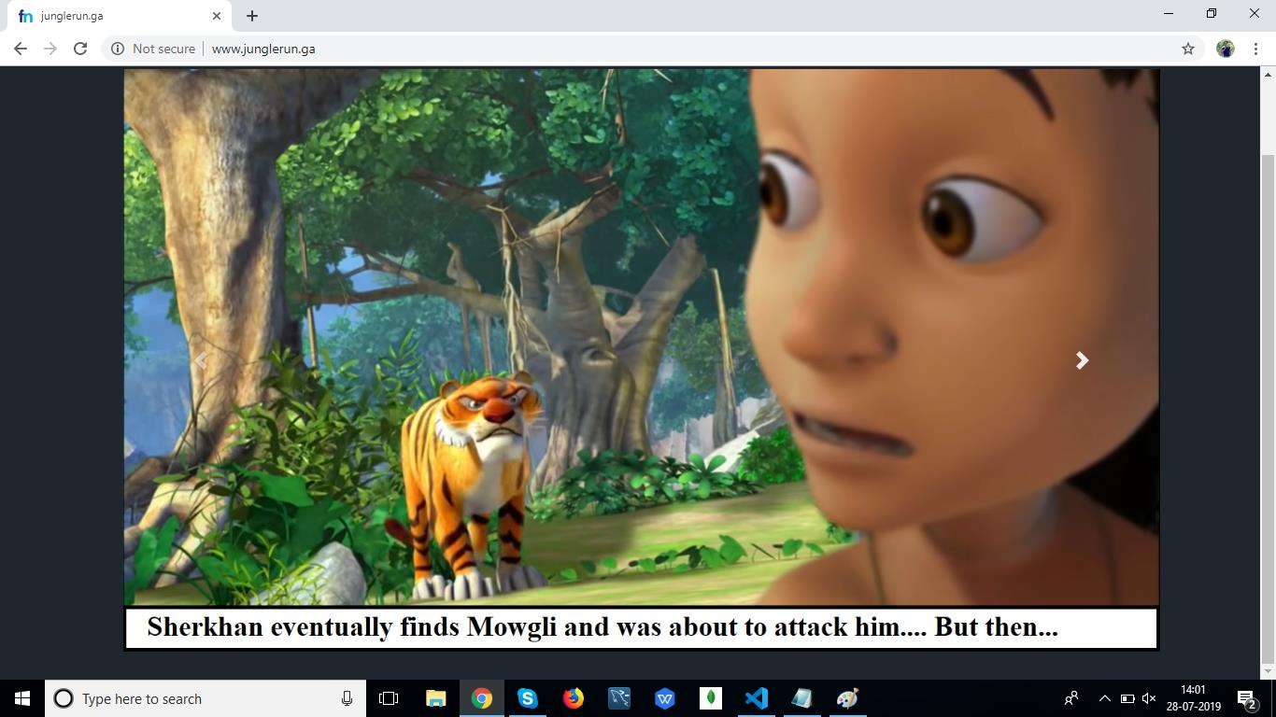

(iii)Game Screen

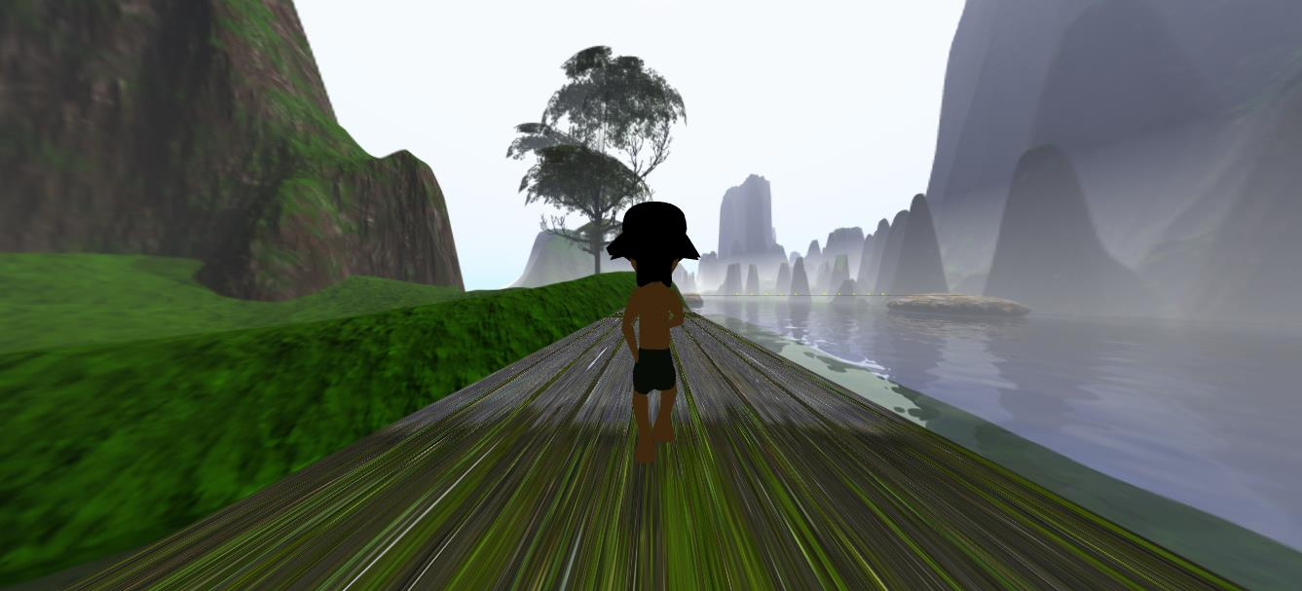

**8.Contributors**

1. Anuj Jaiswal
2. Dewanshu Chhatlani
3. E.Srikant
4. Harsh Thakur
5. Ojas Sharma
6. Shubham Verma

**9.References**

[1]"three.js – Javascript 3D library", *Threejs.org*, 2019. [Online]. Available: https://threejs.org/.

[2]"Skyboxes for download", *Custommapmakers.org*, 2019. [Online]. Available: http://www.custommapmakers.org/skyboxes.php.

[3]"CustomEase for GSAP by GreenSock | JavaScript HTML5 Animation", *GreenSock*, 2019. [Online]. Available: https://greensock.com/customease.

[4]"Sketchfab - Publish & find 3D models online", *Sketchfab*, 2019. [Online]. Available: https://sketchfab.com/.

[5]"W3Schools Online Web Tutorials", W3schools.com, 2019. [Online]. Available: https://www.w3schools.com/.

**10.Source Code Link**