EXPERIMENT NO. 1 — DATA WAREHOUSE DESIGN
Aim: To identify source tables and design Star Schema, Snowflake Schema and Fact Constellation (Galaxy) Schema.

1. Data Warehouse
Definition: A Data Warehouse (DW) is a centralized repository that stores integrated, historical and subject-oriented data from different sources for reporting, analysis and decision-making. It is mainly designed for analytical workloads rather than day-to-day transaction processing.
Main characteristics: Subject-oriented, integrated, time-variant and non-volatile. Historical data is retained so that trends can be compared over time.
Example: A retail company can combine sales, customer, product and store information in a warehouse and analyze total sales by product, city, store, month or year.

2. Data Mart
Definition: A Data Mart is a smaller, subject-specific part of a Data Warehouse. It is created for a department or business area.
Example: Sales Data Mart, Finance Data Mart, HR Data Mart and Marketing Data Mart. In this experiment, the subject is Retail Sales.

3. Fact Table and Dimension Table
Fact Table: Contains records of measurable business events. It normally contains foreign keys to dimensions and numerical measures.
Example: Sales_Fact contains TransactionID, ProductID, CustomerID, StoreID, DateID, Quantity and SalesAmount.
Dimension Table: Contains descriptive attributes used to filter, group and analyze facts.
Examples: Product_Dim, Customer_Dim, Store_Dim and Date_Dim.

4. Measures, Keys and Granularity
Measures: Numeric values that can be aggregated, such as Quantity and SalesAmount.
Primary Key (PK): Uniquely identifies a row in a table.
Foreign Key (FK): Connects a fact table to a dimension table.
Granularity: Defines what one row of a fact table represents. Here, one row represents one retail sales transaction.

THEORY — DIMENSIONAL SCHEMA CONCEPTS

5. Star Schema
Definition: A Star Schema has one central fact table directly connected to several dimension tables. Dimension tables are generally denormalized.
Example: Sales_Fact is connected directly to Product_Dim, Customer_Dim, Store_Dim and Date_Dim.
Advantages: Simple structure, easy reporting, fewer joins and generally fast analytical queries.
Limitation: Dimension data can be repeated, causing more redundancy.

6. Snowflake Schema
Definition: A Snowflake Schema is a normalized form of the star schema. Large dimensions are split into additional related tables.
Example: Product_Dim can contain CategoryID and BrandID, which point to Category_Dim and Brand_Dim. Customer_Dim can point to City_Dim.
Advantages: Reduces redundancy and improves consistency in hierarchical dimensions.
Limitation: More tables and joins make queries and the model more complex.

7. Fact Constellation / Galaxy Schema
Definition: A Fact Constellation, or Galaxy Schema, contains multiple fact tables that share common dimension tables.
Example: Sales_Fact and Returns_Fact can share Product_Dim, Customer_Dim, Store_Dim and Date_Dim.
Advantages: Supports analysis of several related business processes in one warehouse.
Limitation: More complex than star and snowflake schemas because several fact tables and relationships must be managed.

8. ETL Process
Extract: Collect data from operational databases, files or other source systems.
Transform: Clean, validate, standardize and convert data into the required warehouse format.
Load: Load the transformed data into the Data Warehouse/Data Mart.

9. Purpose of Dimensional Modelling
Purpose: Dimensional modelling organizes business data so that analytical questions can be answered easily. It separates measurable events (facts) from descriptive context (dimensions).
Typical analysis: Sales by product, sales by customer, sales by store, sales by city, monthly sales, quarterly sales and yearly sales.

EXAMPLE — RETAIL SALES DATA MART

10. Source Tables Identified
Source Table | Important Attributes | Purpose
Product | ProductID, ProductName, Category, Brand, Price | Stores product details
Customer | CustomerID, CustomerName, Gender, City | Stores customer details
Date | DateID, Date, Month, Quarter, Year | Time-based analysis
Store | StoreID, StoreName, Location | Stores store details
Sales | TransactionID, ProductID, CustomerID, StoreID, DateID, Quantity, SalesAmount | Stores sales events

11. Product Dimension — Sample Data
ProductID | ProductName | Category | Brand | Price
P001 | Laptop | Electronics | Dell | 55000
P002 | Mouse | Electronics | Logitech | 800
P003 | Keyboard | Electronics | HP | 1500
P004 | Office Chair | Furniture | Nilkamal | 4500
P005 | Study Table | Furniture | Godrej | 7000
P006 | Printer | Electronics | Canon | 12000
P007 | Notebook | Stationery | Classmate | 80
P008 | Pen | Stationery | Reynolds | 20
P009 | Backpack | Bags | Skybags | 2500
P010 | Water Bottle | Accessories | Milton | 500

12. Sales Fact — Sample Data
TransactionID | ProductID | CustomerID | StoreID | DateID | Qty | SalesAmount
T001 | P001 | C001 | S001 | D001 | 1 | 55000
T002 | P002 | C002 | S002 | D001 | 2 | 1600
T003 | P003 | C003 | S003 | D002 | 1 | 1500
T004 | P004 | C004 | S001 | D002 | 1 | 4500
T005 | P005 | C005 | S002 | D003 | 1 | 7000
T006 | P006 | C006 | S003 | D003 | 1 | 12000
Dimensions used: Product, Customer, Store, Date. Measures: Quantity and SalesAmount.

13. STAR SCHEMA — DIAGRAM
Central Sales Fact connected directly to all dimensions
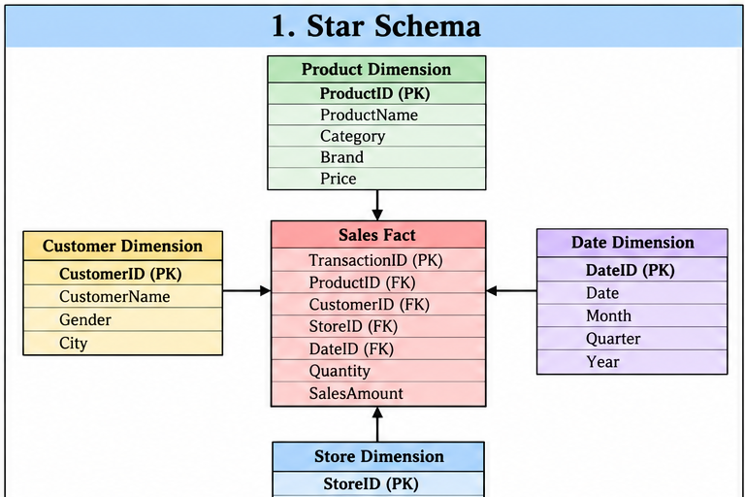

Star Schema Table Structure
Table | Columns
Sales_Fact | TransactionID, ProductID, CustomerID, StoreID, DateID, Quantity, SalesAmount
Product_Dim | ProductID, ProductName, Category, Brand, Price
Customer_Dim | CustomerID, CustomerName, Gender, City
Store_Dim | StoreID, StoreName, Location
Date_Dim | DateID, Date, Month, Quarter, Year

14. SNOWFLAKE SCHEMA — DIAGRAM
Normalized dimensions split into related tables
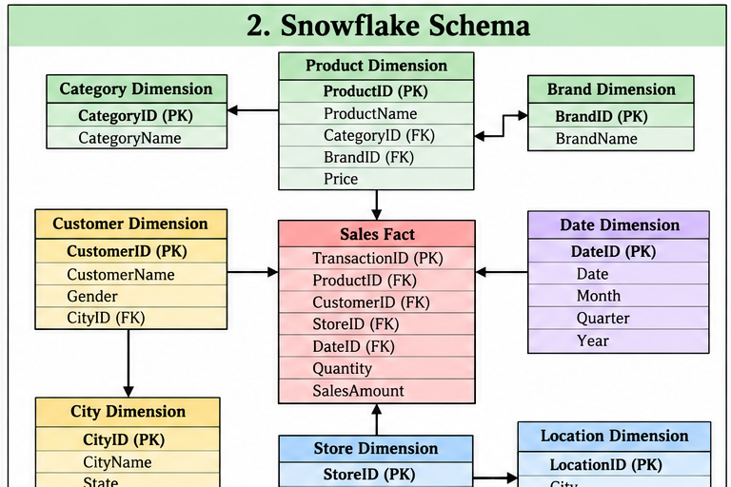

Snowflake Example
Dimension | Normalized Tables
Product | Product_Dim → Category_Dim + Brand_Dim
Customer | Customer_Dim → City_Dim
Store | Store_Dim → Location_Dim

15. FACT CONSTELLATION (GALAXY) SCHEMA — DIAGRAM
Multiple fact tables sharing common dimensions
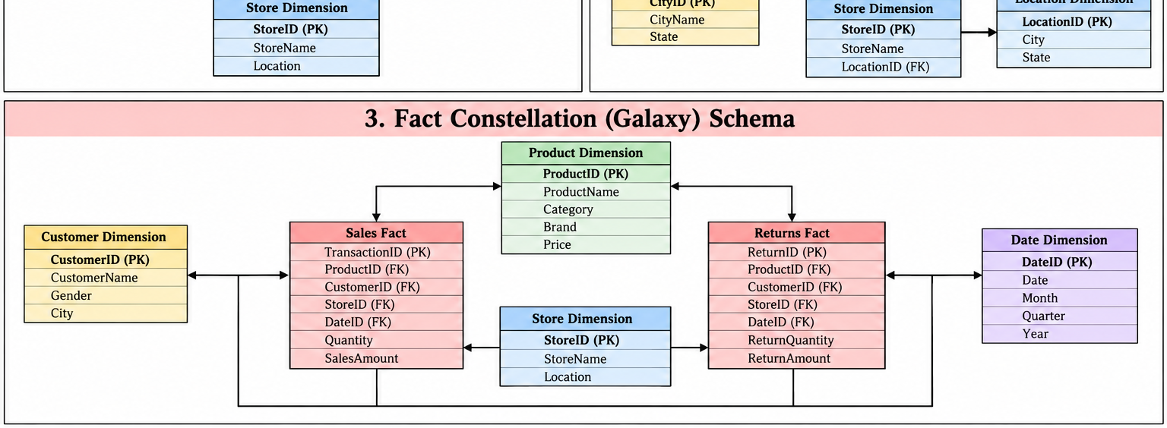

Galaxy Example
Fact Table | Measures | Shared Dimensions
Sales_Fact | Quantity, SalesAmount | Product, Customer, Store, Date
Returns_Fact | ReturnQuantity, ReturnAmount | Product, Customer, Store, Date

16. Comparison
Feature | Star | Snowflake | Galaxy
Fact tables | One main fact | One/main fact | Multiple facts
Dimensions | Denormalized | Normalized | Shared dimensions
Complexity | Low | Medium | High
Example | Sales | Sales + normalized categories | Sales + Returns

17. RESULT AND CONCLUSION

Result
The source tables of the Retail Sales system were identified and the dimensional models were designed using Star Schema, Snowflake Schema and Fact Constellation (Galaxy) Schema.

Conclusion
The Retail Sales Data Mart separates measurable sales events from descriptive dimensions. Star Schema provides a simple analytical model, Snowflake Schema reduces dimensional redundancy through normalization, and Galaxy Schema supports multiple business processes through shared dimensions.

18. Example Analysis
Analysis | Required Dimensions / Measure
Total sales | SalesAmount
Sales by product | Product + SalesAmount
Sales by store | Store + SalesAmount
Sales by customer | Customer + SalesAmount
Monthly sales | Date(Month) + SalesAmount
Quarterly sales | Date(Quarter) + SalesAmount
Sales vs Returns | Sales_Fact + Returns_Fact

