E-commerce Sales Analysis
Exploratory Data Analysis of 5,000 E-commerce Orders
Project Report
Prepared by: Anuj Singh
Dataset: ecommerce_sales_analytics_5000.csv
Tools: Python, Jupyter Notebook, Pandas, Matplotlib, Seaborn

1. Introduction
Online retailers collect a large amount of order data. Analysing it shows which products, regions and payment options bring in the most sales, and how customers respond to discounts and delivery times. This project carries out an exploratory data analysis (EDA) of an e-commerce dataset containing 5,000 orders. The analysis was done in a Jupyter Notebook using Python, and this report summarises the steps taken and the main results.

2. Project Objective
The objective of this project is to explore the e-commerce sales data and describe how sales and customer experience vary across the business. Specifically, the project aims to:
- measure overall sales and revenue and see how they change over time;
- compare revenue and order value across product categories, regions and payment methods;
- examine how discounts relate to order value and quantity;
- look at delivery times and customer ratings and check whether they are related; and
- check the relationships between the numeric variables using correlations.

3. Dataset Description
The dataset (ecommerce_sales_analytics_5000.csv) has 5,000 rows and 12 columns. Each row is one order. Table 1 lists the columns together with the values observed in the data.
Table 1: Columns in the dataset
Column | Type | Description and observed values
order_id | Integer | Order identifier (10001 to 15000, all unique)
order_date | Date | Date of the order (1 Jan 2022 to 9 Sep 2035, one order per day)
customer_id | Integer | Customer identifier (1000 to 1999; 989 different customers)
product_category | Text | Electronics, Clothing, Home, Beauty
region | Text | North, South, East, West
quantity | Integer | Units in the order (1 to 7)
unit_price | Decimal | Price per unit (15.15 to 599.96)
discount | Decimal | Discount rate applied to the order (0.00 to 0.35, i.e. 0% to 35%)
payment_method | Text | Card, COD (cash on delivery), Wallet
delivery_days | Integer | Days taken to deliver (1 to 11)
customer_rating | Decimal | Customer rating (1.0 to 5.0)
revenue | Decimal | Order revenue after discount (11.21 to 4,119.33)

Revenue equals quantity × unit price × (1 − discount), to within rounding, so it is the amount after the discount has been applied. The dataset does not state a currency, so revenue values in this report are shown without a currency symbol. The order dates run to September 2035 with exactly one order on each day, which suggests the data is a sample or simulated dataset rather than a record of real transactions.

4. Tools and Technologies Used
- Python: the programming language used for the whole analysis.
- Jupyter Notebook: the environment used to write and run the code and view the results.
- Pandas: loading the data, cleaning it, and calculating summary tables and statistics.
- Matplotlib and Seaborn: creating the charts and correlation heatmap.
- Microsoft Word: writing this report.

5. Data Preparation and Cleaning
- Loading and inspection: the CSV file was loaded with Pandas. It has 5,000 rows and 12 columns: four integer columns, four decimal columns and four text columns. The data types and summary statistics were checked with the standard Pandas inspection functions.
- Missing values: none of the 12 columns contain missing values.
- Duplicates: there are no duplicate rows and no repeated order IDs. Removal of duplicates and missing values was still included in the notebook as a safeguard, but it removed nothing, so the dataset stayed at 5,000 rows.
- Date conversion: order_date was stored as text (for example 1/1/2022). It was converted to a proper date type using the month/day/year format, and a year column was created from it.
- Columns added for the discount analysis: discount_amount (quantity × unit price minus revenue) and discount_band, which groups discounts into 0–10%, 11–20%, 21–30% and 31–35% (the highest discount in the data is 35%).

6. Exploratory Data Analysis
This section presents the main calculations and charts from the notebook. Group tables show the number of orders, total revenue, average order value (revenue per order) and average customer rating.

6.1 Overall Sales and Revenue
Table 2: Overall sales summary
Measure | Value
Total revenue | 5,109,775.74
Total orders | 5,000
Unique customers | 989
Units sold | 20,224
Average order value | 1,021.96
Median order value | 796.65
Average discount | 18.0%
Average delivery time | 6.12 days
Average customer rating | 2.97

The 5,000 orders generated a total revenue of 5,109,775.74 from 989 customers. The average order value is 1,021.96, while the median is 796.65. Because the average is higher than the median, a smaller number of high-value orders pull the average up.
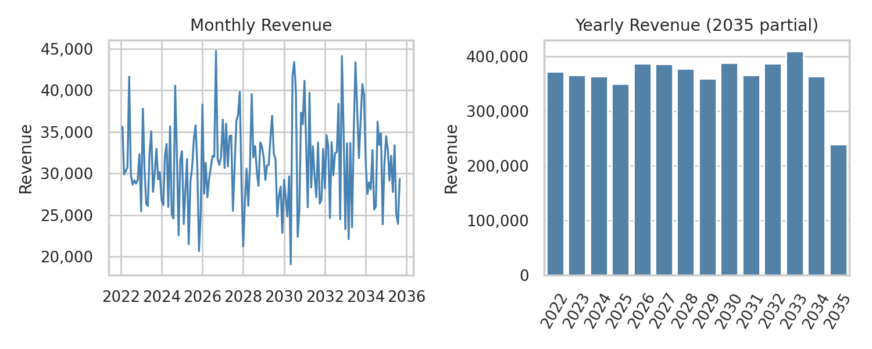
Figure 1: Monthly and yearly revenue (the last, incomplete month is left out of the monthly chart)
Yearly revenue for the full years 2022 to 2034 stays between 349,802.33 (2025) and 408,725.72 (2033), with no clear upward or downward trend. 2035 looks lower (238,733.36) only because the data ends on 9 September 2035 and contains 252 orders for that year. Monthly revenue moves between roughly 19,000 and 45,000 without a visible long-term trend.

6.2 Sales by Product Category
Table 3: Summary by product category
Category | Orders | Total revenue | Revenue share | Avg order value | Avg rating
Electronics | 1,777 | 1,829,899.22 | 35.8% | 1,029.77 | 2.95
Clothing | 1,531 | 1,531,931.72 | 30.0% | 1,000.61 | 3.01
Home | 969 | 982,083.92 | 19.2% | 1,013.50 | 2.94
Beauty | 723 | 765,860.88 | 15.0% | 1,059.28 | 3.01

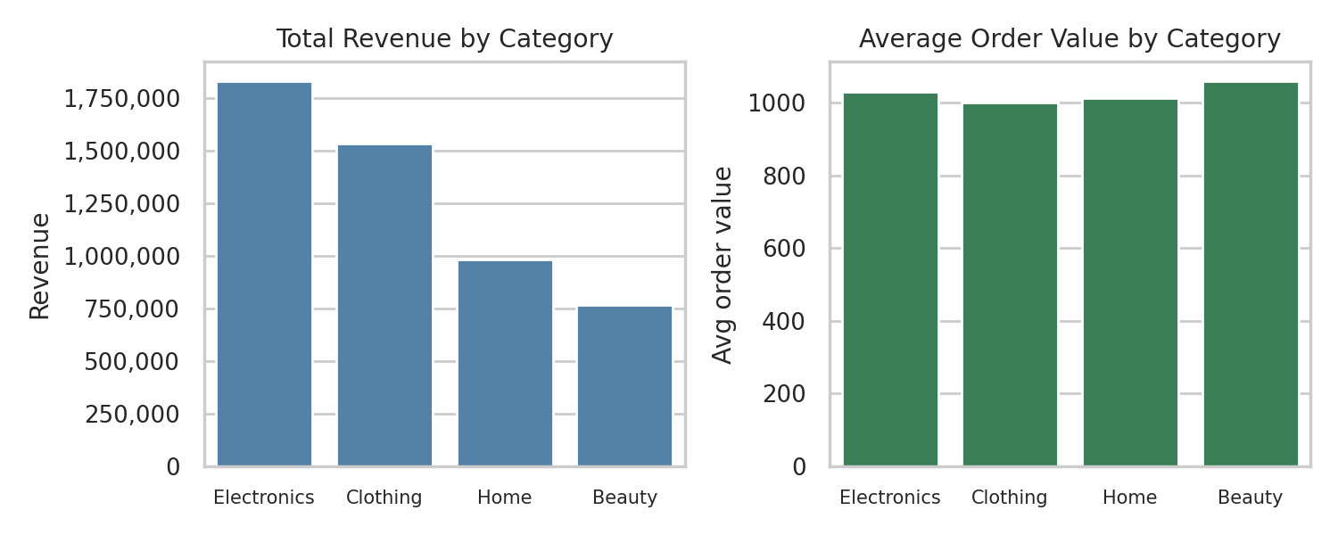
Figure 2: Total revenue and average order value by product category
Electronics generated the most revenue (35.8% of the total), followed by Clothing (30.0%), Home (19.2%) and Beauty (15.0%). Electronics and Clothing together account for 65.8% of all revenue. Average order value is similar across the categories (1,000.61 to 1,059.28), and Beauty, the category with the lowest revenue, actually has the highest average order value. So the revenue differences between categories come mainly from the number of orders (1,777 for Electronics against 723 for Beauty) rather than from the value of each order.

6.3 Sales by Region
Table 4: Summary by region
Region | Orders | Total revenue | Revenue share | Avg order value | Avg rating
West | 1,289 | 1,345,582.16 | 26.3% | 1,043.90 | 2.96
North | 1,276 | 1,281,508.45 | 25.1% | 1,004.32 | 2.99
South | 1,208 | 1,246,640.90 | 24.4% | 1,031.99 | 2.97
East | 1,227 | 1,236,044.23 | 24.2% | 1,007.37 | 2.97

The West region has the highest revenue (26.3%), followed by North (25.1%), South (24.4%) and East (24.2%). The gap between the highest and lowest region is 109,537.93, about 8.9% of the East region's revenue, so the regions are fairly balanced. West also has the highest average order value (1,043.90) and North the lowest (1,004.32). When category and region are combined, the highest revenue for a single combination is Electronics in the South (487,056) and the lowest is Beauty in the East (174,909).

6.4 Payment Methods
Table 5: Summary by payment method
Payment method | Orders | Order share | Total revenue | Avg order value | Avg rating
Card | 2,270 | 45.4% | 2,366,248.20 | 1,042.40 | 3.02
COD | 1,774 | 35.5% | 1,788,408.44 | 1,008.12 | 2.94
Wallet | 956 | 19.1% | 955,119.10 | 999.08 | 2.93

Card is the most used payment method, with 45.4% of orders and 46.3% of total revenue. COD follows with 35.5% of orders (35.0% of revenue) and Wallet with 19.1% of orders (18.7% of revenue). Each method's share of revenue is close to its share of orders. Card orders also have the highest average order value (1,042.40), compared with 1,008.12 for COD and 999.08 for Wallet.

6.5 Discounts
Discounts in the data range from 0% to 35%, with an average of 18.0%. The total value of discounts given, calculated as quantity × unit price minus revenue, is 1,130,246.22. Table 6 groups the orders into discount bands.
Table 6: Summary by discount band
Discount band | Orders | Total revenue | Avg order value | Avg quantity | Avg rating
0–10% | 1,401 | 1,624,404.90 | 1,159.46 | 4.01 | 2.96
11–20% | 1,401 | 1,482,197.03 | 1,057.96 | 4.07 | 2.96
21–30% | 1,502 | 1,417,792.45 | 943.94 | 4.07 | 2.97
31–35% | 696 | 585,381.36 | 841.07 | 4.00 | 3.04

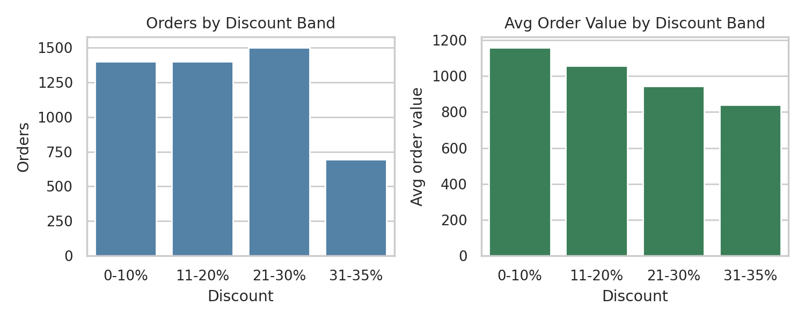
Figure 3: Orders and average order value by discount band
Average order value falls steadily as the discount rises, from 1,159.46 in the 0–10% band to 841.07 in the 31–35% band. Average quantity per order is almost the same in every band (4.00 to 4.07) and the average rating hardly changes (2.96 to 3.04), so larger discounts were not linked to larger orders in this data. Because revenue is recorded after the discount is applied, a higher discount lowers revenue per order directly. The 31–35% band has fewer orders (696) partly because it covers a narrower range of discounts (five percentage points instead of ten).

6.6 Delivery Days and Customer Ratings
Delivery takes 6.12 days on average (median 6 days), ranging from 1 to 11 days. Orders are spread fairly evenly across the delivery times, with between 410 and 492 orders for each number of days. Average delivery time is almost the same for every category, region and payment method (6.07 to 6.20 days).
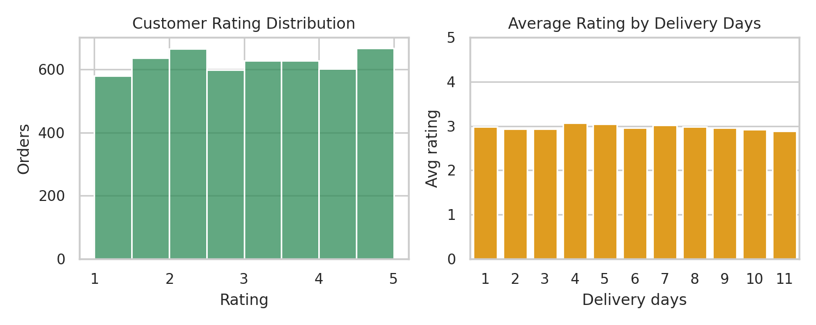
Figure 4: Distribution of customer ratings and average rating by delivery days
Customer ratings average 2.97 (median 3.0) and are spread across the whole 1 to 5 scale rather than concentrated at the top: 25.4% of orders are rated 4 or higher and 26.9% are rated 2 or lower. Average ratings are also very similar across categories, regions and payment methods (2.93 to 3.02). The average rating for each delivery time only varies between 2.89 (11 days) and 3.07 (4 days), with no clear pattern, so longer delivery times are not linked to lower ratings in this data.

6.7 Relationships Between Variables
A correlation matrix was calculated for the numeric variables (quantity, unit price, discount, delivery days, customer rating and revenue). Figure 5 shows the result.
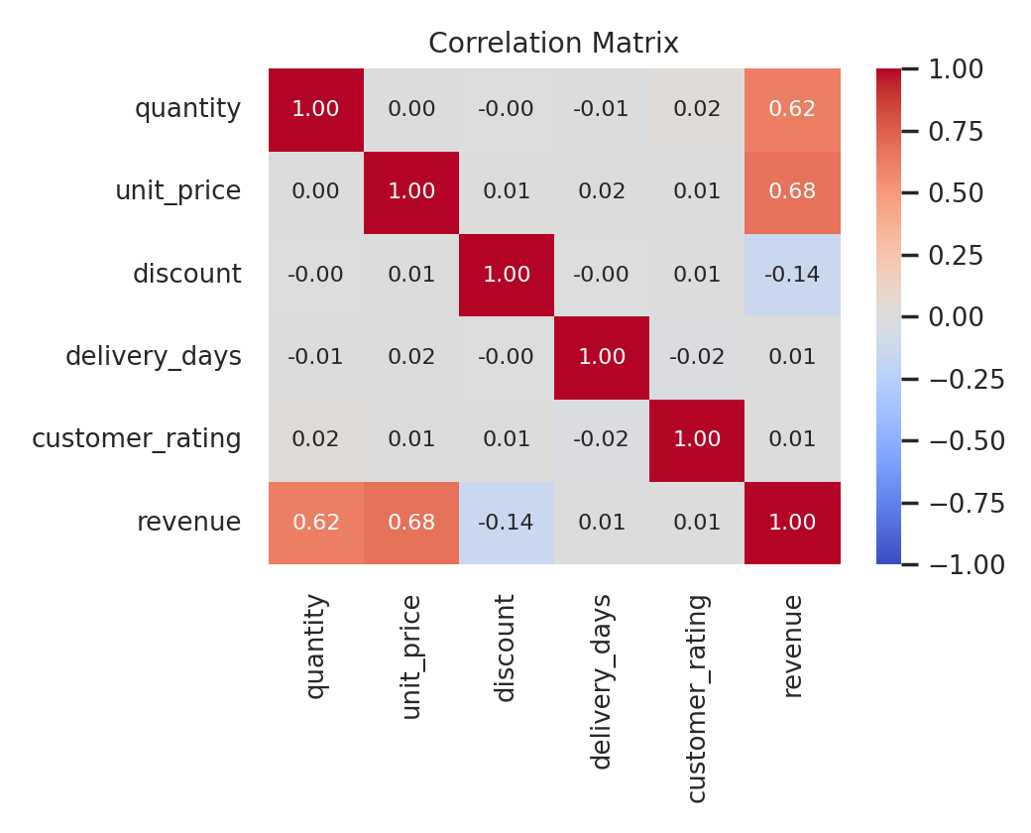
Figure 5: Correlation matrix of the numeric variables
Revenue has a moderate positive correlation with unit price (0.68) and with quantity (0.62), which is expected because revenue is calculated from them. Discount has a weak negative correlation with revenue (−0.14). Delivery days (0.01) and customer rating (0.01) show almost no correlation with revenue. Among quantity, unit price, discount, delivery days and customer rating, every pair has a correlation below 0.02 in absolute value, so there is no linear relationship between them. For example, delivery days and customer rating have a correlation of −0.02. Correlation only describes association and does not show that one variable causes another.

7. Key Findings and Insights
- Overall performance: the 5,000 orders produced total revenue of 5,109,775.74, with an average order value of 1,021.96. Yearly revenue for full years stayed between 349,802.33 and 408,725.72, with no clear trend.
- Electronics and Clothing lead sales: together they make up 65.8% of revenue. The gap between categories comes from order volume, because average order values are similar (1,000.61 to 1,059.28).
- Regions are balanced: West has the highest revenue (26.3%) and East the lowest (24.2%), a difference of about 8.9%.
- Card is the preferred payment method: it accounts for 45.4% of orders and 46.3% of revenue, and has the highest average order value (1,042.40).
- Higher discounts go with lower order value: average order value drops from 1,159.46 (0–10% discount) to 841.07 (31–35%), while the average quantity per order stays around 4.0 to 4.1. Total discounts given amount to 1,130,246.22.
- Unit price and quantity drive revenue: their correlations with revenue are 0.68 and 0.62, while delivery days and ratings have almost no correlation with revenue.
- Ratings are unrelated to delivery time: the average rating is 2.97 out of 5, only 25.4% of orders are rated 4 or higher, and the correlation between delivery days and rating is −0.02.

8. Conclusion
This project explored 5,000 e-commerce orders using Python, Pandas, Matplotlib and Seaborn. The data needed little cleaning: there were no missing values or duplicates, and only the order date had to be converted to a date type.
The analysis shows that revenue is concentrated in Electronics and Clothing, is spread fairly evenly across the four regions, and is most often paid by Card. Order value depends mainly on unit price and quantity, and higher discounts are associated with lower order value without an increase in the number of units bought. Customer ratings stay close to 3 out of 5 whatever the category, region, payment method, discount level or delivery time.
The analysis is exploratory. It relies on summary tables, charts and correlations and does not test the differences statistically, so small differences, such as those between regions, should be read with care. Also, because the order dates extend to 2035 with exactly one order per day, the dataset is probably sample data, and the findings describe this dataset rather than a real business.

