**Title: Resistor Fault Detection system**

Abstract

A resistor fault detection system is a device or circuit that detects the occurrence of a fault in a resistor. Resistor faults can occur due to a variety of factors, such as overvoltage, overheating, or physical damage. If a resistor fault is not detected and corrected, it can lead to a variety of problems, such as circuit failure, fire, or even death. Resistor fault detection systems work by measuring the resistance of the resistor and comparing it to the expected value. If the measured resistance is outside of the expected range, then a fault is detected. There are a variety of different resistor fault detection systems available, but they can be broadly classified into two categories: analog and digital. Analog resistor fault detection systems are typically simpler and less expensive to implement than digital systems, but they can be less accurate. Digital resistor fault detection systems are more accurate than analog systems, but they can be more complex and expensive to implement.

Introduction

A resistor fault detection system is a device or circuit that detects the occurrence of a fault in a resistor. Resistor faults can occur due to a variety of factors, such as overvoltage, overheating, or physical damage. If a resistor fault is not detected and corrected, it can lead to a variety of problems, such as circuit failure, fire, or even death. Resistor fault detection systems work by measuring the resistance of the resistor and comparing it to the expected value. If the measured resistance is outside of the expected range, then a fault is detected There are a variety of different resistor fault detection systems available, but they all work on the same basic principle. They measure the resistance of the resistor and compare it to the expected value. If the measured resistance is outside of the expected range, then a fault is detected. In power electronics applications, resistor fault detection systems are used to prevent circuit failure, overheating, and fire. In telecommunications applications, resistor fault detection systems are used to prevent signal degradation, dropped calls, and equipment outages. In aerospace and military applications, resistor fault detection systems are used to ensure the safety and reliability of critical systems. In automotive applications, resistor fault detection systems are used to prevent engine failure and other problems. In industrial automation applications, resistor fault detection systems are used to prevent production downtime and other problems.

Literature Survey

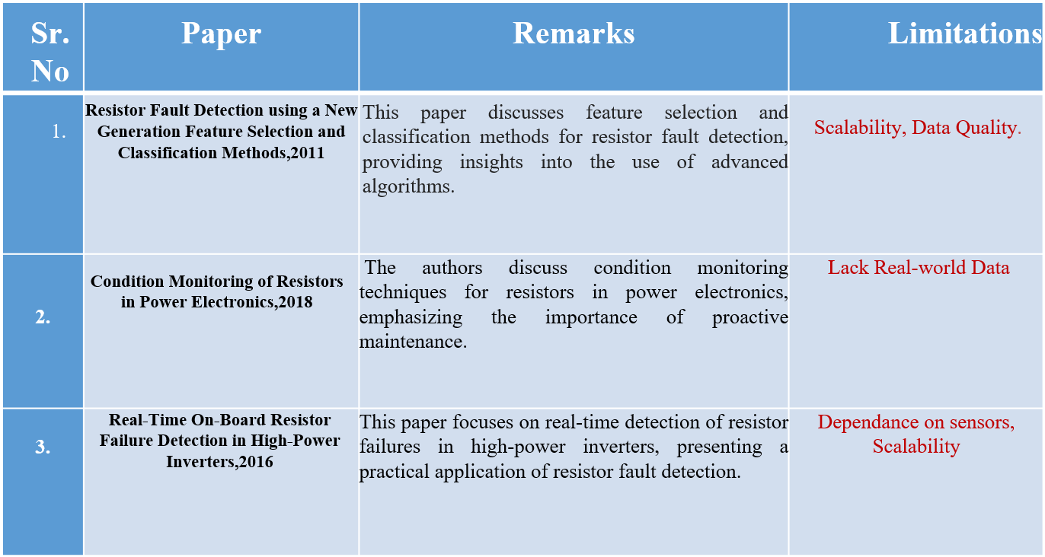

Methodology

The methodology of resistor fault detection systems can be broadly divided into two steps:

## 1. Data Collection:

## Data collection is the initial phase of resistor fault detection. It involves acquiring data from the resistor under test. This may include measuring the resistance value, capturing thermal images, analyzing responses to applied signals, or monitoring the resistor's performance under various conditions. Specialized instruments and sensors are used for data collection.

## 2. Feature Extraction:

## After data collection, relevant information is extracted from the raw data to create informative features. These features may include resistance values, thermal profiles, response signals, and other characteristics that can be indicative of resistor health or faults. Feature extraction simplifies the data and prepares it for analysis, using techniques such as signal processing or thermal analysis.

## 3. Fault Labels:

## Fault labels are important for supervised machine learning or for identifying the type and nature of resistor faults. During this step, the data is labeled to indicate the presence of specific resistor faults or anomalies. These labels can include open circuits, short circuits, temperature variations, or other types of deviations from normal behavior.

## 4. Alert Generation:

## Using machine learning algorithms, rule-based systems, or predetermined thresholds, the system evaluates the collected data and detected features to determine if a resistor fault is present and, if so, what type of fault it is. When a fault is detected, an alert is generated. This alert may take the form of a notification or alarm, indicating the presence of a resistor fault to relevant personnel or monitoring systems.

## 5. Presentation of Output:

The presentation of output is the final step in the resistor fault detection process. The results of the analysis, including the type and location of the fault, as well as any other relevant information, are presented to the end-user. This presentation can be in the form of visual reports, charts, or data displayed on a user interface. The goal is to provide clear and understandable information to facilitate prompt decision-making and action in response to resistor faults, thereby maintaining the reliability of electronic systems.

System Design and Development

The system design and development of a resistor fault detection system can be broadly divided into the following steps:

**Requirements analysis**: The first step is to analyze the requirements of the system. This includes determining the following:

The types of resistors to be monitored

The acceptable range of resistance values

The desired level of accuracy

The desired response times

The environmental conditions in which the system will be used

**System design**: Once the requirements have been analysed, the system can be designed. This includes selecting the appropriate components and hardware, and developing the software algorithms.

**System implementation**: The next step is to implement the system. This includes building the hardware circuit and programming the microcontroller.

**System testing**: Once the system has been implemented, it must be tested to ensure that it meets the requirements. This includes testing the system with a variety of resistors and fault conditions.

**System deployment**: Once the system has been tested and verified, it can be deployed in the field.

Result:

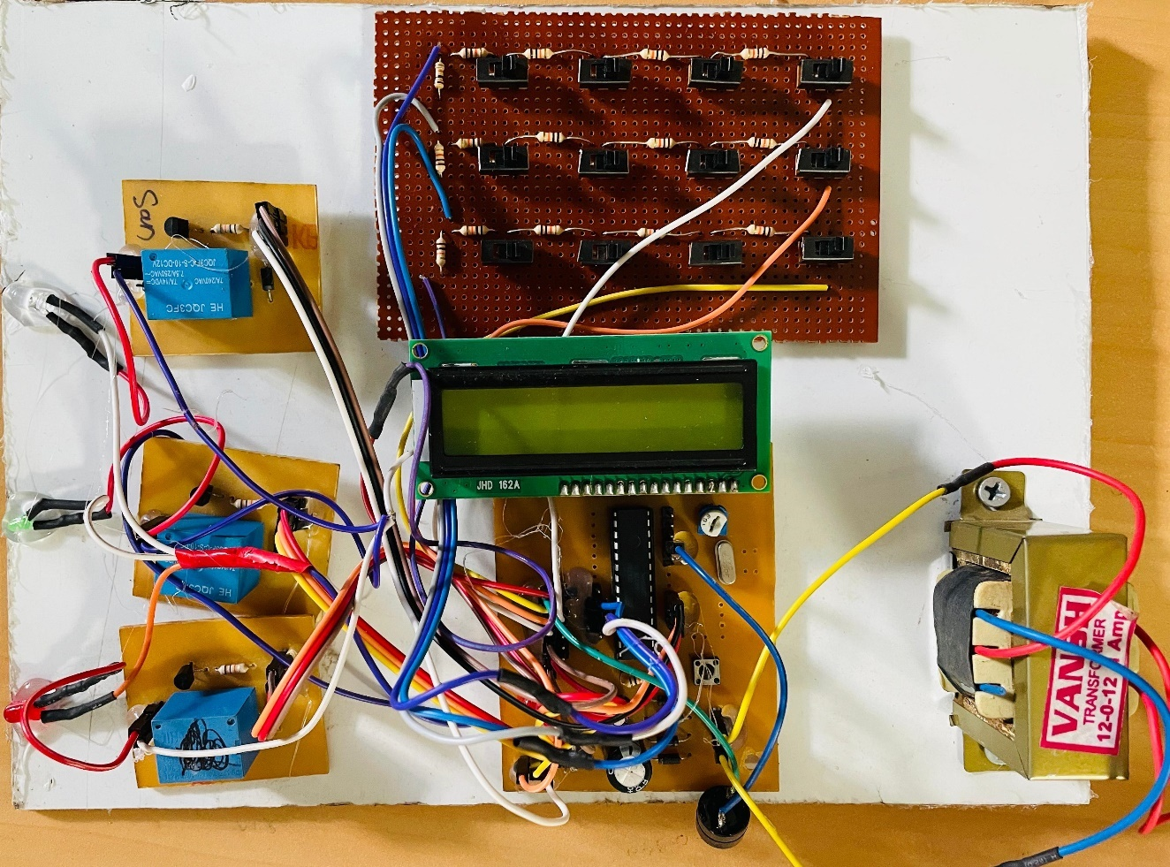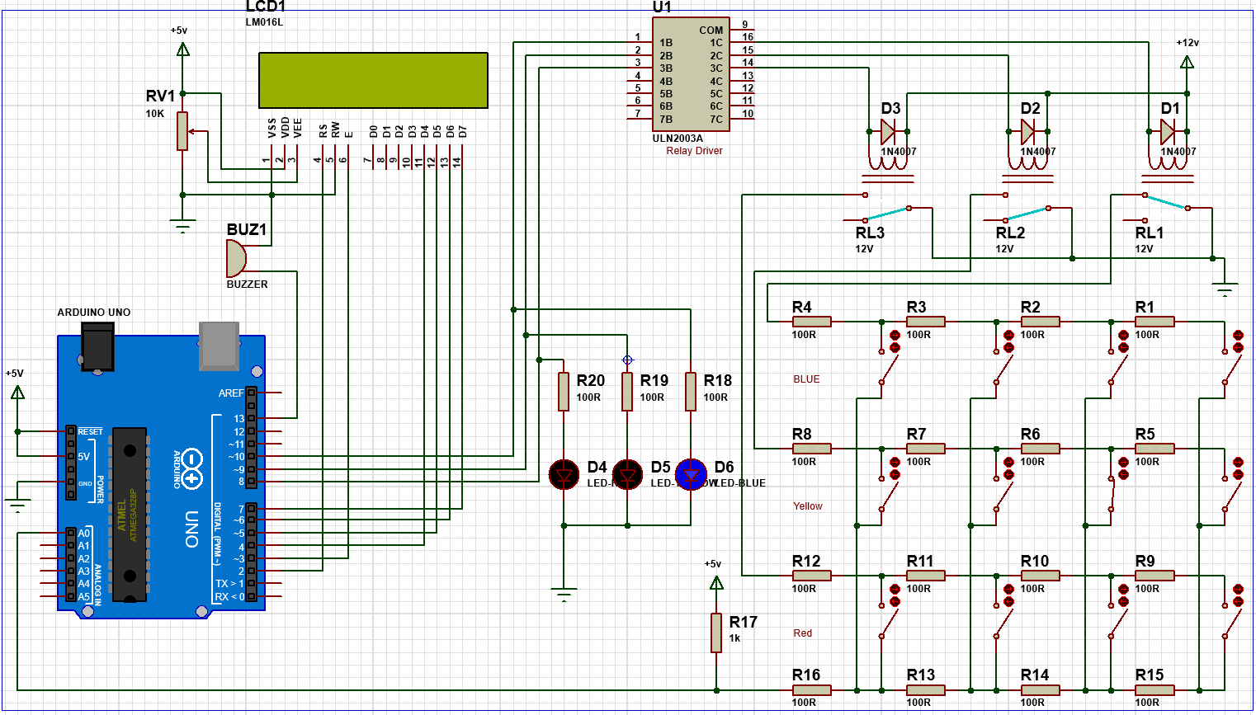

Conclusion

Resistor fault detection systems are important devices that help to ensure the safety, reliability, and performance of electronic equipment. They are used in a wide variety of applications, including power electronics, telecommunications, aerospace, military, automotive, and industrial automation. Resistor fault detection systems can help to prevent circuit failure, overheating, fire, and other problems. They can also help to reduce downtime, extend equipment life, and improve product quality. Resistor fault detection systems can be implemented using a variety of different methods and technologies. The best method and technology for a particular application will depend on the specific requirements of that application.