1. Create a web app using Free Resource – BostonHousing
2. Go to Deployment Center and select Local Git
3. Open GitBash here in the folder where project Is located
4. Use below commands
   1. git init
   2. git status
   3. git add .
   4. git status
   5. git commit -m “Initial_Commit”
   6. git add origin <https://bostonhousing.scm.azurewebsites.net:443/BostonHousing.git>

Above URI can be received from 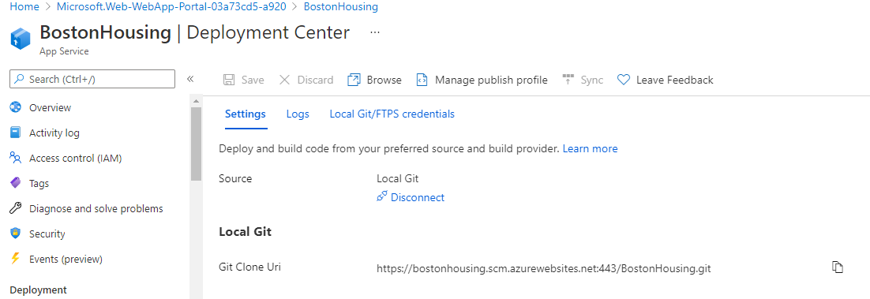

Then git push https://bostonhousing.scm.azurewebsites.net:443/BostonHousing.git master

It will ask for username and pwd. Username is the highlighted one

