Step1: Download project from the url is being provided in the dashboard or clone it from the below url

https://github.com/jiwitesh/rasaxProject.git

git clone https://github.com/jiwitesh/rasaxProject.git

Step2: Create a separate environment

conda create -n rasaproj python==3.6.9

conda install ujson==1.35

conda install tensorflow

pip install rasa

Step – 3 conda activate rasaproj

Now cd to the project folder where rasa project is located after activating. Create a models folder inside the main folder.

Step – 4

pip install rasa-x==0.32.2 --extra-index-url https://pypi.rasa.com/simple

pip install spacy

python -m spacy download en

python -m spacy download en_core_web_md

Step- 5

rasa init

– In case this throws 'rasa' is not recognized as an internal or external command,

operable program or batch file Error, Run python -m rasa init

* It will ask for a directory. Give the project directory

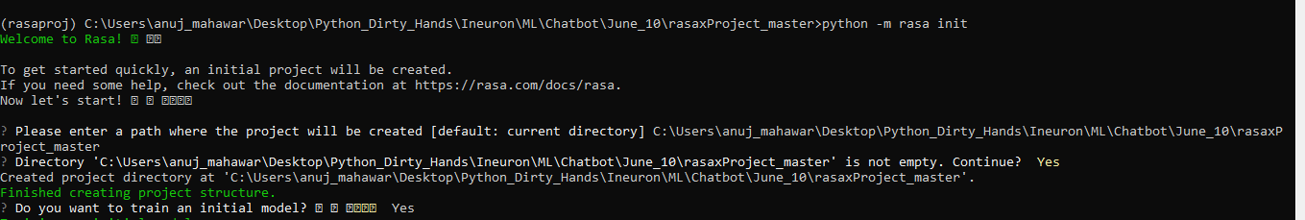

* Once the model is trained, It will store your model inside the models folder of the project



* To open it as a UI
* Run rasa init

- In case this throws 'rasa' is not recognized as an internal or external command,operable program or batch file Error, Run python -m rasa x

