//Assignment No. 1

1]min.cu

#include <cuda.h>

#include <stdio.h>

#include <time.h>

#include<math.h>

#define TPB 512

#define SIZE 2048

__global__ void min(int *a , int *c)

// kernel function definition

{

int i = blockIdx.x * blockDim.x + threadIdx.x;

// initialize i to thread ID

a[2*i] < a[2*i+1]? c[i] = a[2*i]:c[i] = a[2*i+1];

}

int main()

{

int i;

srand(time(NULL)); //makes use of the computer's internal clock to control the choice of the

int a[SIZE];

// int c[SIZE];

int *dev_a, *dev_c; //GPU / device parameters

cudaMalloc((void **) &dev_a, SIZE*sizeof(int));

cudaMalloc((void **) &dev_c, SIZE*sizeof(int));

for( i = 0 ; i < SIZE ; i++)

{

a[i] = SIZE - i; // rand()% 1000 + 1;

}

//assign memory to parameters on GPU

// input the numbers

//copy the array from CPU to GPU

for(i=1;i<log2((double)SIZE); i++)

{

cudaMemcpy(dev_a , a, SIZE*sizeof(int),cudaMemcpyHostToDevice);

min<<<1,SIZE/pow(2,i)>>>(dev_a,dev_c);

// call kernel function

cudaMemcpy(&a, dev_c, SIZE*sizeof(int),cudaMemcpyDeviceToHost);

}

a[0] < a[1]? printf("\nMin: %d", a[0]): printf("\nMin: %d", a[1]);

//printf("\nmax = %d ",a[0]);

//cudaFree(dev_a);

// Free the allocated memory

//cudaFree(dev_c);

// printf("");

return 0;

}

OUTPUT:

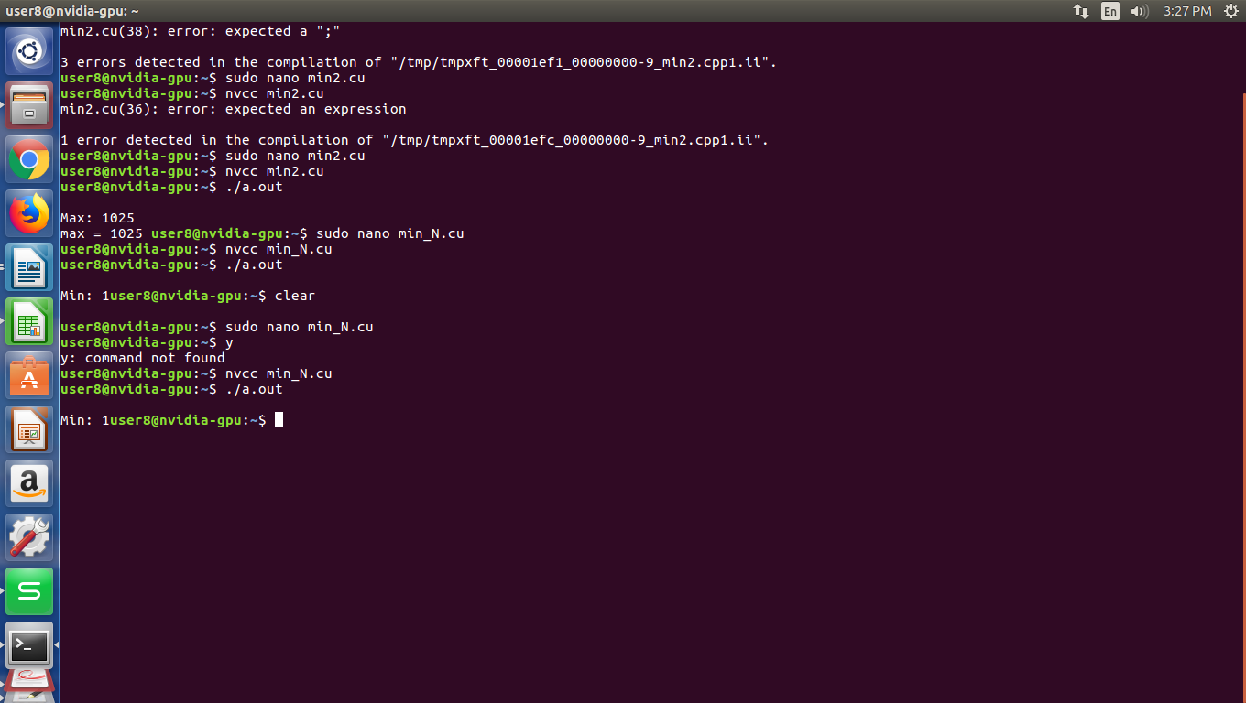

2]max.cu

#include <cuda.h>

#include <stdio.h>

#include <time.h>

#include<math.h>

#define TPB 512

#define SIZE 2048

__global__ void max(int *a , int *c) // kernel function definition

{

int i = blockIdx.x * blockDim.x + threadIdx.x; // initialize i to thread ID

a[2*i] > a[2*i+1]? c[i] = a[2*i]:c[i] = a[2*i+1];

}

int main()

{

int i;

srand(time(NULL)); //makes use of the computer's internal clock to control the choice of the seed

int a[SIZE];

// int c[SIZE];

int *dev_a, *dev_c; //GPU / device parameters

cudaMalloc((void **) &dev_a, SIZE*sizeof(int)); //assign memory to parameters on GPU

cudaMalloc((void **) &dev_c, SIZE*sizeof(int));

for( i = 0 ; i < SIZE ; i++)

{

a[i] = SIZE - i; // rand()% 1000 + 1; // input the numbers

}

//copy the array from CPU to GPU

for(i=1;i<log2((double)SIZE); i++)

{

cudaMemcpy(dev_a , a, SIZE*sizeof(int),cudaMemcpyHostToDevice);

max<<<1,SIZE/pow(2,i)>>>(dev_a,dev_c);

// call kernel function <<<number of blocks, number of threads

cudaMemcpy(&a, dev_c, SIZE*sizeof(int),cudaMemcpyDeviceToHost); // copy the result back from GPU to CPU

}

a[0] > a[1]? printf("\nMax: %d", a[0]): printf("\nMax: %d", a[1]);

// printf("\nmax = %d ",a[0]);

//cudaFree(dev_a); // Free the allocated memory

//cudaFree(dev_c);

// printf("");

return 0;

}

OUTPUT:

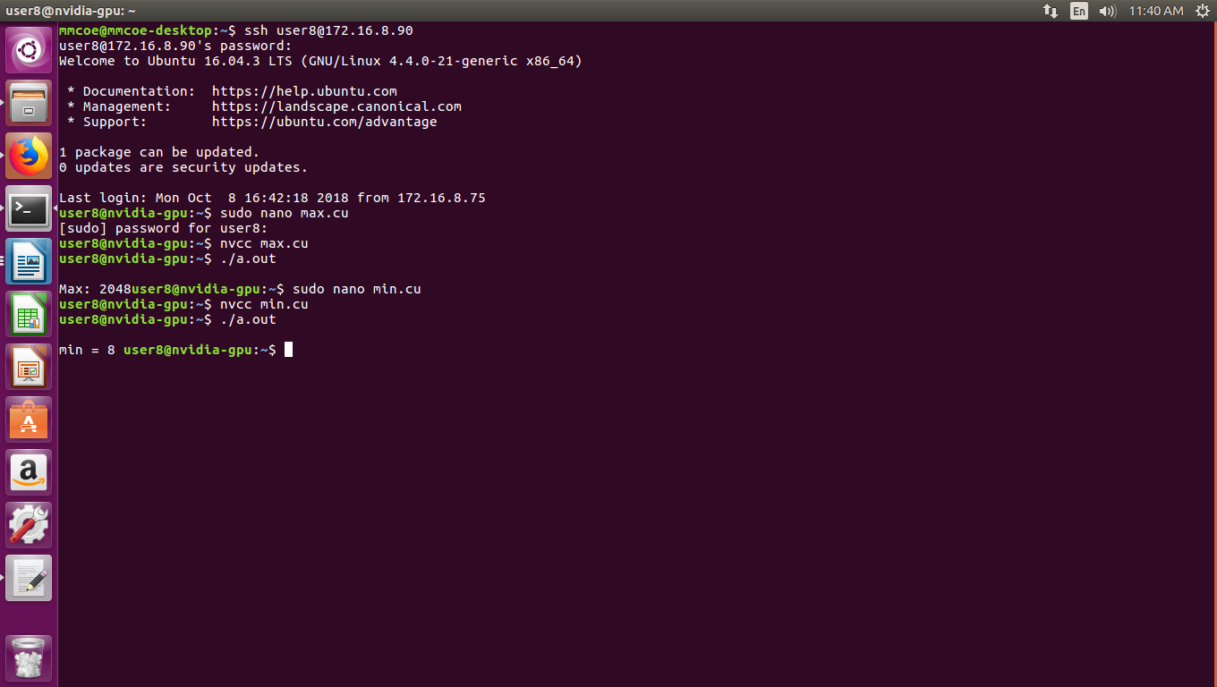

3]mean.cu

#include <cuda.h>

#include <stdio.h>

#include <time.h>

#include<math.h>

#define TPB 512

#define SIZE 32

__global__ void max(int *a , int *c) // kernel function definition

{

int i = blockIdx.x * blockDim.x + threadIdx.x; // initialize i to thre$

c[i] = a[i*2] + a[i*2+1];

}

int main()

{

int i;

srand(time(NULL)); //makes use of the computer's internal clock to control$

int a[SIZE];

// int c[SIZE];

int *dev_a, *dev_c; //GPU / device parameters

cudaMalloc((void **) &dev_a, SIZE*sizeof(int)); //assign memory to parameters on GPU

cudaMalloc((void **) &dev_c, SIZE*sizeof(int));

for( i = 0 ; i < SIZE ; i++)

{

a[i] = rand()% 1000 + 1; // input the numbers

}

//copy the array from CPU to GPU

for(i=1;i<log2((double)SIZE); i++)

{ cudaMemcpy(dev_a , a, SIZE*sizeof(int),cudaMemcpyHostToDevice);

max<<<1,SIZE/pow(2,i)>>>(dev_a,dev_c);

// call kernel function <<<number of blocks, number of threads

cudaMemcpy(&a, dev_c, SIZE*sizeof(int),cudaMemcpyDeviceToHost); // copy the result back from GPU to CPU

}

int sum = a[0] + a[1];

printf("Sum is :%d\n",sum);

float avg = (float)sum/SIZE;

printf("Average is : %f",avg);

cudaFree(dev_a); // Free the allocated memory

cudaFree(dev_c);

printf("");

return 0;

}

OUTPUT:

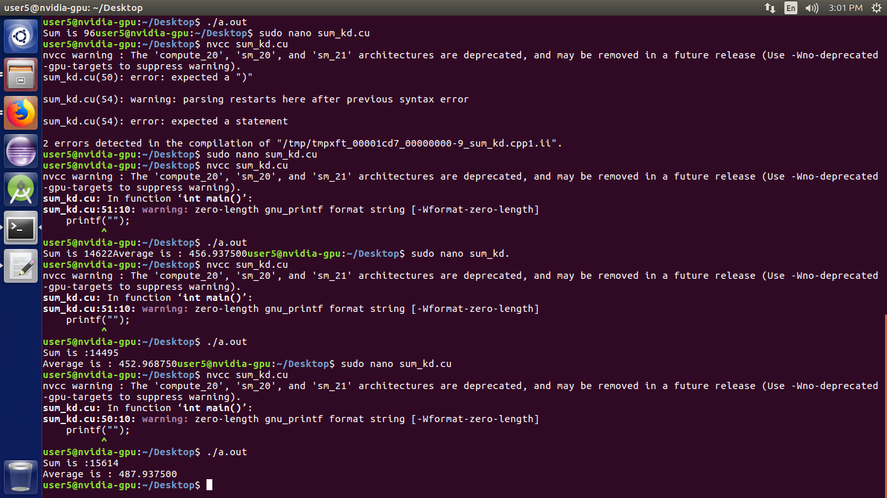

4]std.cu

#include <cuda.h>

#include <stdio.h>

#include <time.h>

#include<math.h>

#define TPB 512

#define SIZE 512

__global__ void sum1(float *a , float *c) // kernel function definition

{

int i = blockIdx.x * blockDim.x + threadIdx.x; // initialize i to thre$

c[i] = a[i*2] + a[i*2+1];

}

__global__ void std1(float *a , float *c,float mean) // kernel function definition

{

int i = blockIdx.x * blockDim.x + threadIdx.x; // initialize i to thre$

c[i] = (a[i] - mean) * (a[i] - mean);

}

int main()

{

int i;

srand(time(NULL)); //makes use of the computer's floaternal clock to control$

float a[SIZE],a_copy[SIZE];

float c[SIZE];

float *dev_a, *dev_c; //GPU / device parameters

cudaMalloc((void **) &dev_a, SIZE*sizeof(float)); //assign memory to parameters on GPU

cudaMalloc((void **) &dev_c, SIZE*sizeof(float));

for( i = 0 ; i < SIZE ; i++)

{

a[i] = i+1 ;// rand()% 1000 + 1; // input the numbers

c[i] = (float)a[i];

a_copy[i] = a[i];

}

//copy the array from CPU to GPU

for(i=1;i<log2((double)SIZE); i++)

{ cudaMemcpy(dev_a , a, SIZE*sizeof(float),cudaMemcpyHostToDevice);

sum1<<<1,SIZE/pow(2,i)>>>(dev_a,dev_c);

// call kernel function <<<number of blocks, number of threads

cudaMemcpy(&a, dev_c, SIZE*sizeof(float),cudaMemcpyDeviceToHost); // copy the result back from GPU to CPU

}

float sum = a[0] + a[1];

printf("Sum is :%f\n",sum);

float avg = (float)sum/SIZE;

printf("Average is : %f \n",avg);

cudaFree(dev_a); // Free the allocated memory

cudaFree(dev_c);

cudaMalloc((void **) &dev_a, SIZE*sizeof(float)); //assign memory to parameters on GPU

cudaMalloc((void **) &dev_c, SIZE*sizeof(float));

cudaMemcpy(dev_a , c, SIZE*sizeof(float),cudaMemcpyHostToDevice);

std1<<<SIZE/TPB,TPB>>>(dev_a,dev_c,avg);

cudaMemcpy(&c,dev_c, SIZE*sizeof(float),cudaMemcpyDeviceToHost);

cudaFree(dev_a); // Free the allocated memory

cudaFree(dev_c);

cudaMalloc((void **) &dev_a, SIZE*sizeof(float)); //assign memory to parameters on GPU

cudaMalloc((void **) &dev_c, SIZE*sizeof(float));

for(i=1;i<log2((double)SIZE); i++)

{ cudaMemcpy(dev_a , c, SIZE*sizeof(float),cudaMemcpyHostToDevice);

sum1<<<1,SIZE/pow(2,i)>>>(dev_a,dev_c); // call kernel function <<<number of blocks, number of threads

cudaMemcpy(&a, dev_c, SIZE*sizeof(float),cudaMemcpyDeviceToHost); // copy the result back from GPU to CPU

}

float std_sum = a[0] + a[1];

printf("std sum is : %f\n",std_sum);

float std_final = sqrt(std_sum/(float)SIZE);

printf("STD is : %f \n",std_final);

}

OUTPUT:

