Game Design – CI7870

The Prison Break Connection

Report

Portfolio Link: <https://anujpatwari.com>

Blog Link: <https://anujpatwari.com/blog/categories/the-prison-break-connection>

Anuj Patwari

K1840581

MA in Game Development (Design)

Table of Contents

Introduction 2

High Concept 2

ID Card 2

Story 2

Gameplay in a Nutshell 2

Technologies and Resources 3

3D Art 3

Version Control 3

Aims & Objectives 3

Process 4

Phase 1 – Brainstorming 4

Phase 2 - Development 4

Issues while modelling 6

Polishing 7

Reducing poly count 8

Portfolio 8

Deliverables 8

Learning Outcomes 9

References 10

# Introduction

## High Concept

The Prison Break Connection is a first person, co-op stealth game where the players have to escape prison, find evidence to prove their innocence and clear their name off from the criminal records.

## ID Card

Name – The Prison Break Connection

Genre – First Person, Stealth, Co-op

Platform – PC, PS4, PS3, XBOX One, XBOX 360

Target Audience – 16+ Years

## Story

***\*Please go through the Story document for the full details story sequence.\****

The players play as Lewis and Daisy (husband and wife) who have been framed by Carlos Mendez and wrongly arrested for something they did not do. Both the players are kept in different blocks of the prison for interrogation. The cops leave each of the interrogation rooms which the players take advantage of and escape.

After each of them leave their respective interrogation rooms, they both knock out a police officer, steal his clothes and act as police officers themselves now. Before doing anything else, both the players need to find each other. After they are re-united, they must find a way to escape from prison and then find evidence against Carlos Mendez and prove their innocence.

## Gameplay in a Nutshell

Most of the game takes place in a small prison where the two players are impersonating police officers. Many sequences through the game require the players to do quick time events. References to how these quick time events will look and feel are all mentioned through the Story document. The main inspiration for how the Quick Time Events (QTE) are supposed to feel is from the new Marvel Spiderman game. This video should give an idea of how the QTEs will take place in The Prison Break Connection - <https://www.youtube.com/watch?v=wfBiGDcdA9M>

During regular play phase, the players have to make sure they do not stay in front of police officers for too long otherwise it may lead to suspicion and their identification (Reference - <https://www.youtube.com/watch?v=jLoowk_7cXc> [Watch first 15 seconds]). This leads to the players always being aware of their surroundings and being careful with every action they take. If the players are identified, the game is immediately lost.

There are multiple varying chase sequences also that take place through the game. References for each of them are mentioned in the story document for where they are relevant.

## Technologies and Resources

### 3D Art

I used **Autodesk Maya 2019 student version** for the artefacts of this project. I had decided to do so because of the following reasons:

1. **Personal Development –** With every new project, I aim to learn something new. These opportunities occur mostly at a student level and prepare me for the industry. So, since I have never done 3D Modelling before and have been wanting to do it for a long time now I decided to learn 3D modelling through this project. Having an idea that revolves around a 3D environment gave me the perfect opportunity and platform to start learning 3D modelling through Maya.
2. **Help and Support –** I have a few friends who are quite familiar in 3D modelling tools like Autodesk Maya and 3Ds Max and are very approachable if I required any help at any point through the development of my 3D models.  
   Apart from these friends, there are tonnes of tutorials and ‘how to’ videos on YouTube which make learning this software a lesser of a challenge.

### Version Control

Like with every project, I set up a **GitHub** repository for this project as well so that I don’t lose any progress through the development of this project. I feel this is a good practice because version control is a huge part of many studios and this habit would be one of the things employers would look at as a good habit during any potential hiring process.

## Aims & Objectives

With this project, I had three major aims which are:

1. I wanted to write down a very detailed story line for the game idea I had. This story had to be immersive and interesting along with unique gameplay sequences which would lead to a fun playing experience.
2. I had to create a “10-pager-document” with the aim of explaining the desired game design in as much detail as possible with relevant references to videos and illustrations where necessary.
3. Learn 3D modelling on an industry standard software.

To achieve the above aims, I set out the following objectives:

1. At the beginning of the project, I had this very vague idea of what kinds of special abilities I wanted the characters to have, so I took that idea and keep brainstorming on it until I had something that could be explained to others. I then spoke about this idea with a number of people and got various opinions from each of them and came up with a base story outline. Then after some more weeks of brainstorming, I finally had a story which I documented immediately before I had forgotten any essential part of it.
2. I used a lot of visual references when making this 10-pager-document to explain the design as clearly as I could within the limit.
3. I started learning hard surface 3D modelling in Maya through YouTube to achieve my third aim.

# Process

## Phase 1 – Brainstorming

Like mentioned earlier, the initial concept I had for this game was very vague. I wanted to make a co-op game where the characters have a special connection and then the theme, “myths and shadows”, guided me to the decision that I don’t need to make a realistic game. After brainstorming for a few days and not coming up with anything at all, a small idea hit me after a couple of weeks. A co-op game where the characters are husband and wife who have special powers of their own. One could turn into a mist-like thing while the other could read the other one’s mind and make small temporary marks on their body.

Upon coming up with this small idea, I wanted to expand it into a story where both the players get to use their powers and not that only one person is dominating the use of his/her power through the game. Both the players needed to be given equal importance and have a fun experience.

I spent the next one and a half weeks trying to further expand this idea and eventually came up with a small story which I explained to my mentors and a few friends. Each person gave me inputs towards improving the story and characters and upon constant consultation from these people, I was able to come up with a fairly detailed story.

## Phase 2 - Development

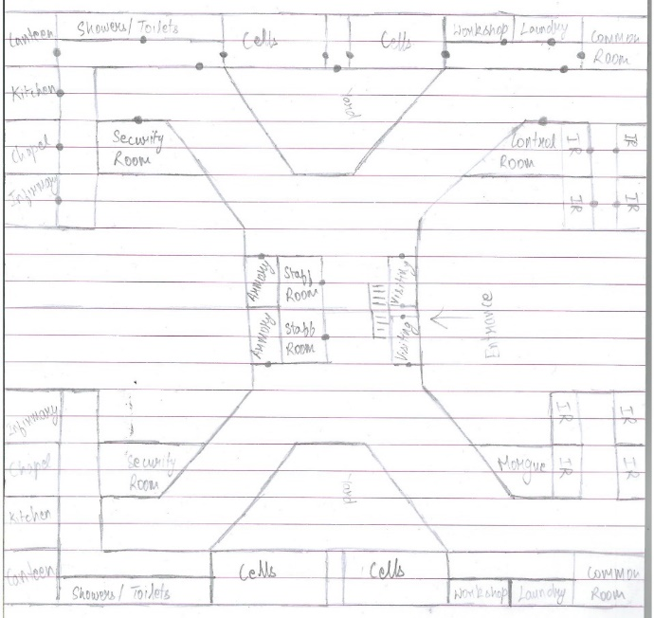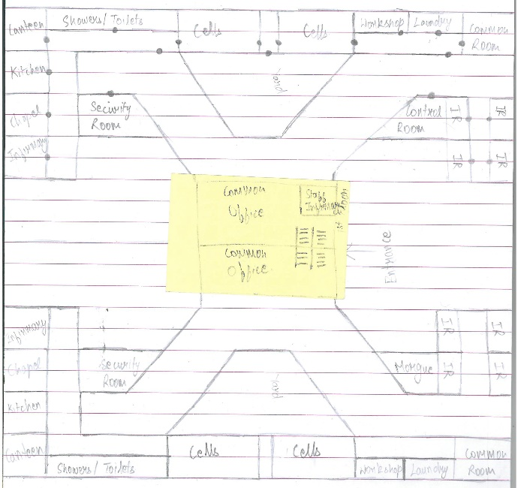For the ‘artefacts’ or ‘prototype’ I decided to make 3D models of various items and props that would be found through the course of the game. Being a complete newbie to 3D modelling, I started off with basic models like a gear, table, chair, clock, etc. and when I started getting a hang of the software, I thought, rather than just making these small assets, why not build the layout of the prison. So then I took the paper design *(See Image 2.1, 2.2, 2.3 & 2.4)* I made for helping me shape the story and made a simple 2D version of the level *(See Image 2.5)*.

*Image 2.2  
First Floor*

*Image 2.1  
Ground Floor*

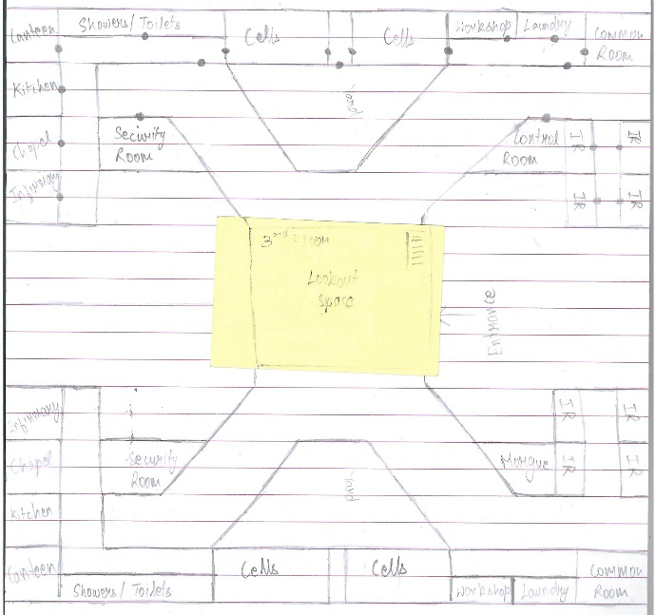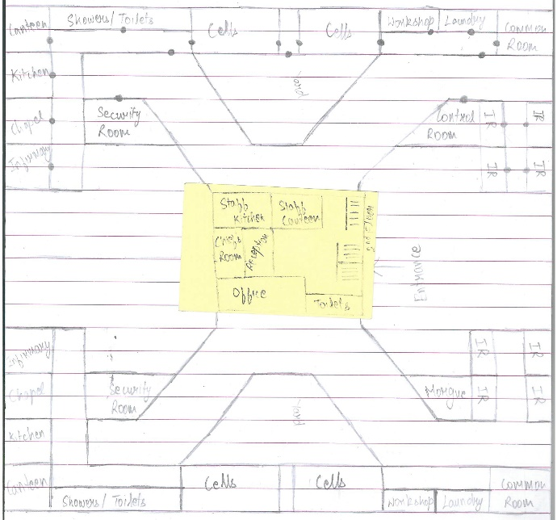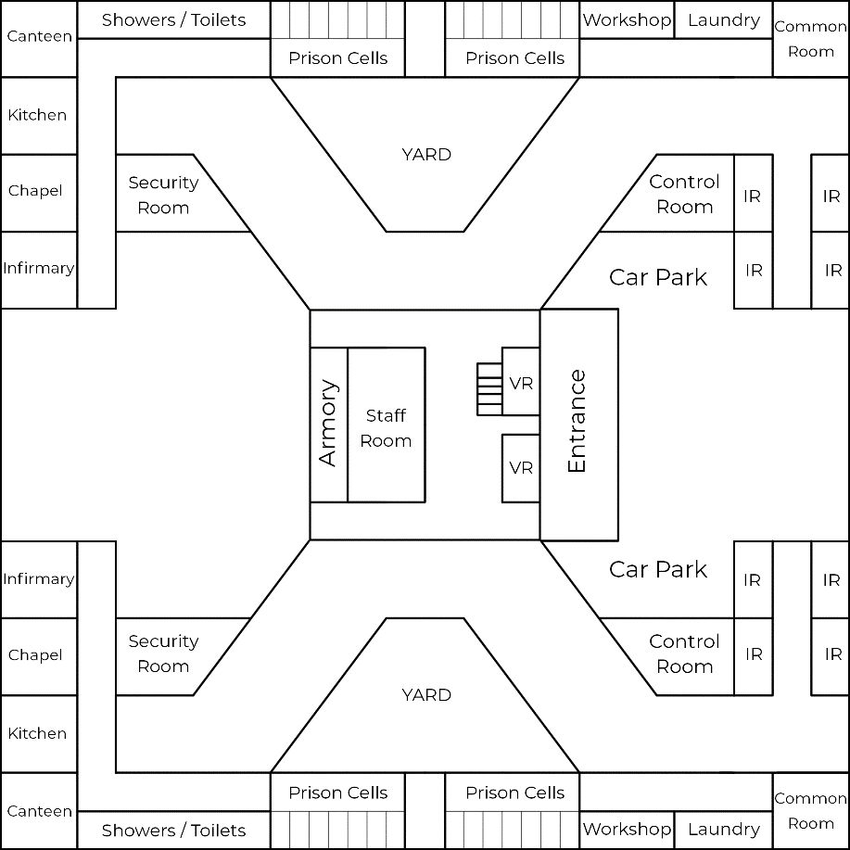

*Image 2.5*

*Ground Floor*

IR – Interrogation Room

VR – Visitor’s Room

*Image 2.4  
Third Floor*

*Image 2.3  
Second Floor*

At the beginning of January, I took this 2D level design and kept it as a reference while making the level in 3D in Maya. I started modelling the level and was very excited with how it was going. It was very time consuming, but it was looking good, but like with every new software, I ran into a number of rookie issues as explained below.

### Issues while modelling

At the beginning, every new modeller is taught to use the extrude option and exploit it into basically using it for everything. The beginners mind-set is always extrude > new object. After blocking out the level using this extrude method for over three days, I ran into a major issue. Every time I made a new edge, it would make it through all the walls in the level, therefore increasing the number of polygons and affecting performance. I spoke to one of my friends about this and he made me aware of my rookie mistake of extruding > new object. He told me just make new objects or instance off similar walls rather than extruding each wall. This would not only be better for the system performance, but also allow me to build the level a lot quicker and if I were to texture it eventually, the model for each of the walls would be much simpler to unwrap and hence easier to texture as well. So I was forced to scrap over three days of my work and start from scratch. With the deadline at the end of January, losing three days’ worth of work was a lot of crucial time lost, so I put in extra time into my work than usual to make up for the lost time and had the block out of the level ready in one day because of the new easy workflow I was told about.

Fast-forward one week, I had learnt a few more tricks in Maya when I learnt that deleting useless edges is a good practice because that reduces the load on the player’s system when trying to render out the level. So I kept deleting a lot of edges which I thought were useless, but when I made an export to view it in Unity, I realized that a lot of my walls were looking very weird (See Image 2.6 and Image 2.7).

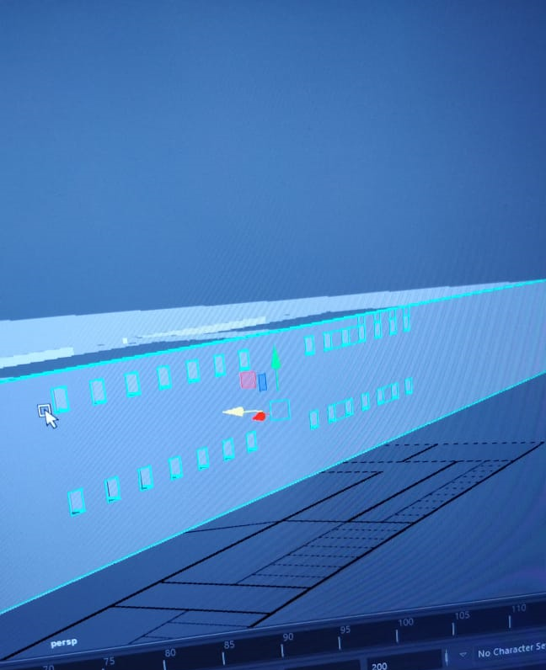

*Image 2.6*

*This is how this wall looked  
in Maya*

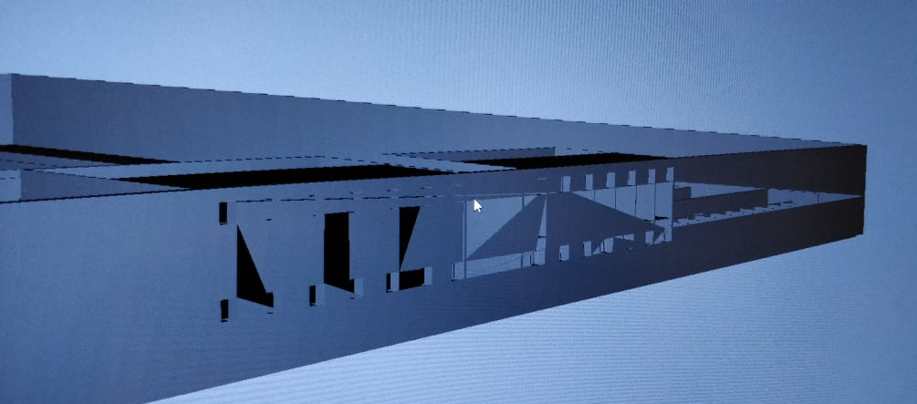  
*Image 2.7 – This is how the wall looked when imported into Unity.*

Upon doing some research, I found out that deleting all those edges caused this issue. I apparently deleted all the supporting edges that would allow Unity to calculate and triangulate any polygon correctly. So I researched a bit more and also asked my friends on how to fix this and to my surprise the fix wasn’t very long. It took a couple of hours to fix because I had to fix the topology of the wall but eventually I fixed it and this is what it looks like now *(See Image 2.8)*.

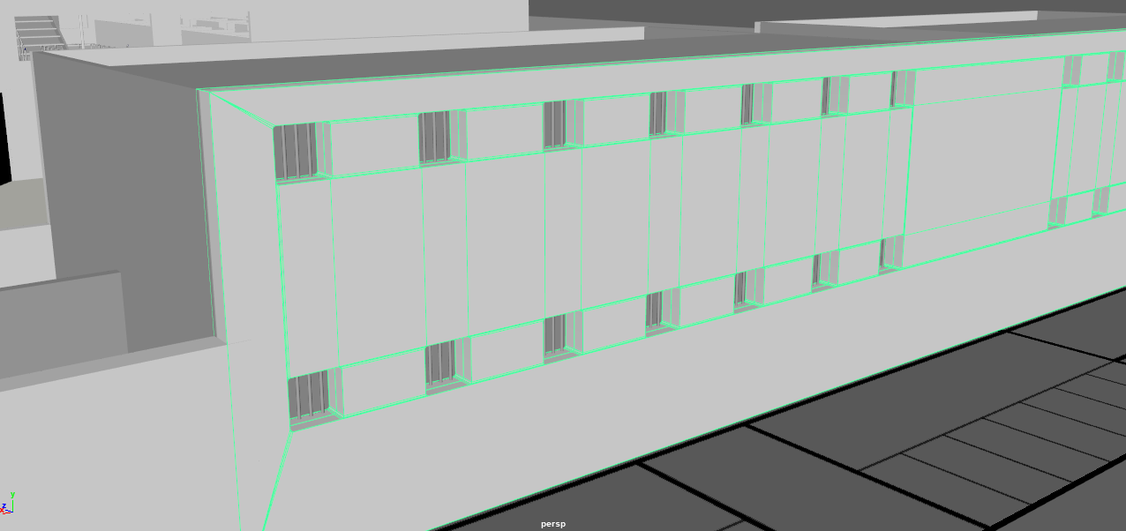

*Image 2.8*

Over the course of my whole experience with Maya in the past month, I’ve come across many issues, all being very rookie/beginner mistakes which I learnt to tackle, either through checking YouTube or asking my friends.

# Polishing

Upon having made quite a few individual assets and the basic block out of the level, I wanted to polish it and give it more life and depth. So I started adding details to the level. Details such as the ones a real level in a game would have. I made proper cells with details on each cells such as locks and hinges, on the stairs I added supporting side planks so that the level feels more realistic. Some models are given small bends towards the edges rather than leave them as 90 degree angles because nothing in the world is actually at a proper 90 degree angle, everything has a small bend rather than a harsh sharp edge.

I further made more models for details such as a baggage scanner at the entrance of the prison, computers, a separate big table for the prison chief’s office, etc.

Finally, when I was done modelling, I took the model into Unity where I put all the separate elements I had made into the level and also got some animated characters from Mixamo to give the prison a little more life. I also gave the separate elements different colours to further add more realism to the level.

***Notes:***

***\* The cars and human characters in the Unity walkthrough demo and Maya file are NOT modelled by me. The car is a free Maya asset and the human characters are from Mixamo. These were added only to give more realism and life to the demo itself.***

***\* The Unity demo is NOT a gameplay demo, it is just a way to see the level in more detail by just walking through it. In this demo, I have given the player a FPS view which can be used to explore the 3D Level that has been constructed.***

***\* Roofs were not added in the model so that they can be easily viewed by the evaluator. For the tower section, all floors have been labelled properly. Please hide the respective parents to hide floors.***

### Reducing poly count

Before taking it into Unity, I realised that the poly count of the level was way too high, so I decided that I’m going to do my best and reduce the poly count as much as possible. I went to every single face that were inside other objects and deleted every single such face. This practice got the poly count down significantly and the process took about two and a half days to complete. Looking for hidden faces in a model that has over 200,000 faces, it was a huge task and required a lot of attention to detail to make sure that anything that I’m deleting isn’t messing with the triangulation otherwise I would encounter the same issue as I did previously. So I was checking everything with extreme detail.

Another thing I did to reduce the poly count was down to the level design. The level being a mirror of itself allowed me to model half the level and then simply take that into Unity and duplicate the other half in Unity rather than duplicating it in Maya. This allows for lesser data to be imported into Unity, thus reducing the amount of draw calls the GPU on the player’s system has to make.

This is what the final model out of Maya looks like:

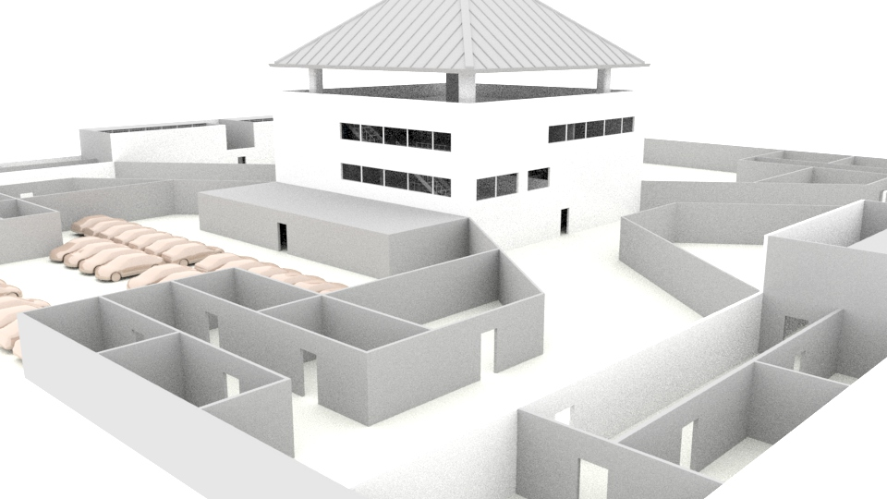

# Portfolio

This project shall soon be uploaded on to my portfolio website – <https://anujpatwari.com> after I continue working on it and polish it more and add more elements to it. This being my first piece of art work on my portfolio, it would bring in a new dimension to my portfolio. It would also show my versatility in the number of softwares I have learnt over the years.

# Deliverables

In this table you can find all the deliverables from my side towards this project:

|  |  |
| --- | --- |
| **Deliverable** | **File Name** |
| Game Design Document | AnujPatwari_GameDesign_GDD.pdf |
| Story | AnujPatwari_GameDesign_Story.pdf |
| Report | AnujPatwari_GameDesign_Report.pdf |
| Prison Level – Maya File | AnujPatwari_GameDesign_Prison.mb |
| Prison – Unity Walkthrough – Zipped Folder | AnujPatwari_GameDesign_Demo.zip |
| Elements Maya Files – Zipped Folder | AnujPatwari_GameDesign_ElementsMaya |
| Elements FBX Files – Zipped Folder | AnujPatwari_GameDesign_ElementsFBX |
| Renders – Zipped Folder | AnujPatwari_GameDesign_Renders |

# Learning Outcomes

I am very proud of what I have been able to create through this module. With the guidance of Hope and Jarek at every stage, the project turned out better than I expected. I got to learn hard surface modelling in a very short span of time, while I’m still new, I’m very happy with how much I have learnt.

What I take away from this project is the sense of achievement that I was able to take on a very challenging task of learning a completely new software and using that software to convert my imagination into a visible 3D Model for others to walk through. I am happy that I was able to put in the amount of details I did into the 3D model and I aim to work on it further and publish it on my portfolio.

# References

Abs4Fun (2019) Marvel Spider-Man All Quick Time Events!!! Available at: <https://www.youtube.com/watch?v=wfBiGDcdA9M> (Accessed: 16 November 2019).

Bayon Fighters (2019) TOM CRUISE JACK REACHER PRISON ESCAPE SCENE HD. Available at: <https://www.youtube.com/watch?v=kY1d-u-XDDI> (Accessed: 6 January 2020).

brentina14 (2007) Kevin and Aaron wall climb. Available at: <https://www.youtube.com/watch?v=cRp2V6NttRY> (Accessed: 29 November 2019).

calloftreyarch (2016) Uncharted 4: A Thief's End - Best Chase In Gaming History. Available at: <https://www.youtube.com/watch?v=2MEpYiS2aOI> (Accessed: 23 December 2019).

ColumbiaPicturesPhils (2017) BABY DRIVER - 6-Minute Opening Clip. Available at: <https://www.youtube.com/watch?v=6XMuUVw7TOM> (Accessed: 9 January 2020).

Entertainment Access (2018) All Spider-People Introduction Scene - SPIDER-MAN: INTO THE SPIDER-VERSE (2018) Movie Clip. Available at: <https://www.youtube.com/watch?v=kAqcxq7kH5s> (Accessed: 2 January 2020).

Frosty Games (2018) HEAVY RAIN How to pick Lock. Available at: <https://www.youtube.com/watch?v=WyTATZQLEgY> (Accessed: 4 January 2020).

Fusion Gaming (2018) A Way Out - Prison Fight Scene. Available at: <https://www.youtube.com/watch?v=yz1pPCCekxk> (Accessed: 5 January 2020).

Gamer's Little Playground (2018) A WAY OUT AMAZING CHASE SCENE. Available at: <https://www.youtube.com/watch?v=yf-sMV9gZvc> (Accessed: 18 December 2019).

HaqiX Helix (2015) Assassin's Creed Syndicate Hide the Body in Nigel in for the Chop Mission. Available at: <https://www.youtube.com/watch?v=jLoowk_7cXc> (Accessed: 12 December 2019).

NBC (2019) See Inside the $9.8M Mansion Perched on the Highest Point of North Texas. Available at: <https://www.nbcdfw.com/news/local/look-inside-the-cedar-hill-mansion-perched-high-above-north-texas/136260/> (Accessed: 2 January 2020).

VGS - Video Game Sophistry (2018) Detroit: Become Human - Connor's Awkward Lunch with Hank (All Options). Available at: <https://www.youtube.com/watch?v=xVEPpwqQh5k> (Accessed: 18 November 2019).