**Steps for Creating Led_Blink Project using STM32F103C8 Microcontroller and Keil µVision5 IDE:-**

* Using Pack Installer install the STM32F103C8 Packs.

* Project->New µVision Project

* Save the project led_blink.

* Open Manage Run-Time Environment window and make the changes shown below:

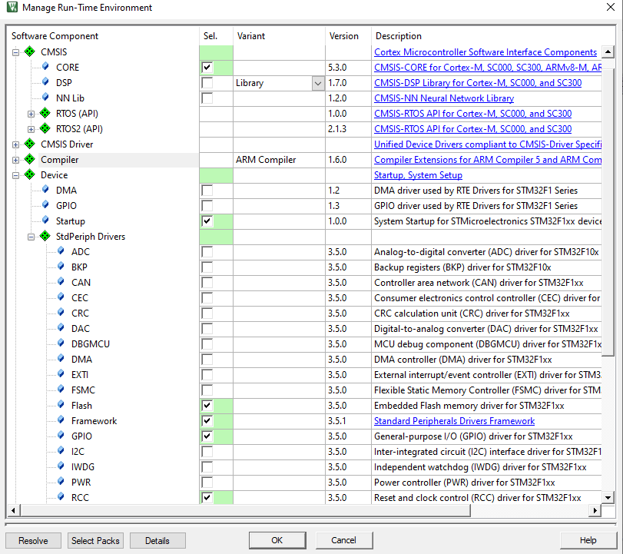

* Project window-> Right-Click on Source Group1-> Add new item to group and save the file led.c

* Write the code for led blink or check the project led_blink.