1. **What is the output of running below code ?**

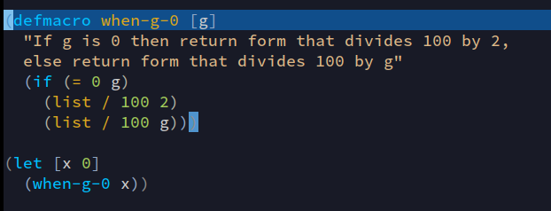

1. 50
2. 100
3. (/ 100 x)
4. ArithmeticException: Divide by zero

**Correct Answer: d**

**2) In question 1 the macro will be expanded at**

1. Compile time
2. Run time
3. Never
4. Both runtime and compile time

**Correct Answer: a**

**3) Which of these is a reader macro in clojure ? (note: multiple correct answers possible)**

1. def
2. defn
3. ` (syntax quote)
4. ~ (unquote)
5. All of the above
6. None of the above

**Correct Answer: c and d**

**4) Which of the following is not a regex pattern ?**

1. **#”abcd”**
2. **#”$$$$”**
3. **#”^^^”**
4. **#**

**Correct Answer: d**

**5) What will be the ouput of below code ?**

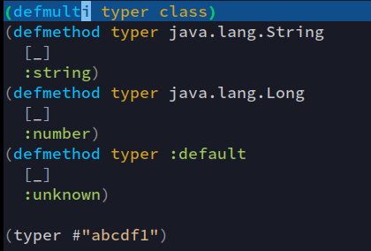

1. :number
2. :string
3. :unknown
4. None of the above

**Correct Answer: c**

**6) A language is homoicionic if**

1. it is considered iconic in the developer community
2. it has special support for displaying icons
3. a program written in it can be manipulated as data
4. it is written by homo sapiens

**Correct Answer: c**

**7) What will be the result of evaluating ~1 ?**

1. 1
2. 0
3. Error
4. None of the above

**Correct Answer: c**

**8) What will be the error if you evaluate ~1 ?**

1. Unable to resolve symbol: 1
2. Attempting to call unbound fn: #'clojure.core/unquote
3. No error will be displayed, the evaluation will be successful
4. All of the above

**Correct Answer: b**

**9) If you are at the repl in the user namespace what will be the result of evaluating `y ?**

1. y
2. user/y
3. 10
4. Unable to resolve symbol: y

**Correct Answer: b**

**10) If you are at the repl in the user namespace what will be the result of evaluating `~’y ?**

1. y
2. user/y
3. 10
4. Unable to resolve symbol: y

**Correct Answer: a**

**11) Which of the following platforms clojure does not target ?**

1. JVM
2. .NET
3. Javascript
4. None of the above

Correct Answer: d

**12) Multimethods can dispatch based on**

1. Type of arguments
2. Arbitrary function return values
3. All of the above
4. None of the above

**Correct Answer: c**

**13) Given the followoing record definition: (defrecord A [a b c]).**

**Which of the following are valid record constructors ? (multiple options possible)**

1. map->A
2. ->A
3. A->map
4. A->

**Correct Answer: a and b**

**14) Records can act like hash maps except they**

1. Cannot act as functions
2. Do not support assoc
3. Do not support dissoc
4. All of the above

**Correct Answer: a**

**15) Clojure is a dialect of which functional language ?**

1. Lisp
2. Smalltalk
3. Python
4. Ruby

**Correct Answer: a**