**1. Clojure is lazy in the way it handles**

* 1. Function arguments
  2. Function calls
  3. Sequences
  4. Clojure is not lazy

**Correct Answer: c**

**2. Which of these functions is not lazy**

1. map
2. for
3. reduce
4. filter

**Correct Answer: c**

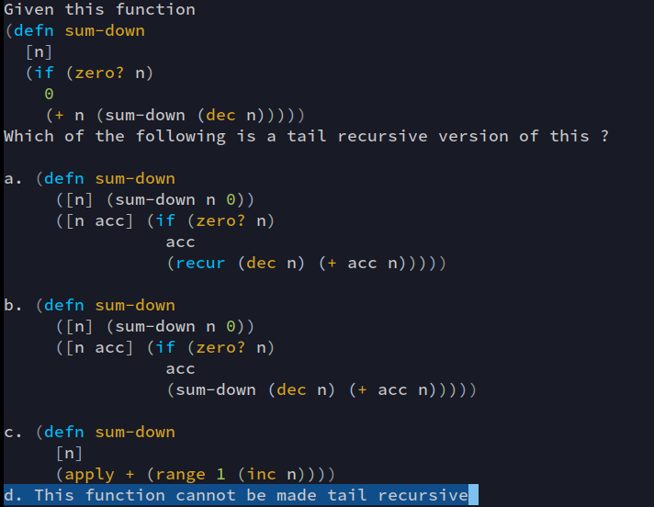**3.**

**Correct Answer: a**

**4. Hash maps in clojure are ordered by**

1. Alphabetic ordering of keys
2. Alphabetic ordering of values
3. Numeric values ascending
4. Any of the above based on type
5. There is no ordering on keys

**Correct Answer: e**

**5. In Clojure lazy sequences can be created by programmers using**

1. In built functions like map, filter only
2. By using lazy-seq
3. All of the above
4. None of the above

**Correct Answer: c**

**6. Which of these does not hold on-to the head of a lazy sequence** (multiple options possible)

1. dorun
2. doseq
3. doall
4. All of the above

**Correct Answer: a and b**

**7. Which of these is not functional programming language ?**

1. Haskell
2. Elixir
3. Ocaml
4. All of the above
5. None of the above

**Correct Answer: d**

**8. Clojure is a homoiconic language**

1. True
2. False

**Correct Answer: a**

**9. What will be the output of the following code ?**



1. nil
2. NullPointerException
3. 0
4. 1

**Correct Answer: b**

**10. What will be the output of the following code ?**



1. Nil
2. NullPointerException
3. 0
4. 1

**Correct Answer: d**

**11. Which of the following is not a macro ?**

1. and
2. or
3. not
4. when

**Correct Answer: c**

**12. Who is the author of Clojure ?**

1. Edward Norton
2. Ryan Gosling
3. Rich Hickey
4. Adam Driver

**Correct Answer: c**

**13. Which of these platforms clojure does not run on ?**

1. Java
2. .NET
3. BEAM
4. None of the above

**Correct Answer: c**

**14. What will be the output of the following code ?**

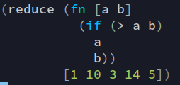

1. 1
2. 14
3. 10
4. None of the above

**Correct Answer: 14**

**15. What will be the output of the following code ?**

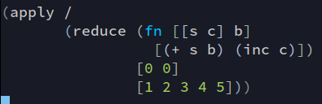

1. [15 5]
2. 0
3. 3
4. NullPointerException

**Correct Answer: c**