FEEL FREE TO CONTACT ,

EMAIL : [anujjain12122000@gmail.com](mailto:anujjain12122000@gmail.com)

Phone Number : 7678519853

**NOTE : THIS API WOULD ONLY WORK FOR A WEEK , after it I would disable the mongodb connection**

I have used Mongodb (NoSql) database .

1.) open vs code terminal and then type node index.js and press enter,

make sure that node is already installed on the system .

2.) that's it , now in vs code terminal you could see the message app is running on 5000 port

and db connected

how to test the api

3.) now open the postman app( make sure it is already installed , if not download and install it.

4.) 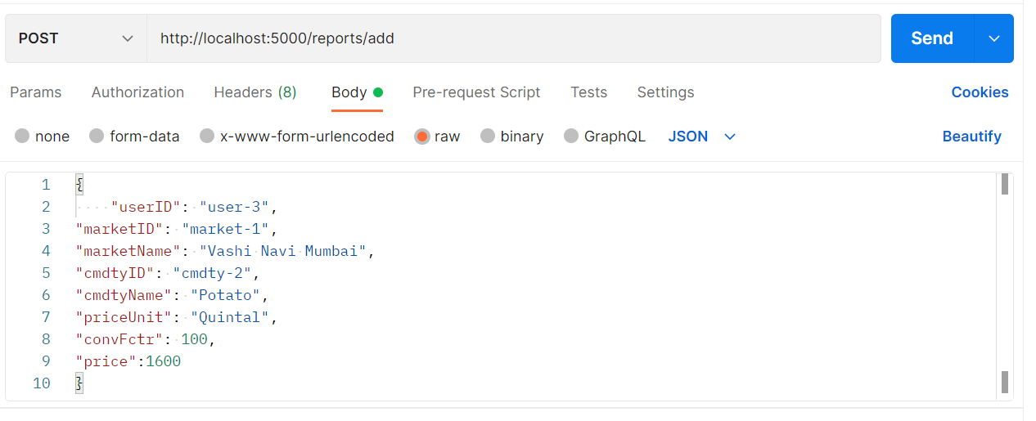

Go in the url parameter and type the following link

<http://localhost:5000/reports/add>

and in the body section , give the desired details , it should look like the above screenshot and then press send , you would get the message success and the report Id

5.) for the get request

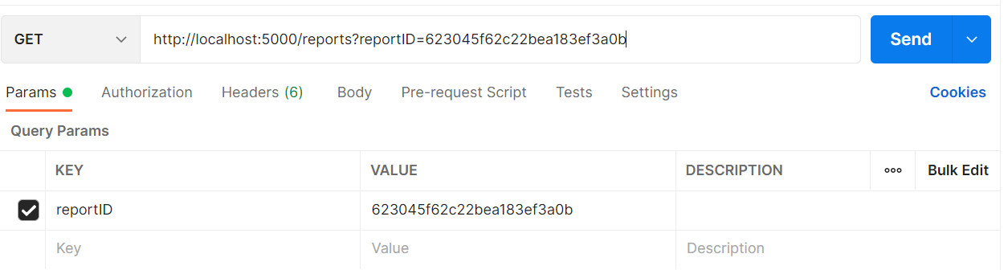

Just set the url to

<http://localhost:5000/reports?reportID=623045f62c22bea183ef3a0b>

you could change the report id to test it , when you press send , you would get the desired result.