TRIBHUVAN UNIVERSITY
INSTITUTE OF ENGINEERING
PULCHOWK CAMPUS

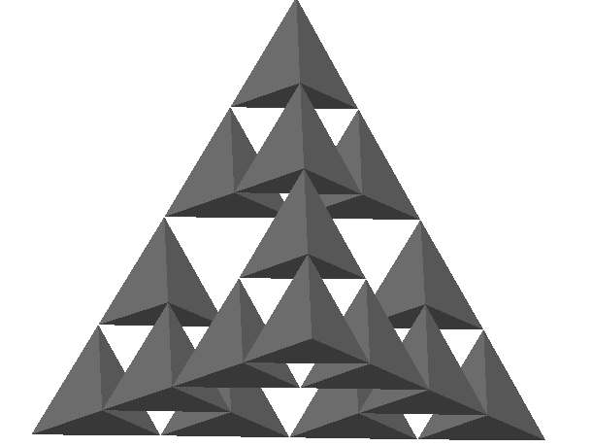

A
PROJECT REPORT
ON
COMPUTER GRAPHICS
(fractal)

SUBMITTED TO:
R.K KANTHA
DEPARTMENT OF ELECTRONICS AND COMPUTER ENGINEERING
SUBMITTED BY:
ANUJ GURUACHARY (060BEX404)
DEVENDRA SHAH (060BEX410)
KAJI KHADKA (060BEX416)

October 29,2006

