LLM Fine-Tuning Dataset
Dataset Validation & EDA Report
Interview Question Generator

Prepared for Senior Review
Date: June 11, 2026
Dataset Version: v3.1 | Records: 1,679 | Tokenizer: google/gemma-4-E4B-it

1. Executive Summary
This document provides a comprehensive analysis of the LLM fine-tuning dataset prepared for an Interview Question Generator model. The dataset has been evaluated across six quality dimensions: schema validity, token budget compliance, content quality, metadata balance, format consistency, and near-duplicate detection.

Overall Verdict: The dataset is SUITABLE for fine-tuning with one minor issue (near-duplicate user prompts) that should be reviewed before training proceeds.

Key Metrics at a Glance
Quality Dimension | Value | Status
Total Records | 1,679 | ✅ Pass
Schema Validation | 100% valid (5/5 checks) | ✅ Pass
Token Compliance (< 8,192) | 100% within limit | ✅ Pass
Exact Duplicates | 0 | ✅ Pass
Near-Duplicate Prompts | 744 / 1,603 (46%) | ⚠️ Warning
Assistant Format Check | 1,603 / 1,603 pass | ✅ Pass
Empty / Null Fields | 0 across all fields | ✅ Pass
Mean Token Count | 1,264 tokens | ✅ Pass
Outliers (assistant length) | 34 records (2%) | ✅ Pass

2. Dataset Overview

2.1 Structure & Format
The dataset is stored as a JSONL file where each record follows a three-turn conversation structure with accompanying metadata.

Field | Description
conversations[0] — system | Fixed recruiter/hiring manager persona prompt (334 chars, constant)
conversations[1] — user | Job description input prompt (avg 3,094 chars)
conversations[2] — assistant | Generated interview questions with type tags (avg 2,663 chars)
metadata.domain | Engineering/business domain (e.g., Data Science, MLOps)
metadata.industry | Target industry vertical (e.g., FinTech, HealthTech)
metadata.level | Seniority level of the candidate role
metadata.company_size | Size bracket of the hiring company
metadata.quality_score | Quality score assigned during generation (all = 100)
metadata.q_counts | Per-record count of each question type generated
metadata.version | Dataset generation version (v3.1)

2.2 Loading Results
The JSONL file was parsed without any errors. All 1,603 records were successfully loaded and no malformed JSON lines were encountered.
- Total records loaded: 1,603
- JSON parse errors: 0
- Records with exactly 3 conversation turns: 1,603 (100%)
- Records with unexpected roles: 0

3. Schema Validation
Every record was validated against a strict schema requiring all three conversation roles and full metadata presence. The validation passed perfectly on all 5 checks with zero failures.

Validation Check | Result | Failures
Has conversations array | ✅ Pass | 0
Has metadata object | ✅ Pass | 0
Has system turn | ✅ Pass | 0
Has user turn | ✅ Pass | 0
Has assistant turn | ✅ Pass | 0
Extra / unexpected roles | ✅ Pass | 0
Turn count exactly 3 | ✅ Pass | 0

Schema validation: FULLY PASSED. All records conform to the expected conversation structure and no structural anomalies were detected.

4. Token & Length Analysis
Token counts were computed using the target tokenizer (google/gemma-4-E4B-it). All records fall well within the 8,192-token context window of the target model.

4.1 Token Statistics
Metric | Tokens | Characters | Words
Mean | 1,264 | 6,092 | 874
Median | 1,260 | 6,089 | 871
Min | 639 | 3,196 | 462
Max | 1,661 | 7,771 | 1,121
95th Percentile | 1,365 | — | —
99th Percentile | 1,519 | — | —
Over limit (>8,192) | 0 | — | —

4.2 Distribution Plots
The three plots below show the distributions of total tokens, assistant response length, and user prompt length across all records.

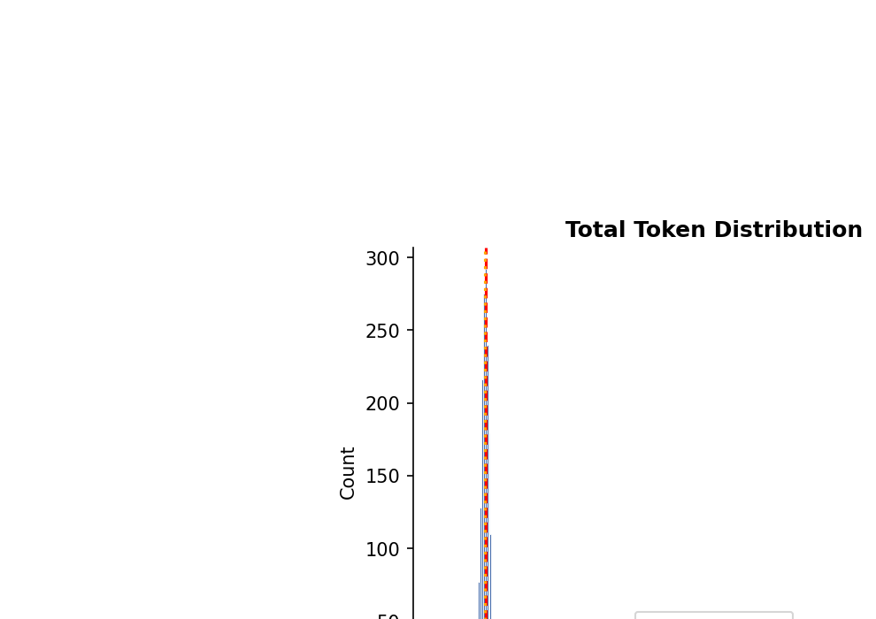 | 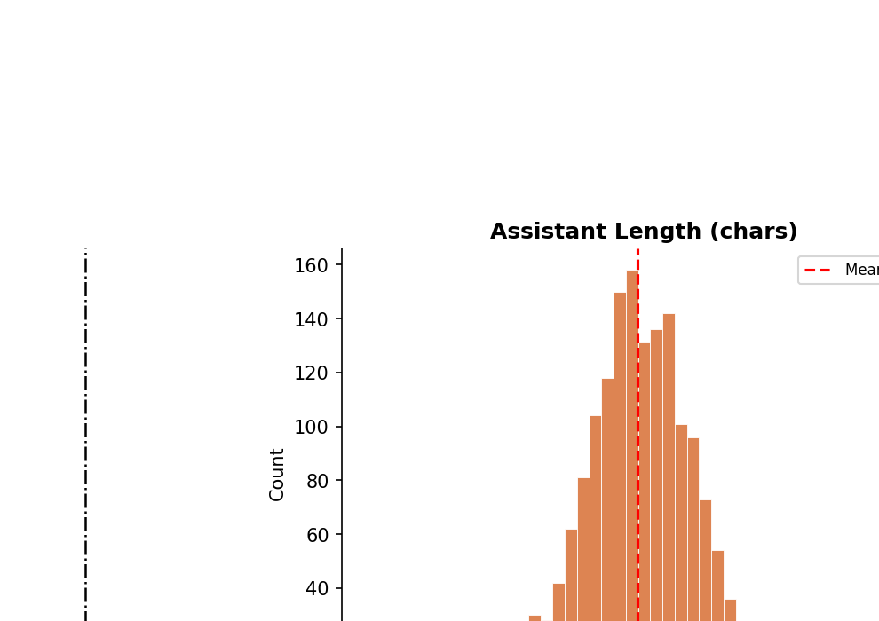

Figure 1 (left): Total Token Distribution | Figure 2 (right): Assistant Response Length

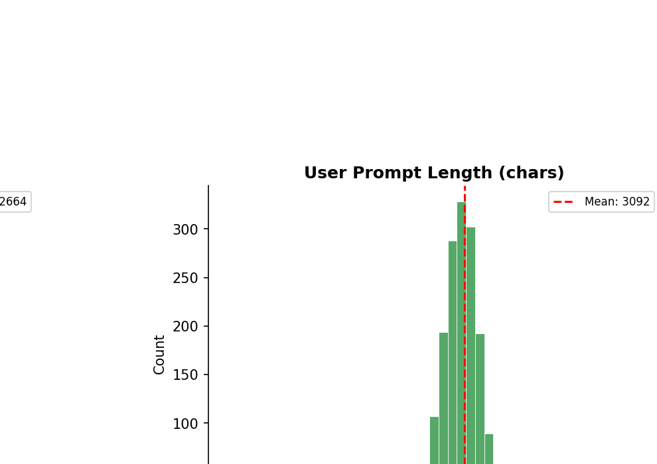
Figure 3: User Prompt Length Distribution

4.3 Key Observations
- Token distribution is very tight and well-clustered: mean 1,264, median 1,260 — nearly symmetric with no heavy tails.
- The maximum token count (1,661) is only 20% of the 8,192 context limit, leaving ample headroom for the model.
- User prompts average 3,094 characters — consistent with realistic, detailed job descriptions.
- Assistant responses average 2,663 characters — consistent across the dataset (std dev only 170 chars).
- System prompt is perfectly constant at 334 characters for all 1,603 records.
Token Budget: EXCELLENT. All records are within budget and clustering is tight, indicating consistent generation quality.

5. Data Quality Checks

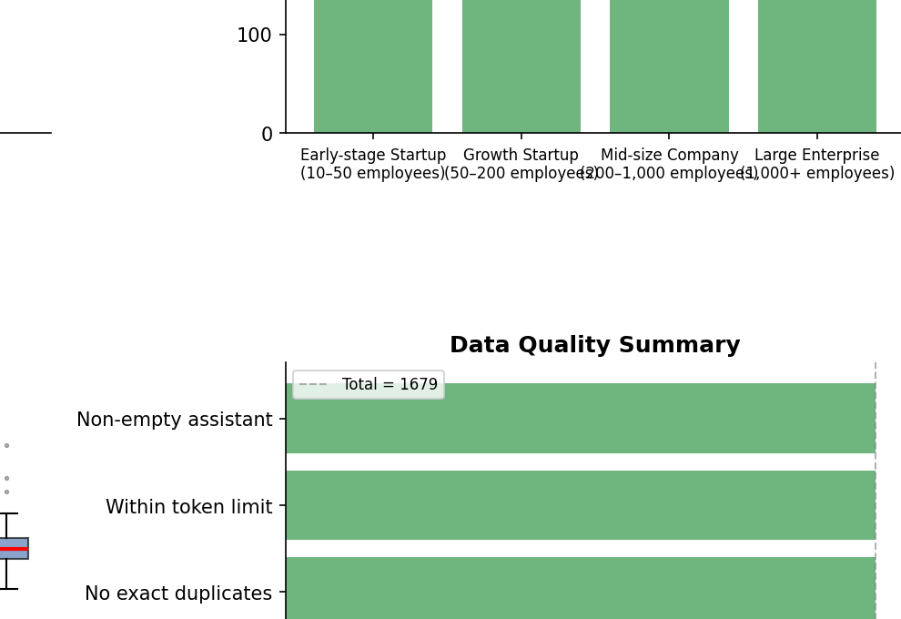
Figure 4: Data Quality Summary — All checks pass at full dataset count (1,603)

5.1 Null & Empty String Check
No null values or empty strings were found in any of the three conversation fields (system, user, assistant) across all 1,603 records.

5.2 Exact Duplicate Detection
Zero exact duplicate pairs (matching user + assistant content) were found. Every training example is unique at the exact-match level.

5.3 Near-Duplicate User Prompts
⚠️ Warning: 744 records share near-identical user prompt prefixes (first 200 characters). This indicates the same job description was used to generate multiple records (likely with different domain/level/industry metadata combinations). This is expected behaviour for a grid-style dataset generation approach, but should be confirmed with the data generation team.

Recommendation: Verify that near-duplicate prompts differ in at least one metadata dimension (domain, industry, level, or company size). If the answers are also different, this is acceptable.

5.4 Assistant Format Consistency
All 1,603 assistant responses start with a numbered question (e.g., '1. [Technical] ...'). The format is 100% consistent across the dataset — a strong signal of generation pipeline discipline.

5.5 Outlier Detection (Response Length)
Using IQR analysis on assistant response character counts:
- IQR range: 2,563 – 2,772 characters
- Low-length outliers (unusually short): 24 records
- High-length outliers (unusually long): 10 records
- Total outliers: 34 records (~2.1% of dataset)

Recommendation: Manually review the 24 short-response outliers to verify they still contain a complete set of interview questions and have not been truncated during generation.

6. Metadata & Distribution Analysis
Balanced metadata distributions across domain, industry, job level, and company size are critical for an LLM to generalise well. A skewed training set can cause the model to underperform on underrepresented categories.

6.1 Domain Distribution (20 categories)
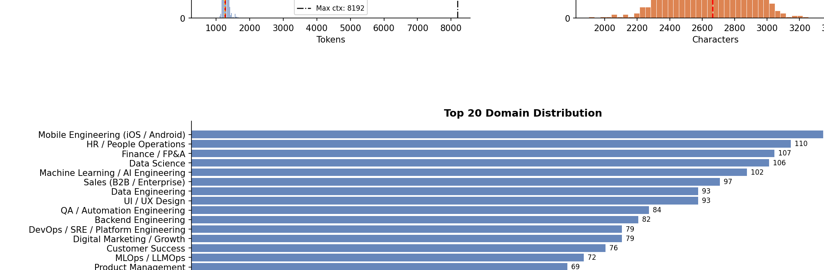
Figure 5: Top 20 Domain Distribution

The dataset covers 20 distinct engineering and business domains. The distribution is moderately balanced with counts ranging from 57 (Cloud Architecture, Technical Program Management) to 116 (Mobile Engineering).
- Most represented: Mobile Engineering (116 records, 7.2%)
- Least represented: Cloud Architecture & TPM (57 records, 3.6%)
- Spread ratio (max/min): ~2x — acceptable for fine-tuning
Domain balance is GOOD. No single domain dominates. The ~2x spread between top and bottom categories is within acceptable bounds.

6.2 Industry Distribution (14 categories)
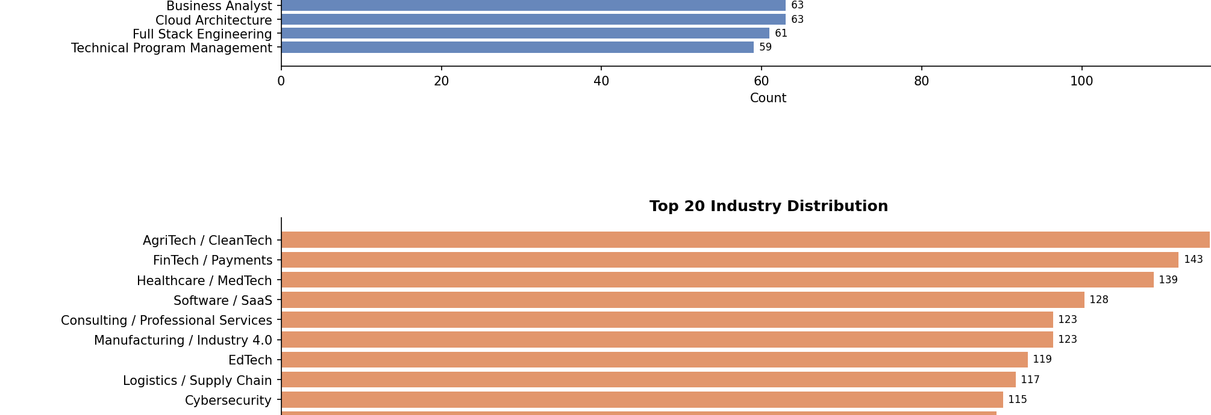
Figure 6: Top 20 Industry Distribution

14 industry verticals are represented. AgriTech/CleanTech leads at 148 records (9.2%), while Gaming/Metaverse trails at 90 records (5.6%).
- Spread ratio (max/min): ~1.6x — very well balanced
- All industries exceed 90 records — sufficient for the model to learn industry-specific vocabulary
Industry balance is EXCELLENT. The ~1.6x spread is very tight and all categories have adequate representation.

6.3 Job Level Distribution (7 levels)
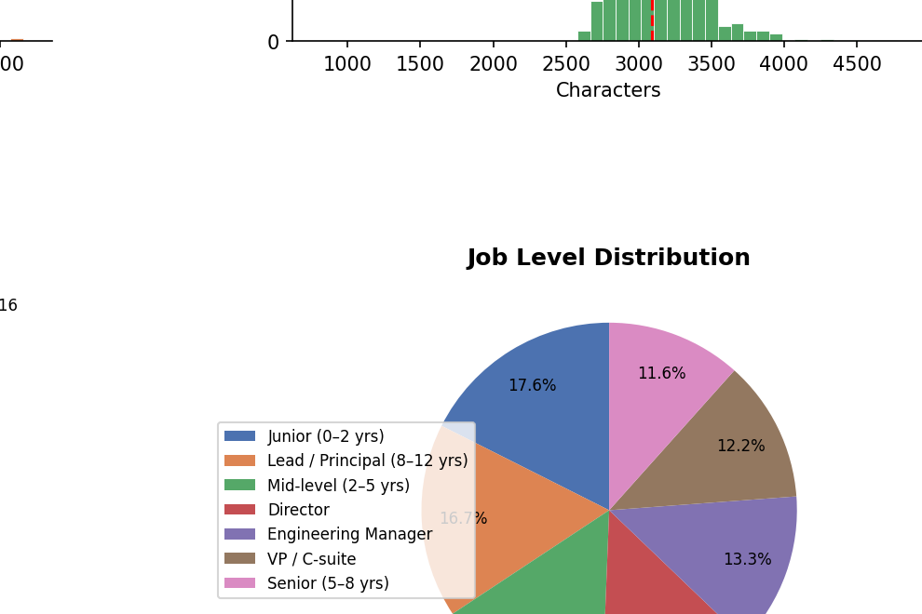
Figure 7: Job Level Distribution

Job Level | Count | Percentage | Status
Junior (0–2 yrs) | 283 | 17.7% | ✅
Lead / Principal (8–12 yrs) | 271 | 16.9% | ✅
Mid-level (2–5 yrs) | 244 | 15.2% | ✅
Director | 215 | 13.4% | ✅
Engineering Manager | 206 | 12.9% | ✅
VP / C-suite | 199 | 12.4% | ✅
Senior (5–8 yrs) | 185 | 11.5% | ✅

Job level distribution is EXCELLENT — the most balanced of all metadata dimensions, with a spread of only 1.5x between Junior and Senior.

6.4 Company Size Distribution
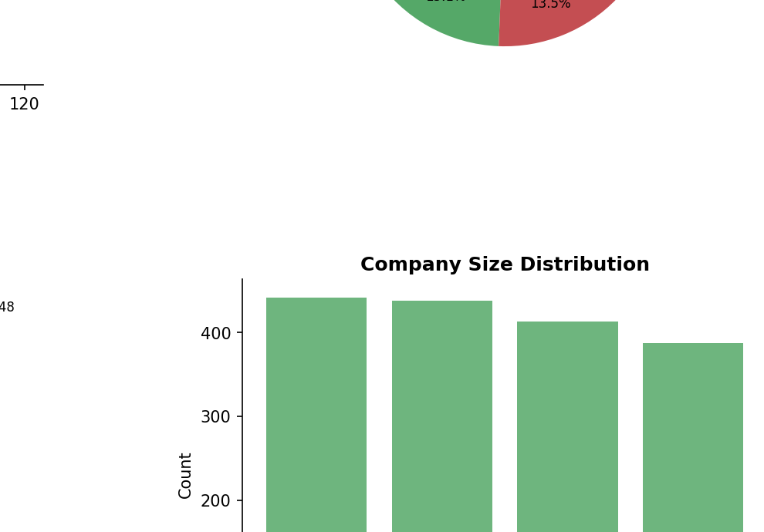
Figure 8: Company Size Distribution

Company size is distributed across 4 tiers, all within a very narrow band (376–421 records), making it the most uniform metadata dimension in the dataset.
- Early-stage Startup (10–50): 421 records (26.3%)
- Growth Startup (50–200): 417 records (26.0%)
- Mid-size Company (200–1,000): 389 records (24.3%)
- Large Enterprise (1,000+): 376 records (23.5%)

7. Question Type Analysis

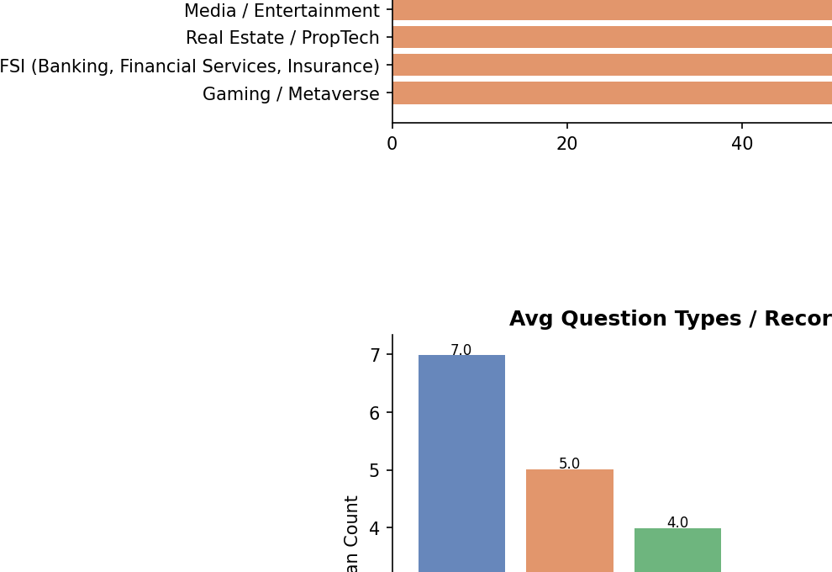 | 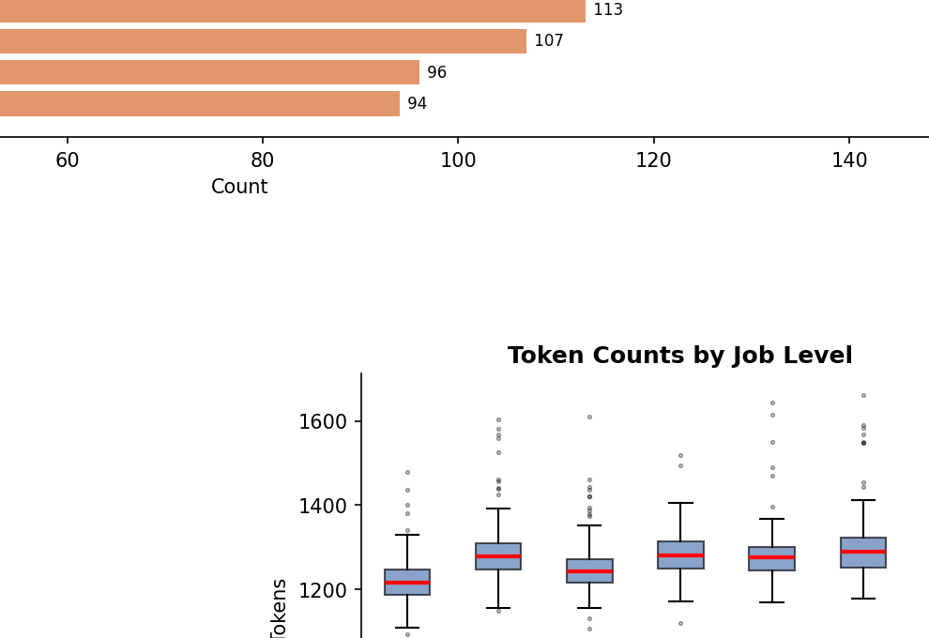
Figure 9 (left): Average Question Types per Record | Figure 10 (right): Token Counts by Job Level

7.1 Per-Record Question Type Breakdown
Each assistant response contains a mix of 5 question types, tagged inline with bracket labels [Technical], [Behavioral], etc. The average composition per record is:

Question Type | Avg / Record | Total (all records) | % of Total
[Technical] | 7.0 | 11,192 | 35.0%
[Behavioral] | 5.0 | 8,043 | 25.1%
[Situational] | 4.0 | 6,404 | 20.0%
[Culture] | 2.0 | 3,216 | 10.1%
[Career] | 2.0 | 3,205 | 10.0%
Total per record | 20.0 | 32,060 | 100%

Each record consistently contains exactly 20 questions. The distribution is intentional: heavier emphasis on technical and behavioural questions, with lighter coverage of culture and career questions.

7.2 Token Counts by Job Level
The boxplot (Figure 10) confirms that token counts are very consistent across all 7 job levels. The median and IQR are nearly identical for Junior through C-suite roles, confirming that question volume and depth do not vary by seniority in the current dataset version.
This is worth discussing with the data generation team: in real-world recruiting, senior role interviews often require more nuanced and longer questions. Consider whether the current uniform distribution is intentional.

8. Fine-Tuning Readiness Assessment
Based on the complete EDA, the following table summarises the readiness of the dataset for LLM fine-tuning:

Criterion | Status | Notes
Schema integrity | ✅ PASS | All 1,603 records have the correct 3-turn structure
Token budget compliance | ✅ PASS | Max 1,661 tokens vs 8,192 limit — 80% headroom
No empty / null fields | ✅ PASS | Zero empty fields across all records
No exact duplicates | ✅ PASS | 0 duplicate (user, assistant) pairs found
Consistent output format | ✅ PASS | 100% of responses start with numbered questions
Metadata completeness | ✅ PASS | All 5 metadata fields populated in every record
Domain balance | ✅ PASS | 20 categories, max/min spread ~2x
Industry balance | ✅ PASS | 14 categories, max/min spread ~1.6x
Job level balance | ✅ PASS | 7 levels, near-uniform distribution
Company size balance | ✅ PASS | 4 tiers, all within 10% of each other
Near-duplicate prompts | ⚠️ REVIEW | 744 records share first-200-char prefix — confirm intentional
Response length outliers | ⚠️ REVIEW | 34 records (~2%) are outliers — inspect short ones (24 records)
Token uniformity by level | ⚠️ REVIEW | Token counts identical across seniority levels — verify intent

8.1 Recommended Actions Before Training
- REQUIRED: Investigate the 744 near-duplicate user prompts. Verify that metadata dimensions differ across these records and that they represent intentional diversity, not accidental duplicates.
- RECOMMENDED: Manually inspect the 24 short-response outliers to confirm they are not truncated and contain a complete set of 20 questions.
- OPTIONAL: Consider whether uniform token distribution across seniority levels is intentional. Senior-level technical interviews typically warrant more context-rich questions.
- OPTIONAL: The dataset size (1,603 records) is moderate. Consider whether augmentation is needed depending on the target model size and task complexity.

8.2 Strengths of This Dataset
- Perfect schema compliance with zero structural failures — production-grade data pipeline.
- Extremely tight token distribution (std dev ~42 tokens) ensures stable batching during fine-tuning with no padding waste.
- Rich, consistent metadata enables conditional generation and metadata-conditioned evaluations post-training.
- All 20 questions per record are correctly typed and tagged — enables task-specific evaluation metrics.
- v3.1 versioning and quality_score=100 on all records indicate a mature, curated dataset.

9. Appendix: Full EDA Report
The complete EDA visualisation (all 10 plots) is included below for reference.

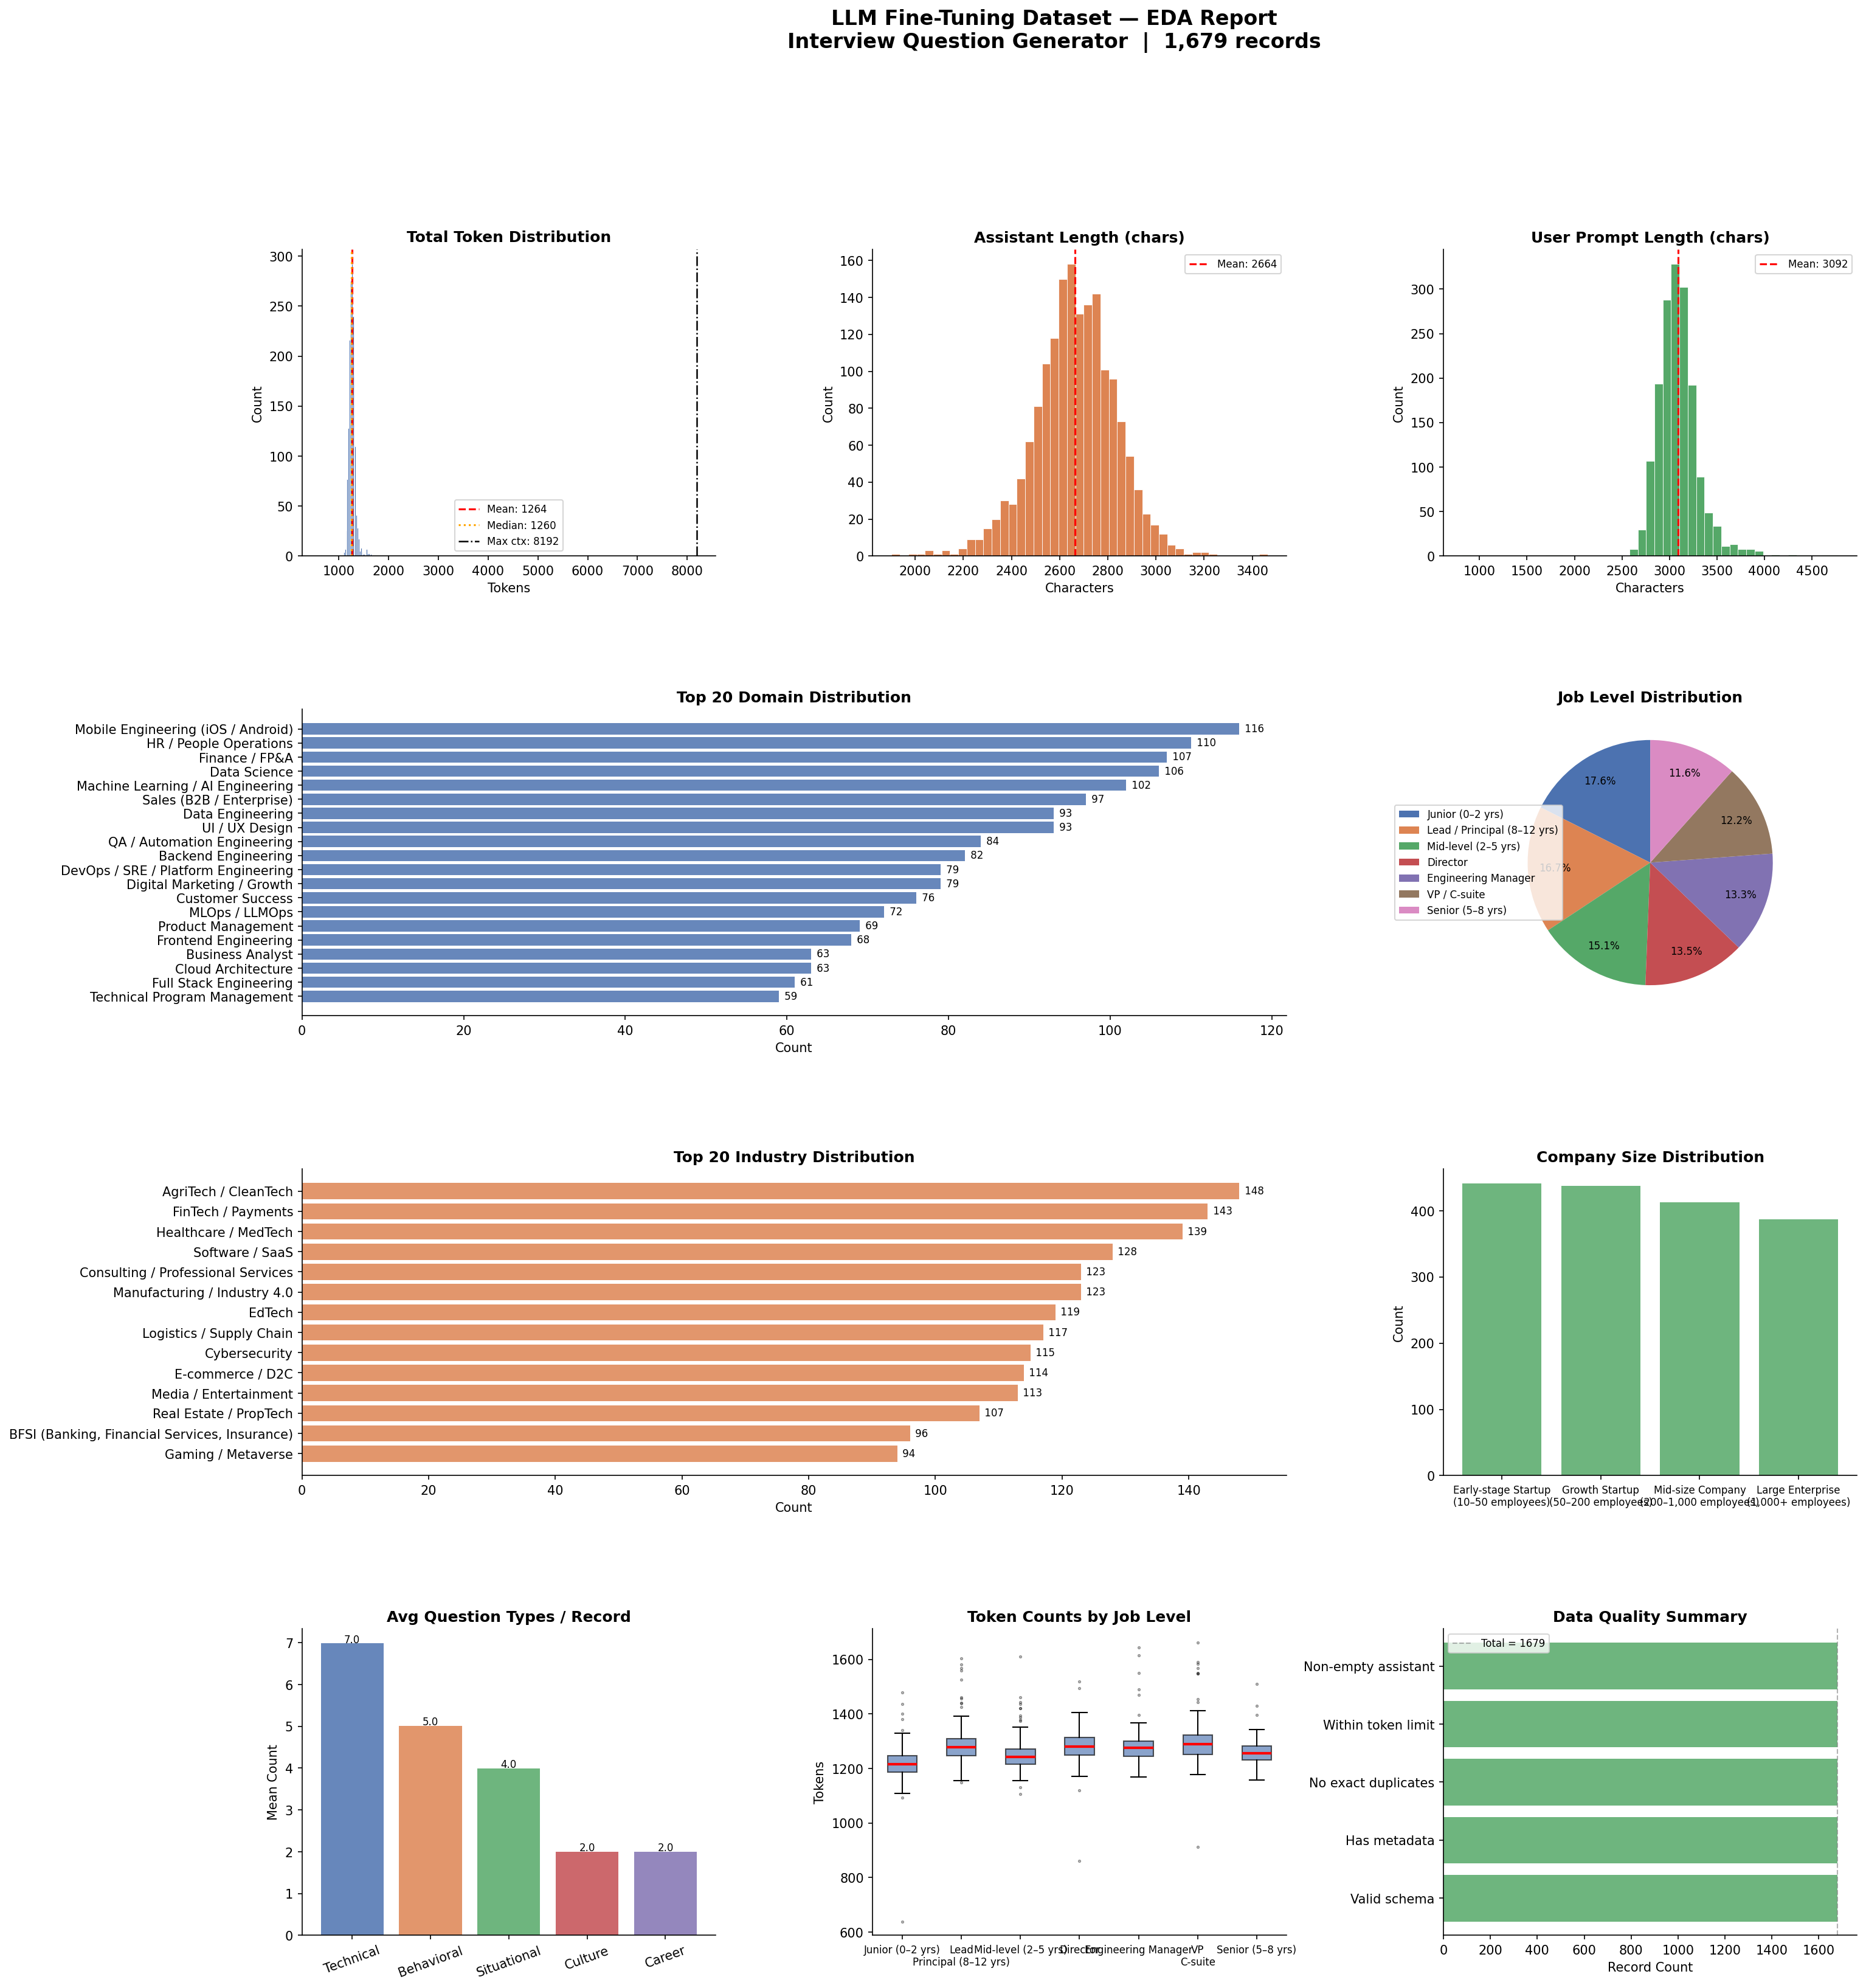
Full EDA Report — LLM Fine-Tuning Dataset (Interview Question Generator, 1,679 records)

9.1 Pipeline Configuration
Parameter | Value
Tokenizer | google/gemma-4-E4B-it
Max Context | 8,192 tokens
Validation Split | 10%
Random Seed | 42
Output Directory | ./prepared_data/
Dataset Version | v3.1
Source File | raw_dataset.jsonl

