AGENTIC AI LANDSCAPE
Comprehensive Technical Analysis

From Natural Language to Technical Execution

Version 1.0 · April 2026
Confidential and Proprietary

Table of Contents

Section 1: Research Overview & Key Findings

1.1 Purpose of This Document
This document presents the findings of a systematic research and evaluation of the agentic AI landscape as of April 2026. The research was conducted to answer a single question:
Which existing software comes closest to enabling a non-technical person to perform technical tasks --- deploying applications, managing infrastructure, building APIs, automating workflows, analyzing data --- purely through natural language, with the system handling all complexity and keeping the user safe?

1.2 Scope of Research
Tier | Definition | Tools
Tier 1: Direct Match | Systems that accept natural language and produce technical outcomes with minimal-to-no technical setup by the user | OpenClaw, Replit Agent, Lovable/Bolt.new
Tier 2: Partial Overlap | Frameworks that enable agentic automation but require technical knowledge to configure, deploy, or operate | LangGraph, CrewAI, Microsoft AutoGen, PydanticAI
Tier 3: Adjacent Tools | Coding assistants, general frameworks, and UI generators that solve part of the problem but not the full pipeline | Cursor, MetaGPT, LangChain, AutoGPT, Vercel v0

1.3 Key Findings --- Executive Summary

Finding 1: No Tool Solves the Full Problem
None of the 12 evaluated platforms enables a non-technical user to accomplish arbitrary technical tasks through natural language with built-in safety guardrails.
Tool | What It Solves | What It Misses
OpenClaw | Multi-channel orchestration, 24/7 background operation, workflow automation | Requires technical setup, no safety layer, severe security vulnerabilities
Replit Agent | Natural language -> deployed web application | Limited to web apps in Replit ecosystem, no infrastructure management
Lovable | Natural language -> full-stack web app with database | Web apps only, no safety validation of user requests
LangGraph | Precise state-machine agent workflows | Requires Python skills, zero natural language interface
CrewAI | Role-based multi-agent team coordination | Requires technical setup, no safety layer, developer-only

Finding 2: The 'Guardian Safety Layer' Does Not Exist Anywhere
Every evaluated tool assumes either full autonomy (dangerous) or developer-in-the-loop (impossible for non-technical users). What's needed is Guardian Mode: an agent that understands intent, validates against risk, explains in plain language, and executes safely.

Finding 3: The Best Building Blocks Exist --- But Are Unassembled
Capability | Best Existing Implementation | Gap
Natural language -> technical execution | Replit Agent (web apps), OpenClaw (workflows) | Limited scope, no safety layer
Multi-channel input (voice, WhatsApp, web) | OpenClaw | Requires technical configuration
Deterministic workflow execution | PydanticAI + Temporal.io | Developer-only frameworks
Type-safe tool execution | PydanticAI | No natural language layer

Finding 4: OpenClaw Is the Closest Starting Point --- But Has Critical Flaws
OpenClaw is architecturally the most relevant. However, it suffers from critical vulnerabilities like default port exposure and malicious skills marketplace.

1.4 Summary Scorecard
Tool | Tier | NL | Tech | Safety | Total
OpenClaw | 1 | 3 | 5 | 1 | 22
Replit Agent | 1 | 4 | 3 | 2 | 22
Lovable | 1 | 4 | 2 | 2 | 19
LangGraph | 2 | 1 | 4 | 2 | 21
PydanticAI | 2 | 1 | 3 | 4 | 20

Section 5: Cross-Tool Comparative Analysis

5.2 The Gap Visualization
The following diagram highlights the market gap in the top-right quadrant where high natural language accessibility meets broad technical scope and guardian safety.
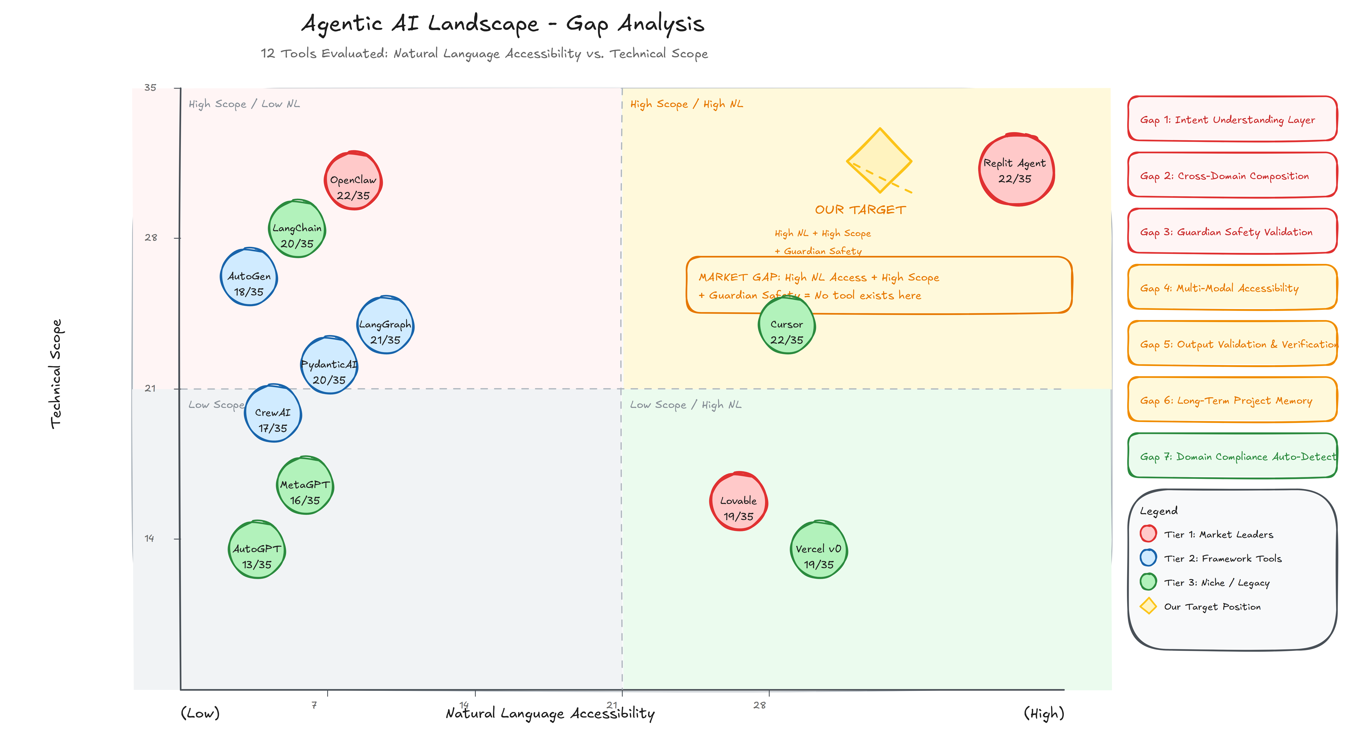

Section 6: High-Level System Architecture

6.1 OpenClaw Architecture
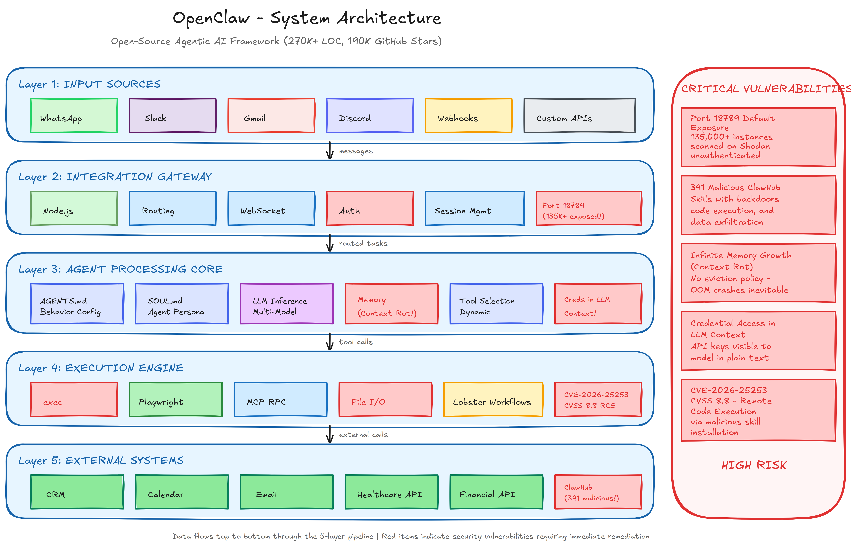

6.2 Replit Agent Architecture
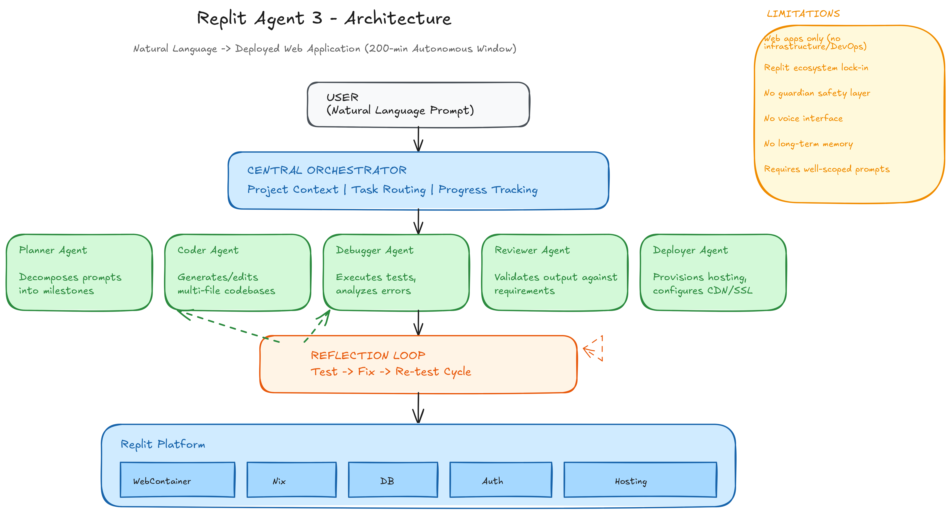

6.3 Lovable Architecture
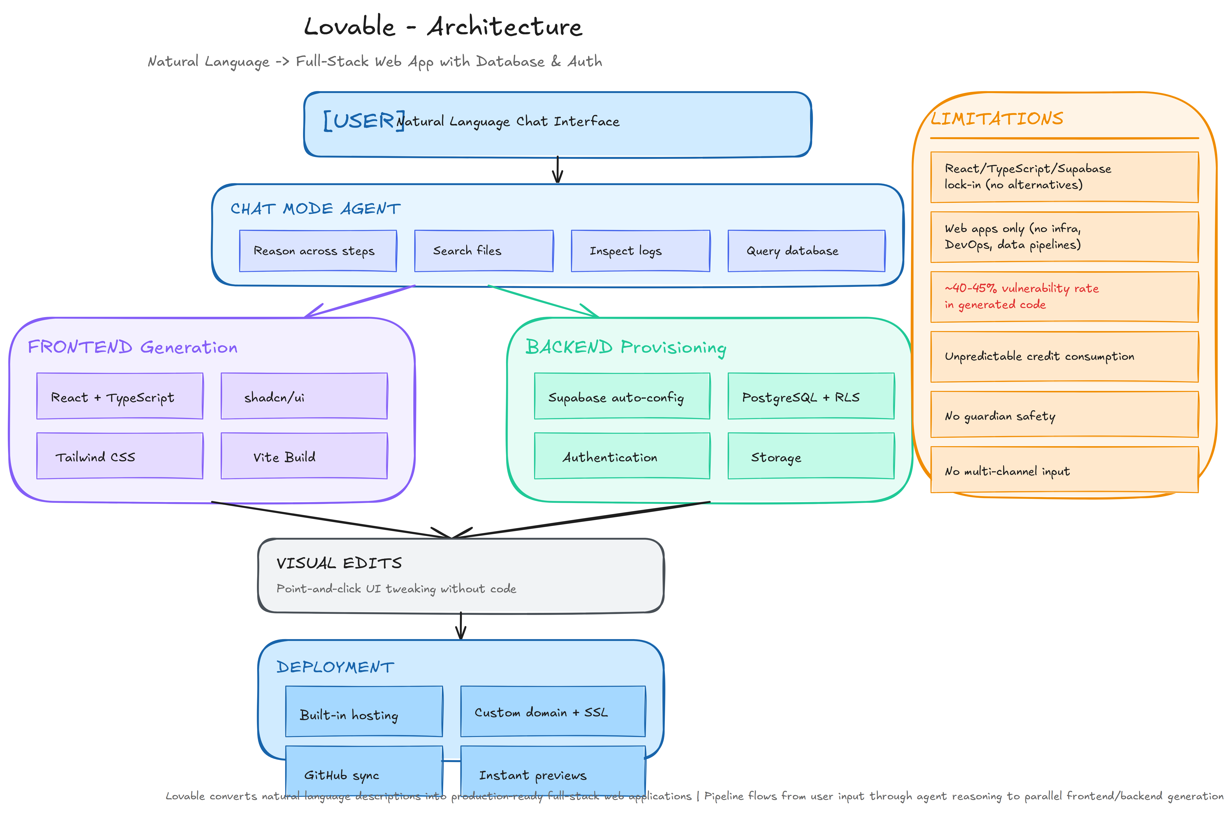

Section 8: Conclusions and Strategic Recommendations

8.1 Summary of Findings
1. No existing tool solves the full problem.
2. The guardian safety layer is universally absent.
3. OpenClaw is the closest starting point but needs significant hardening.

8.2 Strategic Recommendations
Recommendation 1: Fork and Harden OpenClaw as the Foundation.
Recommendation 2: Adopt Temporal.io + PydanticAI as the Deterministic Spine.
Recommendation 3: Build the Intent Understanding Layer as the Core Differentiator.

