**Name : Brishti Das**

**Superset ID : 6363729**

**Week 5 hands-on**

**Chat Application Using Kafka and C#**

1. Create a Chat Application which uses Kafka as a streaming platform and consume the chat messages in the command prompt.

Ans:-

In command prompt - .\bin\windows\zookeeper-server-start.bat .\config\zookeeper.properties

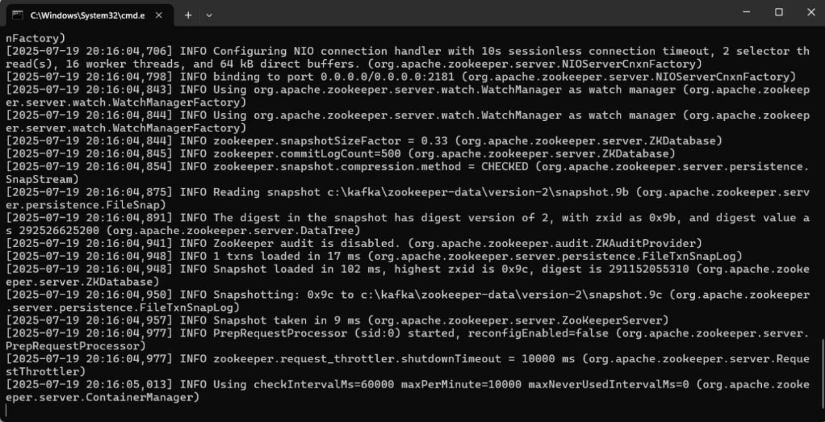

In another command prompt : - .\bin\windows\kafka-server-start.bat .\config\server.properties

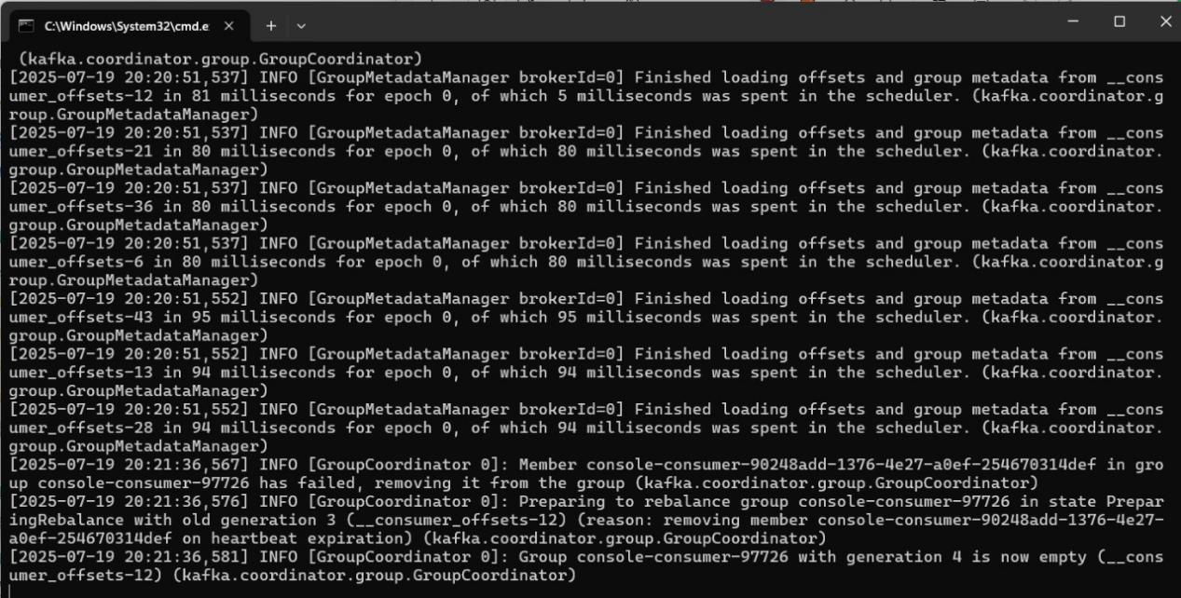

In bin>windows command prompt : atfirst this ->kafka-topics.bat --create --bootstrap-server localhost:9092 --topic chat-message

Then this ->kafka-console-producer.bat --broker-list localhost:9092 --topic chat-message

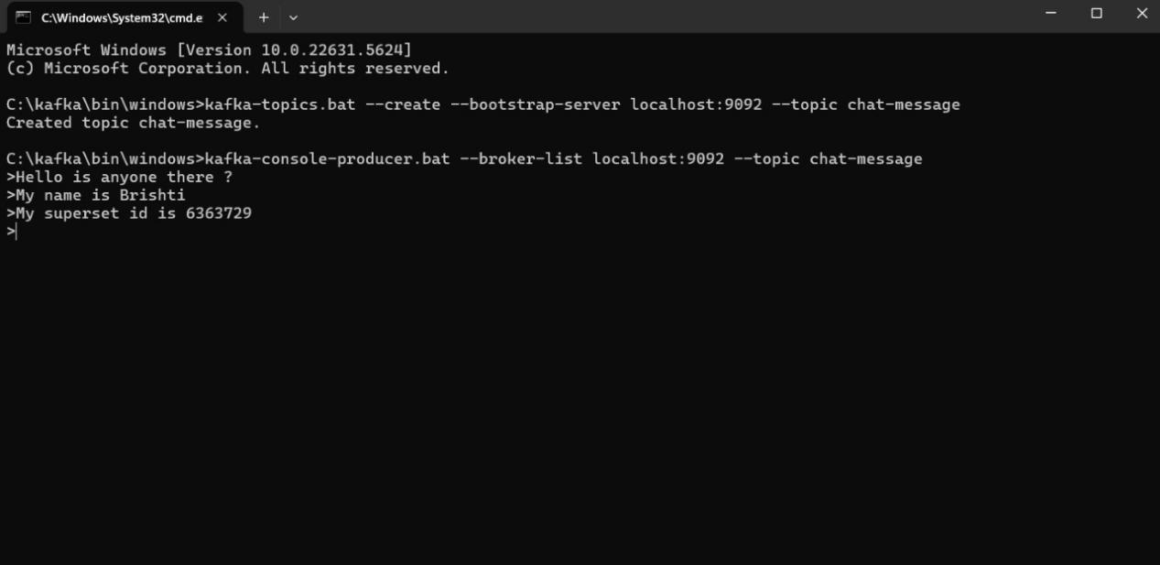

In another bin>windows type : >kafka-console-consumer.bat --topic chat-message --bootstrap-server localhost:9092 --from-beginning

Then send messege from previous bin>window command prompt , it will be visible in the recent command prompt.

