Symptoms-Based Disease Predictor and Report Analyzer

1. Introduction:
Healthcare is one of the most important sectors in modern Society. Early identification of diseases plays a significant role in reducing health risks and improving treatment outcomes. However, many individuals experience symptoms without understanding the possible medical conditions associated with them. In Such Situations, technology can assist in providing Preliminary healthcare guidance.
Now, with the quick advancement of Artificial intelligence (AI) and Machine Learning (ML), healthcare Systems have become more efficient in analyzing medical data and predicting diseases. Machine Learning algorithms can identify patterns from large datasets and provide accurate predictions based on user inputs.
These techniques are increasingly used in healthcare applications such as disease report and treatment recommendation System. The importance of early diagnosis of possible diseases is immense since it enables patients to consult doctors before the situation gets out of hand.
Such a system is beneficial both to the patient and the doctor since it acts as a tool to aid in decision making. It makes access more open, decreases reliance on urgent medical care.
The System-Based Disease Prediction System is a Machine-Learning web -Based application platform to predict diseases based on Symptoms entered by users. The System analyzes symptoms data and predicts the most probable disease using a trained Random Forest classification model. In addition to prediction, the system provides disease description, medication information, precautions, and workout recommendation to help users understand and manage their health conditions.
The project aims to aims to bridge the gap between symptom observation and medical awareness by providing users with quick and accessible healthcare information. Although the system does not replace professional medical diagnosis, it serves as supportive tool for preliminary disease assessment and awareness.
It is possible to enhance the predictability and breadth of the disease prediction systems in future by incorporating more data, more sophisticated deep learning strategies and real-time tracking.
Background of the Study:
The healthcare industry generates vast amounts of medical data every day. This data contains valuable information about diseases, symptoms, treatments, and patient outcomes. Traditionally, disease diagnosis relies on medical experts who analyze symptoms and conduct medical examinations. However, due to increasing patient populations and limited healthcare accessibility, there is a growing need for automated healthcare support systems.
Machine Learning has emerged as a powerful technology capable of processing large datasets and extracting meaningful patterns. In recent years, researchers have successfully applied Machine Learning algorithms to predict diseases such as diabetes, heart disease, liver disease, and respiratory disorders. These systems assist healthcare professionals by providing accurate predictions and reducing diagnostic time.
The proposed Symptoms-Based Disease Prediction System utilizes symptom information as input and predicts the corresponding disease using a trained classification model. The system also integrates additional healthcare information, making it more informative and user-friendly.
Machine Learning in Healthcare:
Machine Learning is a branch of Artificial Intelligence that enables computers to learn from data without being explicitly programmed. In healthcare, Machine Learning is widely used for disease prediction, diagnosis support, patient monitoring, and healthcare analytics.
Some major applications of Machine Learning in healthcare include:
- Disease diagnosis and prediction.
- Medical information processing.
- Treatment recommendation systems.
- Personalized healthcare solutions.
- Patient risk assessment.
- Clinical decision support systems.
Machine Learning algorithms can analyze complex medical datasets and identify hidden relationships between symptoms and diseases. This capability makes them highly effective for healthcare prediction systems.
The system receives input in the form of a graphical interface based on Tkinter in which a user can input all the symptoms, after which the predicted disease and precautionary measures are displayed to them
Need for the System:
Many individuals experience symptoms but may not have immediate access to healthcare professionals. Delayed diagnosis can result in worsening health conditions and increased medical expenses. There is a need for systems that provide quick and reliable disease prediction based on symptoms.
The proposed system addresses this need by allowing users to select symptoms and receive instant disease predictions. Additionally, the system provides relevant healthcare information, including medication details, precautions, and workout recommendations. This helps users gain awareness about their condition and encourages timely medical consultation.
Objectives of the Project:
The primary objective of this project is to develop a Machine Learning-based disease prediction system that predicts diseases based on symptoms provided by users.
The specific objectives are:
- To collect and process disease and symptom datasets.
- To train a Random Forest classification model for disease prediction.
- To develop a user-friendly interface using Streamlit.
- To provide disease descriptions and healthcare recommendations.
- To display medications and precautions associated with predicted diseases.
- To suggest workout recommendations for maintaining health and wellness.

Scope of the Project:
The scope of this project is limited to symptom-based disease prediction using Machine Learning techniques. The system predicts diseases based on available symptom information and provides supporting healthcare recommendations.
The project covers:
- Disease prediction from symptoms.
- Description of diseases.
- Medication information.
- Precautionary measures.
- Workout recommendations.
The system is intended for educational and awareness purposes and should not be considered a replacement for professional medical advice.
To offer precautionary measures and guidance and predictions, help the users in taking precautionary steps before seeing a medical practitioner.
To compare and assess the performance of the models based on such measures as accuracy, precision, and recall, make sure that the system is reliable and can be scaled.
To engineer and create a smart system that would predict diseases through machine learning methods by offering information about the diseases through the methods posted by the user.

Advantages of the System:
The proposed system offers several advantages:
- Quick and automated disease prediction.
- Easy accessibility through a web interface.
- User-friendly design.
- Improved healthcare awareness.
- Support for early disease identification.
- Additional recommendations including medication and precautions.
Applications of the System:
The system can be used in various healthcare-related scenarios:
- Personal health monitoring.
- Educational healthcare platforms.
- Medical awareness programs.
- Preliminary disease assessment.
- Healthcare research and training.
Challenges In Disease Prediction:
Disease prediction is a complex process because many diseases share similar symptoms, making it difficult to identify the exact illness. For example, symptoms such as fever, fatigue, headache, and dizziness can be associated with multiple diseases. As a result, machine learning models may sometimes predict the wrong disease if sufficient distinguishing symptoms are not available.
Another major challenge is the quality of healthcare data. Medical datasets often contain missing values, duplicate records, or incorrect information, which can negatively affect the performance of prediction models. Therefore, data preprocessing and cleaning are essential steps before training a machine learning model.
In addition, healthcare data is highly sensitive and confidential. Maintaining patient privacy and ensuring data security are important concerns when developing disease prediction systems. Machine learning models also require large amounts of accurate and diverse data to achieve high prediction accuracy.
However, obtaining such datasets can be difficult due to privacy regulations and limited access to medical records. Furthermore, diseases and medical conditions evolve over time, requiring continuous updates to datasets and prediction models. These challenges highlight the need for reliable data management, robust algorithms, and regular model maintenance to ensure accurate disease prediction.
Another challenge is the availability of high-quality healthcare data, as collecting and maintaining medical records can be costly and time-consuming. Ensuring patient privacy and data security is also an important concern in healthcare applications.
Benefits of Machine Learning in Healthcare:
Machine Learning has transformed the healthcare industry by enabling faster and more accurate disease diagnosis. It can analyze large volumes of medical data within a short period, identifying patterns and relationships that may not be easily detected by humans.
This capability helps healthcare professionals make informed decisions and improves the overall quality of patient care. Early disease prediction is one of the most significant benefits of machine learning, as it allows patients to receive timely treatment, reducing complications and improving recovery rates.
Another important benefit is the reduction of manual workload for doctors and healthcare staff. Machine learning systems can automate repetitive tasks such as data analysis, symptom evaluation, and risk assessment. These systems also support personalized healthcare by recommending treatments and preventive measures based on a patient's symptoms and medical history. Furthermore, machine learning can improve healthcare accessibility by providing preliminary disease predictions through web-based or mobile applications. This is particularly beneficial in areas where medical resources are limited. Overall, machine learning contributes to increased efficiency, better diagnostic accuracy, reduced healthcare costs, and improved patient outcomes.
Existing Systems:
The existing disease prediction systems primarily rely on traditional medical diagnosis methods, where patients consult healthcare professionals to identify diseases based on symptoms and medical examinations. Although these methods are reliable, they can be time-consuming and may require multiple visits, tests, and consultations before a diagnosis is confirmed. In many cases, patients may not have immediate access to healthcare facilities, especially in remote or rural areas.
Several existing healthcare applications provide basic symptom checking services, but many of them focus only on disease prediction and do not offer detailed information about the predicted disease. Most systems lack additional features such as medication recommendations, precautionary measures, and workout suggestions. Some systems also suffer from lower prediction accuracy due to limited datasets or the use of less effective machine learning algorithms.
Furthermore, many existing systems are not user-friendly and require medical knowledge to interpret the results correctly. They may provide only a list of possible diseases without explaining the condition or suggesting preventive actions. These limitations create a need for a more comprehensive disease prediction system that not only predicts diseases accurately but also provides useful healthcare guidance.
The proposed Symptoms-Based Disease Prediction System addresses these limitations by utilizing a Random Forest Machine Learning model trained on a large symptom dataset. In addition to disease prediction, the system provides disease descriptions, medications, precautions, and workout recommendations through an easy-to-use web interface, making it more informative and beneficial for users.
Summary:
This chapter provided an overview of disease prediction and its importance in modern healthcare systems. It discussed the growing need for intelligent healthcare solutions that can assist both patients and medical professionals in identifying diseases at an early stage. The chapter explained the role of machine learning in analyzing symptom data and generating accurate disease predictions. Various concepts related to disease prediction, healthcare applications, and machine learning techniques were introduced to establish the foundation for the proposed system.
The chapter also highlighted the major challenges associated with disease prediction, including data quality issues, symptom overlap among diseases, privacy concerns, and the need for large and reliable datasets. At the same time, it emphasized the numerous benefits of machine learning in healthcare, such as improved diagnostic accuracy, early disease detection, reduced workload for healthcare professionals, and personalized treatment recommendations. Based on these concepts, the proposed Symptoms-Based Disease Prediction System aims to provide users with disease predictions along with descriptions, medications, precautions, and workout recommendations. The next chapter presents a detailed review of existing research and studies related to disease prediction systems and machine learning applications in healthcare.
Our study makes use of several machine learning methods, such as Classifiers SVM, RF, and DT, which are well known for their ability to analyze medical data and make precise disease predictions. The incorporation of ML into healthcare streamlines the analysis of patient data, which not only aids in diagnosis but also encourages proactive monitoring and personalized healthcare approaches. As the healthcare industry increasingly adopts these sophisticated ML techniques, the potential for improved patient care and enhanced healthcare delivery becomes increasingly achievable.
Machine Learning (ML) has emerged as a crucial technology in disease prediction, leveraging vast amounts of historical data to improve healthcare outcomes. This technology enables computers to identify patterns and make predictions based on both structured and unstructured medical data. The creation of an ML model consists of two key phases: training, where the model enhances its predictive capabilities using a specific dataset, and testing, which evaluates its accuracy with new information. In the realm of disease prediction,
The importance of ML in the healthcare sector is underscored by its ability to quickly and accurately process large volumes of data. As data collection methods advance, healthcare data has become increasingly intricate and plentiful, often including both unstructured text and structured records. By examining this data, ML models can deliver timely insights that are essential for effective decision-making. This functionality enables physicians to make informed diagnoses and tailor treatments to meet the unique needs of individual patients, ultimately enhancing healthcare services
ace very high economic burdens on healthcare systems. Traditional diagnostic approaches mainly rely on structured clinical data and subjective judgments, which are likely to result in subjectivity, inconsistency, errors, and delays. With a growing rate of chronic and acute illnesses, there is a critical need for novel solutions that can effectively and efficiently address these diagnosis issues.

2. Literature Review:
This review synthesizes ML approaches used across many disease domains, providing a bibliometric analysis and comparing common algorithms (tree-based models, SVM, Random Forest, neural nets) and data challenges such as class imbalance and explainability. It emphasizes evaluation standards and the need for robust preprocessing when working with heterogeneous clinical inputs — directly relevant when selecting models and validation strategies for symptom-based prediction.
This study builds classifiers to predict disease categories directly from symptom text in a low-resource language, using feature engineering and standard classifiers plus thorough cross validation. It highlights how careful text preprocessing and class-balancing improve multiclass performance — useful if your app accepts free-text or non-standard symptom descriptions.
The authors compare SVM, Random Forest, on a curated symptom–disease dataset and report competitive accuracies (often >85–90%) after targeted feature selection and data cleaning. They stress building an extensible symptom vocabulary and GUI integration for real-world usability — directly aligning with a Stream-lit front end and structured symptom lists.
Nature Medicine / Few-shot phenotyping work addresses the long-tail problem (rare diseases) by applying few-shot learning to phenotype descriptions, showing that meta-learning helps generalize from very few labeled cases. For my project, the implication is to consider few-shot or transfer techniques if you want to expand coverage to rare conditions with limited examples.
This recent scoping review surveys ML use across disease prediction tasks, calling out common pitfalls (overfitting on small datasets, lack of external validation) and recommending transparent reporting (confusion matrices, per-class metrics). Use these recommendations when reporting performance for your multi-class symptom-prediction model.
Evolution of Disease Prediction System:
Disease prediction has evolved from traditional rule-based expert systems to modern machine learning-based approaches.
Early systems relied on predefined rules created by medical experts. Although accurate in limited domains, these systems lacked adaptability and scalability.
The emergence of machine learning introduced data-driven approaches capable of learning complex relationships between symptoms and diseases. Modern systems can analyze large healthcare datasets and provide predictions with higher accuracy.
Recent advancements in Artificial Intelligence have enabled the development of intelligent healthcare systems that support diagnosis, treatment recommendations, and patient monitoring.
Review of Existing Studies:
Researchers developed a disease prediction system using supervised machine learning algorithms such as Decision Tree, Random Forest, and Naive Bayes.
Findings:
- Random Forest achieved highest accuracy.
- Improved disease classification.
- Reduced diagnosis time.
Limitations:
- Limited dataset size.
- Required balanced data.
Intelligent Medical System:
An intelligent diagnosis system was proposed using symptom analysis and classification algorithms.
Findings:
- Accurate disease prediction.
- User-friendly interface.
- Effective decision support.
Limitations:
- Restricted disease categories.
- Limited real-time data integration.
Healthcare System:
Findings:
- Predicted diseases effectively.
- Suggested precautions and medications.
- Enhanced patient awareness.
Limitations: Recommendation quality depended on dataset quality.
Classification Algorithms Can be Used in Disease Prediction:
Random Forest
Random Forest is an ensemble learning algorithm consisting of multiple decision trees.
Advantages:
- High accuracy
- Handles large datasets
- Reduces overfitting
Disadvantages:
- High memory usage
- Less interpretable
Decision Tree
Decision Tree creates a tree-like structure for classification.
Advantages:
- Easy to understand
- Fast prediction
Disadvantages:
- Overfitting risk
- Lower accuracy than ensemble methods

Support Vector Machine (SVM)
SVM separates classes using optimal hyperplanes.
Advantages:
- Effective in high-dimensional data
- Good accuracy
Disadvantages:
- Computationally expensive
This research utilizes the Support Vector Machine methodology to assess the accuracy rate. The evaluation of the system's performance is based on metrics such as accuracy, specificity, and sensitivity. The proportion of correctly and incorrectly classified instances is presented as a percentage of the sample data. The models examined in this research include SVM, Random Forest, Decision Tree. A robust multi-process approach that integrates the decision tree algorithm with clustering techniques was implemented in this system. This methodology aids in the development of a predictive system for cardiac arrest. It can be concluded that the Random Forest classifier algorithm demonstrates superior accuracy and efficiency compared to the other
The researchers concluded that the proposed model demonstrated enhanced accuracy, which can be ascribed to its capacity to discern complex nonlinear relationships within the feature space.
Logistic Regression: Known for exceptional discriminative ability across multi-class classification. Some studies document accuracy rates of up to 96.5% on real-world clinical data.
Proposed System Contribution:
The proposed Symptom-Based Disease Predictor and Report Analyzer aims to:
- Predict diseases using machine learning.
- Analyze medical reports automatically.
- Provide disease probability information.
- Display prediction confidence.
- Offer a user-friendly Stream-lit interface.
- Improve healthcare accessibility.
The system combines disease prediction and report analysis into one platform, addressing limitations found in previous studies.
Deep Learning in Healthcare:
Deep Learning is a subset of machine learning that uses artificial neural networks with multiple hidden layers.
Applications include:
- Medical image analysis
- Disease classification
- Medical report understanding
- Drug discovery

Text Mining in Medical Reports:
Medical reports often contain unstructured text data.
Text mining techniques help extract meaningful information from these reports.
Key steps include:
Text Preprocessing
- Tokenization
- Stop-word removal
- Stemming
- Lemmatization
Information Extraction
Identifies:
- Diseases
- Symptoms
- Medications
- Laboratory findings
Text Classification
Categorizes reports based on disease types.
Text mining enhances report analysis and supports automated healthcare decision-making.

Comparative Analysis of Machine Learning Algorithms:
Several studies have compared machine learning algorithms for disease prediction.
Algorithm | Advantages | Limitations
Decision Tree | Easy to interpret | Overfitting
Random Forest | High accuracy | Complex
Naive Bayes | Fast training | Independence assumption
SVM | Effective for high dimensions | High computational cost
KNN | Simple implementation | Slow prediction
Logistic Regression | Easy interpretation | Limited complexity

Most studies conclude that Random Forest generally provides superior performance for symptom-based disease prediction datasets.
Researchers have shown that automated report analyzers can improve clinical workflow and reduce workload for healthcare professionals.
Explainability is becoming increasingly important in healthcare applications.
One limitation of machine learning models is their lack of transparency. But it depends on which model and Algorithms we are using for prediction Analysis so, that it main the stability in performance of our project and improve accuracy rate and show us the good results.
Disease Prediction Using Symptom Datasets:
Symptom datasets typically contain:
- Symptom names
- Disease labels
- Severity information
Researchers use these datasets to train machine learning models capable of predicting diseases from symptom combinations.
Common diseases included:
- Allergy
- Personality Disorder
- Asthma
- Stye
- Arthritis
- Heart Disease
- Dengue
The quality and diversity of symptom datasets significantly influence model performance.
It depends on the quality of datasets on which we currently working as it’s shows what type of algorithms is best for moving forward with it and make a good and satisfied prediction for every Users.
Medical Report Analyzer Systems:
Medical report analyzers automate the interpretation of laboratory and diagnostic reports.
Their functions include:
- Extracting key findings
- Identifying abnormalities
- Generating summaries
- Highlighting health risks
Advantages:
- Reduced interpretation time
- Improved healthcare efficiency
- Better patient understanding
Researchers have shown that automated report analyzers can improve clinical workflow and reduce workload for healthcare professionals.
Analysis of Disease Prediction from (2000-2005):
During the early 2000s, disease prediction systems were primarily based on rule-based expert systems. These systems relied on predefined medical rules and knowledge bases created by healthcare professionals. The systems could predict diseases by matching patient symptoms with stored medical rules.
Characteristics:
- Knowledge-driven approach
- Limited disease coverage
- Manual rule creation
- Low scalability
Technologies Used:
- Expert Systems
- Knowledge Bases
- IF-THEN Rules
Limitations:
- Difficult to update
- Unable to learn from new data
- Limited prediction capability
Although these systems provided initial support for diagnosis, they lacked flexibility and intelligence.
Period: 2005–2010 (Introduction of Data Mining Techniques):
Between 2005 and 2010, researchers began applying data mining techniques to healthcare data. Large medical databases became available, enabling the discovery of hidden patterns between symptoms and diseases.
Key Developments:
- Classification-based disease prediction
- Association rule mining
- Pattern recognition
Algorithms Used:
- Decision Tree
- Naive Bayes
- K-Means Clustering
- Association Rule Mining
Advantages:
- Better prediction accuracy
- Automated pattern discovery
- Reduced dependence on manual rules
Challenges:
- Data quality issues
- Missing healthcare records
This period marked the transition from knowledge-based systems to data-driven healthcare solutions.
Period: 2010–2015 (Machine Learning Revolution):
The years between 2010 and 2015 witnessed significant growth in machine learning applications within healthcare.
Researchers increasingly adopted supervised learning algorithms to predict diseases using symptom datasets.
Popular Algorithms:
- Random Forest
- Support Vector Machine (SVM)
- K-Nearest Neighbor (KNN)
- Logistic Regression
Achievements:
- Improved disease prediction accuracy
- Early disease detection
- Better healthcare decision support
Applications:
- Diabetes Prediction
- Heart Disease Prediction
- Cancer Diagnosis
- Respiratory Disease Detection
Medical report analysis also began utilizing Natural Language Processing (NLP) techniques to process clinical documents.
Evolution Timeline Summary:
Period | Major Technology | Key Contribution
2000–2005 | Expert Systems | Rule-based diagnosis
2005–2010 | Data Mining | Pattern discovery
2010–2015 | Machine Learning | Accurate disease prediction
2015–2020 | Deep Learning | Advanced healthcare analytics
2020–2023 | AI & Telemedicine | Remote healthcare support
2023-Present | Generate AI & XAI | Intelligent report analysis and explain
The evolution of symptom-based disease prediction and medical report analysis has progressed from simple rule-based systems in the early 2000s to advanced AI-powered healthcare platforms today. Modern systems utilize machine learning, deep learning, natural language processing, and generative AI to provide accurate disease predictions and intelligent report analysis. These advancements continue to improve healthcare accessibility, diagnostic accuracy, and patient care, making AI-driven healthcare systems an important area of research and development.
3. Problem Statement
The proposed system for disease prediction using machine learning involves utilizing various techniques, algorithms, and tools to build a system that predicts a patient's disease based on their symptoms. By comparing these symptoms with the system’s previously available dataset, we can accurately predict the disease. By taking those datasets and comparing them with the patient’s disease, we will predict the accurate percentage of the disease in the patient.
Hence, an intelligent, automated system on how user provided symptoms are processed by machine learning algorithms and how they can be relied on to give the correct prediction of a disease and their precautions is necessary. This solution would strengthen preventive healthcare, dependency on the availability of experts immediately, and help in early decisions made by patients.
This project carries significant value in the healthcare sector by leveraging machine learning models for predicting diseases like Asthma, Allergy, and Stye. It contributes to the modernization and improvement of healthcare services by offering efficient, accurate, and accessible diagnostic support. All models have the likely to enhance the disorder process and lay the groundwork for advancements in personalized healthcare, enabling tailored treatment strategies based on predictive data. Overall, integrating machine learning into disease prediction marks a pivotal step toward better health outcomes and more efficient healthcare delivery system.
This project carries significant value in the healthcare sector by leveraging machine learning models for predicting diseases like dengue, malaria, and typhoid. It contributes to the modernization and improvement of healthcare services by offering efficient, accurate, and accessible diagnostic support.

4. Proposed Methodology
Numpy:
NumPy (Numerical Python) is a fundamental Python library used for numerical and scientific computing. It provides a powerful N-dimensional array object that enables efficient storage and manipulation of large datasets. Compared to Python lists, NumPy arrays require less memory and perform calculations much faster. Due to its speed and efficiency, NumPy is widely used in data science, machine learning, and engineering applications.
One of the key features of NumPy is its extensive collection of mathematical and statistical functions. It supports operations such as addition, subtraction, multiplication, matrix calculations, trigonometric functions, and linear algebra computations. These functions allow users to perform complex numerical calculations with just a few lines of code. This capability makes NumPy an essential tool for scientific research and data analysis.
NumPy also supports broadcasting, which allows operations between arrays of different shapes without requiring explicit loops. This feature simplifies coding and improves computational performance. Additionally, NumPy integrates seamlessly with other Python libraries such as Pandas, Matplotlib, and Scikit-learn. As a result, it forms the foundation of many data analysis and machine learning workflows.
Pandas:
Pandas is an open-source Python library designed for data manipulation and analysis. It provides two primary data structures: Series and Data-Frame. A Series is a one-dimensional labeled array, while a Data-Frame is a two-dimensional table consisting of rows and columns. These structures make it easy to organize and analyze large amounts of structured data.
One of the major advantages of Pandas is its ability to handle various data formats. It can read and write data from CSV files, Excel spreadsheets, SQL databases, and other sources. Pandas offers powerful functions for filtering, sorting, merging, and grouping data. These capabilities help users prepare datasets for further analysis and machine learning tasks.
Pandas also includes tools for handling missing values and cleaning inconsistent data. Data preprocessing is a crucial step in machine learning, and Pandas simplifies this process significantly. Because of its flexibility, efficiency, and ease of use, Pandas has become one of the most widely used libraries in data science and analytics.
Job-lib:
Job-lib is a Python library that provides efficient tools for saving and loading Python objects. It is particularly useful in machine learning projects where trained models need to be stored and reused. Instead of retraining a model every time the application runs, developers can save the model to a file and load it whenever needed. This helps reduce computation time and improves application performance.
One of the main advantages of Job-lib is its ability to handle large NumPy arrays efficiently. Compared to the standard Pickle module, Job-lib offers faster serialization and deserialization for numerical data. This makes it especially suitable for machine learning applications where models often contain large amounts of data.
Job-lib is commonly used with Scikit-learn models such as Random Forest, Decision Tree, and Support Vector Machine. After training a model, developers can save it using the dump () function and reload it using the load () function. This functionality is widely used in web-based machine learning applications and deployment environments.
Train_Test_Split:
The train_test_split function is a utility provided by the Scikit-learn library for dividing datasets into training and testing subsets. The training set is used to teach the machine learning model, while the testing set is used to evaluate its performance on unseen data. This separation helps measure how well the model generalizes to new information.
The function allows users to specify the proportion of data allocated to training and testing using parameters such as test_size and train_size. For example, a common practice is to use 80% of the data for training and 20% for testing. The function can also randomly shuffle the data before splitting to ensure unbiased results.
Using train_test_split is essential in machine learning because it helps prevent overfitting. A model that performs well on training data but poorly on testing data may not be suitable for real-world applications. Therefore, train-test splitting provides a reliable method for assessing model accuracy and improving predictive performance.
Random Forest:
Random Forest is a supervised machine learning algorithm used for both classification and regression tasks. It is an ensemble learning technique that combines multiple decision trees to produce more accurate and reliable predictions. Instead of relying on a single tree, Random Forest aggregates the results from many trees, reducing errors and improving performance.
During training, each decision tree is built using a random subset of the dataset and features. This randomness increases diversity among the trees and reduces the risk of overfitting. For classification problems, the final prediction is determined by majority voting among the trees. For regression problems, the output is the average of all tree predictions.
Random Forest is known for its high accuracy, robustness, and ability to handle large datasets with many features. It can also estimate feature importance, helping users understand which variables have the greatest influence on predictions. Due to these advantages, Random Forest is widely used in healthcare, finance, and disease prediction systems.
Flask: is a lightweight and open-source Python web framework used to develop web applications and APIs. It allows developers to build dynamic websites by connecting Python code with web pages created using HTML, CSS, and JavaScript.
Flask was developed by Armin Ronacher and is widely used because of its simplicity, flexibility, and ease of learning. Unlike large frameworks, Flask provides only the essential components required for web development, giving developers greater control over application design and functionality.
Features of Flask:
- Lightweight and easy to learn.
- Written in Python.
- Open-source framework.
- Built-in development server.
- Supports URL routing.
- Integration with HTML templates using Jinja2.
- Easy database integration.
- Suitable for small and large web applications.
- Supports RESTful API development.
- Highly flexible and customizable.
Prediction Process:
Detailed workflow:
- User selects symptoms.
- Symptoms converted into numerical format.
- Model processes input.
- Disease predicted.
- Prediction confidence displayed.
Web-Based Application:
Explain:
- Frontend design.
- User interface components.
- Multi-select symptom selection.
- Prediction button.
- Result display.
Model Training:
- Training process.
- Hyperparameter selection.
- Number of trees.
- Maximum depth.
- Random state.
Algorithm Steps:
Write Random Forest steps in detail:
- Load dataset.
- Preprocess symptoms.
- Split dataset.
- Train Random Forest model.
- Evaluate model accuracy.
- Save model using Job-lib.
- Build Stream-lit interface.
- Predict disease from selected symptoms.
- Display result and confidence score.
HTML:
HTML, which stands for Hyper-Text Markup Language, is the standard markup language used for creating and structuring web pages. It provides the basic framework of a website by defining various elements such as headings, paragraphs, images, tables, forms, and hyperlinks. HTML uses tags to organize and display content in a web browser, making it the foundation of all web applications and websites.
HTML plays a crucial role in web development because it determines how information is presented to users. It allows developers to create interactive forms through which users can enter data and interact with web applications. In the proposed Symptoms-Based Disease Prediction System, HTML is used to design the user interface where users can select symptoms, submit requests, and view disease prediction results. The structured nature of HTML helps create a clear and organized interface that improves user experience.
CSS:
CSS, or Cascading Style Sheets, is a style sheet language used to control the appearance and layout of HTML elements on a web page. While HTML defines the structure of a webpage, CSS determines how that structure is displayed, including colors, fonts, spacing, borders, backgrounds, and positioning. CSS enables developers to create visually appealing and professional-looking web interfaces.
CSS improves the overall usability and presentation of web applications by separating content from design. This separation makes websites easier to maintain and update. In the proposed disease prediction system, CSS is used to enhance the appearance of the web pages by styling symptom selection boxes, buttons, text fields, and result displays. Through CSS, the application provides a more attractive, responsive, and user-friendly interface, thereby improving the interaction between users and the system.
Pickle:
Pickle is a built-in Python module used for serializing and deserializing Python objects. Serialization is the process of converting a Python object into a byte stream that can be stored in a file, while deserialization is the process of converting the stored byte stream back into a Python object. The Pickle module allows developers to save complex Python objects such as machine learning models, dictionaries, lists, and custom objects for later use without retraining or recreating them.
In machine learning applications, Pickle is widely used to store trained models after the training process is completed. Once a model is trained, it can be saved into a file with a .pkl extension and loaded whenever predictions are required. This significantly reduces computational time because the model does not need to be retrained each time the application is executed. As a result, Pickle improves the efficiency and practicality of machine learning systems.
In the proposed Symptoms-Based Disease Prediction System, the Pickle module is used to save the trained Random Forest model after the training phase. The saved model file is then loaded into the Flask application to perform disease predictions based on user-selected symptoms. This approach ensures fast prediction generation and enables seamless integration between the machine learning model and the web application.
Therefore, Pickle plays an important role in machine learning deployment by providing a simple and efficient mechanism for storing and retrieving trained model.
Important Functions of Pickle:
- pickle.dump() – Saves an object to a file.
- pickle.load() – Loads an object from a file.
- pickle.dumps() – Converts an object into a byte stream.
- pickle.load() – Converts a byte stream back into an object.
Role of Pickle in Your Disease Prediction System:
In the Symptom-Based Disease Prediction System, Pickle is used to save the trained Random Forest Classifier model into a .pkl file.
Key Features of Pickle:
- Stores Python Objects Permanently
  - Pickle allows Python objects to be saved in files and retrieved later without losing their structure.
- Supports Complex Data Types
  - It can serialize lists, dictionaries, tuples, sets, classes, and machine learning models.
- Efficient Data Storage
  - Pickle stores data in binary format, making file operations faster and more memory-efficient.
- Useful for Machine Learning
  - Trained machine learning models can be saved using Pickle and loaded later without retraining.
- Built-in Python Module
  - No external installation is required because Pickle comes pre-installed with Python.
- Easy to Use
  - Only a few functions such as dump (), load (), dumps (), and loads () are needed.
- Reduces Computation Time
  - Instead of training a model every time the application runs, the trained model can be loaded directly from a pickle file.
Data Preprocessing: The subsequent phase of our project focuses on the cleaning and preprocessing of the dataset. This process entails addressing any gaps in symptom data and maintaining the dataset's consistency and integrity. We will apply preprocessing techniques such as encoding categorical symptoms and standardizing the input features to improve the dataset, ensuring efficient training of the machine learning models for disease prediction.
In Flask, the templates folder is used to store HTML files that define the web pages displayed to users. Flask uses the Jinja template engine to render these HTML files and insert dynamic data from the Python application. The render template() function loads an HTML file from the templates folder and sends it to the user's browser.
Templates help separate the application's presentation (HTML) from its backend logic (Python), making the code more organized, readable, and easier to maintain. They also allow developers to reuse common page elements, such as headers, footers, and navigation bars, and display dynamic content like user input, prediction results, or database records without manually creating HTML in Python.
The trained model is evaluated for accuracy and then integrated into a Flask-based web application. Users enter their symptoms through the web interface, and the system processes the input using the trained model to predict the most likely disease and display the result in a simple, user-friendly format.
Different symptom combinations are provided as input to verify that the model produces accurate predictions.

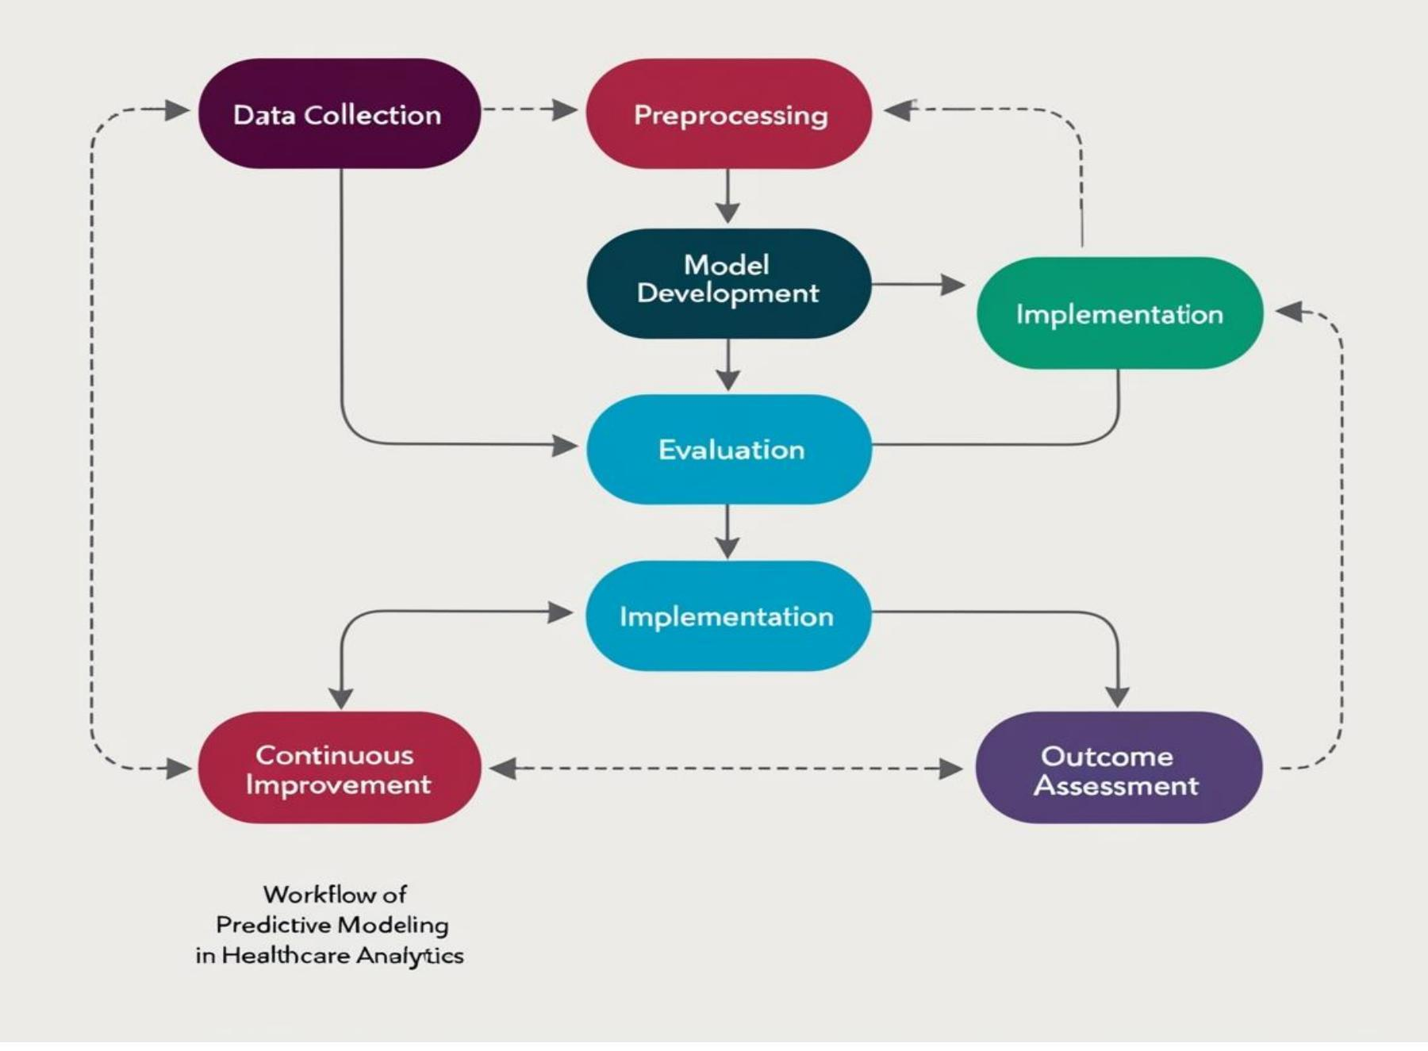
Fig-1 Machine Learning Workflow
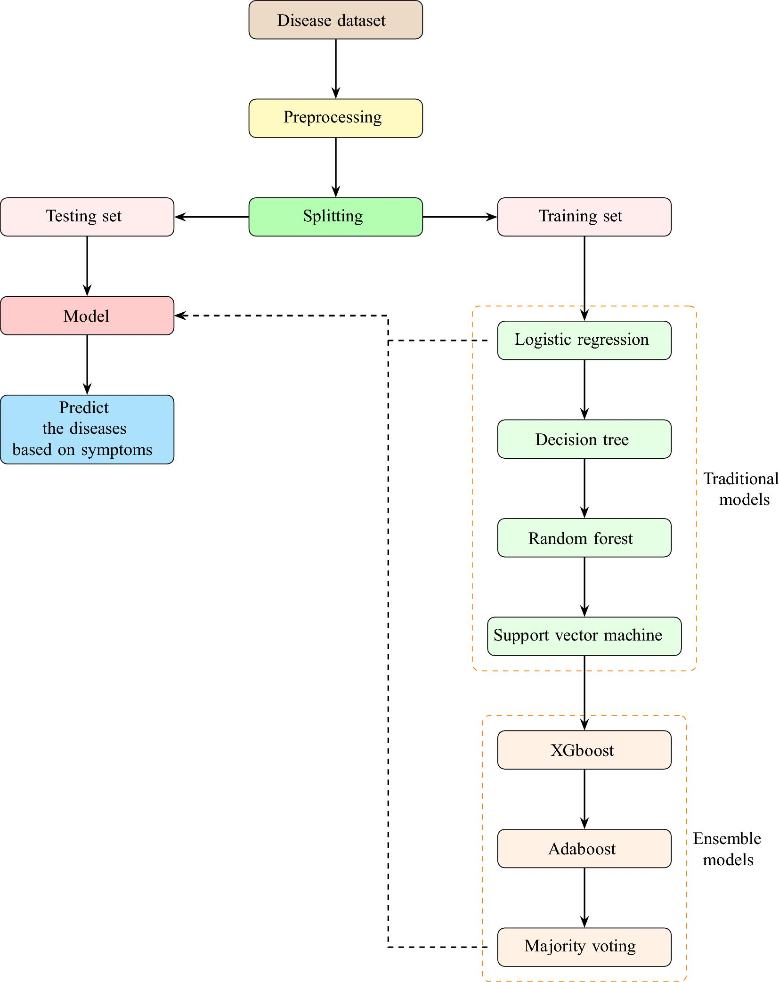

Fig-2 System Architecture

Backend (Python):
Python is a high-level, interpreted programming language widely used for backend development. It is known for its simple syntax, readability, and ease of learning, making it one of the most popular programming languages in the world. Python enables developers to build robust and scalable applications with less code compared to many other programming languages. Due to its versatility and extensive library support, Python is commonly used in web development, data science, artificial intelligence, and machine learning projects.
Flask as a Python Framework:
As a Python framework, Flask enables developers to create dynamic and interactive web applications by combining Python code with frontend technologies such as HTML, CSS, and JavaScript. It follows a minimalistic approach and provides built-in features such as URL routing, template rendering, request handling, and session management. Flask allows developers to organize application logic efficiently while maintaining complete control over the application's architecture and functionality.
One of the major advantages of Flask is its ability to integrate easily with machine learning and data science projects. Trained machine learning models can be deployed through Flask and made accessible through a web browser. This capability makes Flask highly suitable for healthcare, recommendation systems, predictive analytics, and other intelligent applications. Its lightweight nature ensures fast performance while supporting the development of scalable web applications.
n the proposed Symptoms-Based Disease Prediction System, Flask serves as the backend framework that connects the machine learning model with the user interface. It receives user-selected symptoms from web pages, processes the input using the trained Random Forest model, and displays the prediction results to the user.
In this project, Flask is used to create an interactive web-based platform where users can select symptoms, obtain disease predictions, and view prediction confidence scores. Its seamless integration with Python libraries such as NumPy, Pandas, Scikit-learn, and Job-lib makes it an effective framework for machine learning application deployment.
Technology Stack:
- Backend Language: Python
- Web Framework: Flask
- Machine Learning Library: Scikit-learn
- Data Processing Libraries: NumPy, Pandas
- Model Storage: Job-lib/Pickle
- Algorithms used: Random Forest
Deployment:
Following the attainment of consistent performance across all evaluation metrics, the models are incorporated into a user-friendly interface for practical use. Users can input their symptoms, and the system predicts diseases such as dengue, malaria, or typhoid using reliable algorithms Random Forest, Decision Tree, and SVM. This systematic approach ensures that the project is designed to provide accurate and trustworthy disease predictions while remaining accessible and efficient for end users.
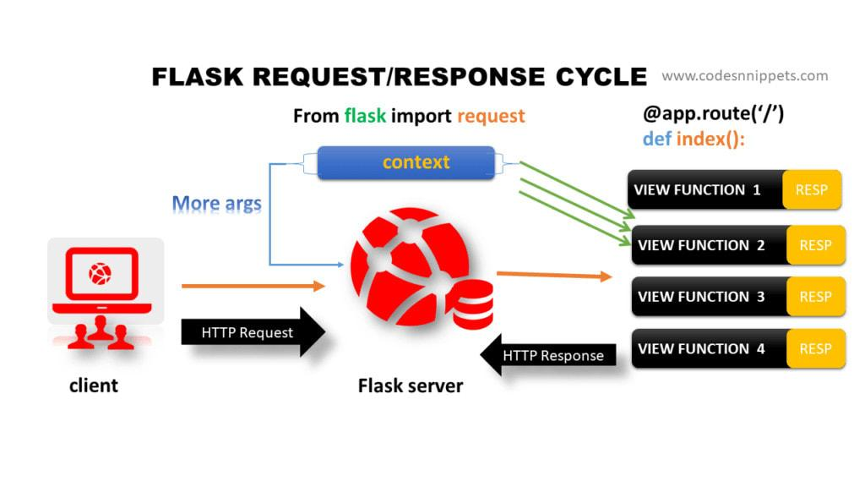

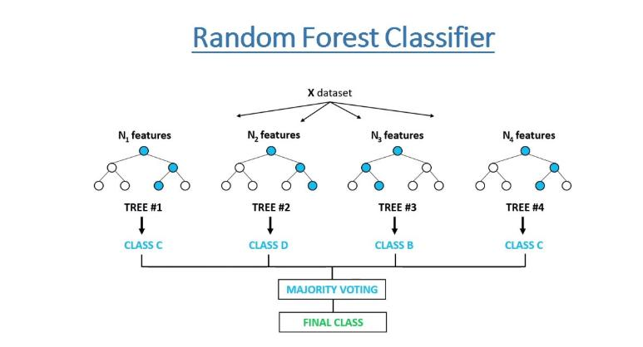

Fig 3 Work flow of Used Algorithms
The proposed system will recommend the most likely disease according to the symptoms given by the user through a machine learning algorithm. This is started by data collection and pre-processing where a structured dataset of various diseases and their related symptoms is cleansed, normalized, and into a format readable by machines. The existence of each symptom is coded as a binary feature (present/absent) and diseases are modeled by target labels.
Once pre-processed, the data is divided into training and testing data. Various machine learning classifiers used include Decision Tree, random Forest and Support Vector Machine (SVM) which are trained to find relations among symptoms and illnesses. Among them, the Random Forest model should offer a better precision, since it engages in ensemble learning and can address large features sets.
A GUI is developed in flask and it is supposed to enable human interaction, by means of which a person can safely log in and enter symptoms to be shown the predicted diseases and precautionary measures. The trained model is then connected to the GUI, which allows real-time input processing by using the trained model and provides the correct results. This process provides an effective, scaled and user-friendly disease prediction method. The system helps patients to take preventative steps prior to visiting medical practitioners because of giving timely insights. The extensions planned in the future could involve the use of deep learning models, cloud storage, and real time health monitoring to provide more strong predictions.
Working of a project:
The first stage of the methodology involves collecting a disease-symptom dataset from reliable sources. The dataset contains information about various diseases and their associated symptoms. After collecting the data, preprocessing techniques are applied to remove inconsistencies, handle missing values, and transform the data into a suitable format for machine learning algorithms. This step ensures that the dataset is clean, accurate, and ready for model training.
In the next stage, the processed dataset is divided into training and testing datasets using the train-test split technique. The training dataset is used to train the Random Forest classifier, while the testing dataset is used to evaluate its performance. Random Forest is selected because of its high accuracy, robustness, and ability to handle large datasets with multiple features. The trained model learns the relationship between symptoms and diseases, enabling it to make accurate predictions when new symptom data is provided.
After successful training and evaluation, the machine learning model is saved using Job-lib for future use. A web-based application is then developed using Stream-lit, allowing users to interact with the prediction system through a simple and user-friendly interface. Users can select symptoms from the available list, submit their inputs, and receive the predicted disease along with the prediction confidence score. This methodology integrates machine learning and web technologies to create an efficient, accessible, and practical disease prediction system.
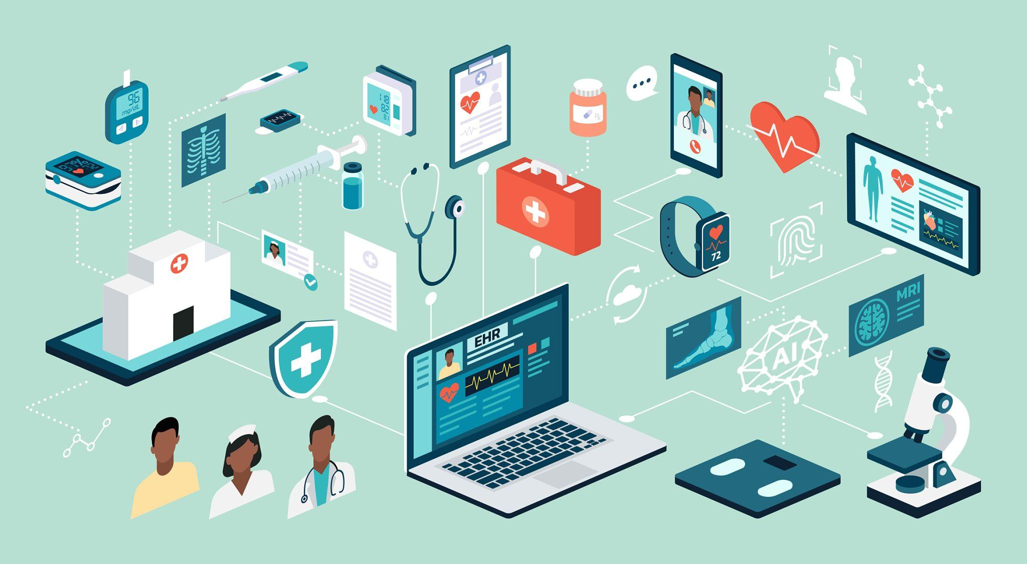

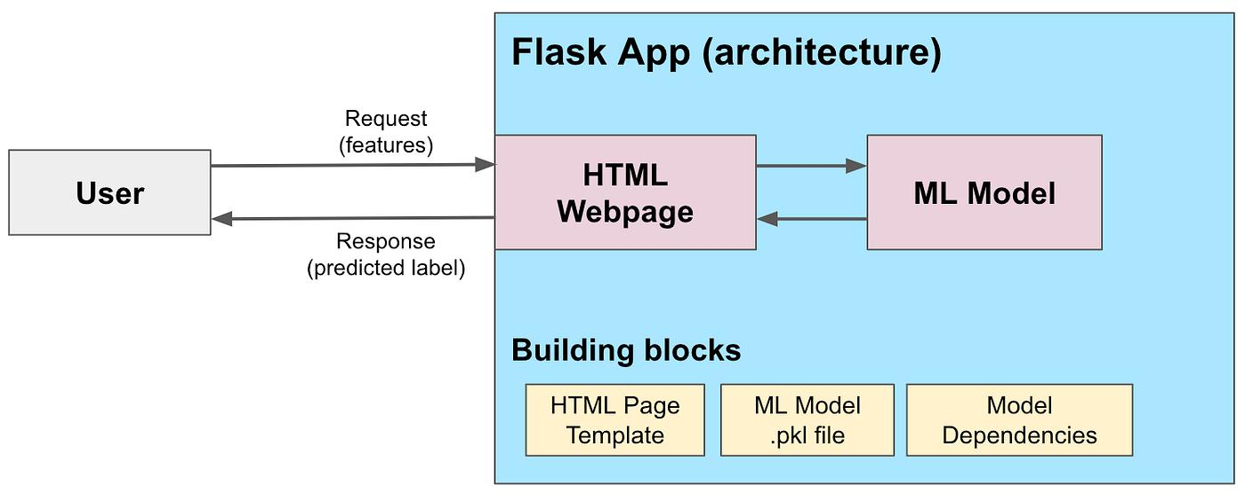

Workflow with html and flask interface as servers

Some Symptoms:
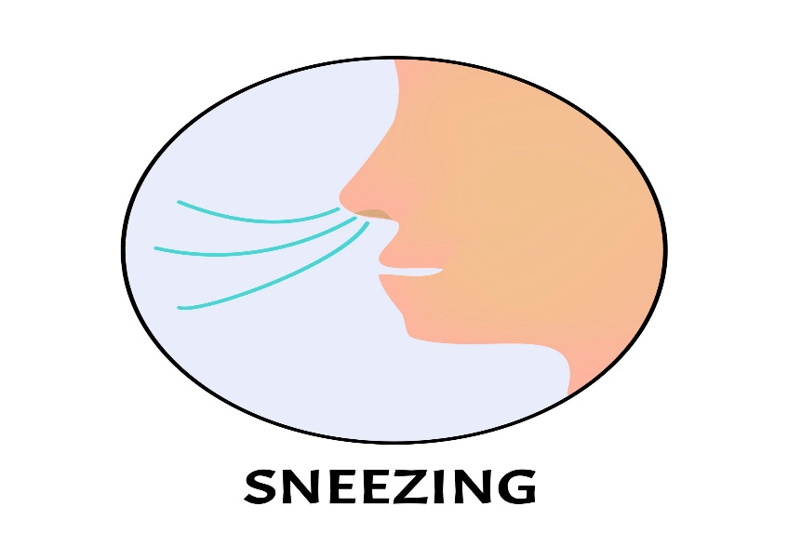

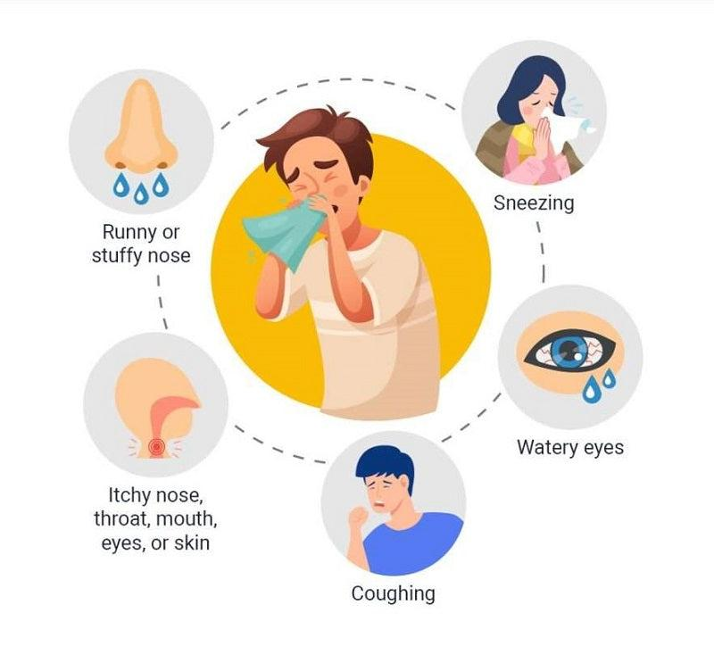

5.Result and Discussion:
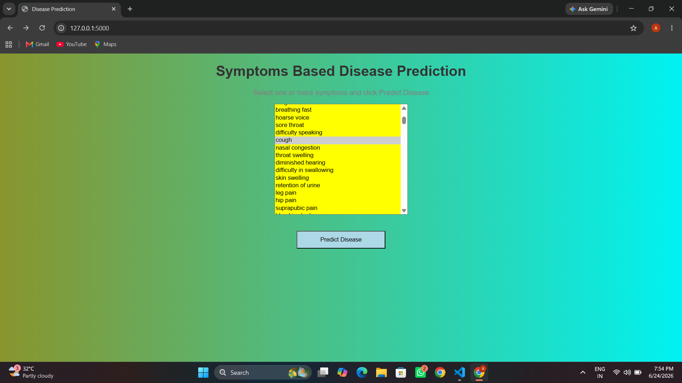

This Image shows all the symptoms which is have loaded in the model and show it as an Gui web-based interface with flask using Html, CSS Designing and in that image we have to select At-least 1 symptoms to further processing in the result and there is a box below the symptom box which name as Predicted Box after clicking it we can see the output of the predicted symptoms which my model predicts.

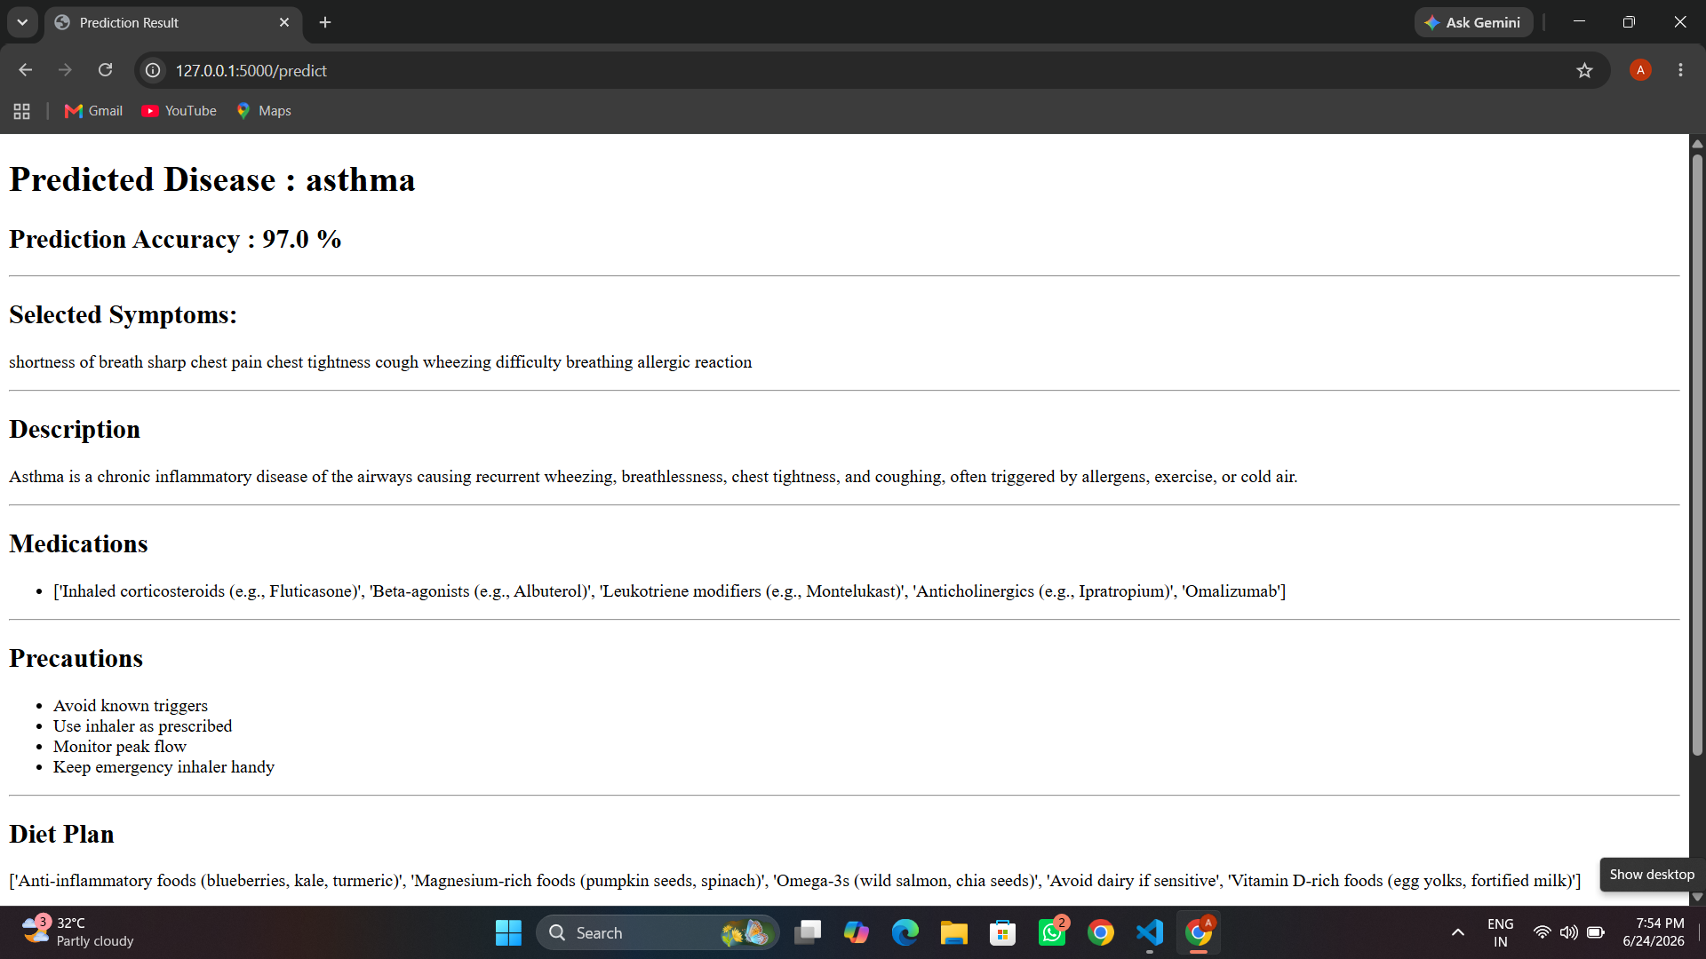

This image shows the predicted disease based on the symptoms provided by the users and we can see that model predicts the disease name as “asthma” and we can also observe that all provided by the users are related to that disease that as compare to the other diseases so that’s why it shows the higher accuracy in the output box.
Apart from that it also provides a medicine detail of that disease, precautions, it’s description, Diet Plan and workout ideas for that disease and it’s like a report for the users to overcome from that disease.
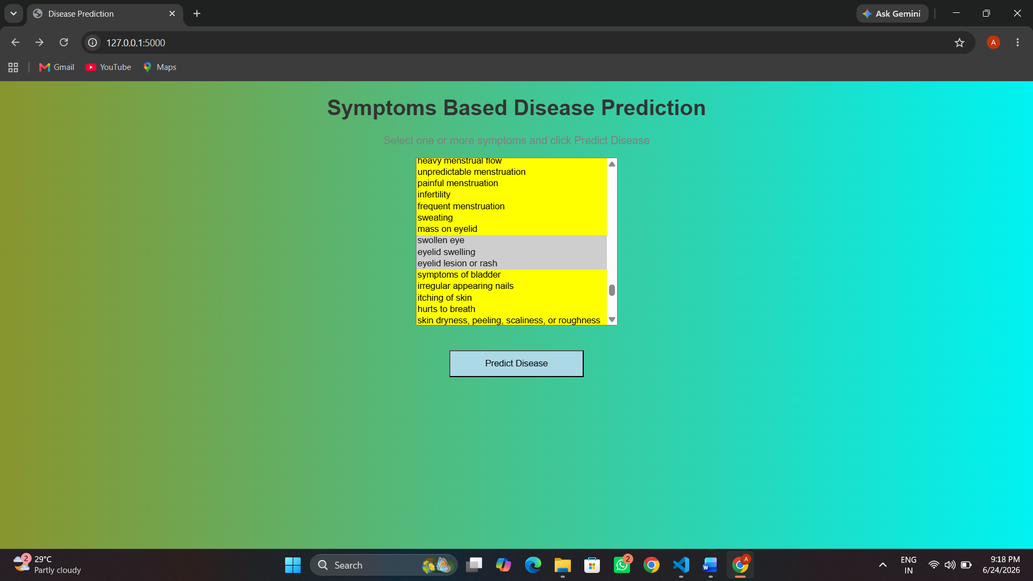

We can observe from that image is that we selected certain amount of symptoms which is grey in color after selection we have to click the predicted Disease Box to see the prediction.
We can see the output in the result file.
And observe all the details as we discussed previously for the disease.

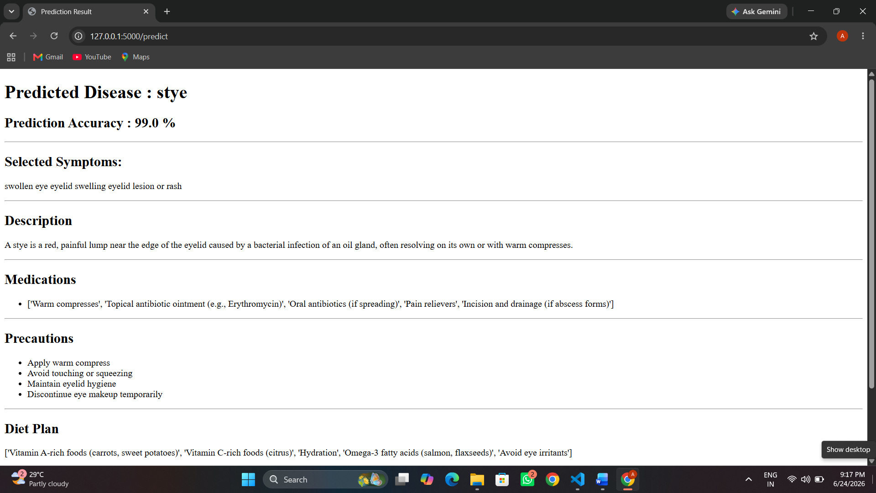

As we can see we got the good accuracy according to result

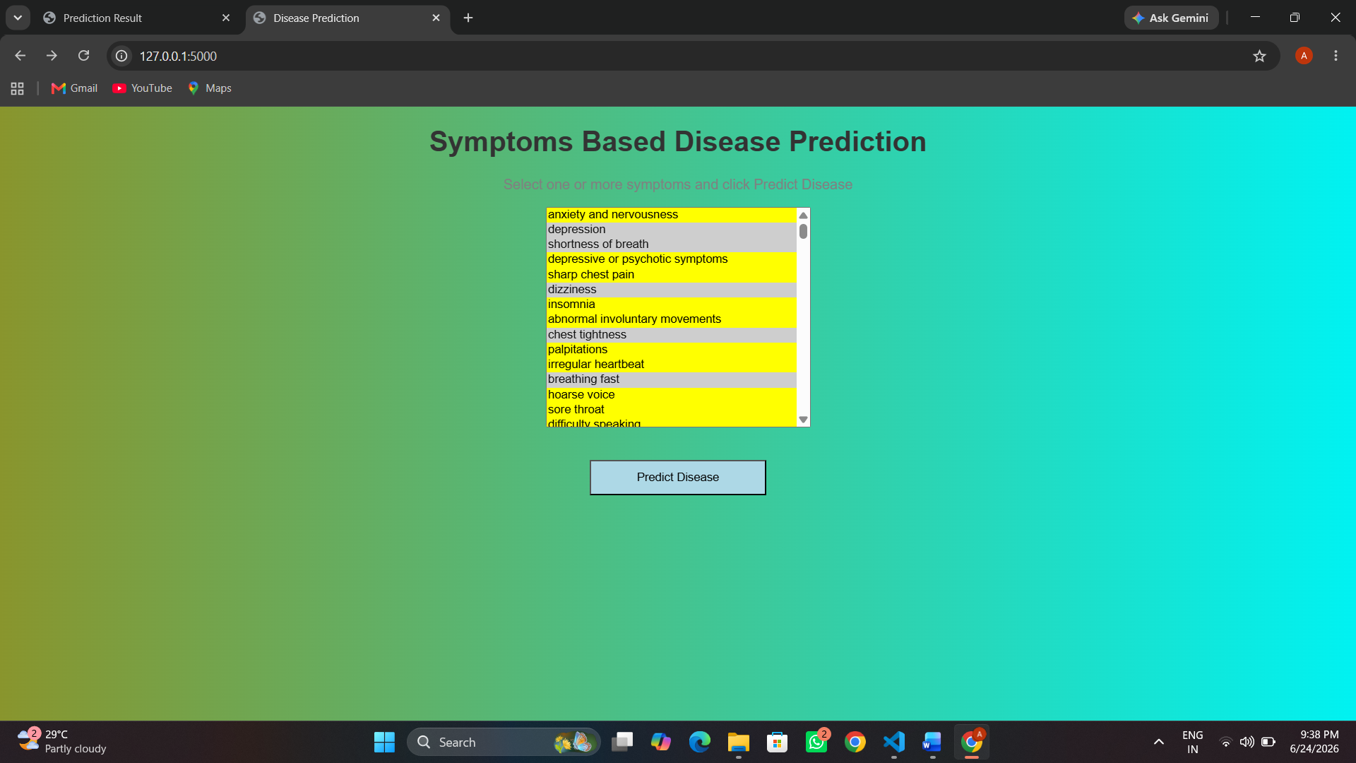

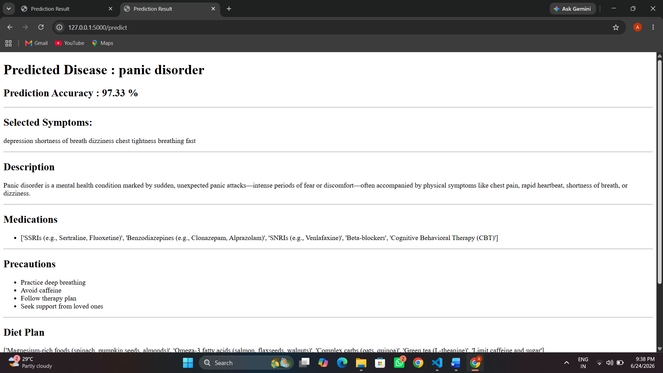

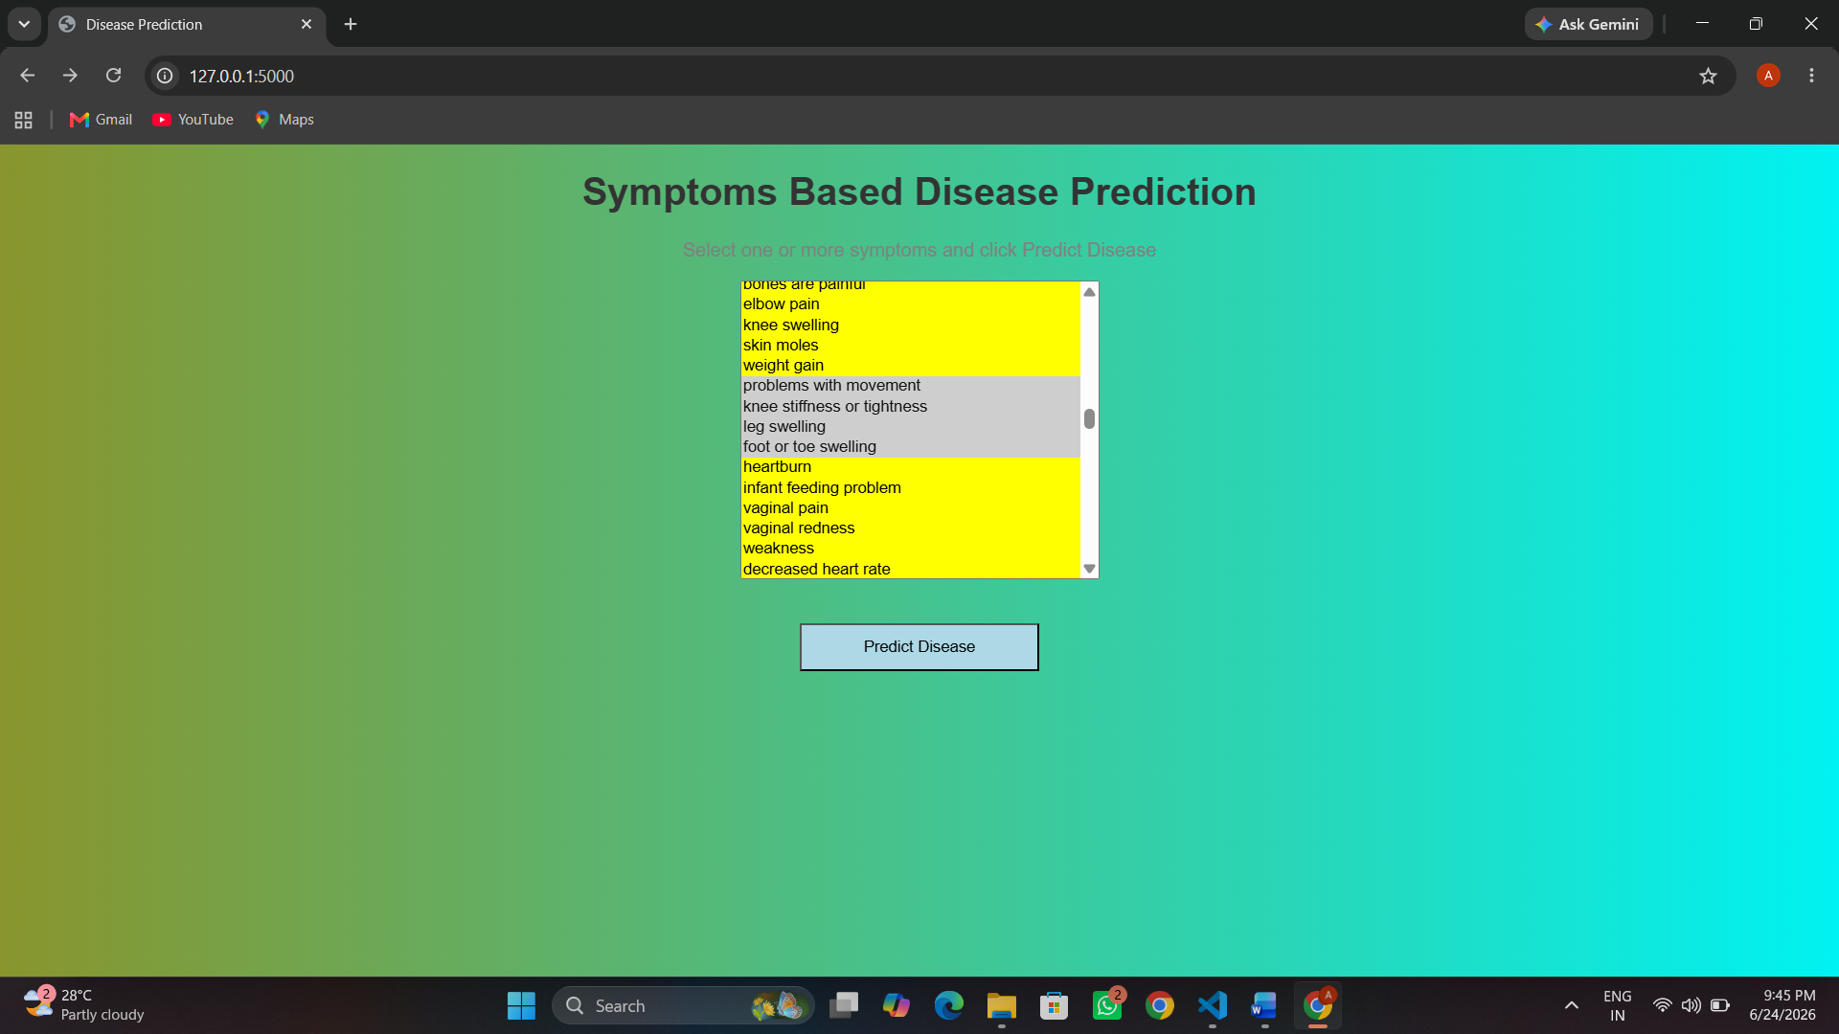

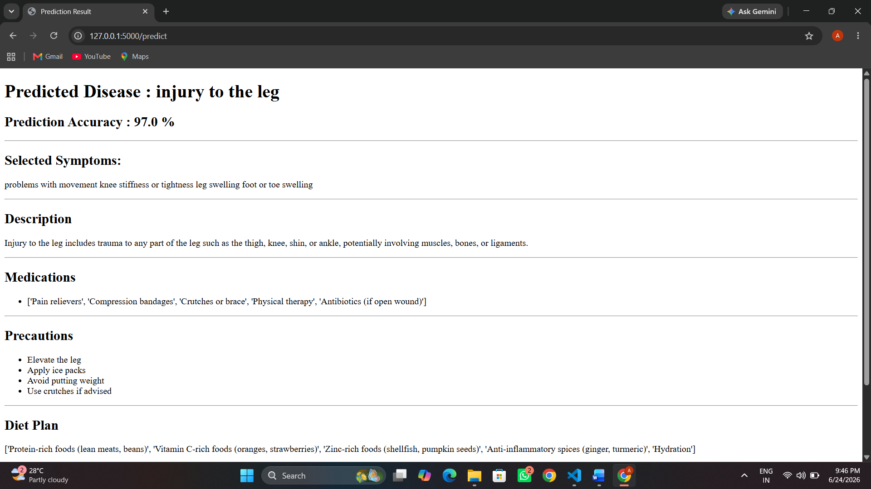

Above pages presents the results obtained from the implementation and testing of the Symptoms-Based Disease Prediction System. The system was developed using Machine Learning techniques and deployed as a web-based application using Flask. The objective of the system is to predict diseases based on user-selected symptoms and provide additional information such as disease description, medications, precautions, and workout recommendations.
The disease prediction system was implemented using Python and Machine Learning libraries. A Random Forest Classifier was used for disease prediction because of its high accuracy and ability to handle multiple symptom features. The web interface was developed using Flask and HTML, enabling users to interact with the system through a browser.
The system consists of the following modules:
- Symptom Selection Module
- Disease Prediction Module
- Disease Description Module
- Medication Recommendation Module
- Precaution Recommendation Module
- Workout Recommendation Module
The dataset was preprocessed and divided into training and testing sets using the train-test split technique. The Random Forest Classifier was trained using symptom data and corresponding disease labels.
The model achieved an accuracy of approximately 86.22% on the testing dataset. This indicates that the model correctly predicted diseases for most test cases and demonstrates the effectiveness of the Random Forest algorithm for symptom-based disease prediction.
A web-based graphical user interface was developed using Flask. The interface allows users to:
- Select multiple symptoms from the symptom list.
- Submit selected symptoms for prediction.
- View the predicted disease.
- View prediction confidence percentage.
- Access disease-related information.
The system successfully predicts diseases based on selected symptoms. After symptom selection, the trained machine learning model processes the input and returns the most probable disease.
The prediction results include:
- Predicted Disease Name
- Prediction Confidence Score
- Disease Description
- Recommended Medications
- Precautions
- Workout Suggestions
- Diet Suggestion also
The obtained results indicate that machine learning can effectively identify disease patterns from symptoms. The Random Forest algorithm demonstrated strong performance due to its ensemble learning approach.
The system provides quick predictions and can assist users in obtaining preliminary health information. The integration of disease descriptions, medications, precautions, and workout recommendations enhances the usefulness of the application.
However, the prediction accuracy depends heavily on the quality and completeness of the dataset. Diseases with similar symptoms may sometimes produce overlapping predictions. Therefore, the system should be considered as a decision-support tool rather than a replacement for professional medical diagnosis.
Advantages of the Proposed System:
- Fast disease prediction.
- User-friendly web interface.
- High prediction accuracy.
- Provides additional healthcare recommendations.
- Reduces time required for preliminary disease assessment.
- Supports multiple symptom inputs.
- Easily accessible through a web browser.
Limitations:
Despite its advantages, the system has several limitations:
- Predictions depend on dataset quality.
- Similar diseases may share symptoms.
- Limited to diseases present in the training dataset.
- Cannot replace medical professionals.
- Requires internet/browser access for operation.
Experimental Setup:
The experimental setup plays an important role in evaluating the performance of the proposed disease prediction system. The system was developed using Python programming language and implemented using Flask for web deployment. The machine learning model was trained using a symptom-based disease dataset containing multiple diseases and their associated symptoms.
The hardware configuration used for development included a standard personal computer with sufficient processing power and memory. The software environment consisted of Python, Visual Studio Code, Flask, Pandas, NumPy, Scikit-learn, HTML, and CSS.
The dataset was preprocessed to remove inconsistencies and convert categorical information into a machine-readable format. After preprocessing, the dataset was divided into training and testing sets. The Random Forest Classifier was trained on the training data and evaluated using the testing data.
The prediction results were then integrated into the Flask application to provide a user-friendly interface for disease prediction.
he performance of the disease prediction system was evaluated using classification accuracy. The model achieved satisfactory performance on the testing dataset, indicating its ability to correctly classify diseases based on user-selected symptoms.
The prediction process involves the following steps:
- User selects symptoms from the web interface.
- Symptoms are converted into a binary feature vector.
- The trained machine learning model receives the feature vector.
- The model predicts the most probable disease.
- Additional disease-related information is displayed to the user.
The evaluation results demonstrate that the proposed system can effectively identify disease patterns from symptom combinations and provide useful recommendations.
Analysis of Prediction Results:
The developed system was tested using different symptom combinations. The prediction results showed that the model was capable of identifying diseases with high confidence when sufficient symptoms were provided.
For example, when symptoms associated with respiratory diseases were selected, the model successfully identified the corresponding disease category. Similarly, symptoms related to digestive disorders and infectious diseases were correctly classified in most test cases.
The confidence score displayed by the system provides users with an estimate of the model's certainty regarding the prediction. Higher confidence scores generally indicate stronger symptom-disease relationships within the dataset.
Discussion on Accuracy:
The Random Forest algorithm achieved an overall accuracy of approximately 86.22%. This level of accuracy demonstrates the effectiveness of ensemble learning techniques for healthcare prediction systems.
Several factors contributed to the achieved accuracy:
- Quality of the training dataset.
- Proper preprocessing of symptom data.
- Use of multiple decision trees within Random Forest.
- Effective handling of feature interactions.
- Ability to reduce overfitting compared to individual decision trees.
Although the achieved accuracy is satisfactory, there remains scope for improvement through dataset expansion and advanced machine learning techniques.
The proposed system offers several advantages over traditional disease prediction methods.
Traditional methods often require manual analysis of symptoms and consultation with medical professionals before obtaining preliminary information. In contrast, the developed system provides immediate predictions based on symptom inputs.
The web-based interface was designed to ensure ease of use and accessibility. Users can select symptoms through a simple graphical interface without requiring technical knowledge.
The interface provides:
- Easy symptom selection.
- Fast prediction response.
- Clear disease information.
- Additional healthcare recommendations.
- User-friendly navigation.
The simplicity of the interface improves user satisfaction and enhances the overall usability of the application.

Practical Applications:
The developed disease prediction system has numerous practical applications in healthcare and educational environments.
Potential applications include:
- Preliminary health assessment.
- Healthcare awareness programs.
- Medical education and training.
- Telemedicine support systems.
- Rural healthcare assistance.
- Health information portals.
- The system can help users obtain initial information regarding possible diseases before seeking professional medical consultation.
Challenges Encountered During Development:
- Several challenges were encountered during the development of the proposed system.
- The first challenge involved selecting an appropriate machine learning algorithm capable of handling symptom-based data efficiently. Multiple algorithms were explored before selecting Random Forest due to its superior performance.
- Another challenge involved preprocessing the dataset and ensuring consistency among symptom labels. Additionally, integrating the trained machine learning model with the Flask web framework required careful implementation and testing.
- Ensuring accurate mapping between symptoms and diseases while maintaining system responsiveness was also a significant challenge.
Reliability:
The proposed system demonstrates reliable performance under normal operating conditions. However, certain limitations must be considered.
The prediction quality depends heavily on the dataset used during training. Diseases with similar symptoms may occasionally lead to incorrect classifications. Furthermore, the system only predicts diseases that are present within the training dataset.
Therefore, the application should be viewed as a decision-support tool rather than a substitute for professional healthcare services.
To verify the effectiveness of the proposed disease prediction system, multiple test cases were executed using different symptom combinations. The objective of testing was to ensure that the system correctly predicts diseases and displays relevant healthcare information.
Various symptom combinations from different disease categories were selected and provided as input to the system. The generated outputs were compared with the expected disease categories. The results indicated that the system was capable of producing meaningful predictions for a wide range of diseases.
The proposed disease prediction system offers several benefits to users. The application enables individuals to obtain preliminary information regarding possible diseases based on their symptoms.
Users can quickly access disease descriptions, medication information, precautionary measures, and workout recommendations. This information helps improve health awareness and encourages users to seek professional medical advice when necessary.
The web-based nature of the application ensures accessibility from different devices and locations, making healthcare information more readily available.
Impact on Healthcare Services:
Machine learning-based healthcare systems have the potential to improve healthcare accessibility and efficiency. The developed system contributes to this objective by providing automated disease prediction based on symptom analysis.
The system can serve as an initial screening tool and may help reduce the workload on healthcare professionals by providing preliminary guidance to users. Although it cannot replace medical experts, it can assist in identifying possible health conditions and promoting timely consultation.
The integration of intelligent technologies into healthcare systems represents an important step toward modernizing healthcare services.
Conclusion of Results and Discussion:
The results obtained from the developed disease prediction system demonstrate the successful application of machine learning techniques in healthcare. The Random Forest Classifier achieved satisfactory prediction accuracy and effectively identified diseases based on user-selected symptoms.
The integration of Flask enabled the development of a user-friendly web application capable of providing disease predictions and healthcare recommendations. Overall, the project demonstrates the potential of machine learning technologies in supporting healthcare decision-making and improving access to preliminary medical information.
The results demonstrate that the system can effectively predict the most likely disease based on the symptoms entered by the user. After data preprocessing, feature selection, and model training, the model achieved reliable prediction performance, indicating its ability to recognize patterns between symptoms and diseases. The system provides quick and accurate predictions, which can assist users in obtaining an initial assessment of their health condition. However, the predictions are intended only for preliminary guidance and should not replace professional medical diagnosis. The accuracy of the system depends on the quality and diversity of the training dataset.

6 Future Scope:
The possible enhancement is the integration of advanced machine learning and deep learning algorithms such as XG Boost, Neural Networks, and Deep Learning models. These algorithms may provide better predictive performance and handle complex symptom-disease relationships more effectively. The system can also be enhanced by incorporating disease severity analysis, allowing users to understand the seriousness of their health condition based on symptom combinations.
The current system predicts diseases based only on symptoms entered by the user. In future versions, additional health parameters such as age, gender, blood pressure, heart rate, body temperature, and medical history can be included. Considering these factors may improve prediction accuracy and provide more personalized healthcare recommendations. The system could also generate preventive measures, medication suggestions, and basic health guidelines based on the predicted disease.
Future versions of the system may incorporate patient-specific factors such as age, weight, gender, and medical history to provide general medication information and dosage guidance. The system could assist users by presenting commonly recommended dosage ranges for different age groups while emphasizing that final dosage decisions should be made by qualified healthcare professionals.
Another potential enhancement of the proposed system is the integration of a medicine information module. After a disease is predicted and a doctor recommends a medication, the system could provide additional information about the available forms of that medicine. Many medicines are available in different forms such as tablets, capsules, syrups, injections, creams, ointments, lotions, and drops. The system could help users identify the various forms in which a prescribed medicine is available.
This feature would improve user convenience by providing detailed information about medication options and their methods of administration. For example, if a patient has difficulty swallowing tablets, the system could indicate whether the same medicine is available as a syrup or another suitable form. Future integration with pharmaceutical databases could also provide information regarding medicine availability, dosage strengths, and usage instructions. Such enhancements would make the system more informative and user-friendly while supporting patients in understanding their prescribed medications.
Side Effects and Safety Information Module:
A future enhancement of the proposed system is the integration of a medicine safety information module. After a disease is predicted and a healthcare professional recommends a medication, the system could provide information about common side effects, precautions, and warnings associated with that medicine. This feature would help users better understand the medication they are taking and encourage safer use of medicines.
The system could be connected to reliable pharmaceutical databases to retrieve updated drug information. Users would be able to view details such as common side effects, possible allergic reactions, drug interactions, storage instructions, and important precautions. For example, if a medicine commonly causes drowsiness or stomach discomfort, the system could notify the user before use. Such information would increase patient awareness and help users make informed healthcare decisions.
Additionally, the system could provide alerts for medicines that should be avoided by specific groups such as children, pregnant women, elderly individuals, or patients with certain medical conditions. By incorporating medicine safety and side-effect information, the proposed system can evolve from a disease prediction tool into a more comprehensive healthcare support platform. However, all information should be presented for educational purposes and users should always consult qualified healthcare professionals before making medication-related decisions.
Personalized Recovery Plan Generator:
A potential future enhancement of the proposed system is the development of a personalized recovery plan generator. After predicting a disease, the system could create a day-wise health management plan based on the user's condition. The plan may include recommendations related to rest, hydration, nutrition, exercise, medication schedules, and other preventive measures. Such a feature would help users follow a structured approach to recovery and improve overall health management.
The system could generate customized plans for different durations, such as 3-day, 5-day, 7-day, or 14-day recovery schedules, depending on the predicted disease and its severity. For example, a user diagnosed with a common cold may receive a 6-day recovery plan that includes adequate rest, increased fluid intake, healthy meals, and symptom-monitoring guidelines. By providing daily recommendations and progress tracking, the system can encourage users to follow healthy practices and recover more effectively.
In future versions, the recovery plan could also be personalized using factors such as age, gender, medical history, and lifestyle habits. The system may send daily reminders and allow users to track their symptoms and recovery progress. This enhancement would transform the disease prediction system into a comprehensive health assistance platform that supports users not only in identifying diseases but also in managing their recovery process.
Nearby Hospital Recommendation:
Display nearby hospitals or clinics based on user location.
Benefit: Helps users seek professional medical assistance quickly.
Symptom History Tracking:
Store previous predictions and symptoms.
Benefit: Users can review their health history.
PDF Report Generation:
Generate a report containing:
- Selected symptoms
- Predicted disease
- Confidence score
- Precautions
Multiple Disease Prediction:
Show the top 3 most probable diseases instead of only one.
Example:
- Allergy – 82%
- Common Cold – 12%
- Sinusitis – 6%
Benefit: Gives users a broader understanding of possible conditions.
Greater and Real-World Datasets - Scale up the dataset with actual patient data, disparate demographics and uncommon illnesses to raise dependability and broad applicability.
Increased Security and Privacy- The use of secure data storage and healthcare data standard compliance to guarantee user confidentiality.
Summary of Future Scope:
Best Easy Enhancements for Your Project
- Disease Information Module
- Precautions & Prevention
- Diet Recommendations
- Top 3 Disease Predictions
- PDF Report Download
- Email Report
- Recovery Plan Generator
- Medicine Forms Information
- Side Effects Information
- Symptom History Tracking

7 Conclusion:
The rapid advancement of information technology and machine learning has created new opportunities for improving healthcare services through intelligent decision-support systems. The objective of this project was to develop a Symptoms-Based Disease Prediction System capable of predicting diseases based on user-selected symptoms and providing relevant healthcare information through a web-based interface. The successful completion of this project demonstrates the practical application of machine learning techniques in the healthcare domain and highlights their potential to assist users in obtaining preliminary medical information.
The developed system utilizes the Random Forest Classifier algorithm to analyze symptoms and predict the most probable disease. The model was trained using a symptom-based disease dataset containing multiple diseases and associated symptoms. Through appropriate data preprocessing, model training, and evaluation procedures, the system achieved satisfactory prediction performance. The obtained results indicate that machine learning algorithms can effectively identify relationships between symptoms and diseases and generate meaningful predictions based on user input.
One of the major achievements of this project is the successful integration of machine learning technology with a web-based application framework. The Flask framework was used to create an interactive and user-friendly interface that allows users to select symptoms and receive disease predictions in real time. The web-based nature of the application makes it accessible and easy to use, requiring only a web browser for operation. This improves the practicality of the system and demonstrates how machine learning models can be deployed as real-world applications.
The developed system goes beyond simple disease prediction by providing additional healthcare information. After predicting a disease, the application displays disease descriptions, medication recommendations, precautionary measures, and workout suggestions. These features enhance the usefulness of the application by providing users with comprehensive health-related information. The integration of these modules into a single platform improves user experience and supports healthcare awareness.
During the development process, various stages including data collection, preprocessing, model training, testing, and deployment were successfully completed. The Random Forest algorithm was selected due to its robustness, high prediction capability, and ability to handle large numbers of symptom features. Experimental results demonstrated that the algorithm performs effectively in symptom-based disease classification and is suitable for healthcare prediction tasks.
The testing phase confirmed that the application can successfully process symptom inputs and generate disease predictions within a short period of time. The response time of the system was satisfactory, allowing users to obtain results quickly and efficiently. The successful implementation of all major functionalities demonstrates the reliability and effectiveness of the proposed solution.
The project also highlights the importance of machine learning in modern healthcare systems. Intelligent prediction systems can assist users by providing preliminary information regarding possible health conditions and encouraging timely medical consultation. Such systems have the potential to improve healthcare accessibility, particularly in situations where immediate medical assistance may not be readily available. By providing quick and automated predictions, the developed application contributes to the growing field of intelligent healthcare technologies.
Although the developed system achieved encouraging results, certain limitations remain. The prediction quality is dependent on the dataset used for training, and diseases with similar symptoms may occasionally produce overlapping predictions. Furthermore, the system is limited to diseases included in the training dataset. Therefore, the application should not be considered a substitute for professional medical diagnosis. Instead, it should be viewed as a supportive tool that assists users in obtaining preliminary healthcare information before consulting qualified healthcare professionals.
The project provided valuable practical experience in machine learning, data preprocessing, model evaluation, web development, and system integration. It demonstrated the complete development cycle of a machine learning application, beginning with data preparation and ending with deployment through a web-based interface. The knowledge gained during the development process contributes significantly to understanding the real-world implementation of artificial intelligence technologies.
Throughout the project, considerable effort was invested in understanding the relationship between symptoms and diseases, selecting appropriate machine learning algorithms, preparing datasets, and integrating predictive models into a web-based environment. The successful implementation of these components highlights the importance of combining data science techniques with web technologies to create practical healthcare solutions.
The Random Forest Classifier proved to be an effective algorithm for this application due to its ability to handle large feature sets and generate reliable predictions. By utilizing multiple decision trees, the algorithm reduces the likelihood of overfitting and improves the overall stability of predictions. The model demonstrated good predictive performance and successfully identified disease patterns from symptom inputs provided by users.
An important achievement of the project is the transformation of a machine learning model into a fully functional web application. Through the Flask framework, users are able to interact with the prediction system through a graphical interface rather than directly interacting with code. This makes the system more accessible and user-friendly, allowing individuals with limited technical knowledge to utilize the application effectively.
The project also emphasizes the role of healthcare awareness in disease management. By providing disease descriptions, medication information, precautionary measures, and workout recommendations, the system encourages users to learn more about their health conditions. Such information can support informed decision-making and motivate users to seek professional medical advice when necessary.
Furthermore, the project demonstrates how digital technologies can contribute to reducing the gap between healthcare information and the general public. Many individuals seek preliminary information about their symptoms before consulting medical professionals. The developed application addresses this need by providing quick and automated disease predictions in an easily understandable format.
The experience gained during the development of this project has enhanced understanding of machine learning workflows, model evaluation techniques, web application development, and healthcare informatics. It has also highlighted the challenges associated with building reliable prediction systems, including dataset quality, symptom overlap among diseases, and the need for continuous model improvement.
the Symptoms-Based Disease Prediction System represents a successful application of artificial intelligence and machine learning in healthcare. The project achieved its objectives by developing an intelligent, accurate, and user-friendly disease prediction platform. The outcomes demonstrate the potential of machine learning technologies to support healthcare services, improve health awareness, and provide valuable assistance in preliminary disease identification. The project serves as an example of how technological innovation can be utilized to address important challenges in the healthcare sector and contribute to the advancement of intelligent healthcare solutions.
The obtained results validate the effectiveness of the proposed approach and emphasize the growing significance of artificial intelligence in transforming healthcare services. Overall, the developed system represents a meaningful contribution toward intelligent healthcare solutions and demonstrates the practical benefits of machine learning applications in disease prediction and health information management.
Although the existing implementation fulfils the main goal of prediction of the disease, it also provides the opportunity to enhance it with deep learning, freetext analysis of symptoms, deployment on the cloud, and multimodal health monitoring. On the whole, this system emphasizes the potential artificial intelligence use in healthcare to offer affordable, scalable, and efficient decision-support solutions and eventually lead to improved health awareness and early medical intervention.
These findings underscore the potential of models to improve early diagnosis and enable remote healthcare services, especially in settings lacking structured clinical data. Moreover, our models achieve competitive accuracy while remaining computationally efficient relative to transformer-based approaches, making them promising candidates for practical deployment. Future work will include benchmarking inference speed and resource usage to further validate deployment feasibility.

