1. On a table with details of each treatment record, we group by uin and disease ID to get count of each insurance plan claim count for each disease. Then using that main CTE we create a CTE showing insurance plan and max count of claim for a specific disease. Third CTE will give us for a said company ID all plans, their claim count and disease(s) they have most claims.

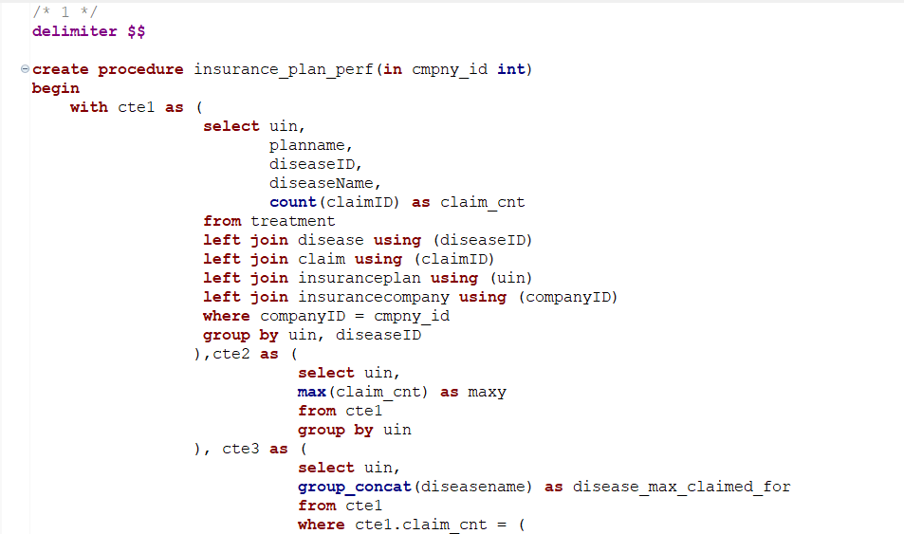

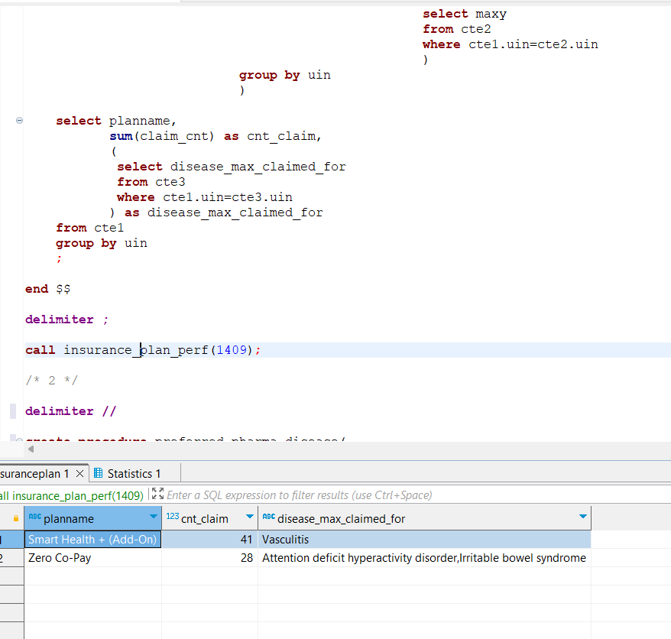

FETCH TIME = 23ms

1. Having 2 CTEs one that calculates for a said disease name, top 3 insurance plan and their count. And the other shows the same for year 2022.

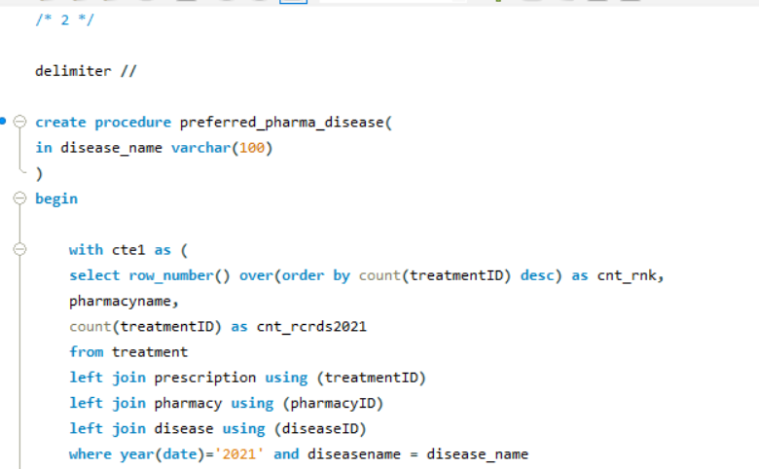

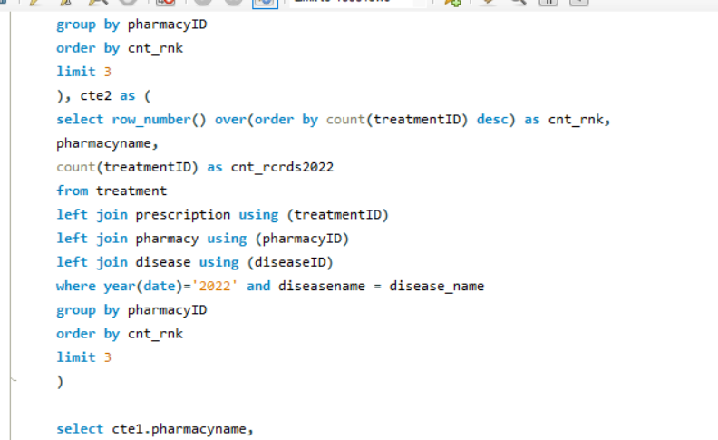

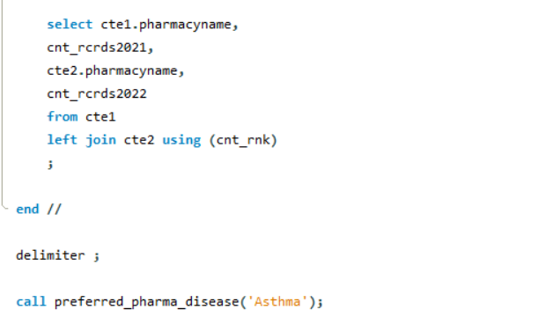

FETCH TIME=16ms

1. Simply grouping by state and calculating desired ratio

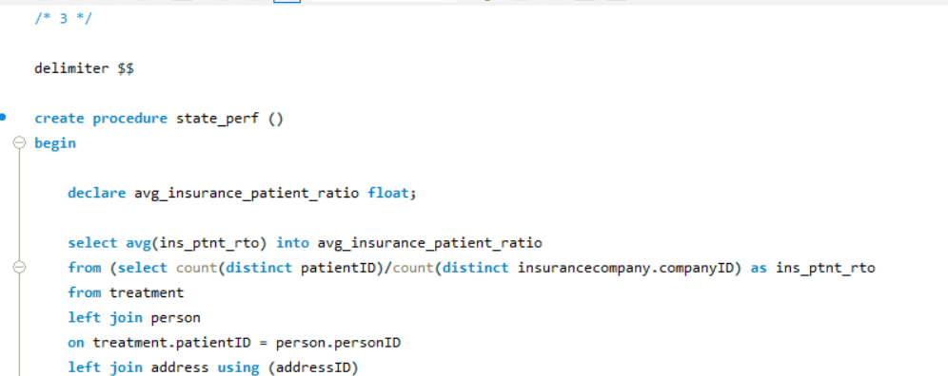

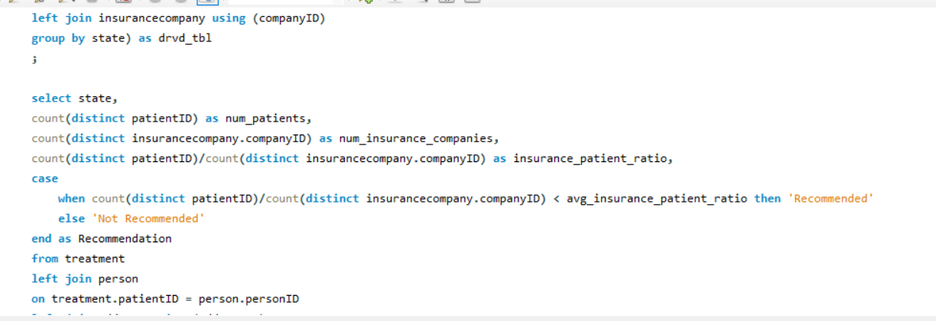

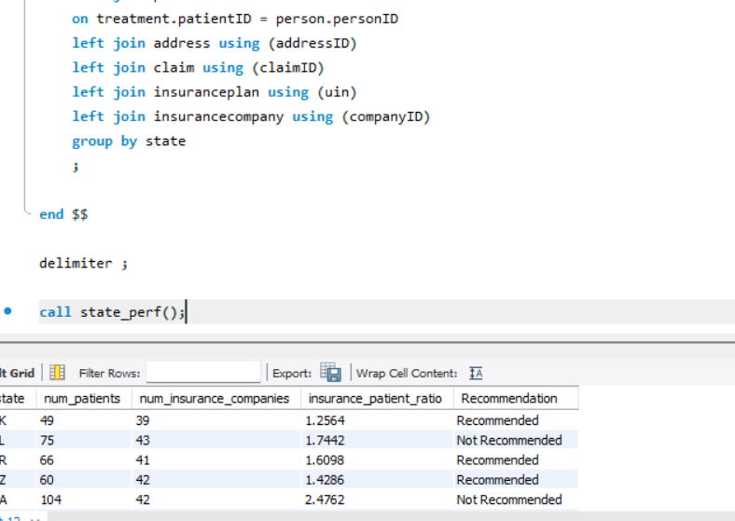

FETCH TIME = 344ms

1. 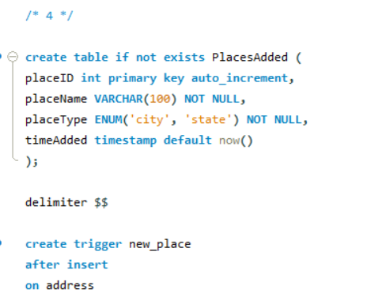

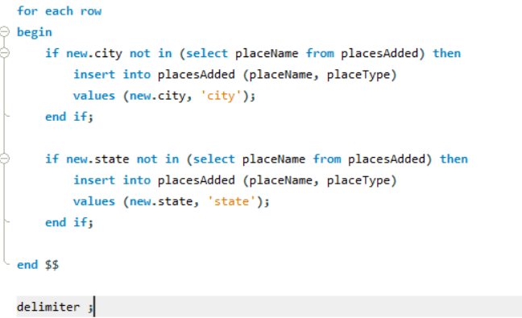

1. 