// IMPORTING THE DATA //

- Creating heathcare database

- Importing the data into database by initially dropping constraints and running respective .sql file for each table.

{ SQL Command line is used to import the data using the "source" keyword }

- Individually assessing the tables to set up constraints like primary key and foreign keys.

- While setting up Primary key Constraint for the Keep table we find duplicated values on columns need to be set as primary keys, so we decide not to setup primary key constraints on those columns and include all columns to make a primary key.

// PROBLEM SOLVING //

Sheet - 1

1. Creating a table using switch case to determine age group of each treatment record and then grouping by to show the count.  
     
   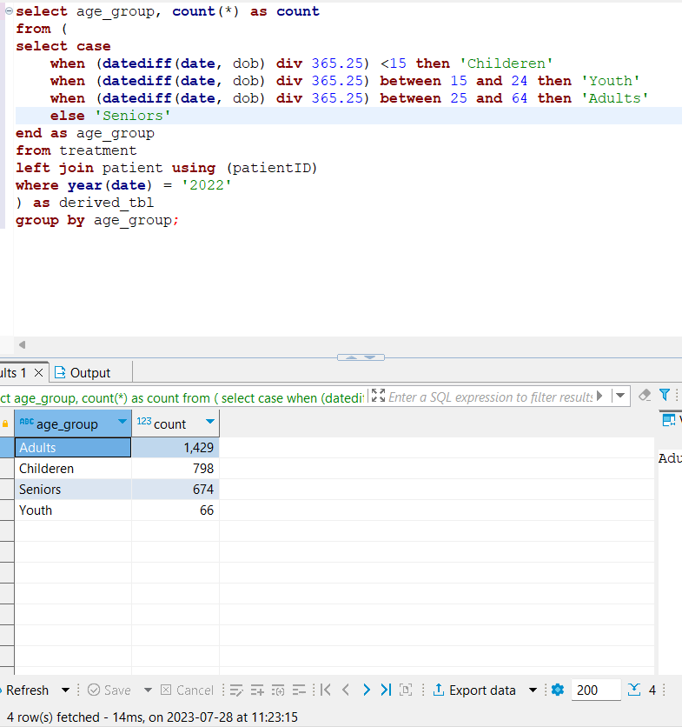

FETCH TIME – 14ms

EXPLAIN

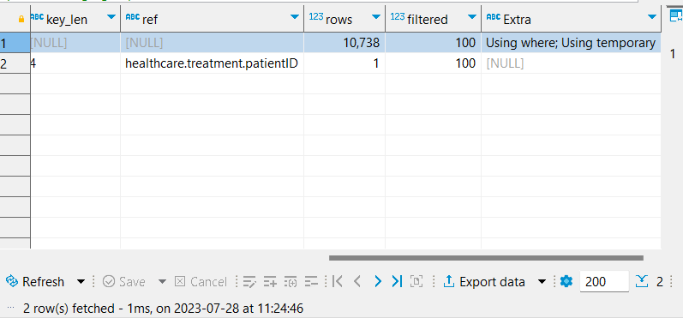

1. Using CTEs we create one main table joining treatment, disease and person. 2 CTEs based on the main one gives us count of male and female for each disease. And then combining them in our query statement.

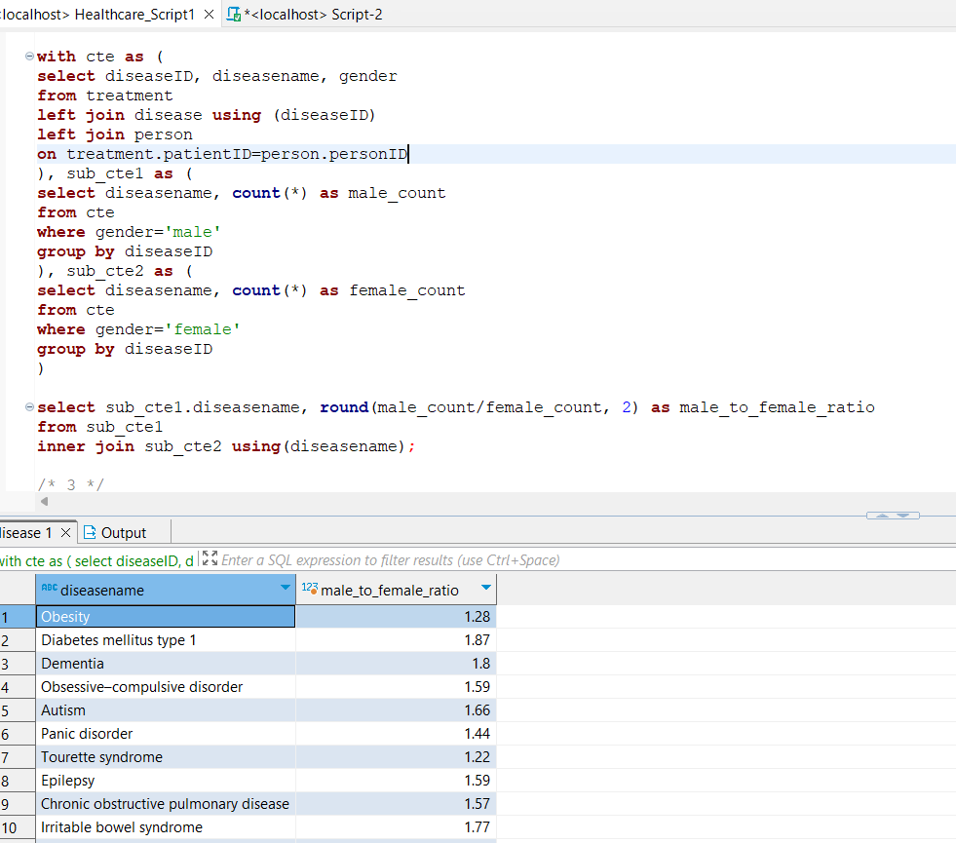

FETCH TIME = 80ms

EXPLAIN

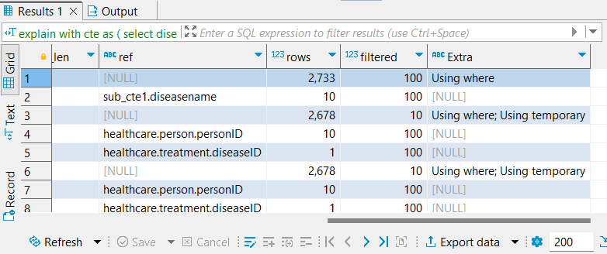

1. Joining person on treatment, grouping by gender and counting # of treatment, claims and treatment to claim ratio.

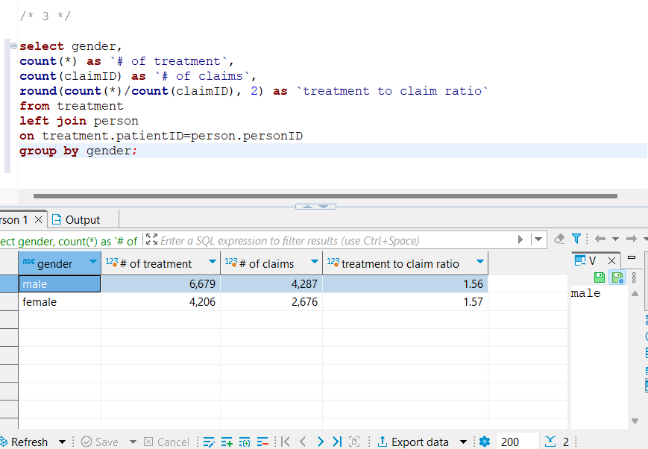

FETCH TIME=35ms

EXPLAIN

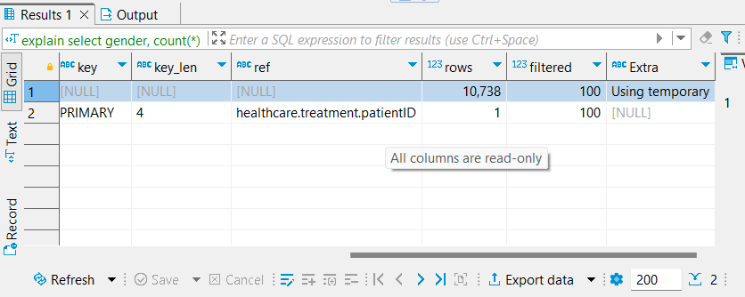

1. Interpreation-1  
     
   Joining medicine and pharmacy to keep, grouping by pharmacyID and medicineID and calculating sum.

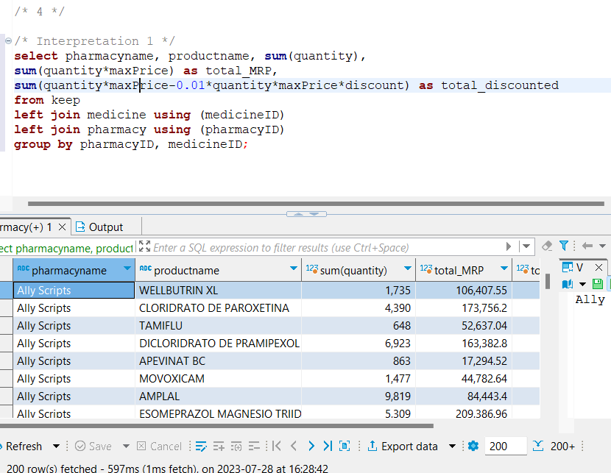

FETCH TIME=597ms

EXPLAIN

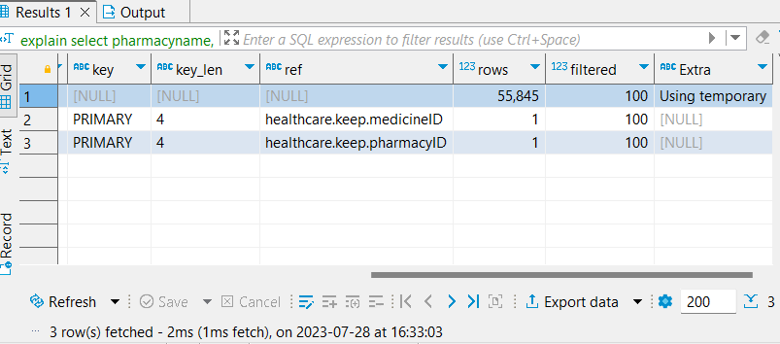

Interpretation 2

Joining medicine and pharmacy to keep, grouping by pharmacyID and calculating sum.

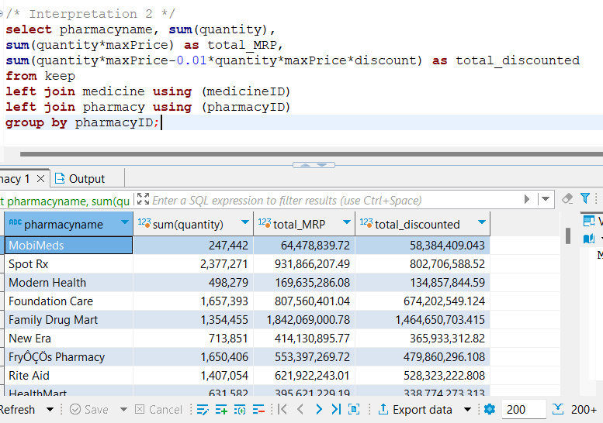

FETCH TIME=382ms

EXPLAIN

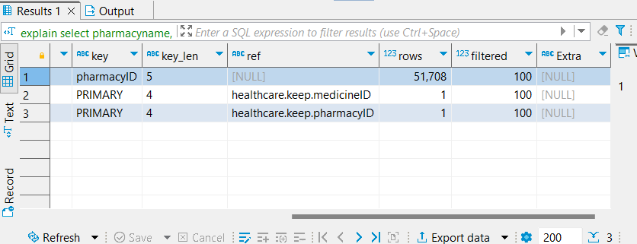

1. Join contain on prescription to get details of each medicine in a prescription and quantity. Then find for each unique pharmacy and prescription how many total medicines were prescribed. After that use that table to find the max, min and avg. # of medicines prescribed.

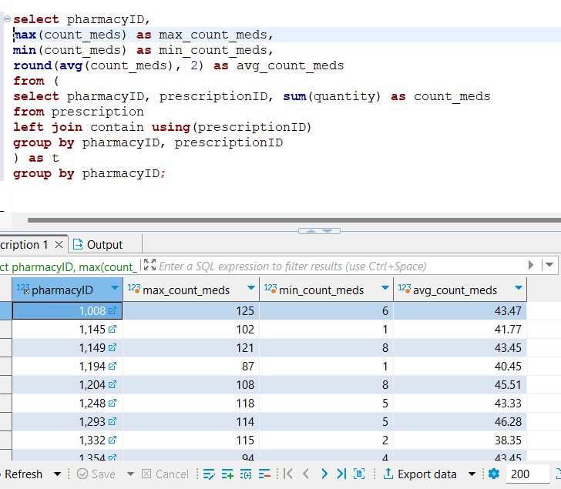

FETCH TIME=139ms

EXPLAIN

