1. Joined address and prescription to pharmacy, grouped by city having more than 100 prescriptions and then displaying top 3 cities with lowest pharmacy count to prescription count.

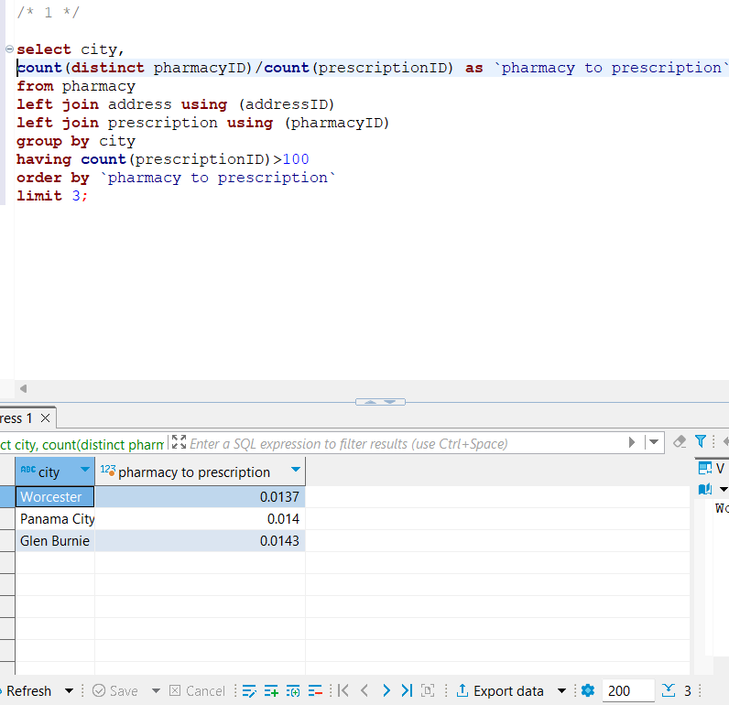

FETCH TIME=31ms

EXPLAIN

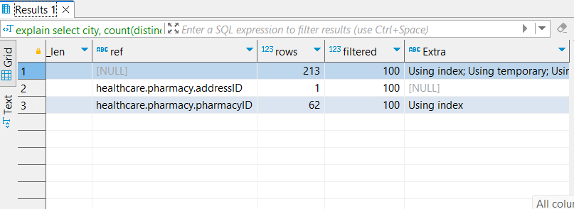

1. METHOD -1  
     
   Joining person and address with treatment, filtering by state ‘AL’ grouping by city and diseaseName.  
   Doing a group concat where the patient count is maximum

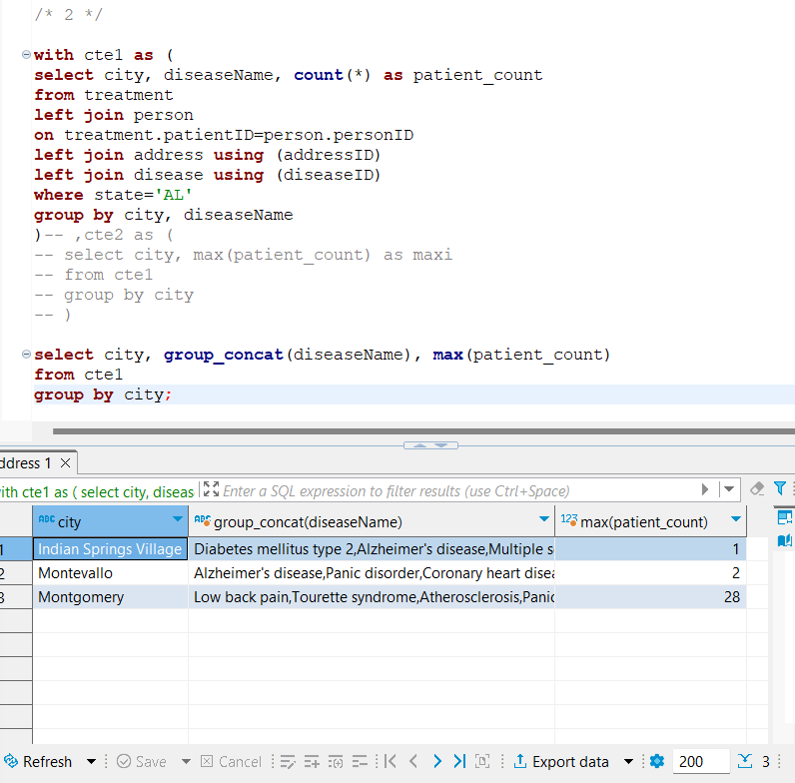

FETCH TIME=24ms

EXPLAIN

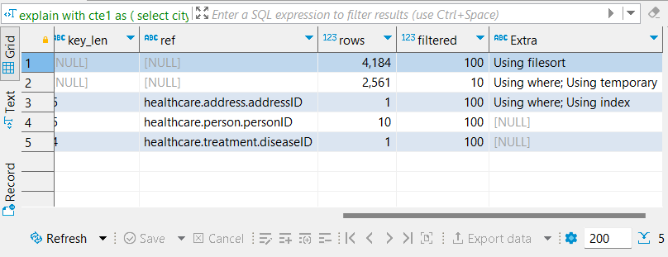

METHOD-2

Creating 2 CTEs, one containing city, disease and it’s count. The other CTE using the previous one to give us city and max patient count.

Writing a query to find records in cte1 which have same city and same count as max.

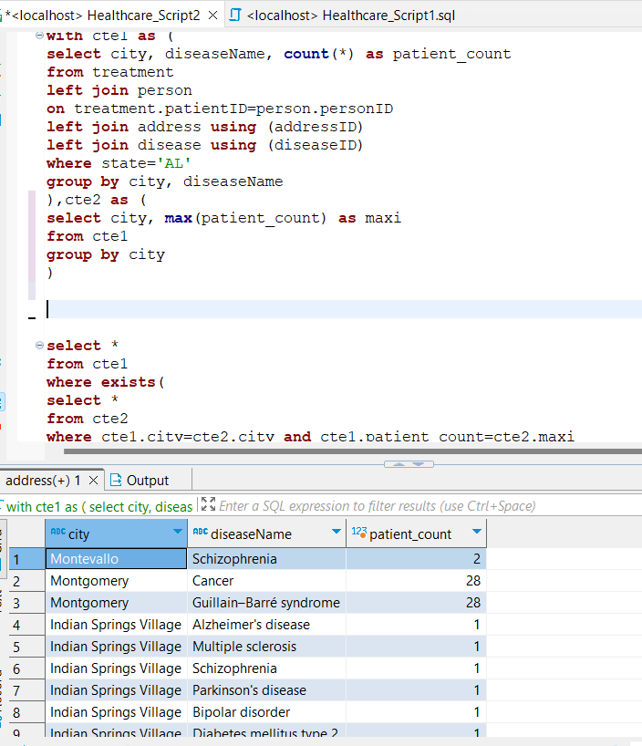

FETCH TIME=17ms

EXPLAIN

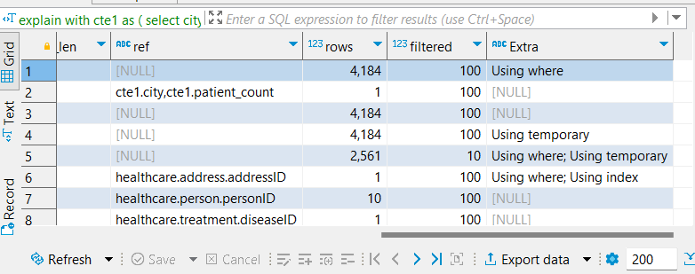

1. Constructing cte1 to count the number of occurrences of each plan for each disease. Using the results from cte1 we generate cte2 that tells us count of maximum occurring plan(s) for a disease.  
     
   Finally querying results from cte1 where for a said disease count of a plan matches maximum count.

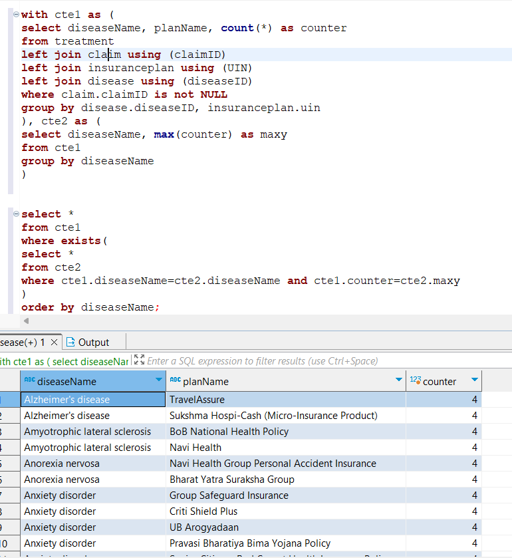

FETCH TIME=163ms

EXPLAIN

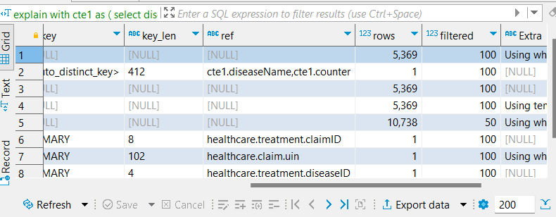

1. Creates a main table containing for each disease the number of patients in each address and filtering addresses whose who have more than 2 patient count. Then feeding this table to find count of these addresses for each disease.

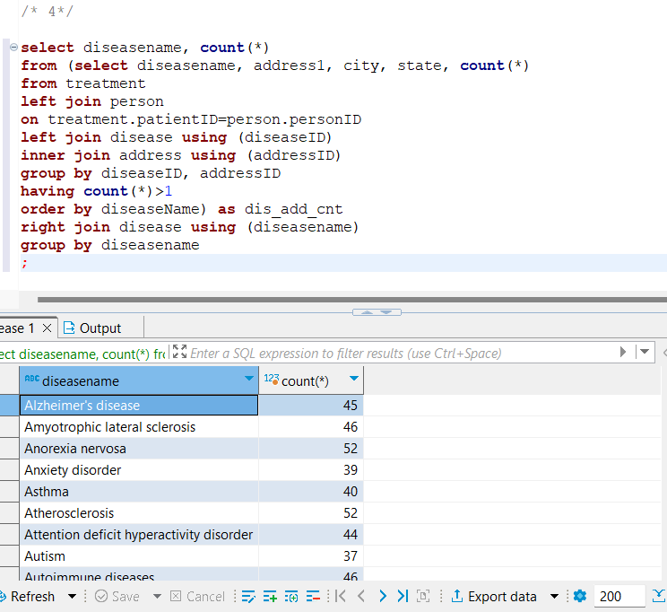

FETCH TIME=139ms

EXPLAIN

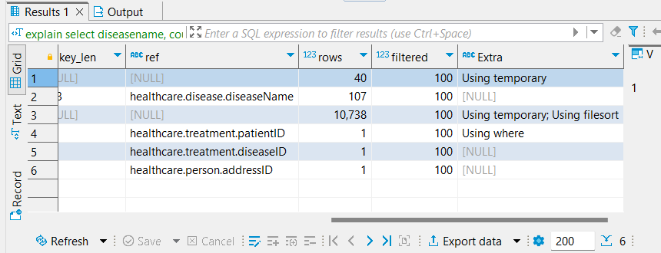

1. Having a table containing all treatments, its patient’s address. Filtering date, then showing treatment to count ratio for each state in descending order.

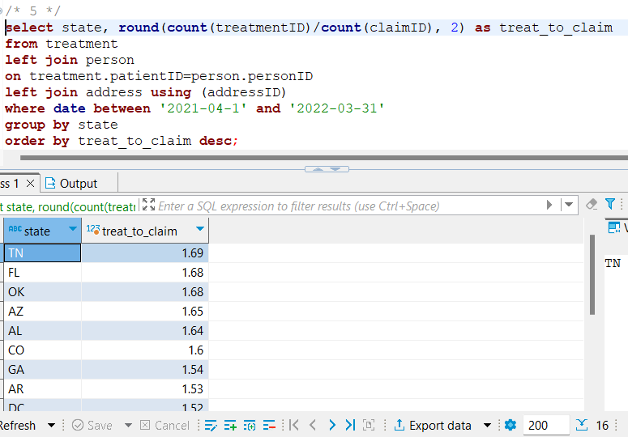

FETCH TIME=37ms

EXPLAIN

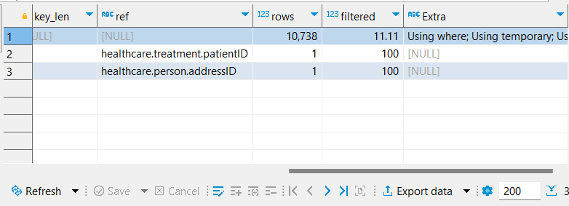

Additional:  
  
Query performance could be better if we put an index on **treatment.date**, but as of now creation of this index looks not that important because filtering based on date hasn’t been done frequent enough.

