1. Create a table containing records of all medicine and pharmacy detail for a said prescription, filter date between 2021, 2022 and medicines that are only hospital exclusive. Print out the count in descending order for each pharmacy, how many records are there where they have prescribed a hospital exclusive medicine.

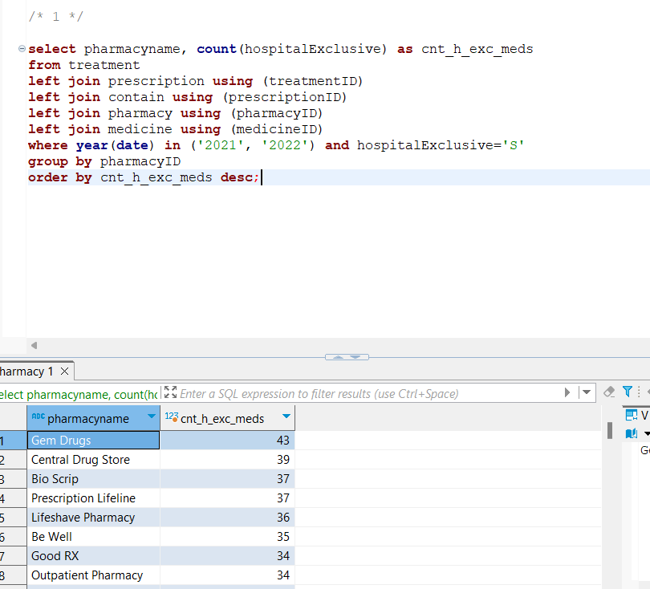

FETCH TIME=162ms

EXPLAIN

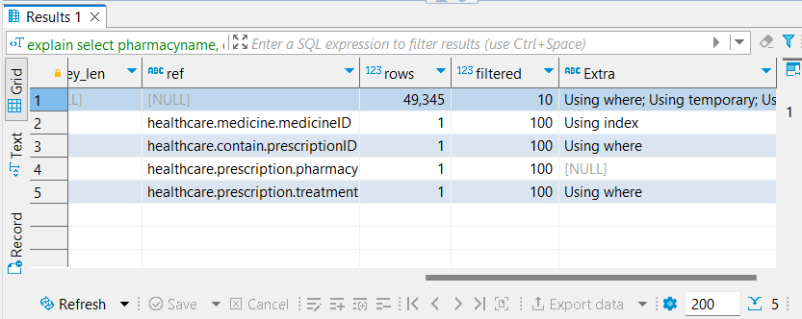

2. Creating a table having details about each claim, its insurance plan and the insurance company. Printing count in descending order of how many times an particular insurance plan has been claimed.

Approach - 1

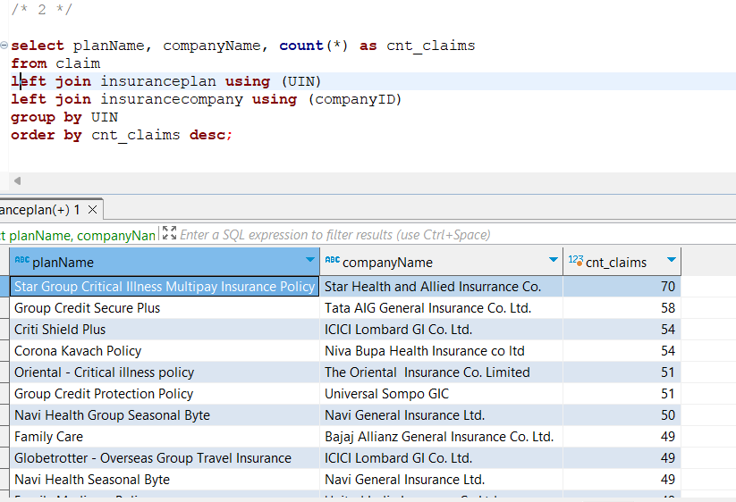

FETCH TIME=21ms

EXPLAIN

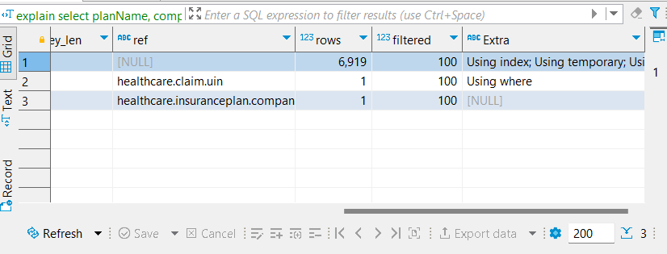

Approach – 2

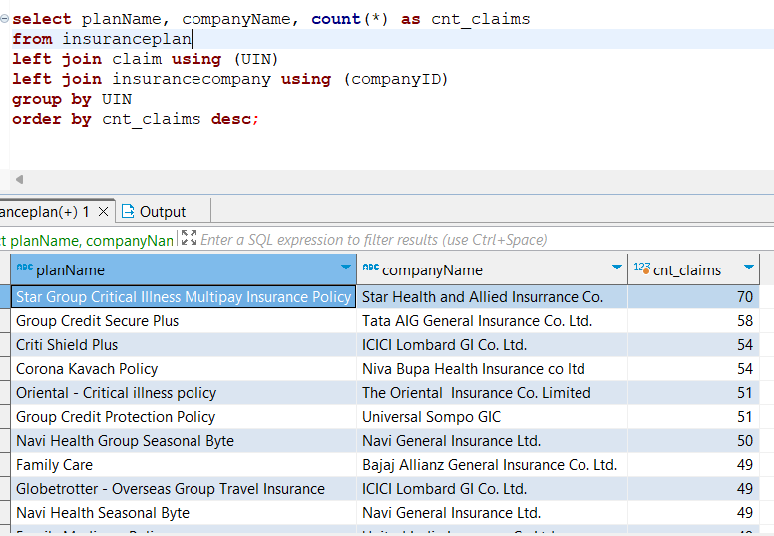

FETCH TIME=16ms

EXPLAIN

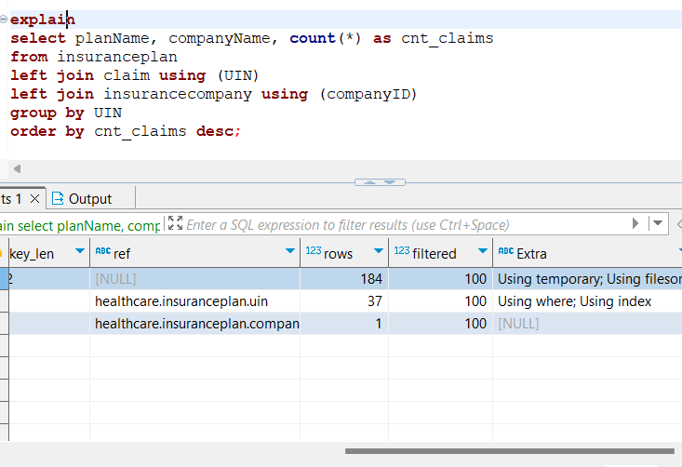

Additional –

As, data is not large enough fetch time for both the queries is similar but, when seeing the execution plan it is evident that approach #2 is more efficient. It requires a smaller number of reads. Also, the second approach is superior for this problem, because doing a left join on insurance plan will make sure we do not lose detail of an insurance plan even if it is never claimed, luckily that is not the case in this dataset, so both the approaches yield the same result but result may vary if data changes.

3. A table having information of each claim along with its insurance plan and insurance company that issued it. Generating count for number claims for each insurance plan.

Then writing a correlated subquery to that retrieves the insurance plan for a company that has been claimed the most and least

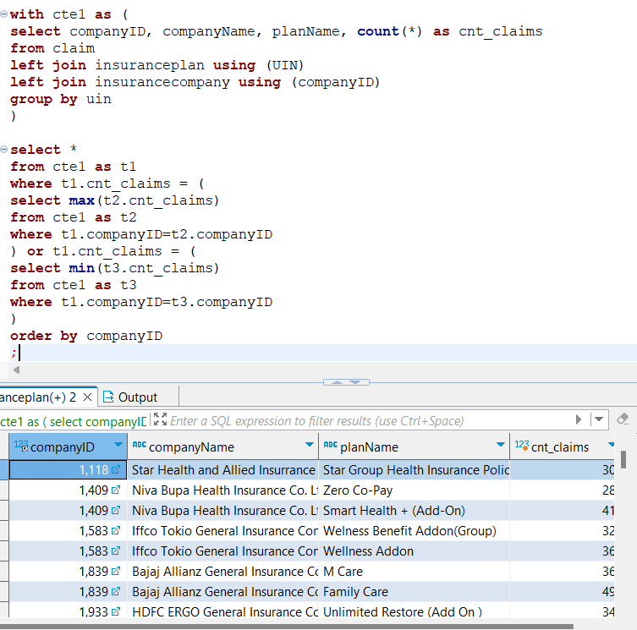

FETCH TIME=19ms

EXPLAIN

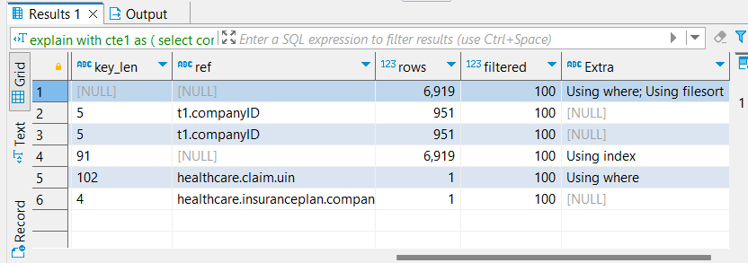

Additional –

Some companyIDs containing only one record thus we have same max and min in the result set.

4. On a table containing all states and its treatment records, we retrieve the count for number of people, patients and people-to-patient ratio.

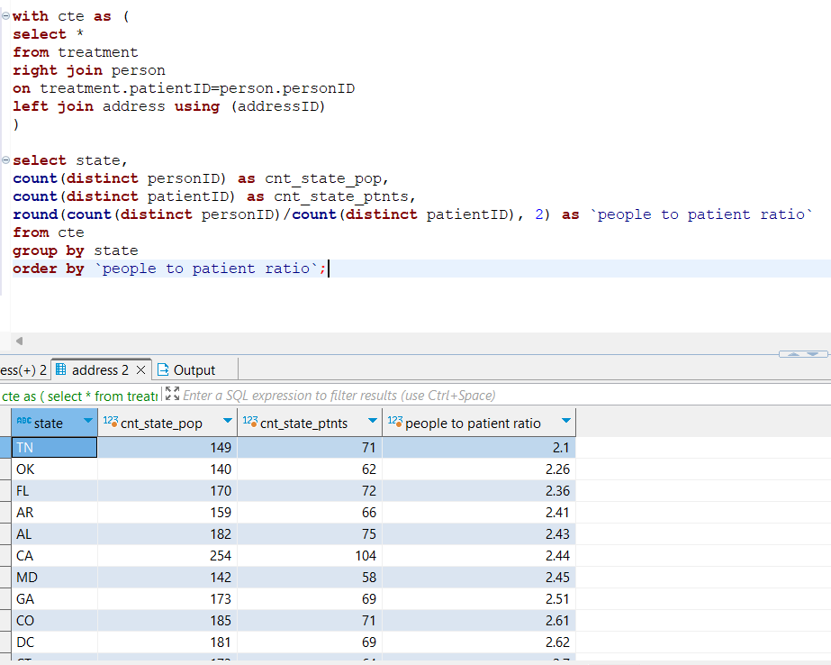

FETCH TIME=55ms

EXPLAIN

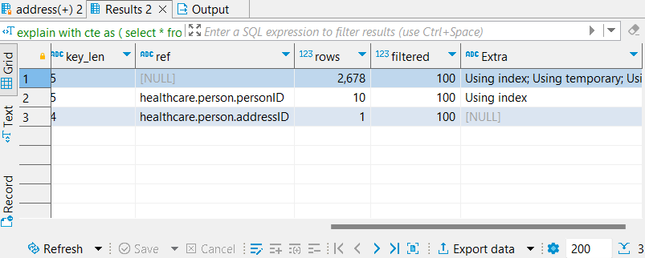

5. Creating a table containing a complete prescription info (related treatment, pharmacy, address the prescription was taken from, medicine details in each prescription). Filtering state, year and tax criteria. Then showing the total quantity of medicine prescribed grouped by pharmacy.

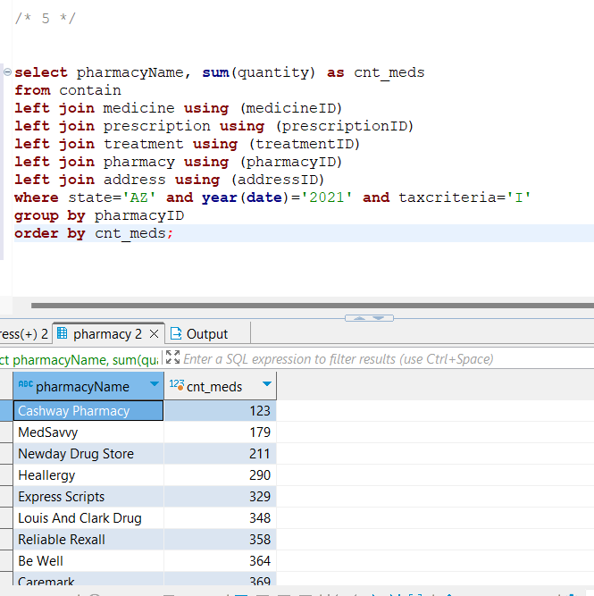

FETCH TIME=3ms

EXPLAIN

