1. Using union to join the two result sets from med category (1,2,3) and med category (4,5,6)

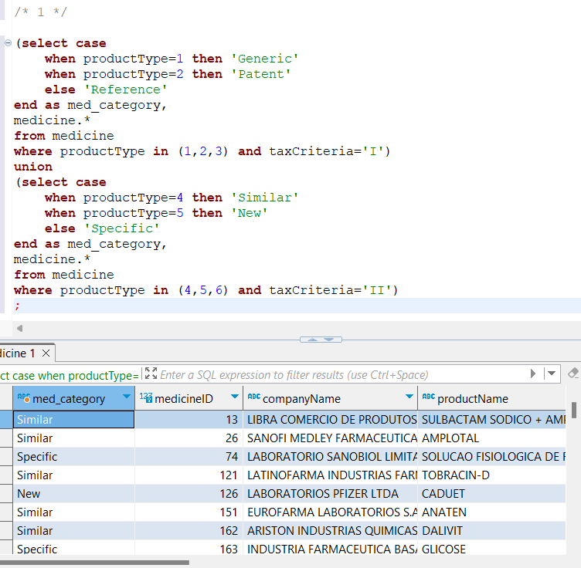

FETCH TIME=6ms

EXPLAIN

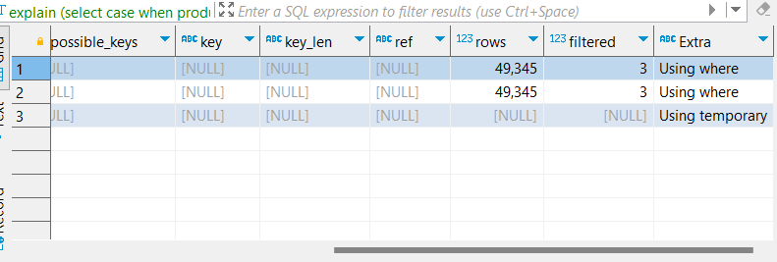

1. Fetching ‘Ally Scripts’ pharmacy’s pharmacy ID. Then on a table containing each prescription and details of each medicine in prescription for ‘Ally Scripts’ we calculate the quantity of meds for each prescription.

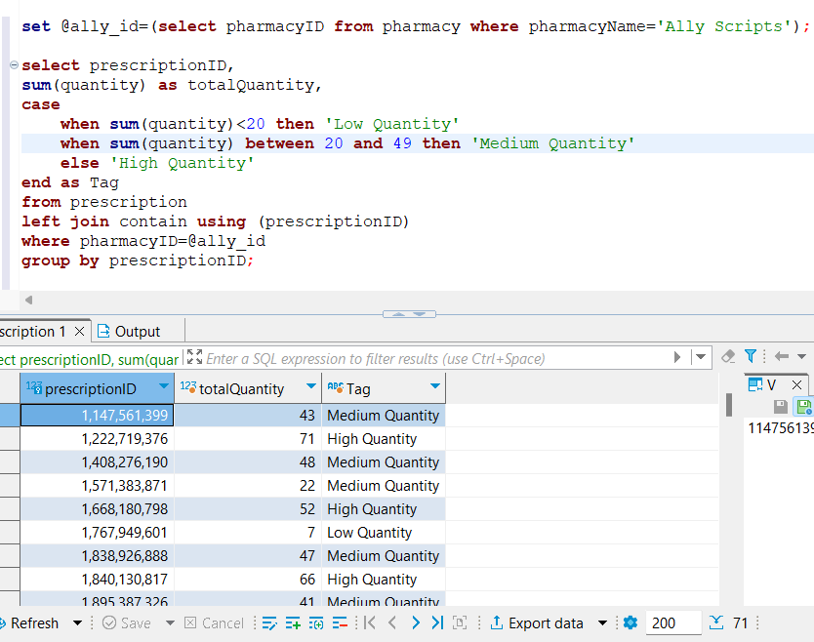

FETCH TIME=2ms

EXPLAIN

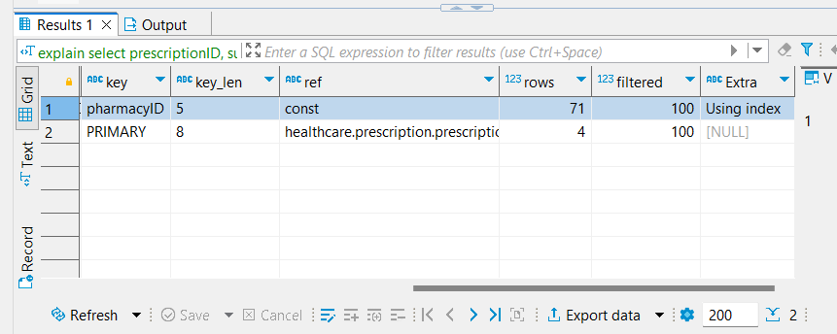

Additional –

We could’ve filtered records based on pharmacy name, but that makes our query a bit costlier as filtering is not done using any indexed column. And a full table scan happens.

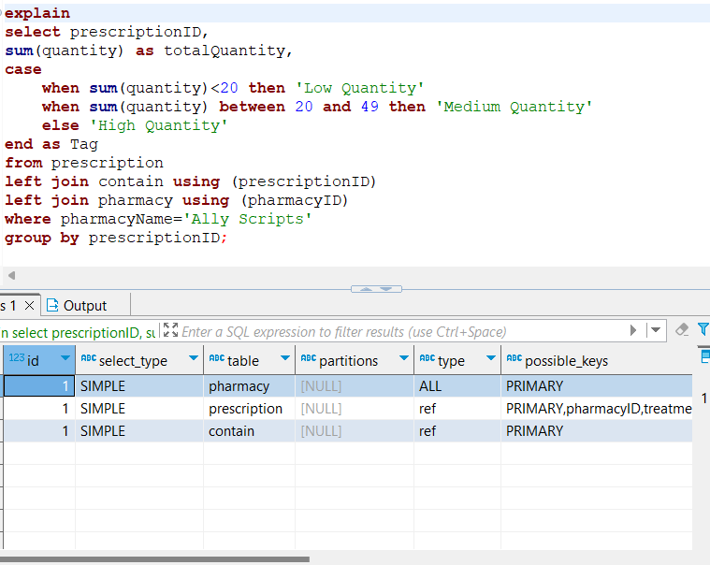

1. Fetching all records for ‘spotrx’ pharmacy. Then filtering and using case when to get the desired result.

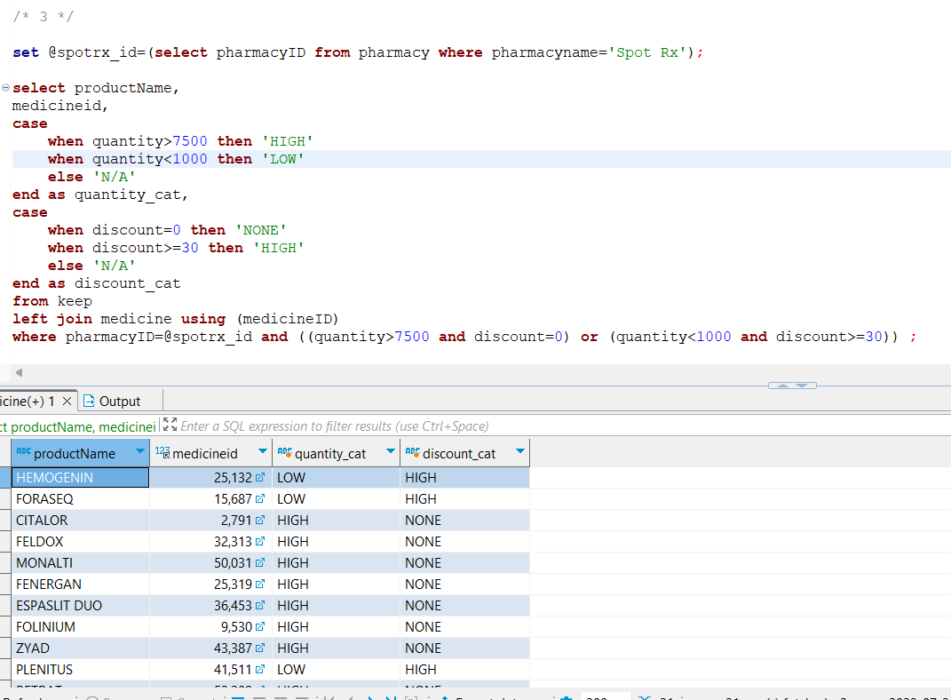

FETCH TIME=2ms

EXPLAIN

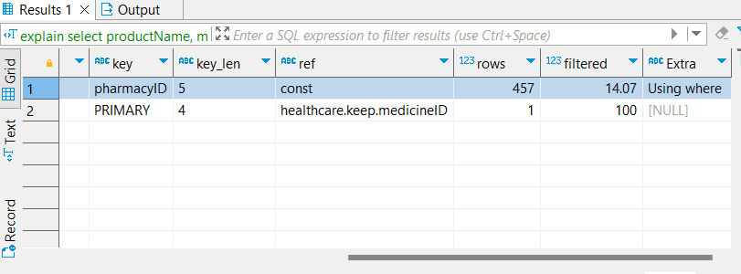

1. Simple filtering based on max price of a medicine, then using if to display desired result.

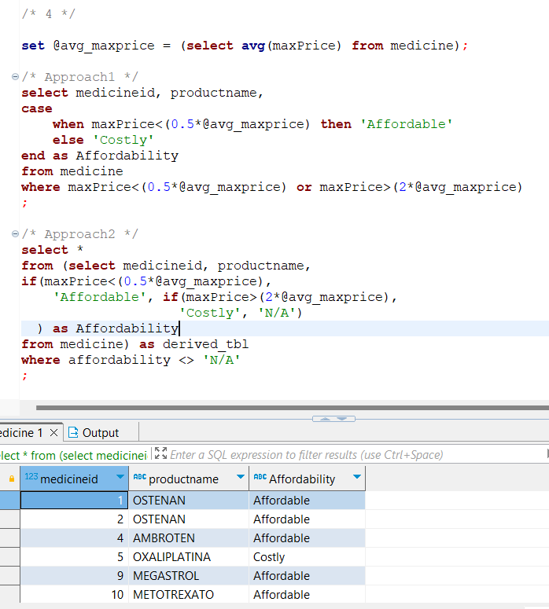

FETCH TIME=2ms

EXPLAIN

Approach1

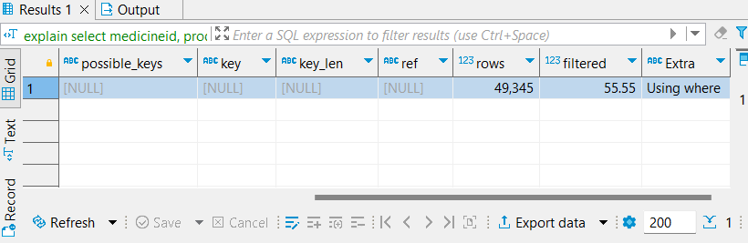

Approach2

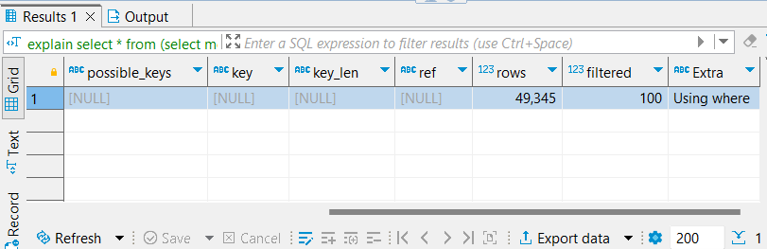

1. Joining person table with patients, and using case when to obtain desired result set

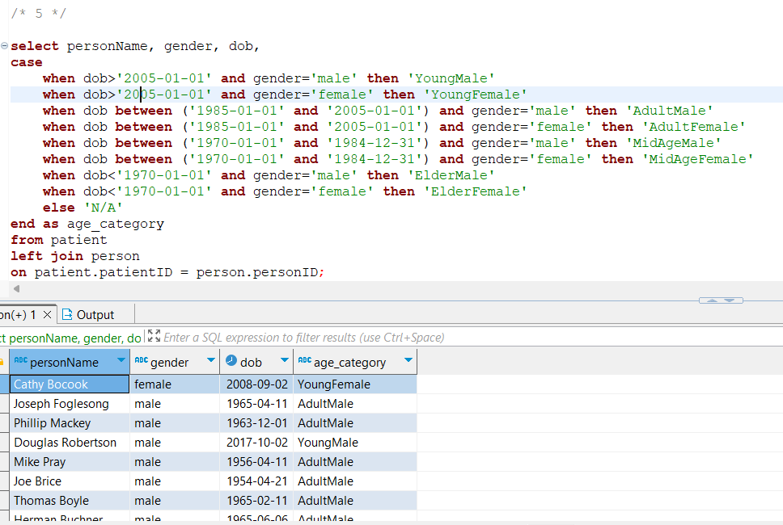

FETCH TIME=14ms

EXPLAIN

