1. Creating a table containing record of each treatment and its patient details. Count the number of treatments grouped for each patient.

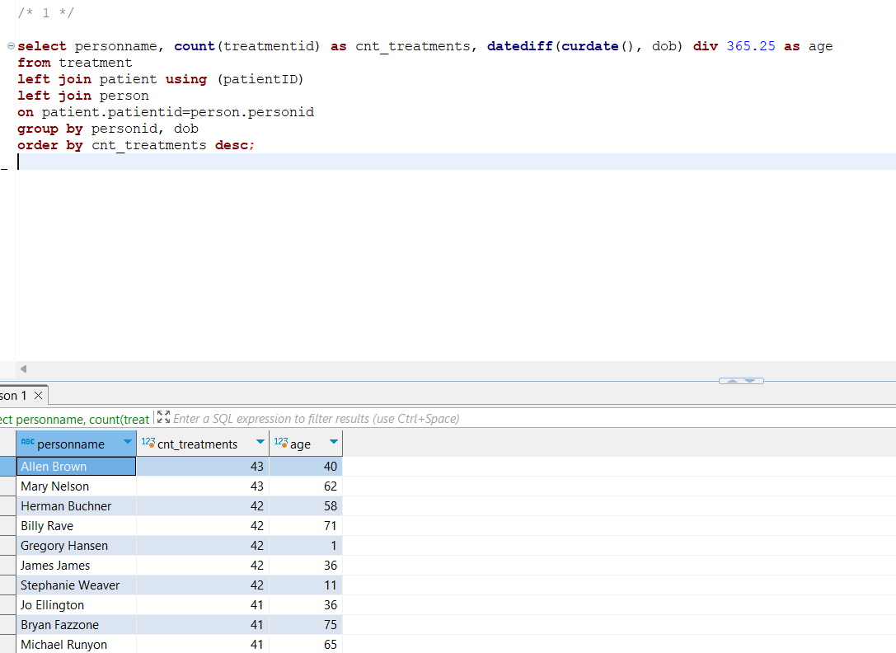

FETCH TIME=39ms

EXPLAIN

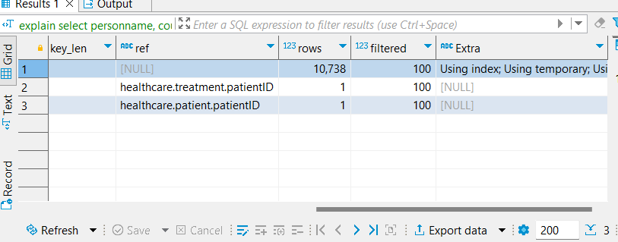

1. Generating a main table having all the information about treatment of a patient. Now creating 2 other tables feeding off the main table, to extract gender count of female, and male.  
   Finally, writing a query to consolidate all the columns from two sub tables into one.

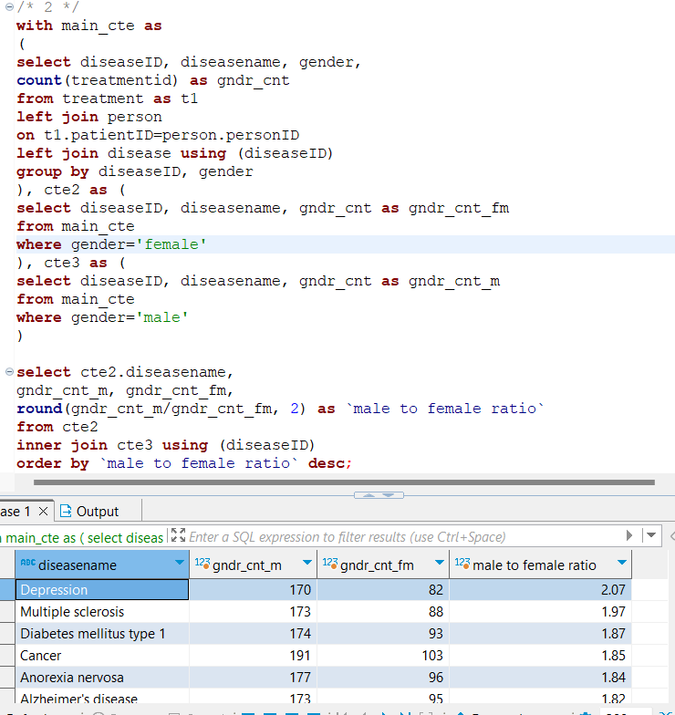

FETCH TIME=83ms

EXPLAIN

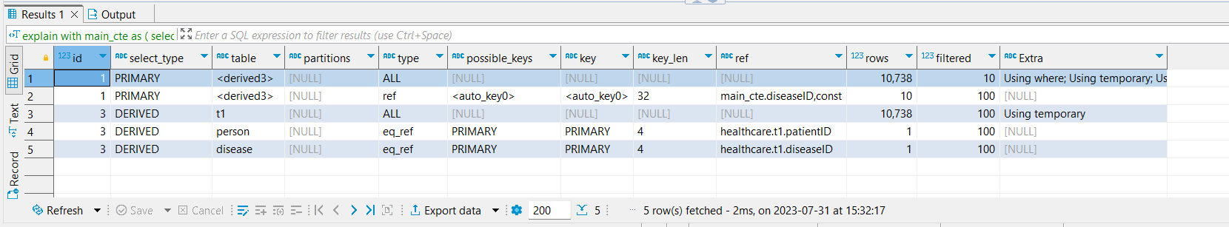

1. In this one we made use of multiple levels of nested subqueries. Creating a table containing information of treatment, its patient and disease. Counting number of treatment for each disease and specific city.  
   After that creating another derived table from previous one containing rank of each treatment count within the same disease group.  
   Finally writing the outer query to retrieve top 3 records for each disease.

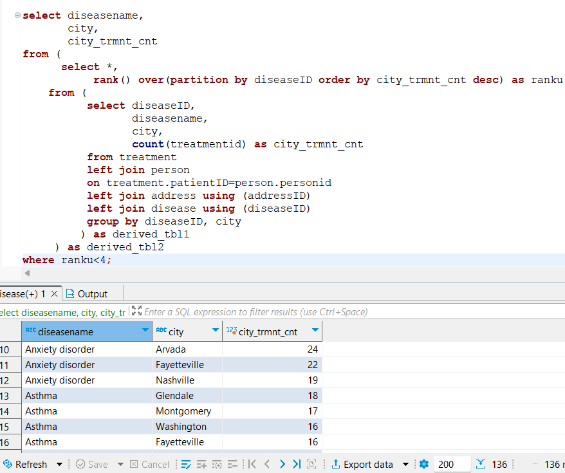

FETCH TIME=112ms

EXPLAIN

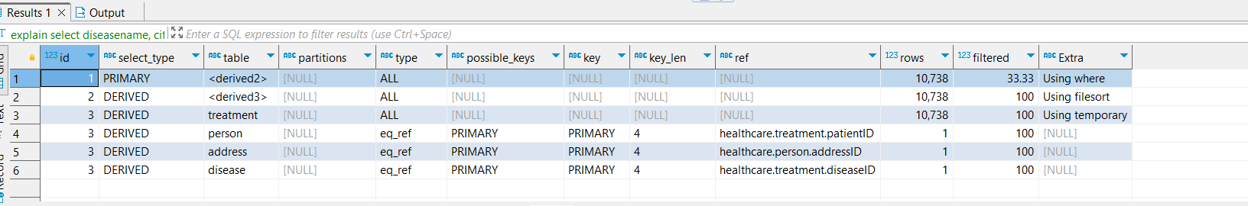

1. First to make sure we have each pharmacy and disease name combination; we use a cross join. After that using correlated subquery for two columns, we calculate count of prescriptions for year ‘2021’ and ‘2022’ where pharmacy name and disease name is a combined match.

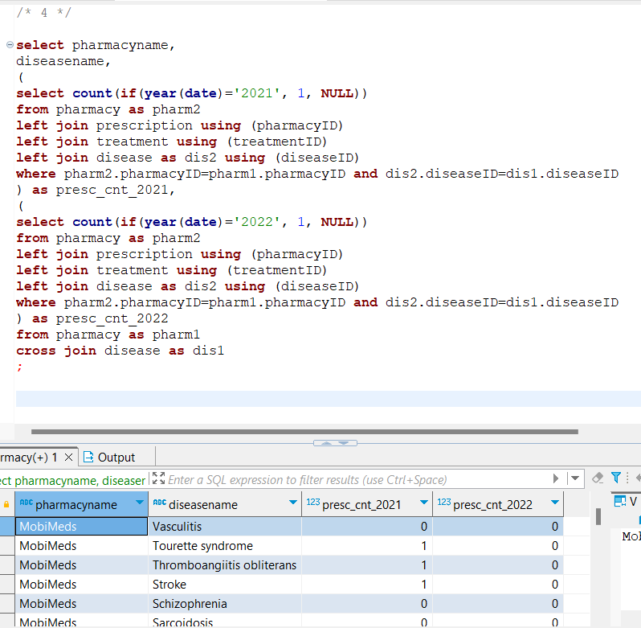

FETCH TIME=143ms

EXPLAIN

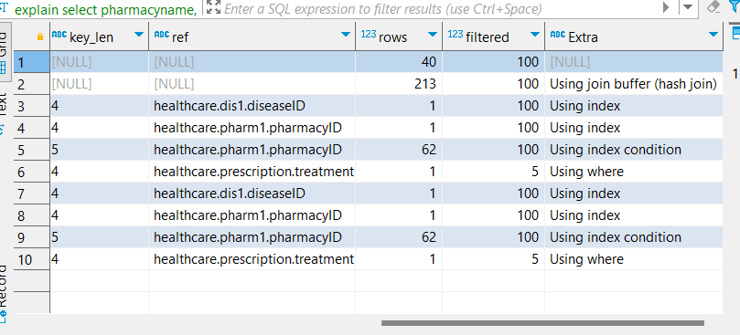

1. Forming a main table containing all the details about a treatment, its claim and address of patient. Counting number of treatments for group of company and state.  
   Then in the query below we use a correlated subquery to find the max count for claims for all companies and state(s) involved.

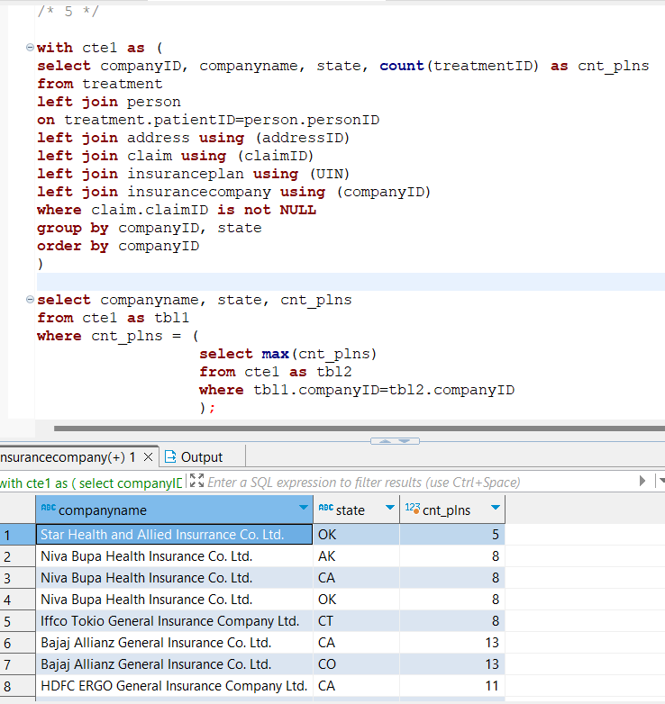

FETCH TIME=107ms

EXPLAIN

