Created a view `complete treatment details` containing data about each treatment, its patient, pharmacy, medicine and prescription. As, it is most commonly used.

1. Using our newly created view we segregate records based on same pharmacyID, filtered for only year ‘2022’. Then generating total quantity of meds, hospital exclusive meds and % hospital exclusive qty.

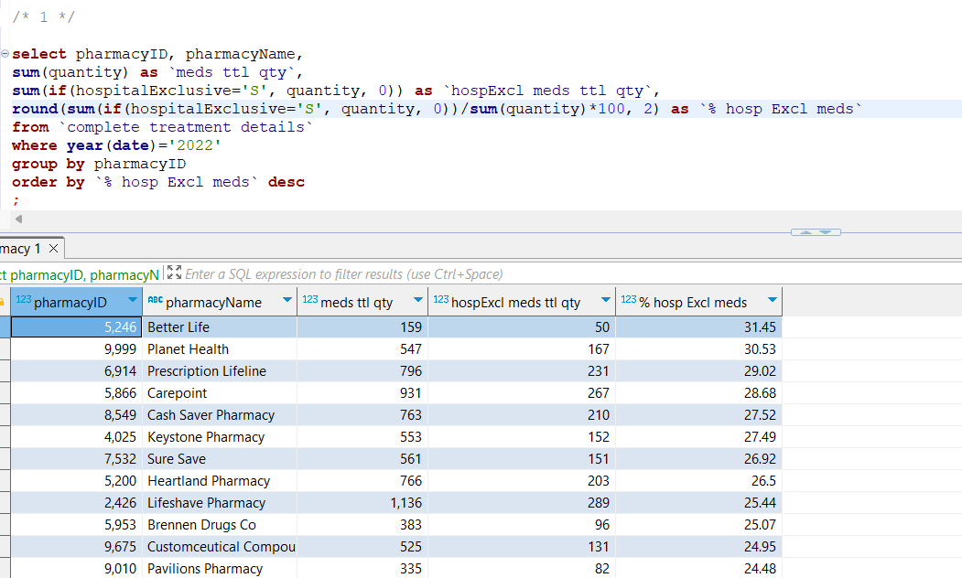

FETCH TIME=95ms

EXPLAIN

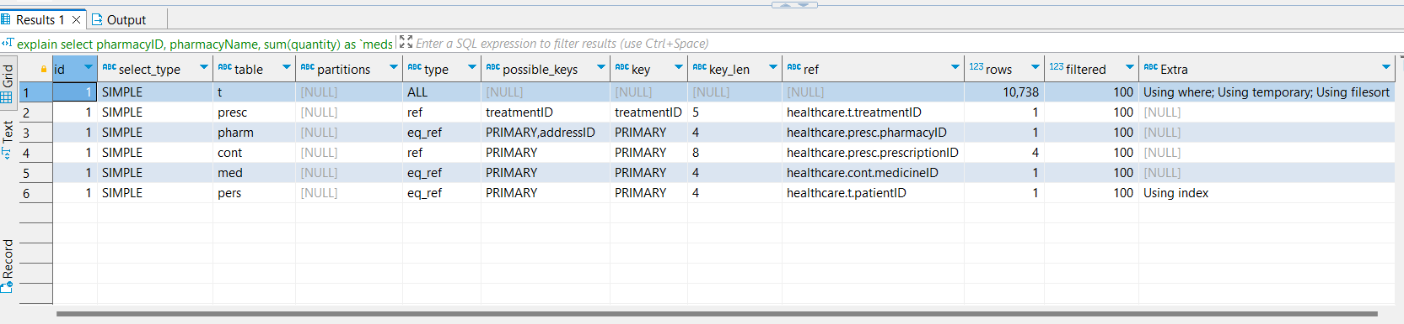

1. Using view `complete treatment details` and joining patient address on it we synthesize data on which we group by state and calculate `% no claim ratio`

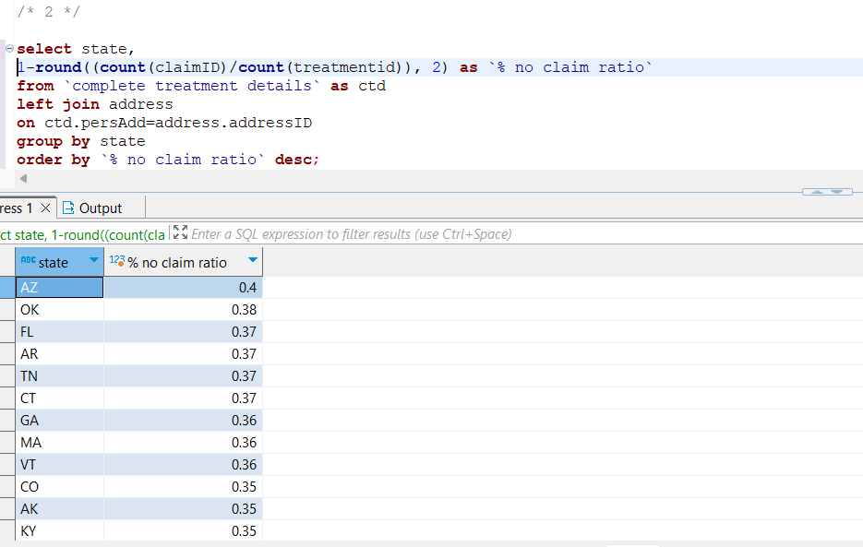

FETCH TIME=670ms

EXPLAIN

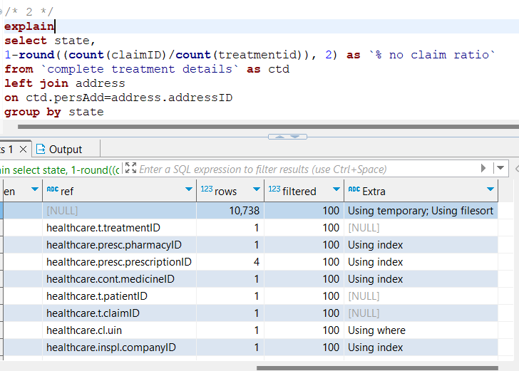

1. Having a main CTE containing each treatment’s disease, patient information. Then, calculating for each state max count of a disease amongst all disease in that state, for each state min count of a disease amongst all disease in that state.

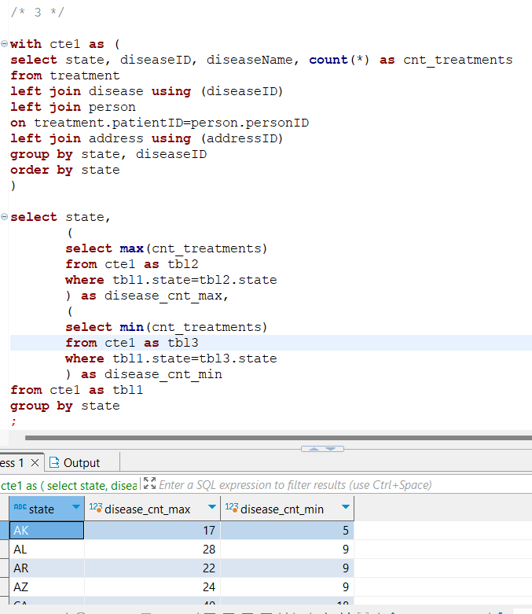

FETCH TIME=90ms

EXPALIN

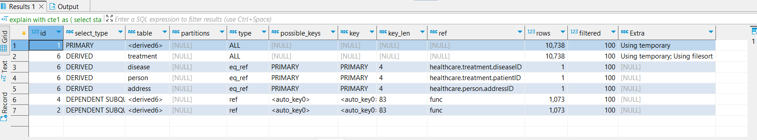

1. From a table having data about all people and their address, along with who all are patients. Grouping by city and generating percentage patient to people count.

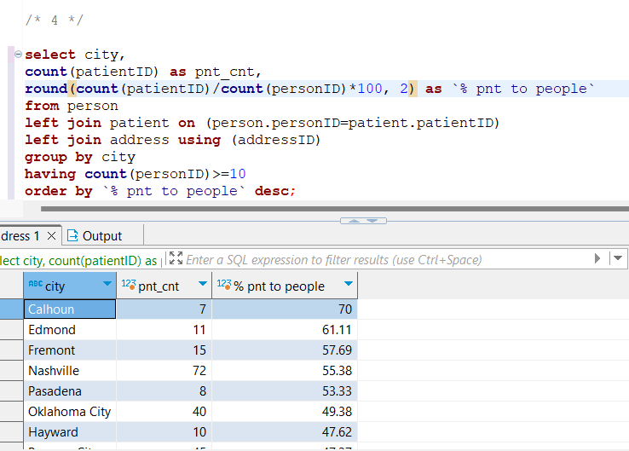

FETCH TIME=10ms

Explain

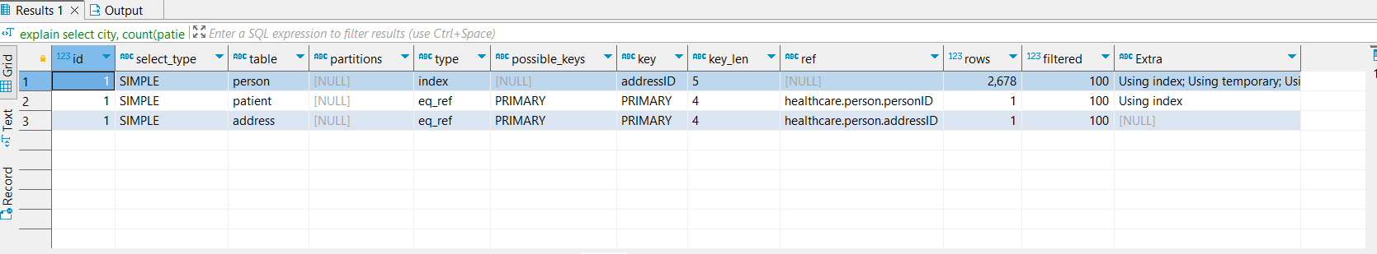

1. In the medicine table, filter medicines where “ranitidine” is a substance. After that count the number of medicine each company sells, and display the top 3.

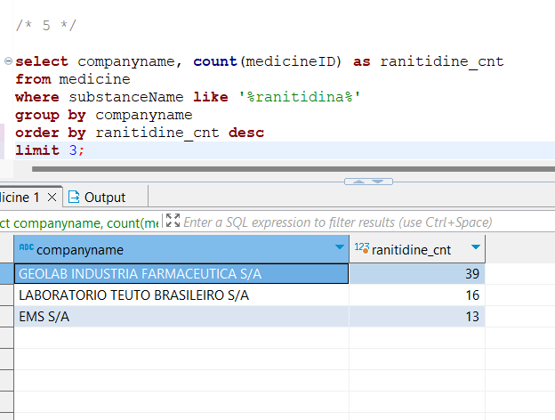

FETCH TIME=34ms

EXPLAIN

