1. 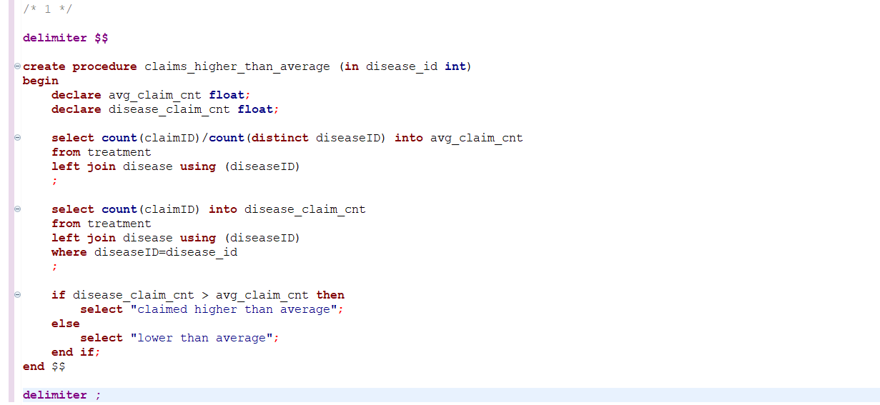
2. 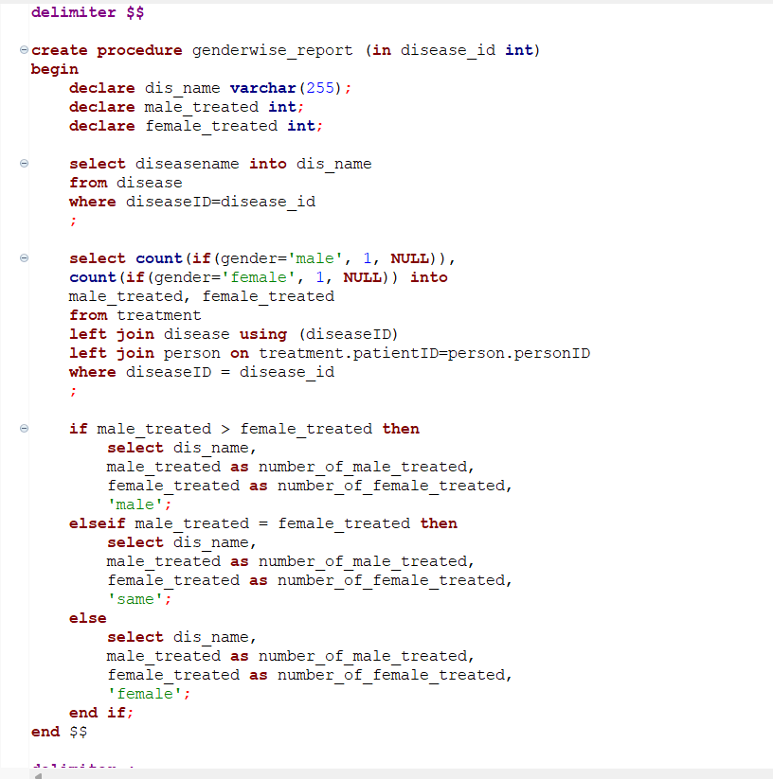
3. Using union joining two tables, having 3 top most claimed insurance plan and lest 3.

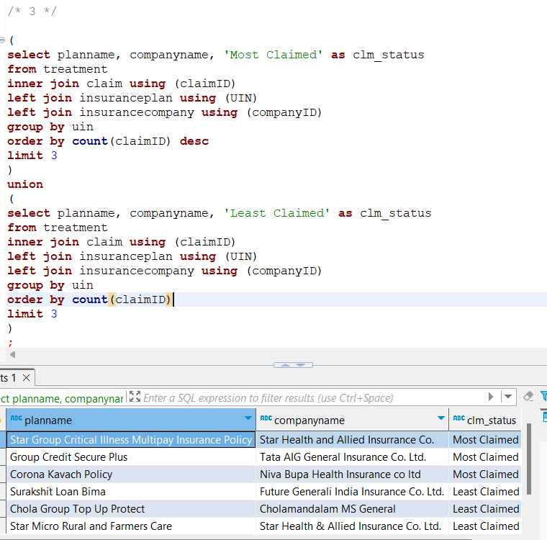

FETCH TIME=86ms

EXPLAIN

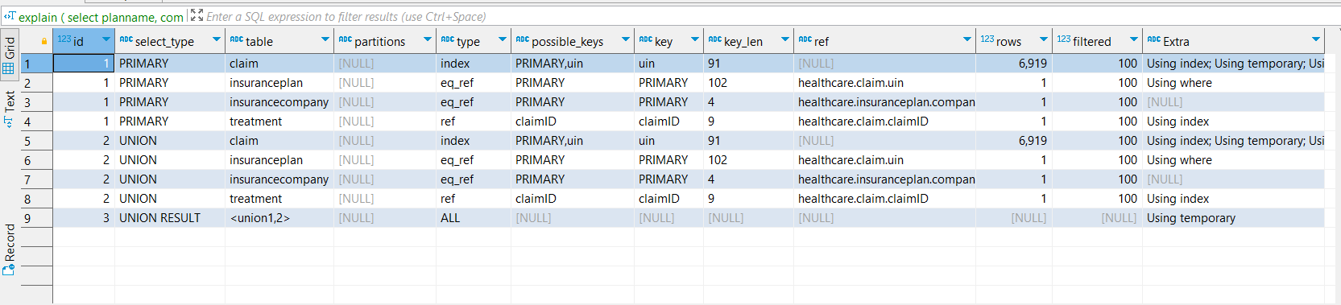

1. Created a procedure, that determines person’s age category based on their date of birth and gender. After that create a table showing number of patients for each disease in each age category. After that querying the disease name, and age category having most patients for that disease.

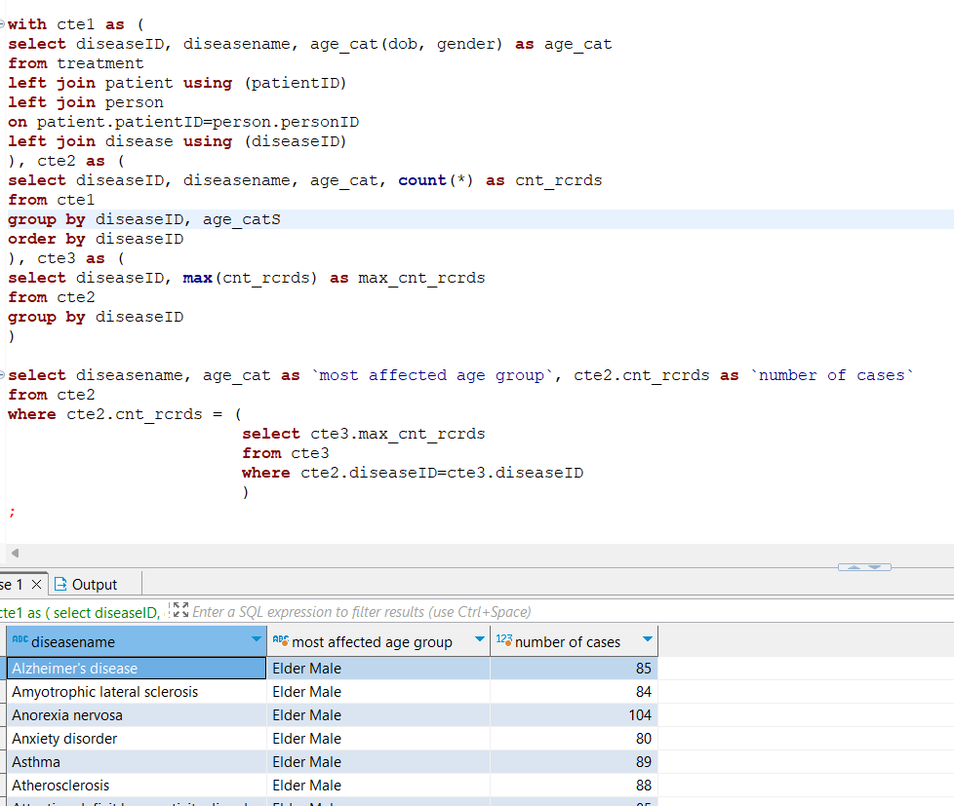

FETCH TIME=571ms

EXPLAIN

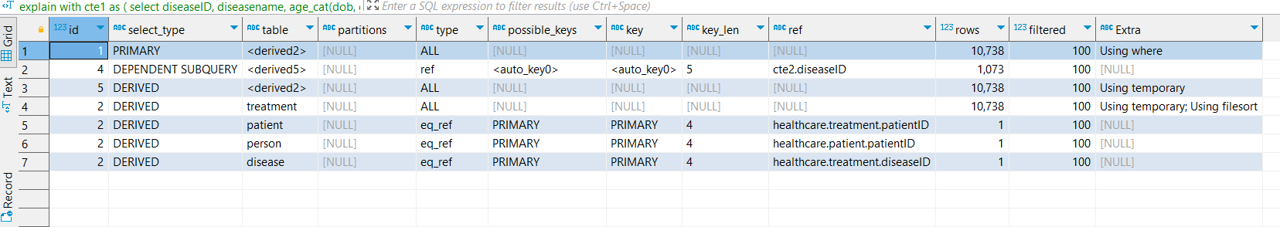

1. On medicine table, simple filtering and querying.

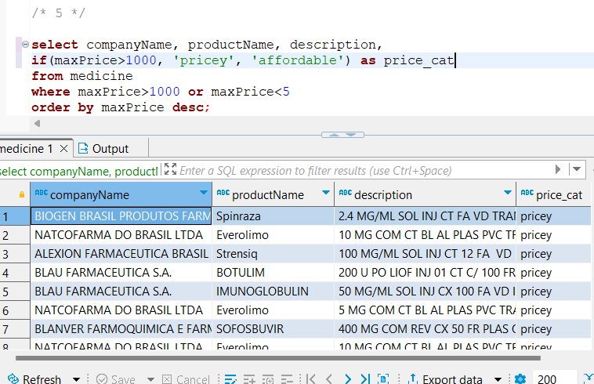

FETCH TIME=72ms

EXPLAIN

