1. Simply creating table where each treatment record also contain information about disease and patient. Using simple group by on rollup.

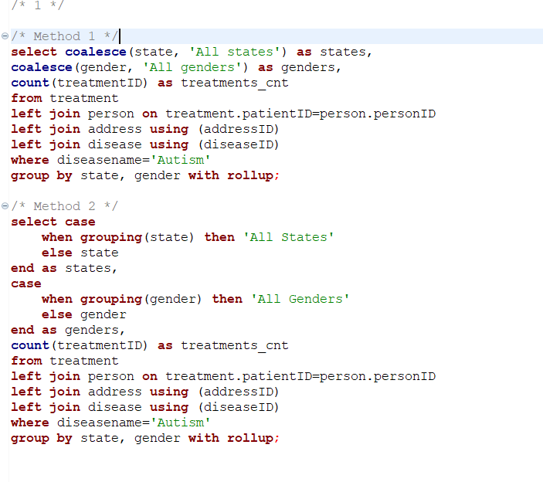

FETCH TIME=4ms

EXPLAIN

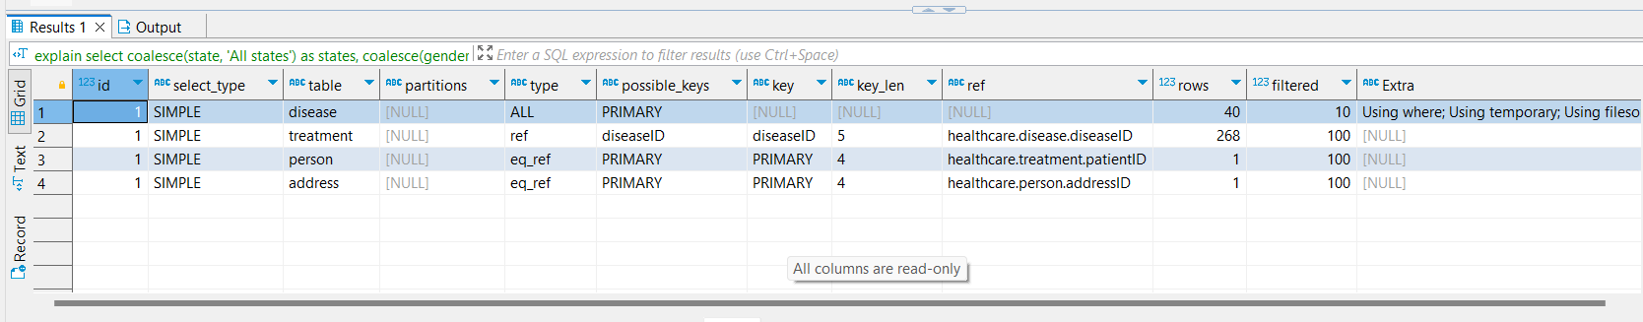

1. Filtering data based on year of date, then apply group by roll up based on uin and year(date).

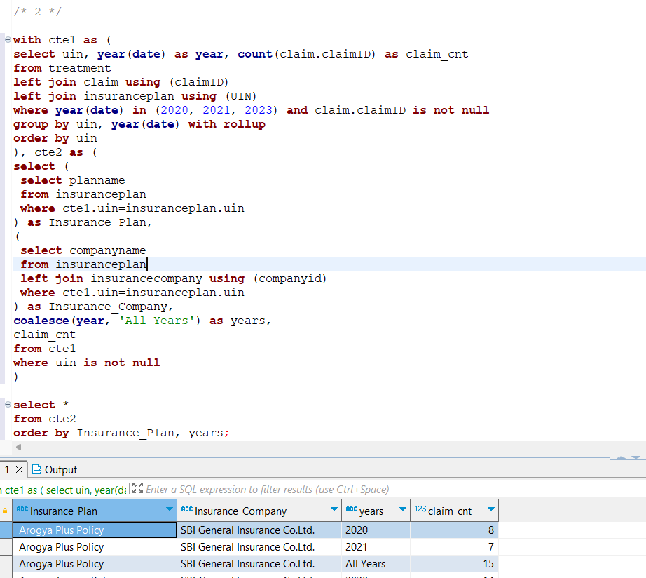

FETCH TIME=44ms

EXPLAIN

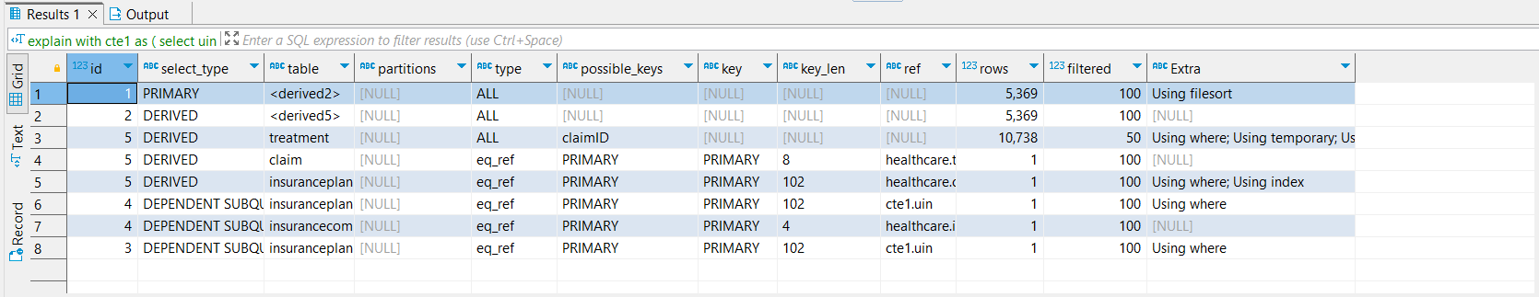

1. On a table grouped by state and diseases, we select the max and min occurrence of a disease for a state and also a consolidated data for a state regardless of disease.

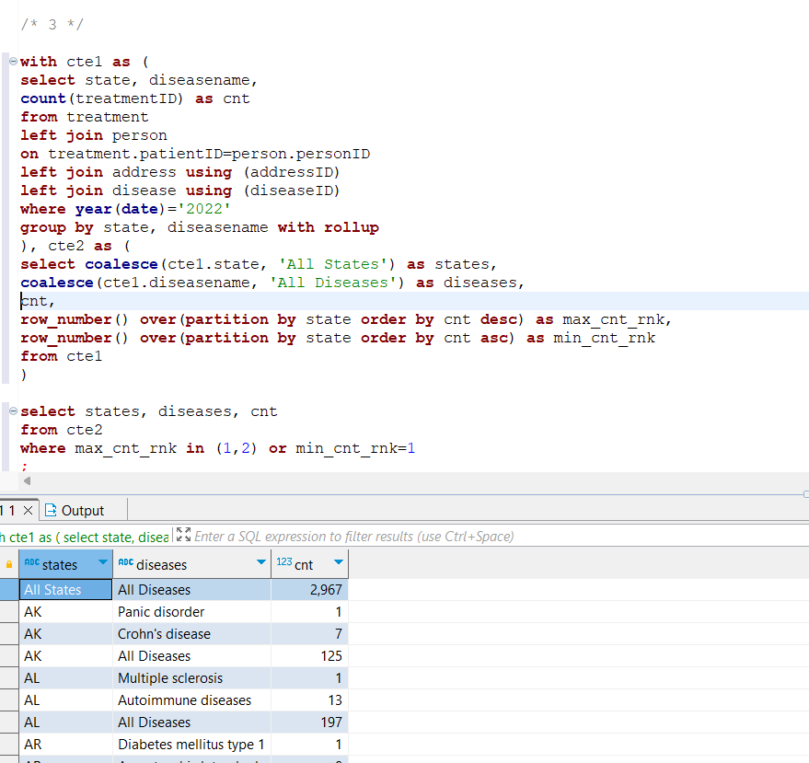

FETCH TIME=36ms

EXPLAIN

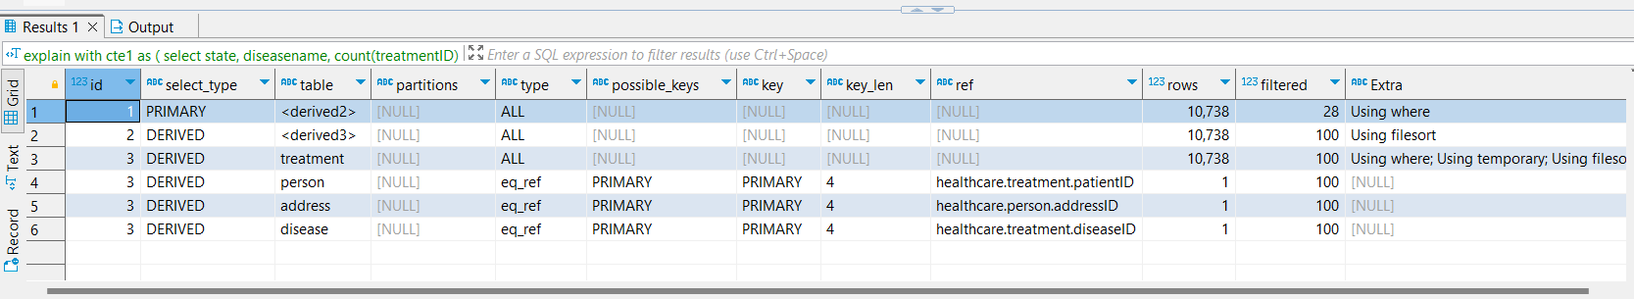

1. On a table with information for all treatments, along with its prescription, disease and pharmacy. We group by disease and pharmacy with the help of rollup.  
   After that, with the help of subqueries, we determine, disease name and pharmacy name relating to a disease ID and pharmacy ID.

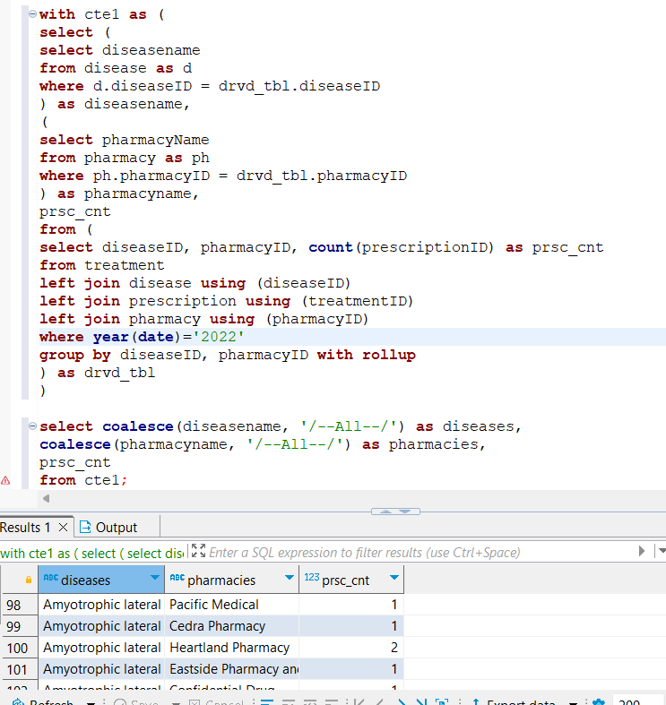

FETCH TIME=78ms

EXPLAIN

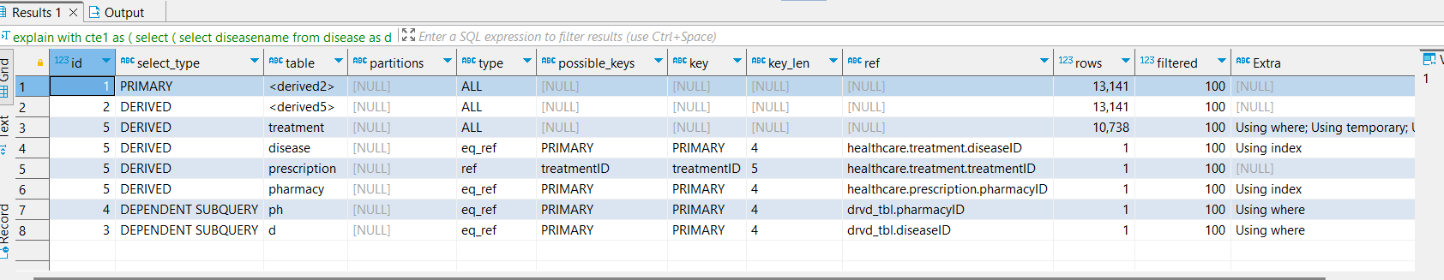

1. A simple group by with roll up by disease name and gender.

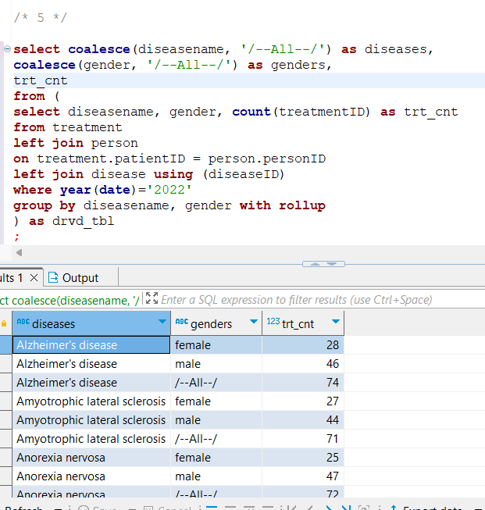

FETCH TIME=32ms

EXPLAIN

