🧾 TINY TUMMIES
FULL WEBSITE EXPERIENCE & DESIGN DOCUMENT
Tagline: “Little Tummies, Big Nutrition.”

🌱 1. THE SOUL OF TINY TUMMIES (READ THIS FIRST)
Tiny Tummies is not a food business.
It is built around a daily emotional moment in every household.
A parent standing in the kitchen every morning…
wondering if what they are packing is good enough.
Not just filling the box.
But nourishing their child.
There is love in that moment.
But also stress. Uncertainty. Repetition. Guilt.
And on the other side of that lunchbox…
A child who:
- Gets bored easily
- Rejects food quickly
- Is drawn to taste, color, and fun

💡 The Core Realization
Children don’t reject healthy food.
They reject:
- Monotony
- Poor presentation
- Lack of excitement
And parents don’t fail at nutrition.
They struggle with:
- Time
- Consistency
- Daily decision fatigue

🎯 Why Tiny Tummies Exists
Tiny Tummies was created to bridge this gap.
To take away the daily stress from parents…
and replace it with confidence, trust, and joy.
To turn food from:
👉 A struggle
into
👉 A habit kids actually look forward to

🎨 2. DESIGN PHILOSOPHY (CRITICAL FOR YOUR DESIGNER)
Before a single pixel is placed, the designer must understand:

🧠 What should the website FEEL like?
When a parent opens your website, they should feel:
- “This looks safe”
- “This looks clean”
- “This is made for kids like mine”
- “I can trust these people with my child’s food”

🎭 Emotional Tone Balance
Element | Tone
Kids | Playful, joyful
Parents | Calm, reassuring
Brand | Clean, trustworthy

🎨 Visual Language
- Soft rounded edges → safety & warmth
- Clean spacing → hygiene & clarity
- Bright accents → energy & kids appeal
- Real food imagery → trust

🚫 What to avoid
- Loud cluttered designs
- Cartoon overload (kills trust)
- Corporate stiffness
- Stock photos that feel fake

🌐 3. WEBSITE FLOW (STORY-DRIVEN STRUCTURE)
The website should not feel like pages.
It should feel like a guided journey.

🏠 3.1 HOME PAGE — THE FIRST IMPRESSION
🎯 Objective:
Capture trust within 5 seconds.

🔹 HERO SECTION (MOST IMPORTANT)
Visual Direction:
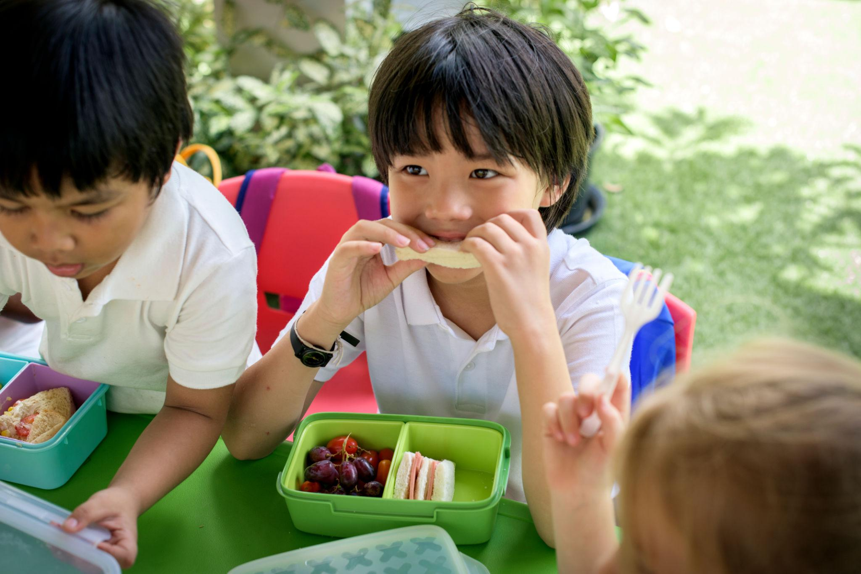
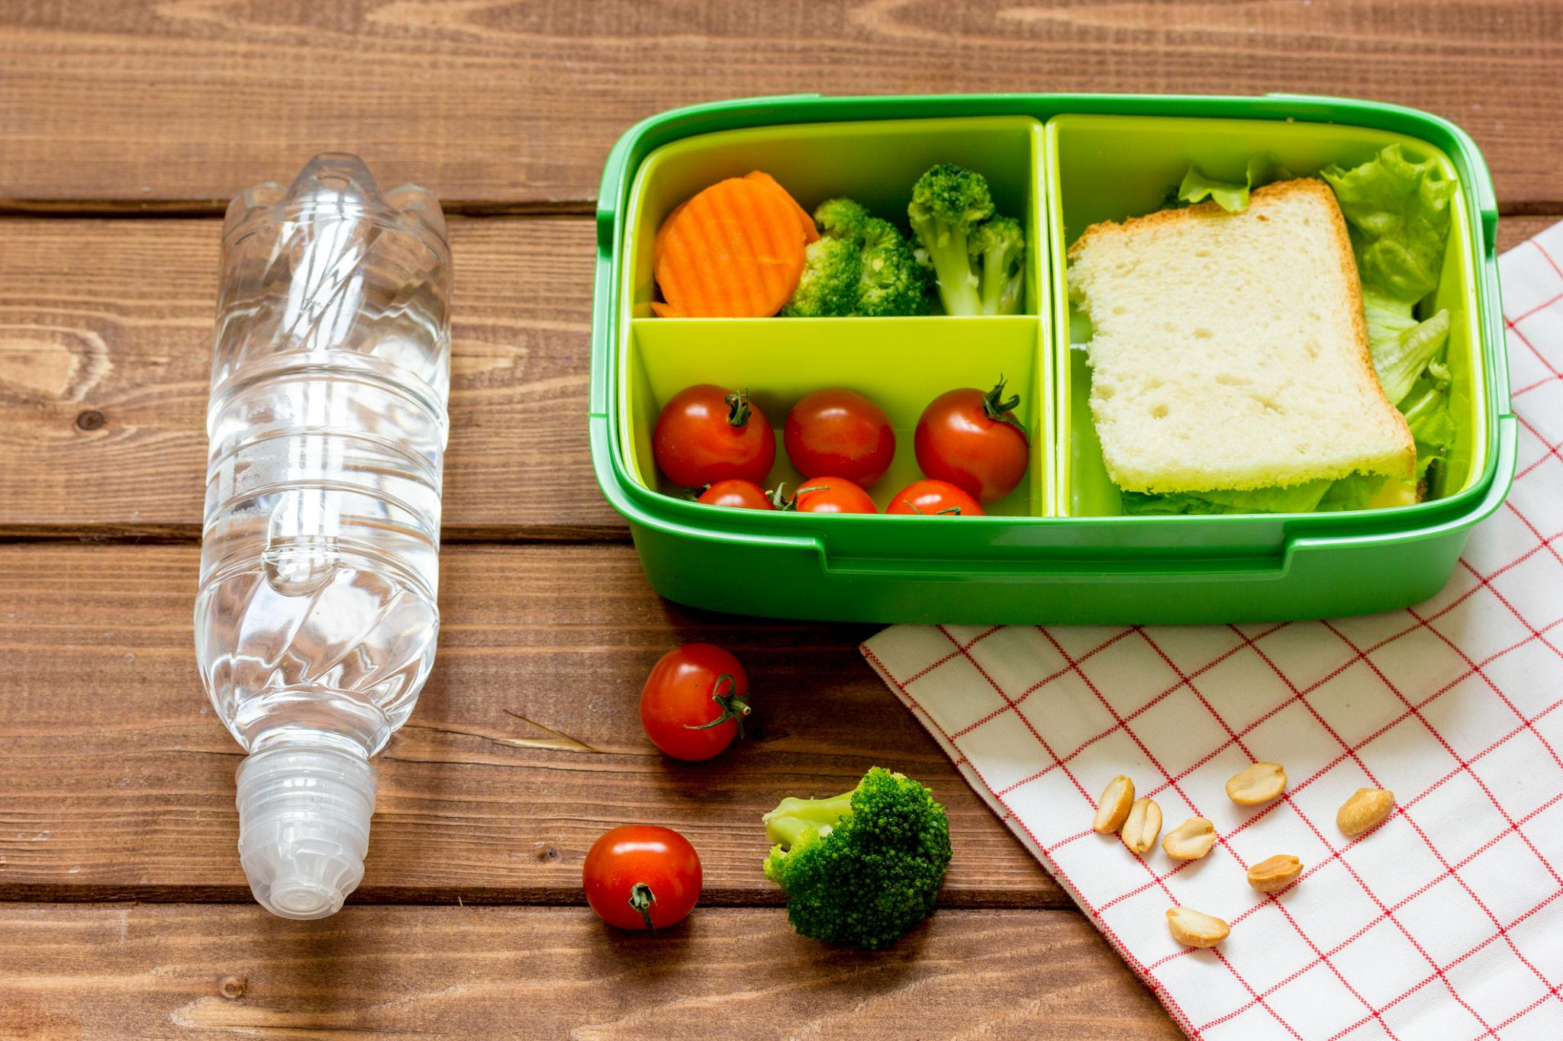
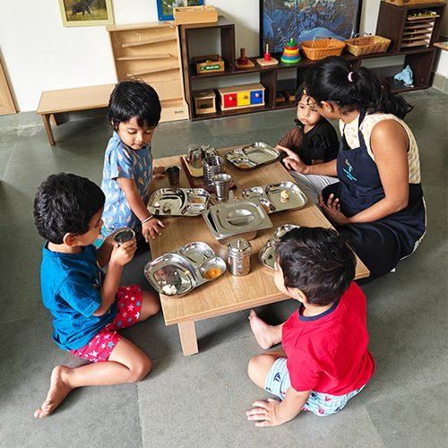
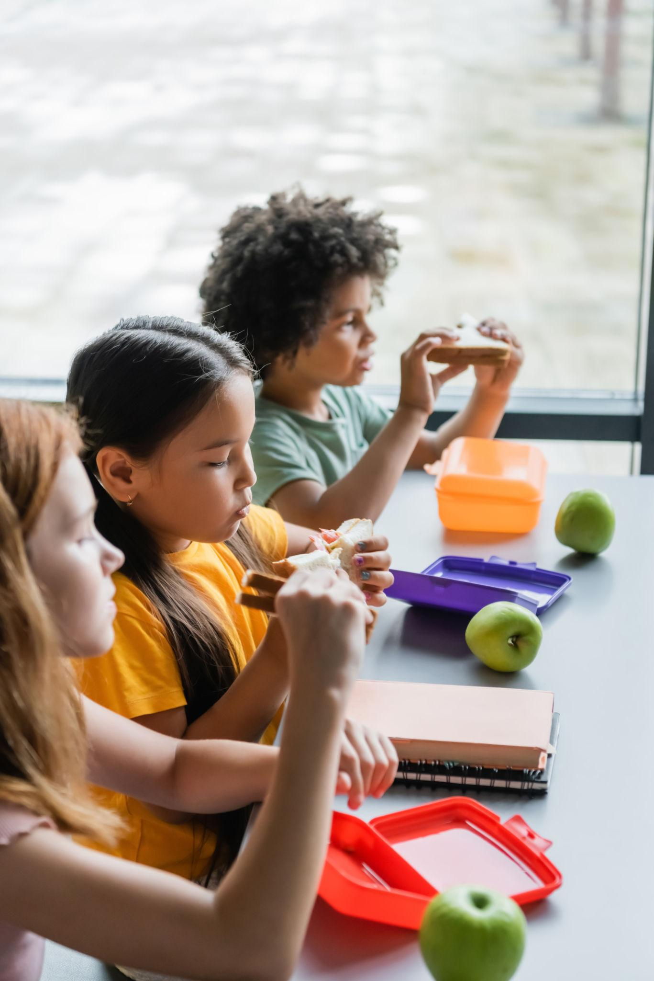
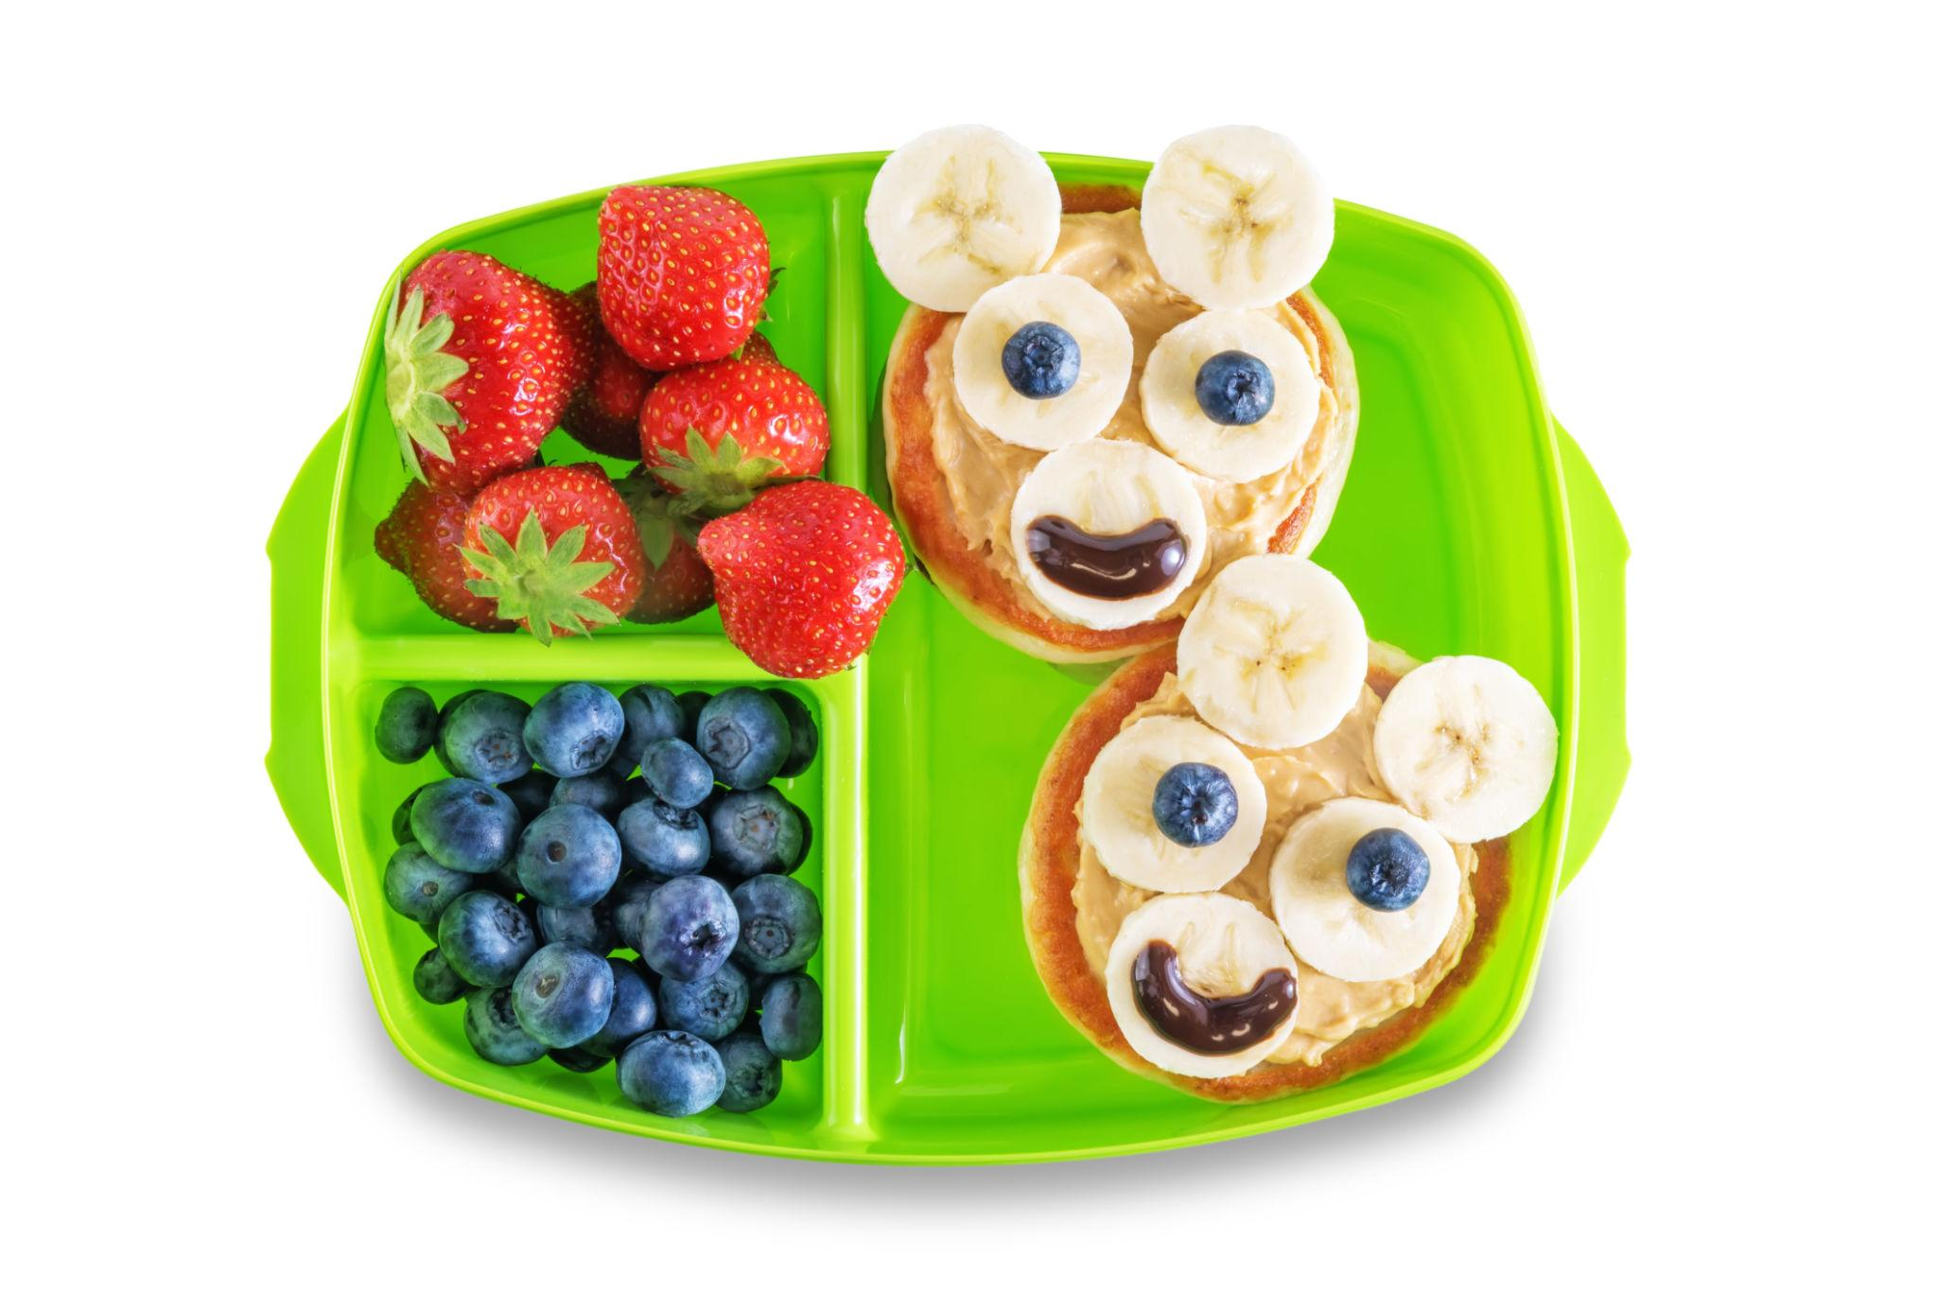
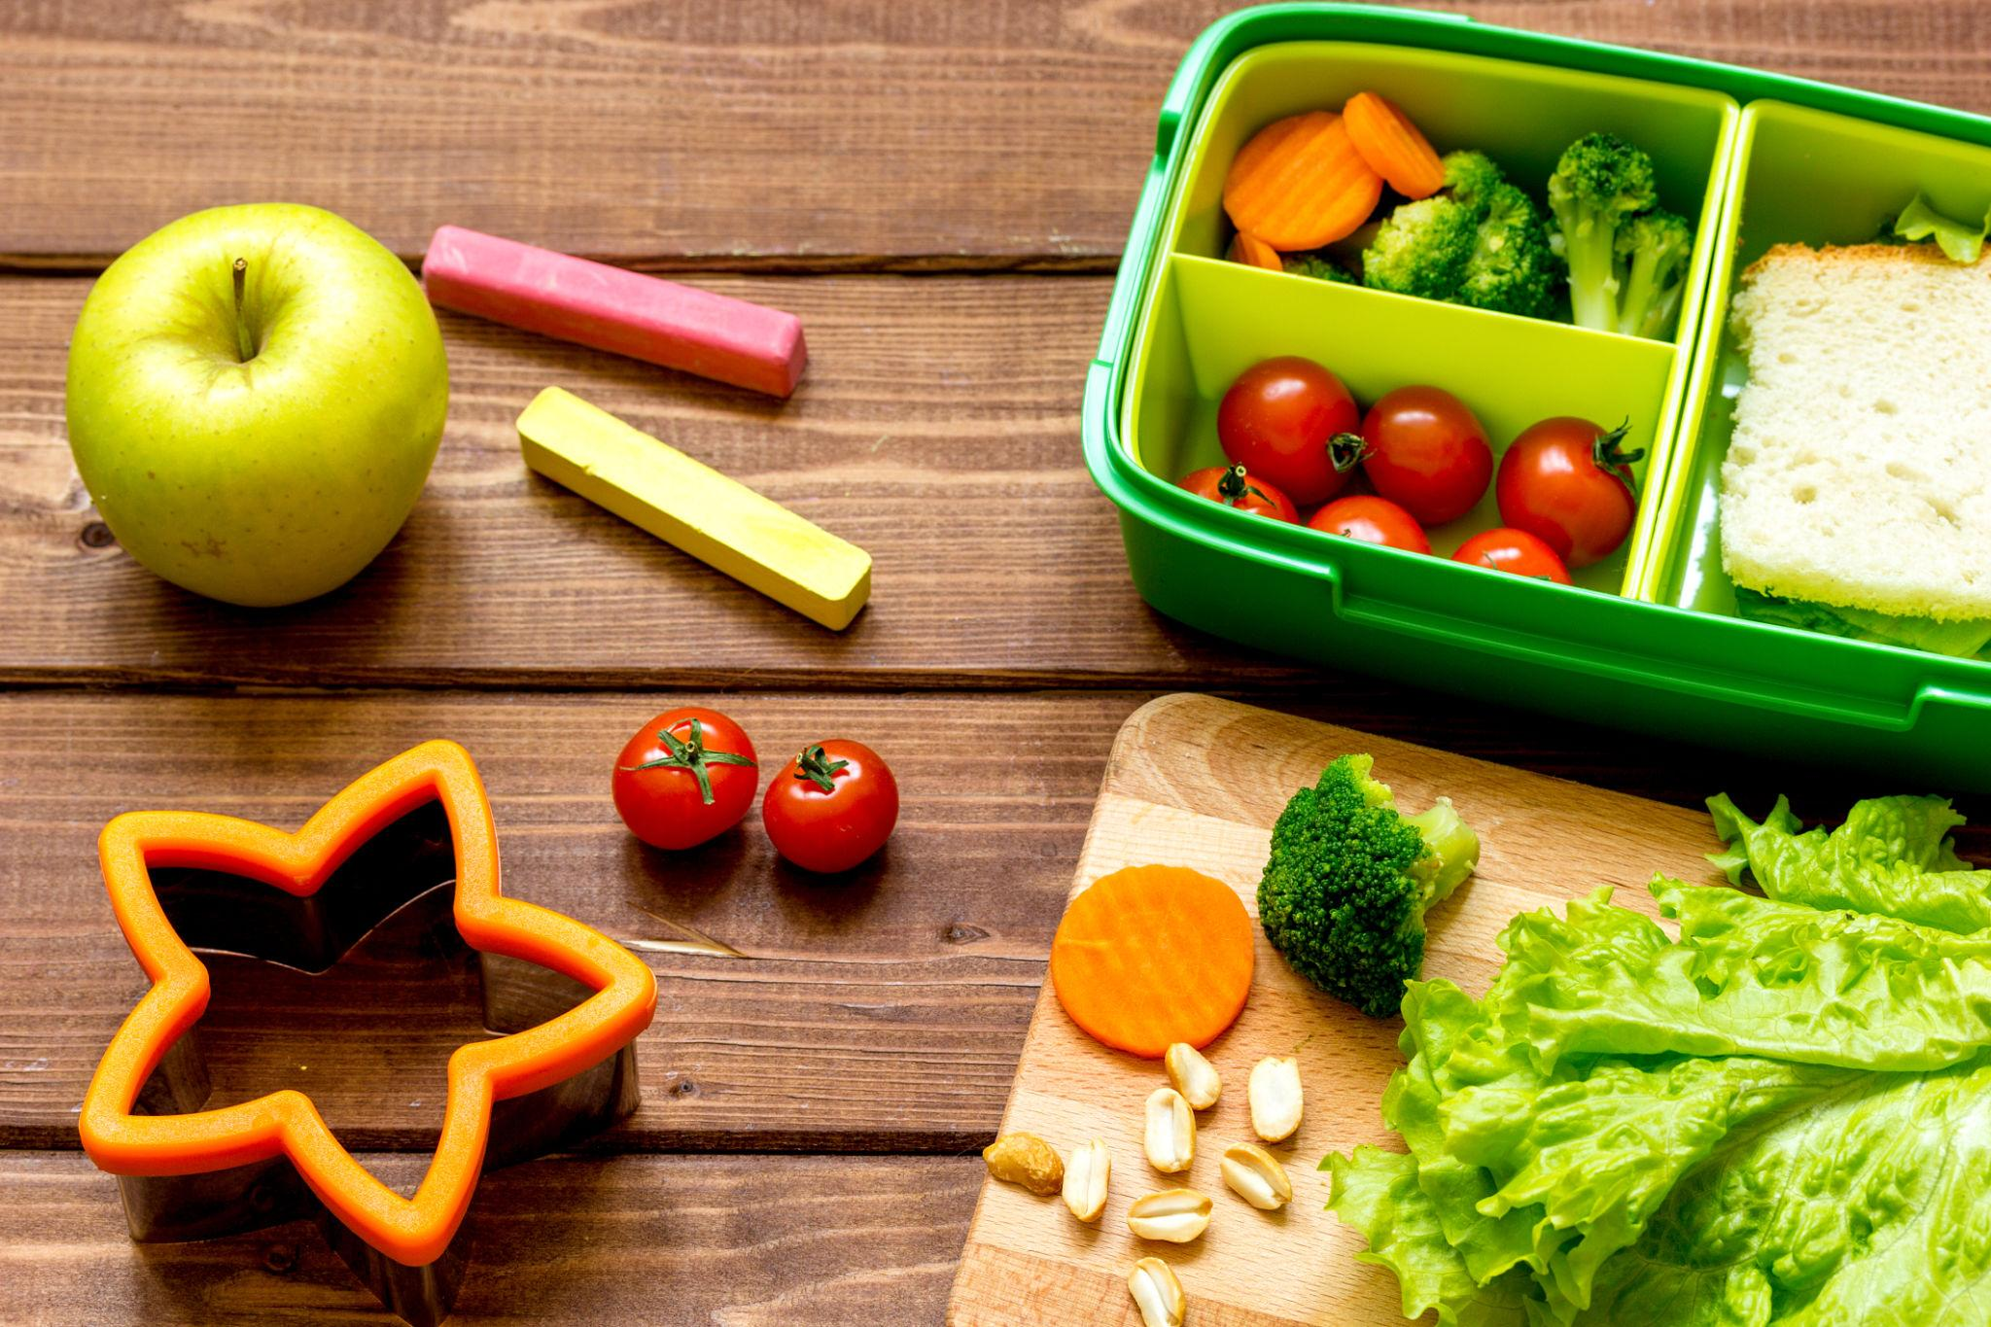
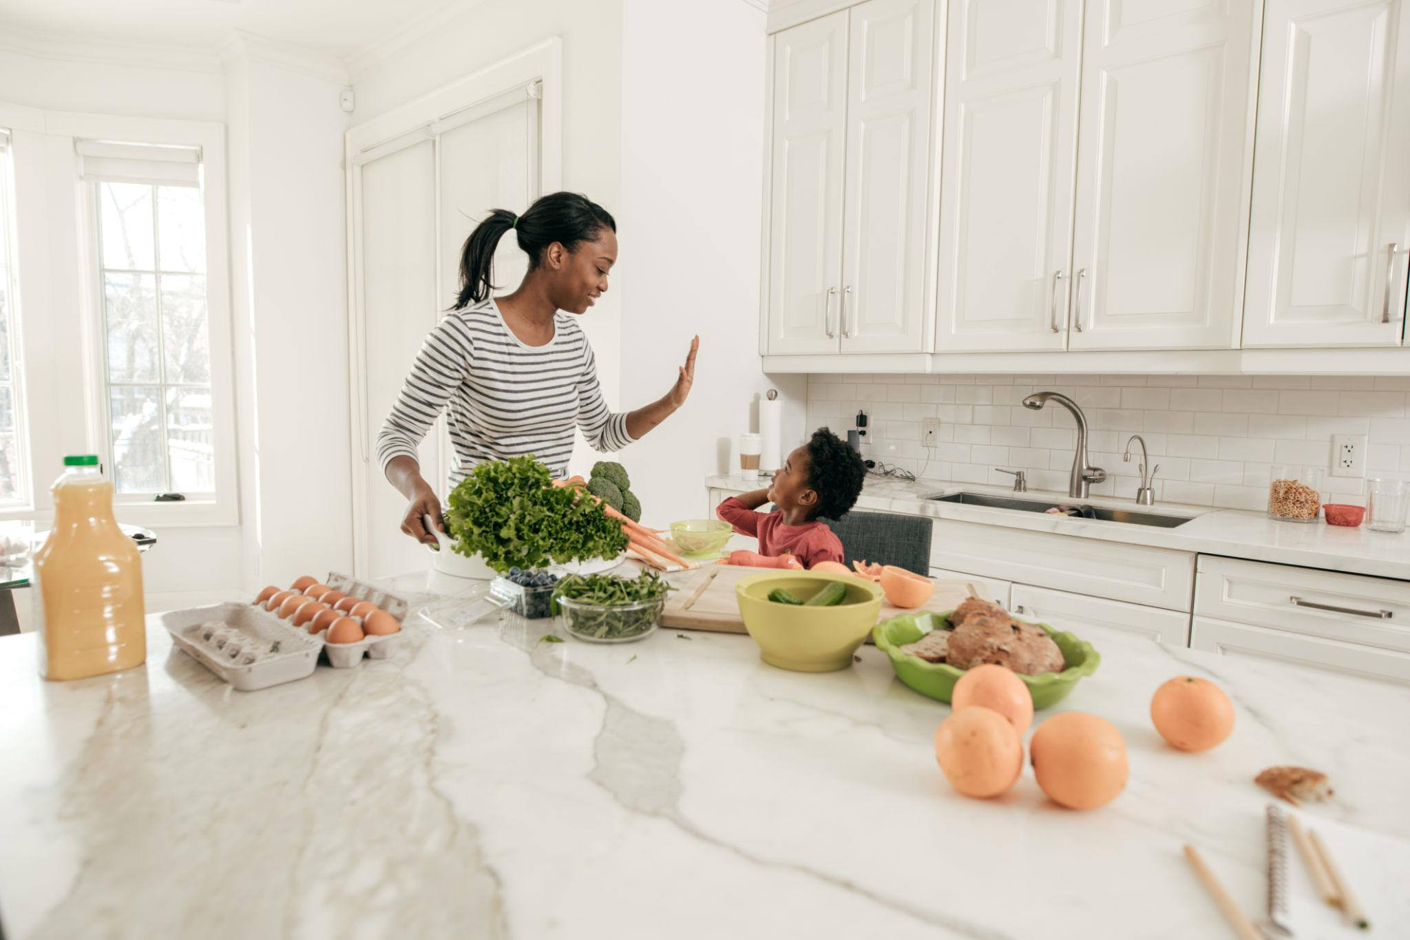
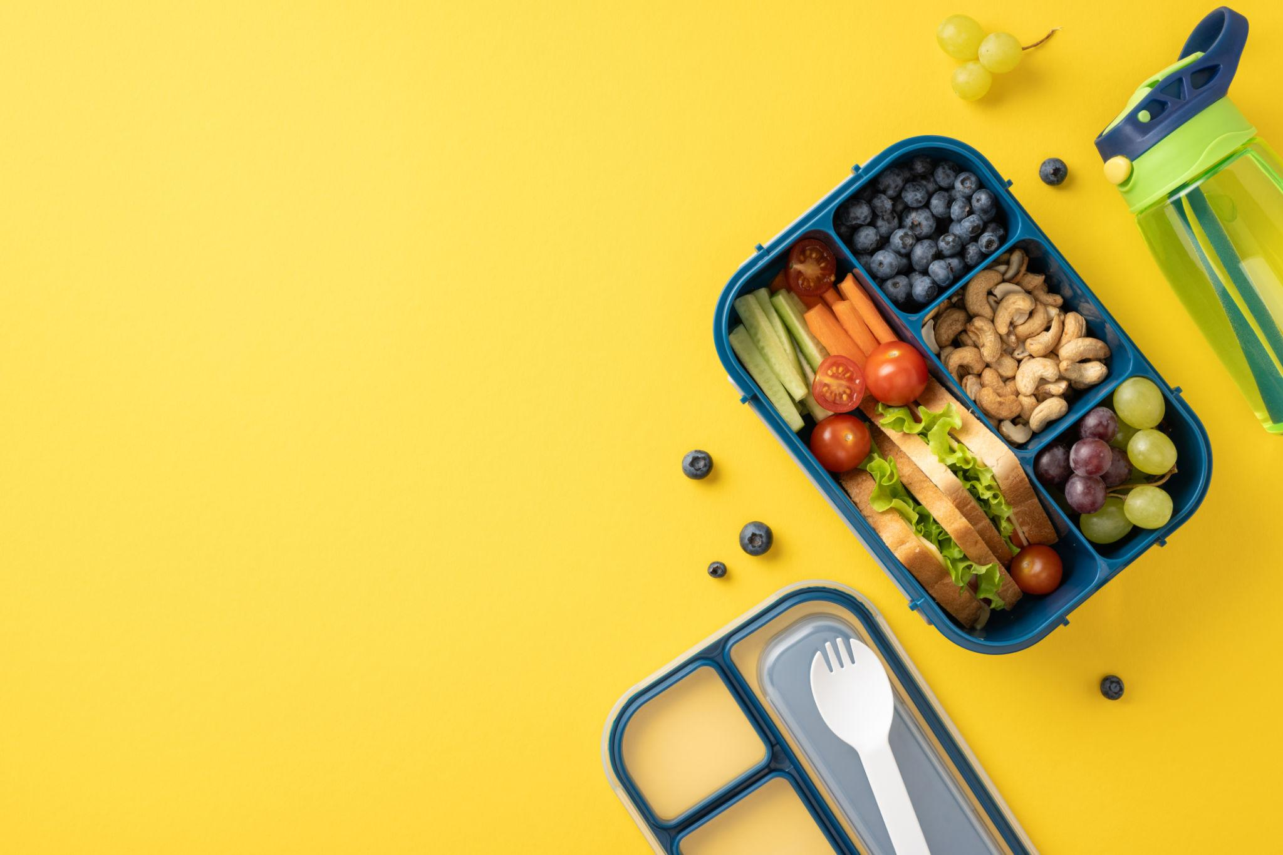
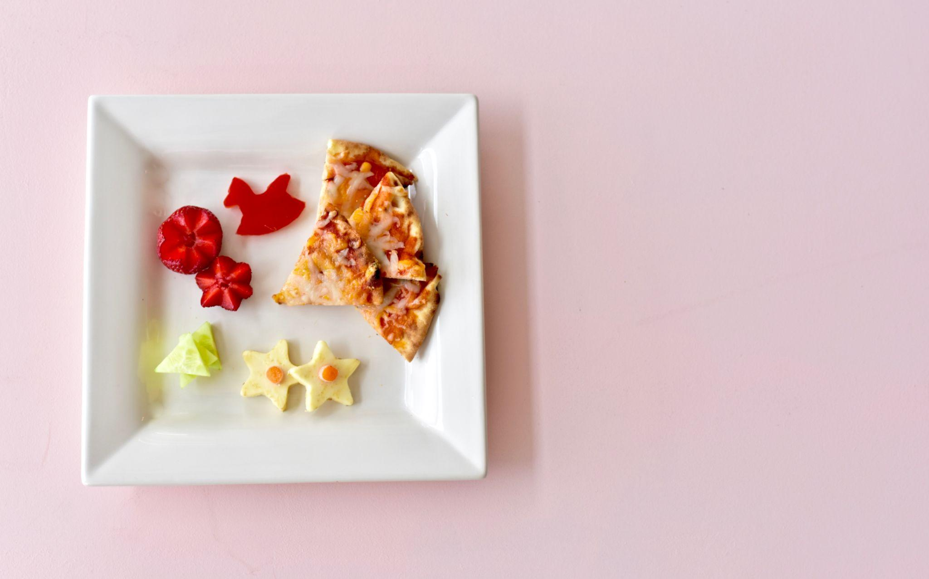

Content Experience:
Headline (centered, bold):
👉 Little Tummies, Big Nutrition.

Subtext (gentle, reassuring):
“Fresh, balanced meals designed for young children—delivered directly to their school, every day.”

Primary CTA:
👉 “Get Started”
Secondary CTA:
👉 “View Weekly Menu”

What user should feel here:
- Emotional connection
- Visual trust
- Immediate clarity

🌿 3.2 TRANSITION SECTION — BUILDING TRUST
Instead of shouting features, you subtly reassure.

Content:
- Freshly prepared daily
- Designed for young taste preferences
- Hygienically handled and delivered
- Trusted by parents and schools

Design:
- Icon-based
- Clean spacing
- Minimal text

🔄 3.3 HOW IT WORKS (SIMPLICITY WINS)
This section reduces friction.

Flow:
- Sign up through our app
- Add your child and school
- Choose a plan
- Meals delivered daily

Visual:
- Step cards
- Friendly illustrations

🥗 3.4 FOOD EXPERIENCE (MAKE THEM HUNGRY + TRUST YOU)
This is not just “menu”—this is persuasion.

Visual Direction:
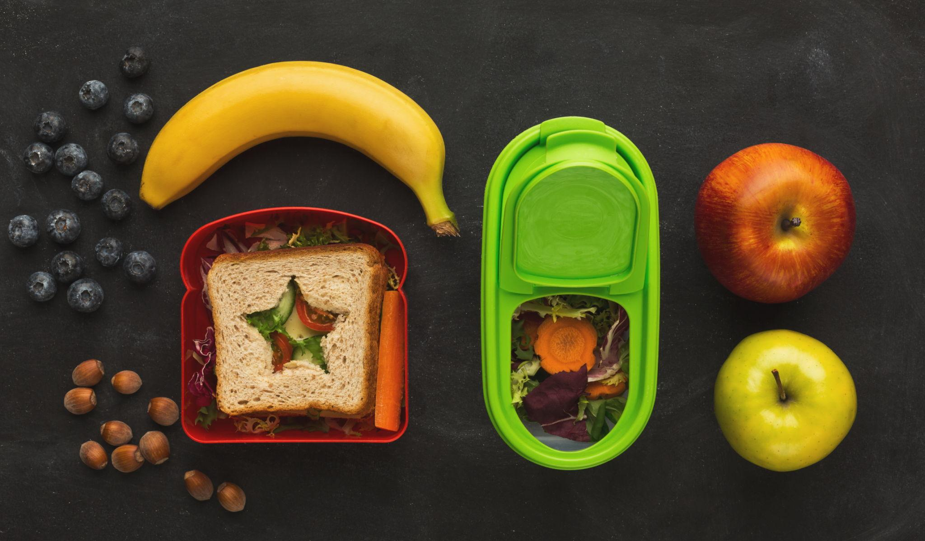
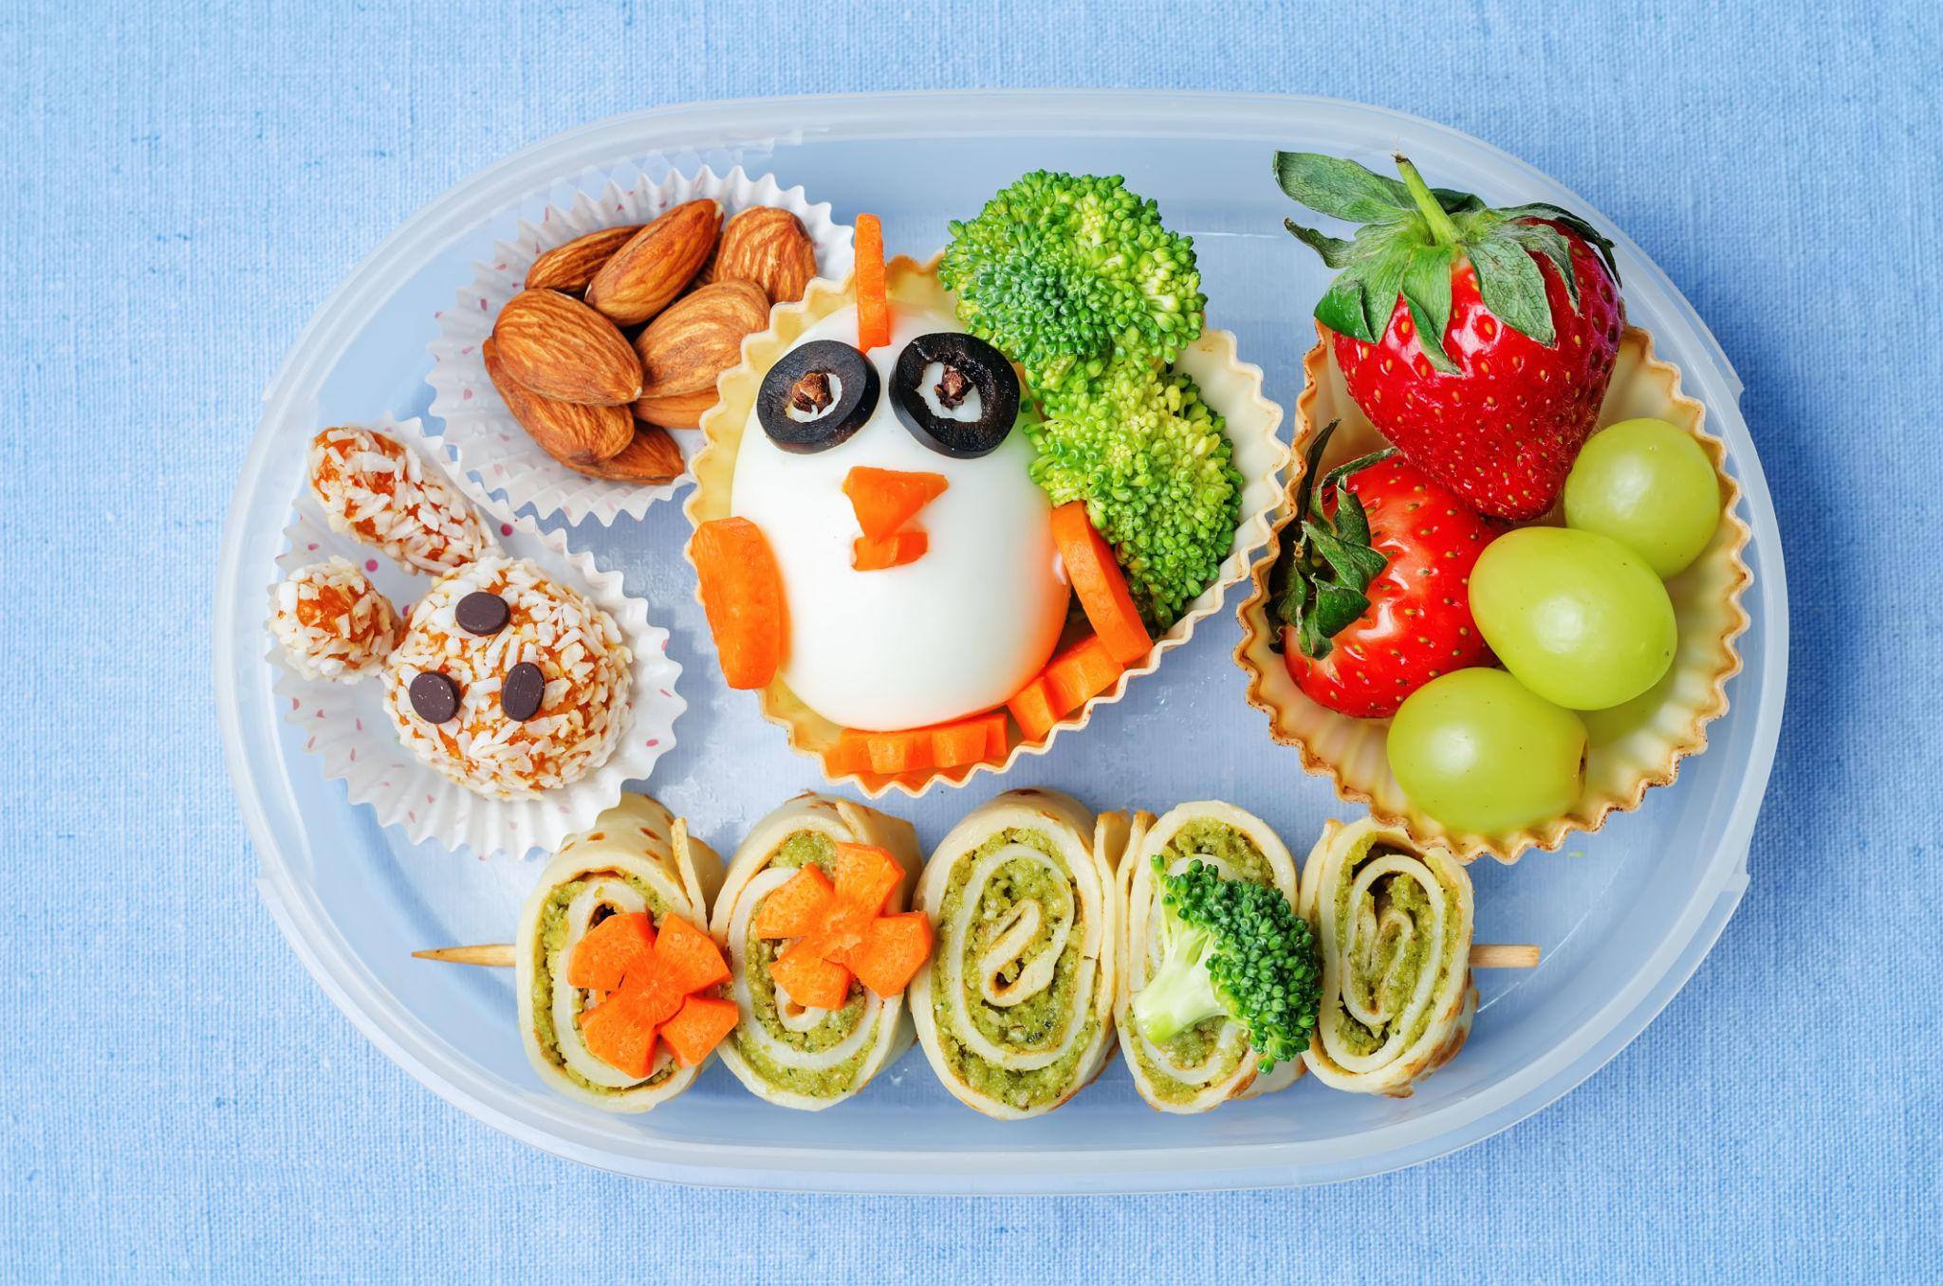
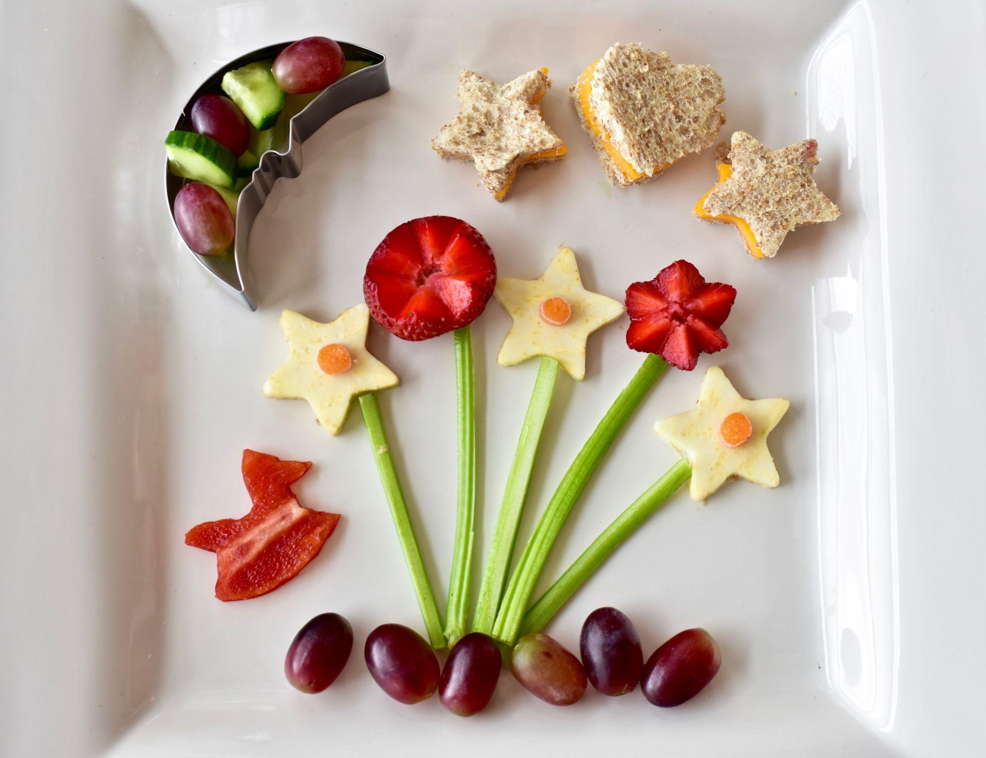
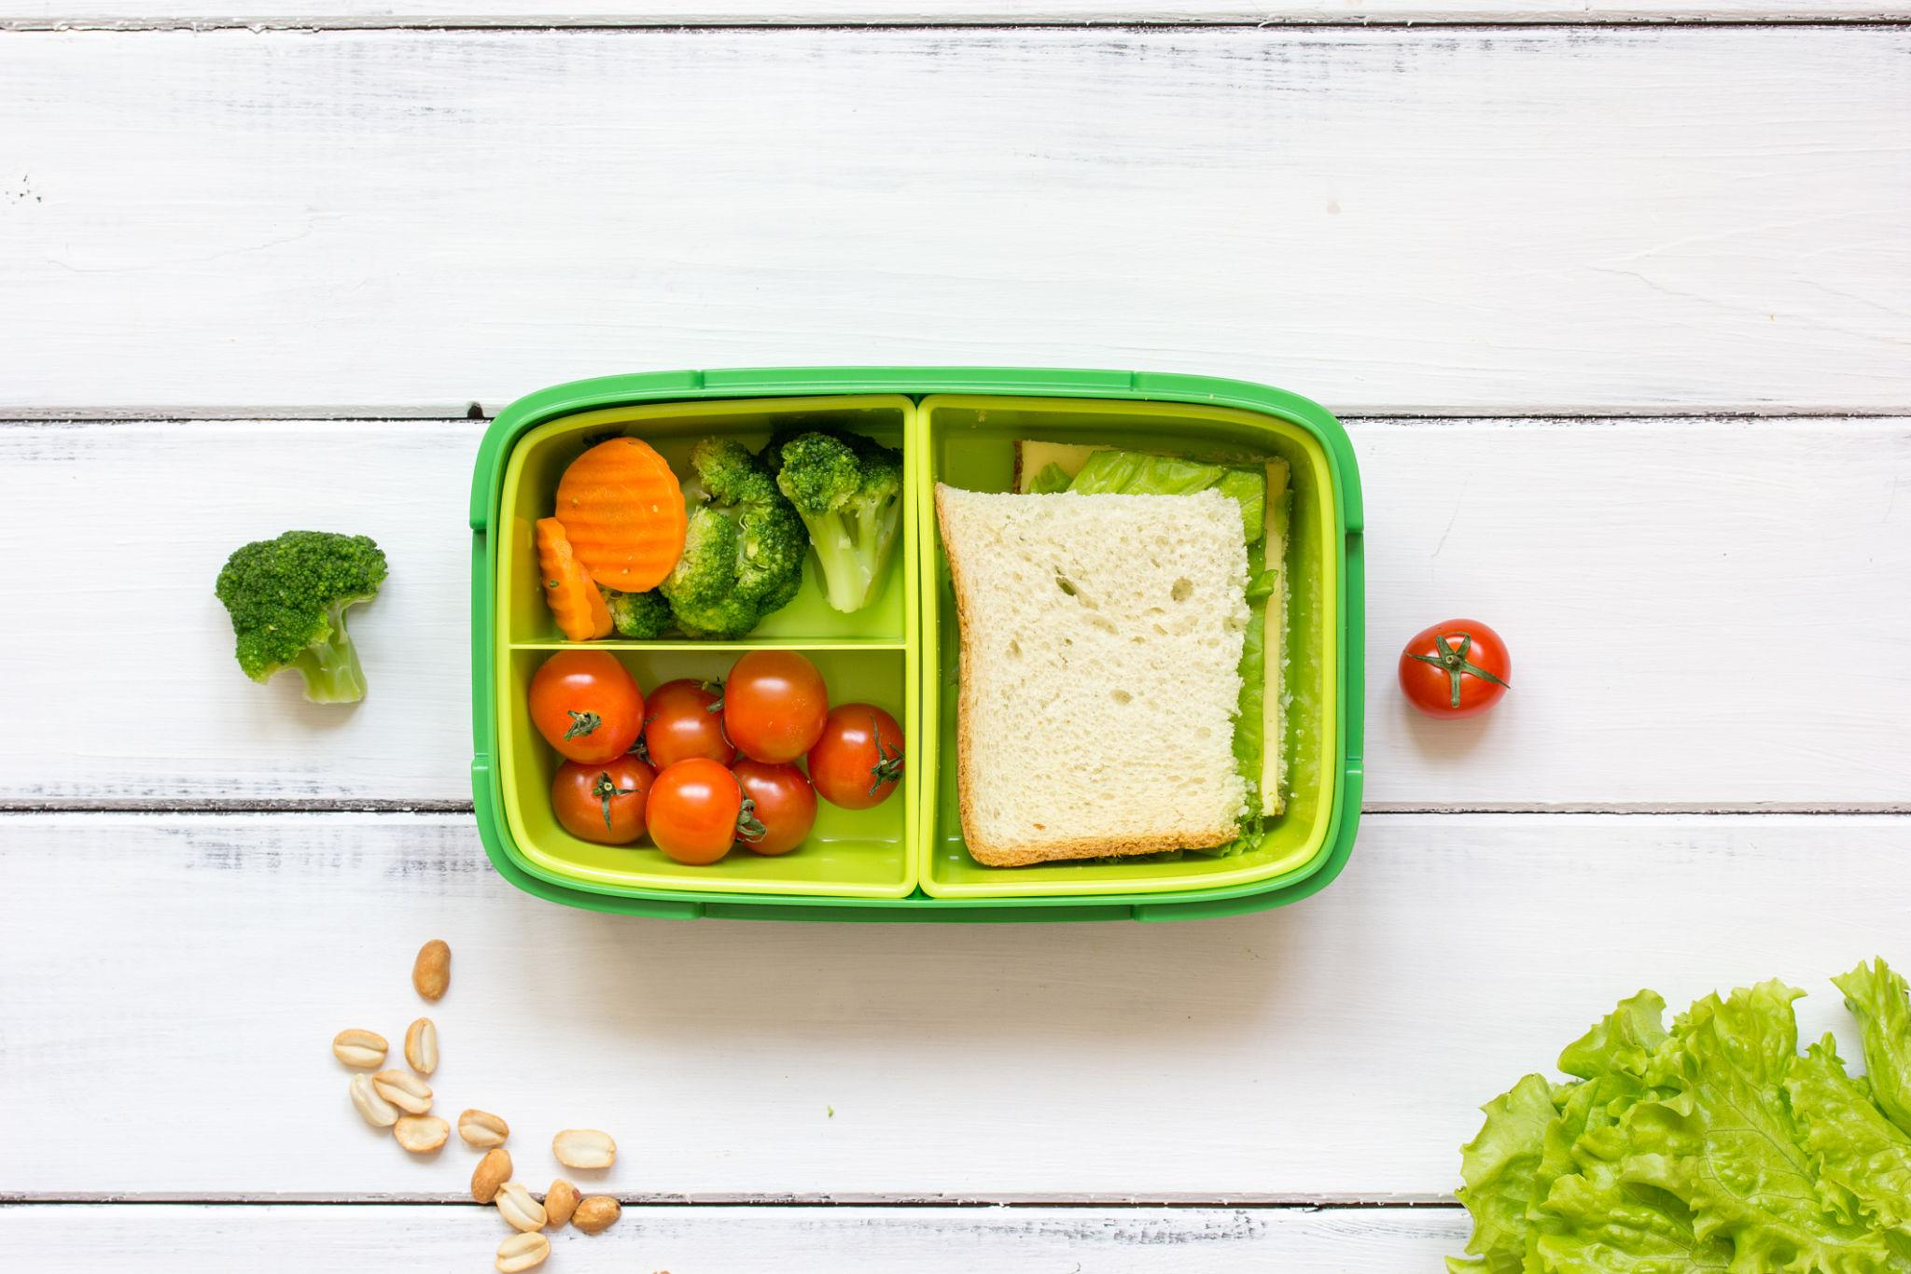
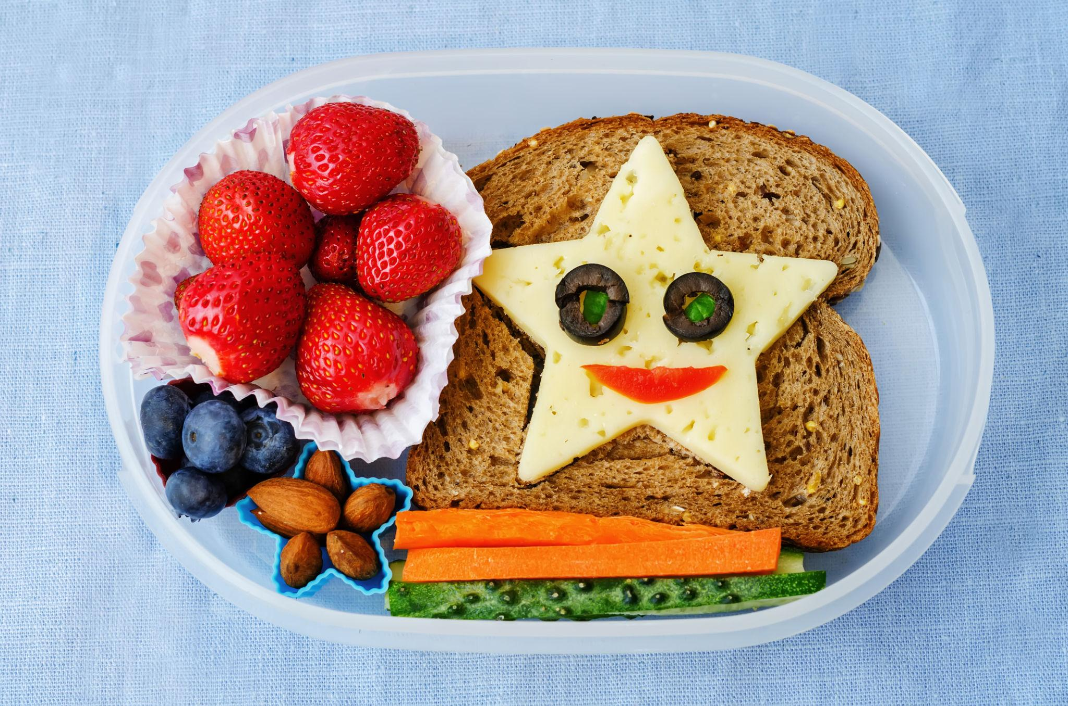
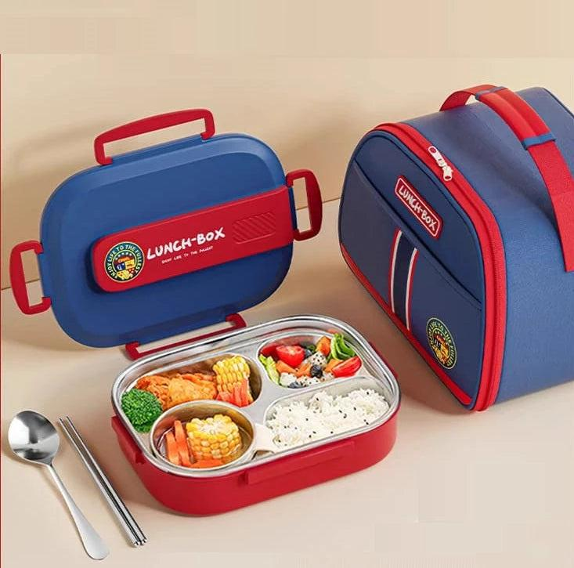
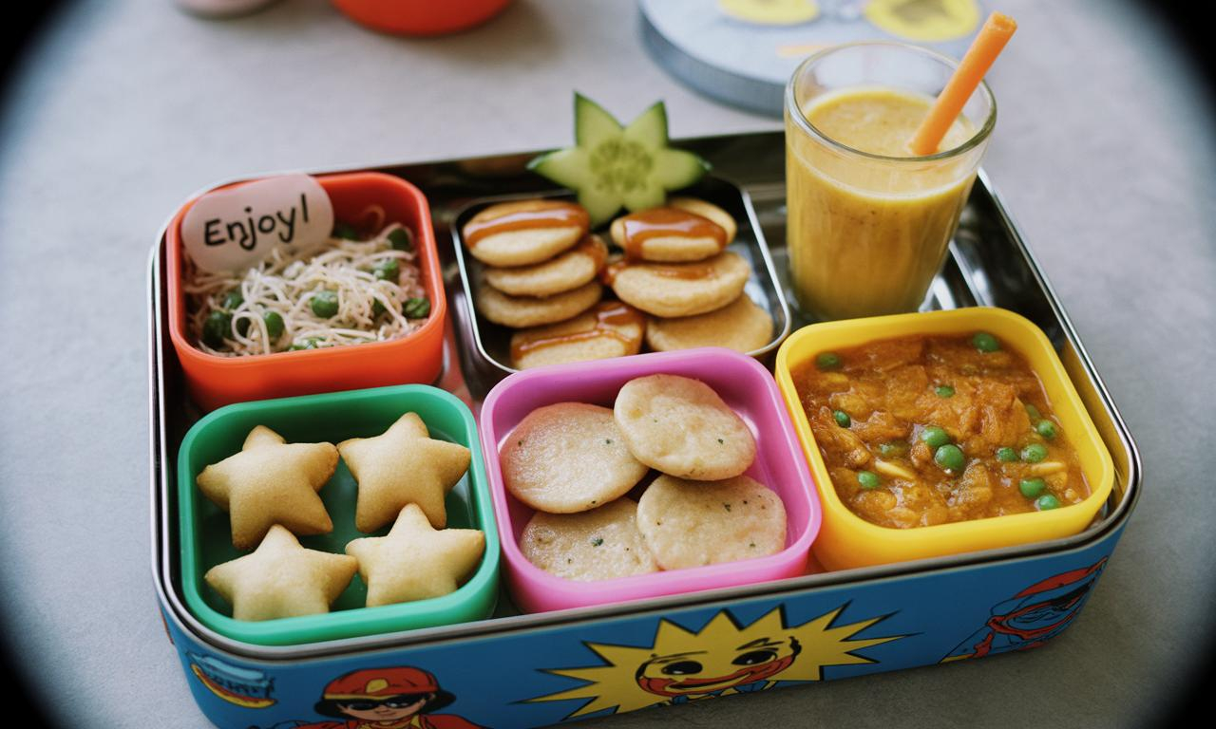

Content Tone:
“Our meals are thoughtfully designed to balance nutrition and enjoyment.”
- Variety to avoid boredom
- Familiar yet healthy choices
- Visually engaging meals

Sample Menu (simple table)

🧼 3.5 HYGIENE & SAFETY (TRUST BUILDER)
This section must feel calm, not aggressive.

Content:
“At Tiny Tummies, hygiene is not an add-on—it is a foundation.”
- Fresh ingredients
- Clean preparation
- Safe packaging
- Careful handling

Visual:
- Real kitchen shots
- Clean surfaces
- Staff in hygiene gear

🏫 3.6 SCHOOL PARTNERSHIP (B2B TRUST)

Emotional Hook:
“Healthy habits grow stronger when supported by the right environment.”

Content:
We work closely with schools to:
- Ensure consistent meal delivery
- Support better nutrition habits
- Reduce parent concerns

CTA:
👉 “Partner With Us”

💳 3.7 PRICING (CLARITY > SMARTNESS)

Presentation:
Two simple cards:

Starter Plan
- Weekly meals (5 days)

Growth Plan
- Monthly meals (20–22 days)

Tone:
- Transparent
- No hidden complexity

📱 3.8 APP EXPERIENCE (CONTROL FOR PARENTS)

Content:
“Everything you need, right at your fingertips.”
- Track meals
- View menu
- Mark absence
- Manage plan

Include links:
👉 Google Play Store
👉 Apple App Store

❤️ 3.9 ABOUT US (HUMAN CONNECTION)

Tone:
Story-driven, not corporate.

Content:
Tiny Tummies started with a simple observation:
Parents care deeply about what their children eat…
but daily life makes consistency difficult.
We built Tiny Tummies to support that care—
with structure, simplicity, and trust.

📞 3.10 CONTACT
Simple, accessible:
- Phone
- WhatsApp
- Email
Tone:
👉 Friendly, open, approachable

🧠 4. MICRO DETAILS (WHAT MAKES THIS “TOP NOTCH”)

🔹 Copy Style
- Short sentences
- Easy words
- Emotional but grounded

🔹 Button Language
Instead of:
- Submit ❌
Use:
- Get Started
- Explore Menu
- Join Tiny Tummies

🔹 Empty States (important for app mindset)
- “No meals yet? Let’s get started!”
- “Plan your child’s meals today”

🔹 Consistency Rule
Everywhere:
👉 “Little Tummies, Big Nutrition.”
Not variations. Not experiments.

⚠️ 5. FINAL REALITY CHECK
If your website:
- Looks too playful → parents won’t trust hygiene
- Looks too serious → kids brand lost
- Looks too complex → users drop
👉 You fail.

🧠 FINAL POSITIONING (LOCK THIS IN YOUR HEAD)
Tiny Tummies is:
👉 A daily support system for parents
👉 A habit-building platform for kids
👉 A trust partner for schools

