Module 6.1 : Student Fee Payment

Allow the student to login to the portal and display the students bills which are due. Every
student may have a different bill amount or even multiple bills. Allow the student to pay the bill
in multiple instalments and track all of them towards the total payment.

Tables:

Table name = bill
Name of Column | Data Type | Constraints
bill_id | int | PK, AUTO_INCREMENT
amount | int | NOT NULL
bill_date | varchar(255) | NOT NULL
description | varchar(255)
student_id | int | FK REFERENCES student.student_id, NOT NULL

Table name = student
Name of Column | Data Type | Constraints
student_id | int | PK, AUTO_INCREMENT
email | varchar(255) | NOT NULL, UNIQUE
first_name | varchar(255) | NOT NULL
last_name | varchar(255)
password | varchar(255) | NOT NULL
roll_number | varchar(255) | NOT NULL, UNIQUE

Table name = receipt
Name of Column | Data Type | Constraints
receipt_id | int | PK, AUTO_INCREMENT
amount_paid | int | NOT NULL
date_of_payment | varchar(255) | NOT NULL
bill_id | int | FK REFERENCES bill.bill_id, NOT NULL

Conceptual Design:
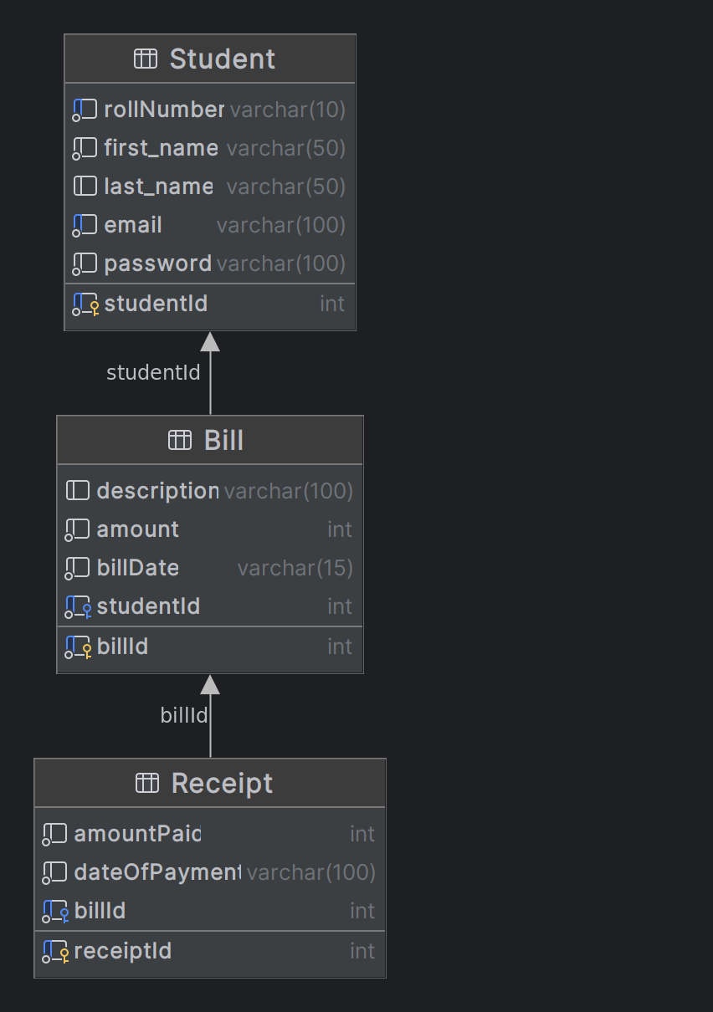
Database Scripts:

1) CREATE TABLE student (
student_id int NOT NULL AUTO_INCREMENT,
email varchar(255) NOT NULL,
first_name varchar(255) NOT NULL,
last_name varchar(255) DEFAULT NULL,
password varchar(255) NOT NULL,
roll_number varchar(255) NOT NULL,
PRIMARY KEY (student_id)
);

2) CREATE TABLE bill (
bill_id int NOT NULL AUTO_INCREMENT,
amount int NOT NULL,
bill_date varchar(255) NOT NULL,
description varchar(255) DEFAULT NULL,
student_id int NOT NULL,
PRIMARY KEY (bill_id)
);

3) CREATE TABLE receipt (
receipt_id int NOT NULL AUTO_INCREMENT,
amount_paid int NOT NULL,
date_of_payment varchar(255) NOT NULL,
bill_id int NOT NULL,
PRIMARY KEY (receipt_id)
);

4) ALTER TABLE bill
ADD FOREIGN KEY (student_id)
REFERENCES student (student_id);

5) ALTER TABLE receipt
ADD FOREIGN KEY (bill_id)
REFERENCES bill (bill_id);

6) INSERT INTO student (email, first_name, last_name, password, roll_number) VALUES (‘Anuja.Gode@iiitb.ac.in’, ‘Anuja’, ‘Gode’, ‘password’, ‘MT2023039’);

7) INSERT INTO student (email, first_name, last_name, password, roll_number) VALUES (‘Shatakshi.Tiwari@iiitb.ac.in’, ‘Shatakshi’, ‘Tiwari’, ‘password’, ‘MT2023013’);

8) INSERT INTO student (email, first_name, last_name, password, roll_number) VALUES (‘Sejal.Tapdiya@iiitb.ac.in’, ‘Sejal’, ‘Tapdiya’, ‘password’, ‘MT2023063’);

9) INSERT INTO bill (amount, bill_date, description, student_id) VALUES (‘80000’, ‘12/12/2023’, ‘Tuition fee’, ‘1’);

10) INSERT INTO bill (amount, bill_date, description, student_id) VALUES (‘10000’, ‘12/12/2023’, ‘Lab fee’, ‘1’);

11) INSERT INTO bill (amount, bill_date, description, student_id) VALUES (‘60000’, ‘23/12/2023’, ‘Tuition fee’, ‘2’);

12) INSERT INTO bill (amount, bill_date, description, student_id) VALUES (‘65000’, ‘23/12/2023’, ‘Tuition fee’, ‘4’);

