Infosys Springboard Virtual Internship 6.0 Completion Report

Team Details
G. Chaitra Sai Chakravarthi | Designed and developed the Upload API, User API, Quiz API, and Dashboard API; integrated multiple modules with the backend ensuring smooth data communication between frontend and database.
B. Abarna | Designed and developed the Upload API, Notification API, and Progress API; contributed to backend optimizations and ensured consistency across APIs.
Abhijit Bheemavarapu | Designed and developed the Quiz API and Mock Test Submission modules; contributed to backend testing and validation logic.
Hari Vinay | Designed and developed the Study Plan API; ensured efficient data retrieval and management for personalized study plans.
Hemanth Tavva | Designed and developed the Upload API; contributed to handling secure file transactions and data validation.
Phani | Designed and developed the Notification API and Progress API; optimized backend responses for real-time updates and analytics.
Poluri Jayachandra | Designed and developed the Study Plan API; supported integration and ensured seamless connection between backend logic and database models.
Siddhi Vinayak | Designed and developed the Mock Test API and Submission module; implemented efficient evaluation logic and backend workflow for test handling.

Batch Number 6.0
Start date 13th August 2025
Names: Ganapaneni Chaitra Sai Chakravarthi
Internship Duration: 8 Weeks

1. Project Title
AI-Integrated Web Tool for Personalized Study Planning

2. Project Objective
The main goal of the AI Tutor project was to develop an intelligent, adaptive learning platform that automates the creation of personalized study plans and quizzes. For the organization, this project aimed to create a scalable, data-driven educational tool that enhances student engagement and learning outcomes by leveraging AI and modern web technologies, positioning it as a potential solution in the EdTech market.

3. Project description in detail
The AI Tutor is a full-stack web application designed to personalize a student's learning journey. My role was on the backend team, where our approach was to build a robust, secure, and scalable API-driven architecture.
Our Approach:
We followed an Agile methodology, breaking down the development into four 2-week milestones. The backend development was tightly integrated with the frontend, requiring us to establish clear API contracts early on.
Technology Used:
- Backend Server: Node.js with the Express.js framework.
- Database: MongoDB for storing user profiles, syllabus data, topics, progress, and quiz attempts.
- AI & Processing: A Python microservice using PyMuPDF for PDF parsing and spaCy for NLP-based topic extraction.
- Vector Database: FAISS (or Pinecone) to store embeddings of syllabus topics and questions, enabling semantic search for future AI features.
- Authentication: Integrated with Firebase Auth via the frontend, with user context managed in our MongoDB.
- Frontend: React.js, Firebase, Tailwind CSS, JavaScript

4. Timeline Overview
Week | Activities Planned | Activities Completed
Week 1 | Backend project setup, Define DB Schemas | Set up Node.js/Express server, connected to MongoDB, defined User, Syllabus, and Topics schemas.
Week 2 | Build File Upload API, Connect Python Parsing Service | Created POST /upload-syllabus endpoint, integrated Python service for PDF parsing and topic extraction.
Week 3 | Develop Study Plan & Quiz Generation APIs | Built GET /study-plan/:userId and GET /quiz endpoints with logic to fetch and structure data from MongoDB.
Week 4 | Implement Quiz Submission & Progress APIs | Created POST /submit-quiz and GET /progress/:userId endpoints, including scoring logic and progress calculation.
Week 5 | Build Mock Test & Notifications APIs | Developed GET /mock-test and GET /notifications/:userId endpoints with more complex scoring and alert logic.
Week 6 | Enhance Progress API & Final Integration Testing | Added weekly summaries and mock test history to the Progress API. Conducted end-to-end API testing with Postman.
Week 7 | Bug Fixing and Integration | fixed issues with quiz scoring and mock test
Week 8 | Final Documentation & Deployment Prep | Documented the project and updated it in Github

5a. Key Milestones
Milestone | Description | Date Achieved
Project Kickoff | Introduction to the project team, mentor, and coordinator. Overview of internship guidelines, project expectations, and deliverables. | 13th August 2025
Prototype/First Draft | Completion of Milestone 1, including backend setup, user authentication integration, syllabus upload API, and the initial PDF parsing service. | 26th August 2025
Mid-Term Review | Review of progress till Milestone 2. Successfully developed and integrated core APIs for generating study plans, delivering quizzes, and tracking user progress. | 9th September
Final Submission | Completion of Milestone3 and 4, Technical completions of the project. All backend APIs for mock tests, notifications, and enhanced analytics are finalized, tested, and documented for deployment. | 3rd October
Presentation | Preparation and delivery of the final presentation and demo to the team. Includes mock presentation practice and feedback sessions. | Tentative

5b. Project execution details
The project was executed in a phased manner as per the milestones. As a backend team member, our execution involved:
- Foundation (Milestone 1): We started by setting up the Node.js/Express server and designing the MongoDB schemas to ensure data was structured correctly from the beginning. The file upload API (/upload-syllabus) was created to receive files from the frontend, which were then sent to our Python service for parsing. The parsed topics and their vector embeddings were stored in MongoDB and FAISS.
- Core Logic (Milestone 2): We developed the algorithms for the GET /study-plan/:userId API, which divided the user's syllabus topics across their available study hours. The quiz system involved two APIs: GET /quiz to fetch questions and POST /submit-quiz to handle answers, perform scoring, and update the user's progress in the database. The GET /progress/:userId API aggregated this data for the front-end charts.
- Advanced Features (Milestone 3): We implemented the full-length GET /mock-test API, which assembled questions from different subjects. The POST /submit-mock-test endpoint included more complex scoring logic, including section-wise results. The GET /notifications/:userId API queried the database for upcoming deadlines and performance-based alerts.
- Integration & Polish: Throughout the project, we maintained constant communication with the frontend team, sharing API contracts (JSON structures) and testing endpoints with Postman to ensure seamless integration.

6. Snapshots / Screenshots
Include relevant visuals such as screenshots of work done, dashboards, code snippets, or designs.
/api/dashboard
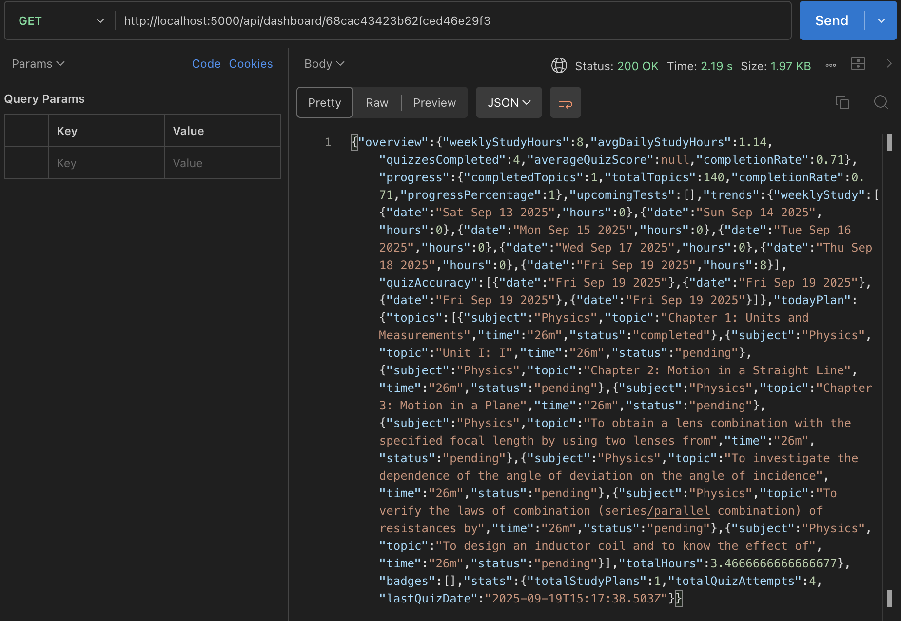
/progress/:userId
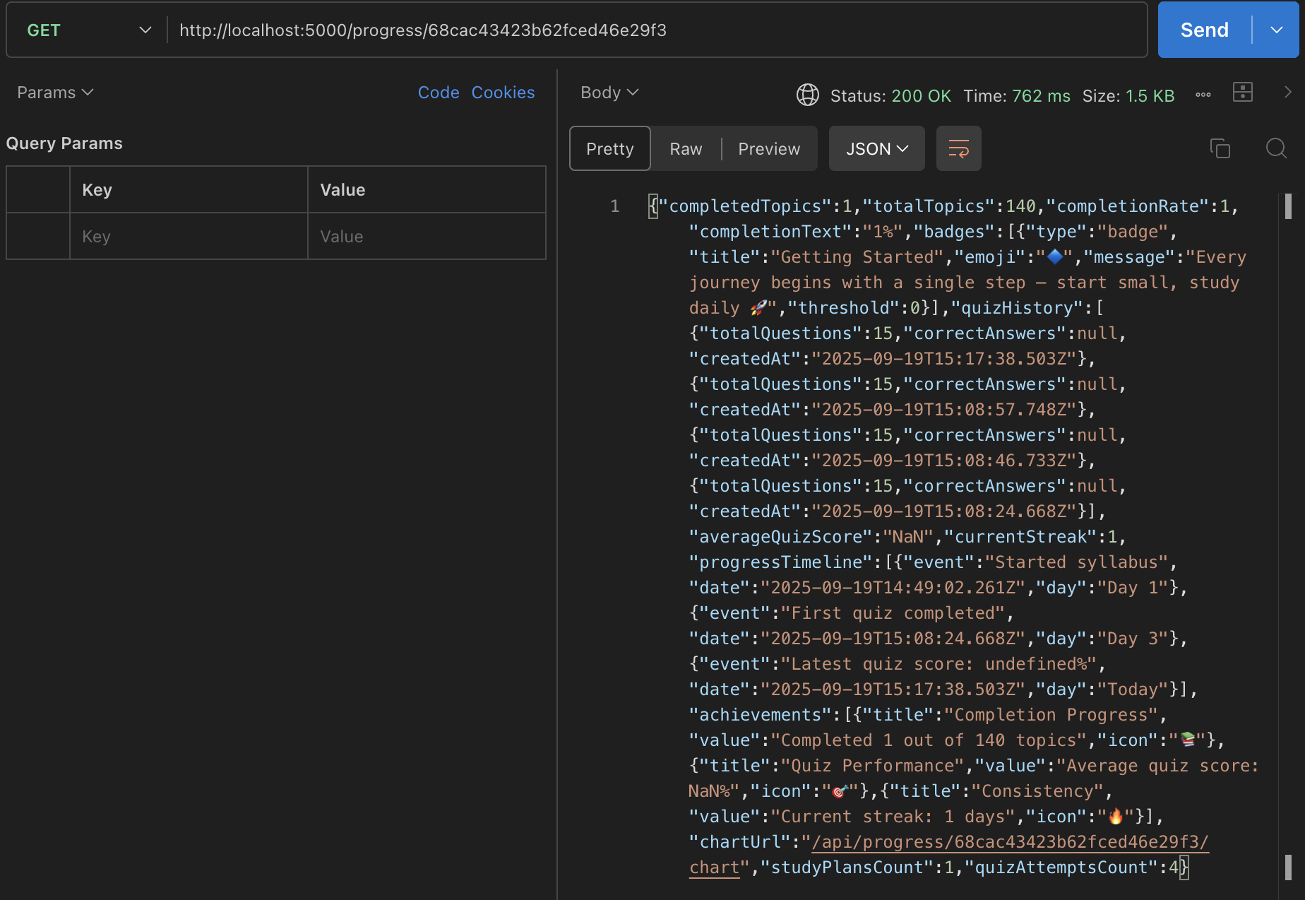

/upload-syllabus
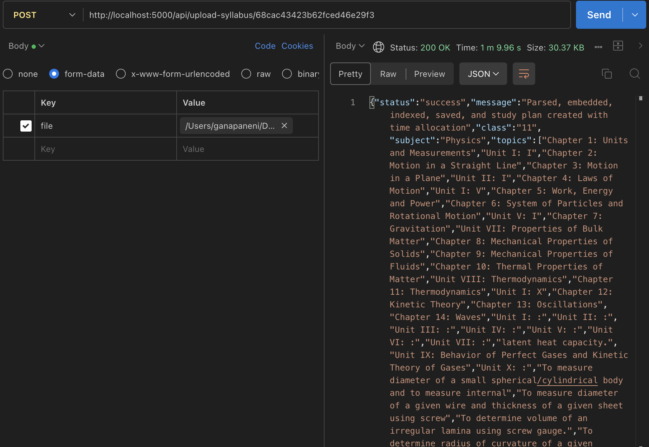
/quiz/submit
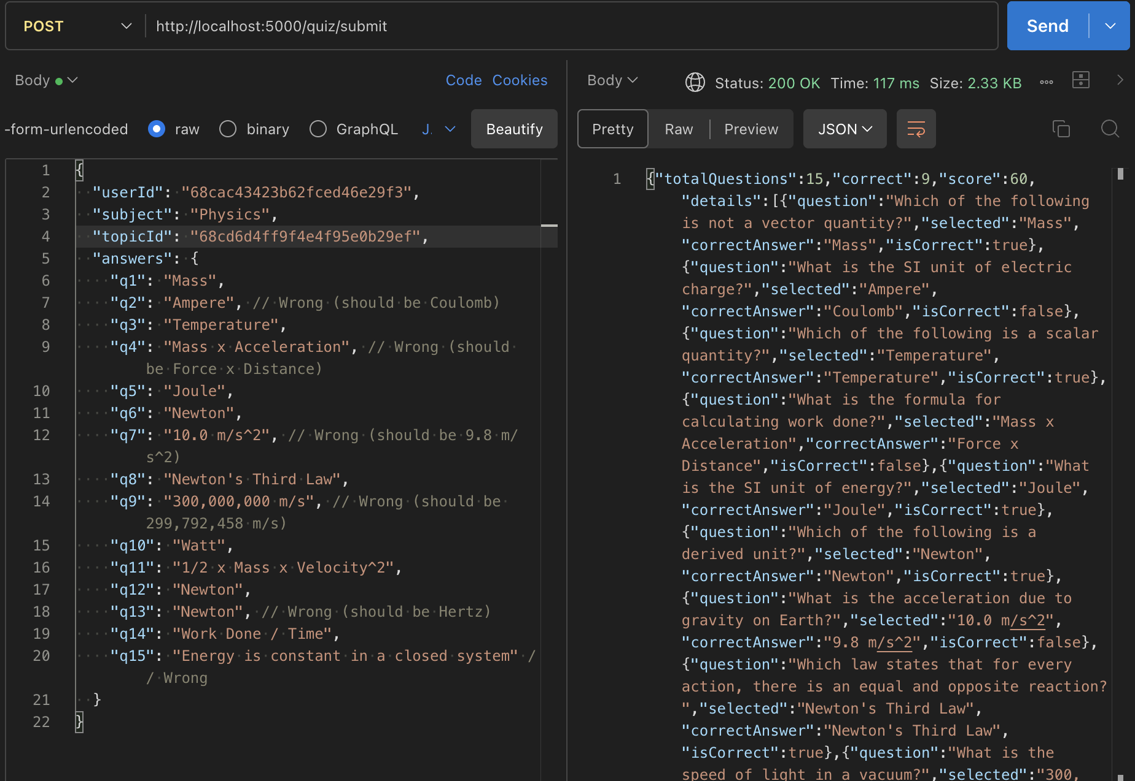

7. Challenges Faced
- Challenge 1 (Technical): Integrating the Python parsing service with Node.js. Initially, file passing and data exchange between the two services were unstable.
  - Resolution: We designed a robust RESTful API for the Python service, ensuring proper error handling and data formatting, which made the integration reliable.
- Challenge 2 (Technical): Designing an efficient algorithm for the Study Plan API. Dynamically allocating topics based on available hours and subject difficulty was complex.
  - Resolution: We implemented a priority-based scheduling algorithm that considered topic order and estimated time, which was then refined after feedback.
- Challenge 3 (Communication): In the start we teammates were all from different places and different colleges, getting to know and work together was a bit challenging
  - Resolution: We sorted out this problem by pulling and pushing the codes in GitHub and working through the class interaction.

8. Learnings & Skills Acquired
- Technical Skills:
  - Backend Development: Gained deep, practical experience in building RESTful APIs with Node.js and Express.
  - Database Management: Learned to design and manage both NoSQL (MongoDB) and Vector Databases (FAISS).
  - AI Integration: Understood how to integrate machine learning microservices (Python/spaCy) into a JavaScript backend.
  - API Design: Mastered the skill of creating clear, consistent, and well-documented API contracts for frontend-backend integration.
- Soft Skills:
  - Collaboration: Enhanced my ability to work effectively in a cross-functional team, constantly communicating with front-end developers.
  - Problem-Solving: Improved my debugging and logical reasoning skills by tackling complex challenges like adaptive scheduling and data syncing.
  - Project Management: Experienced the Agile development lifecycle firsthand, delivering features in iterative sprints.

9. Testimonials from team
This internship was a deep dive into real-world backend development. Successfully building the system that powers the entire AI Tutor application, from parsing complex PDFs to generating intelligent quizzes, was incredibly rewarding. It was a great experience to see our APIs come to life through the front-end team's work.

10. Conclusion
This internship provided an invaluable opportunity to apply academic knowledge to a complex, end-to-end software project. Working on the backend of the AI Tutor allowed me to understand the architecture of data-driven web applications and the critical role of a robust server-side system. The experience solidified my career goal of becoming a backend engineer and provided me with a strong portfolio piece that demonstrates my skills in API development, database design, and AI integration.

11. Acknowledgements
I would like to express my sincere gratitude to Infosys Springboard for providing this incredible internship opportunity. A special thanks to our mentor, Revathi Venugari mam, for their invaluable guidance, patience, and technical insights throughout the project. I am also thankful to our coordinator, Pradyumna V sir, for their constant support and for ensuring a smooth and well-organized internship experience. Finally, I want to thank my teammates, both frontend and backend, for their collaboration and support, which made this journey both educational and enjoyable.

