***ASSIGNMENT-1***

***Date:31/10/2019***

***ANUJA B***

***ROLL NO:05***

**NODEJS WITH MONGODB**

**A simple project created with Nodejs, Express and Mongodb(CRUD).**

**Node.js** Node.js is an open-source server side runtime environment built on Chrome's V8 JavaScript engine. It provides an event driven, non-blocking (asynchronous) I/O and cross-platform runtime environment for building highly scalable server-side application using JavaScript.

[**Express**](https://expressjs.com/) is a framework for building web applications on top of Node.js. It simplifies the server creation process that is already available in Node. Node allows to use JavaScript as server-side language.

[**MongoDB**](https://www.mongodb.com/) is a database. This is the place where store the information for web websites (or applications).

**EJS** stands for Embedded JavaScript, which describes it well: it is essentially HTML with JavaScript -based features embedded for templating**.**

[**CRUD**](https://en.wikipedia.org/wiki/Create,_read,_update_and_delete) is an acronym for Create, Read, Update and Delete. It is a set of operations we get servers to execute (POST, GET, PUT and DELETE respectively). This is what each operation does:

* **Create (POST)** - Make something
* **Read (GET)**_- Get something
* **Update (PUT)** - Change something
* **Delete (DELETE)**- Remove something

### **Commands used to start the application**

* cd C:\NODEJS with MongoDB
* install npm
* npm express
* node app.js

**About Website**

A simple project created using ‘nodejs’ (as front-end) and ‘mongo-db’( as back-end).It is a CRUD application.Project contain a form to insert data. Also website contain a table to display inserted data value. Table contain a operations field which have buttons for update , delete data displayed in table.

**Buttons used**

**Add** : Button used to add data into operations table.

**Done** : Button used to confirm data entered ie, insert data into the Database.

**Delete**: Button used to Delete data entered ie, delete data from the Database.

**Edit**  : Button used to Update data inserted ie, update data inserted inside the Database.

**Fig:Screenshot of main page**

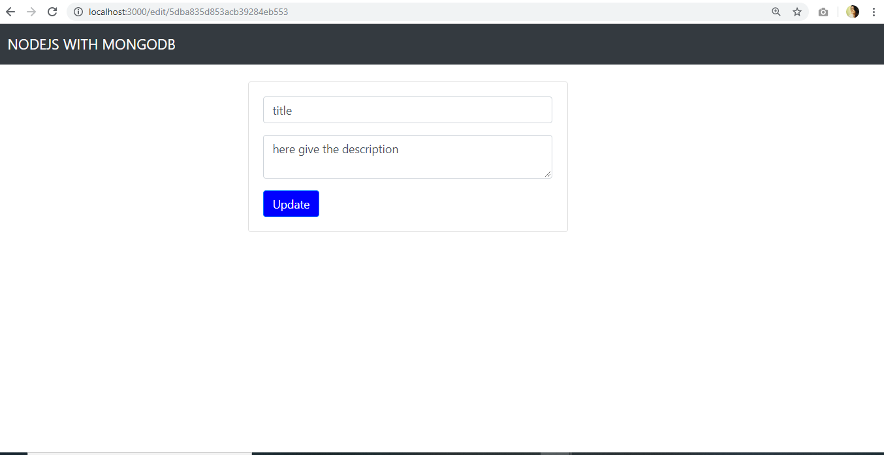

**Fig:screenshot of update page.**