Bean Classes:

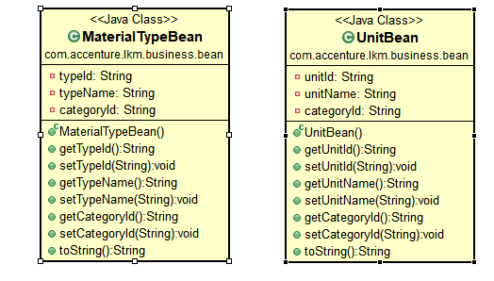

Entity classes: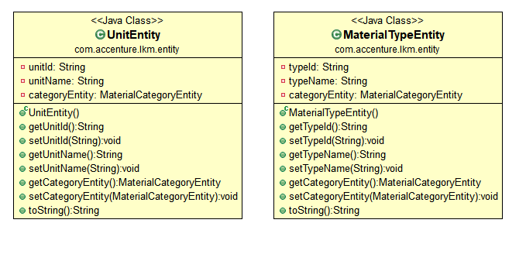

Note : For categoryEntity property in UnitEntity and MaterialTypeEntity class use below given annotations on the top of the property

@ManyToOne(cascade=CascadeType.***ALL***)

@JoinColumn(name="category_id")

**private** MaterialCategoryEntity categoryEntity;

DAO:

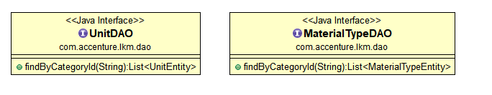

Service:

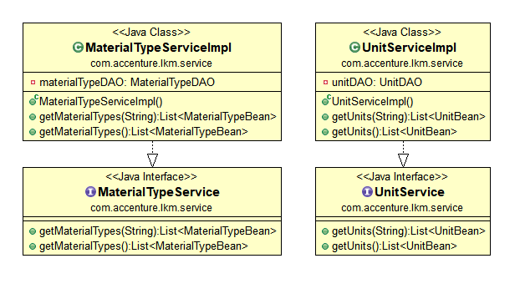

Controller:

