**Tailviewer**

1. Download link: - <https://kittyfisto.github.io/Tailviewer/>
2. Current stable version 0.8.0.
3. Tailviewer is supported on Windows 7, 8 and 10 and requires .NET 4.5 or higher.
4. To open log files drag and drop or open using the “+” button

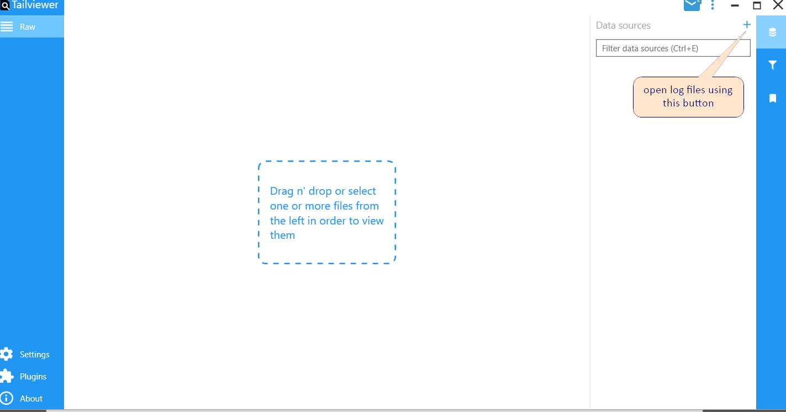

1. Can import multiple log files.

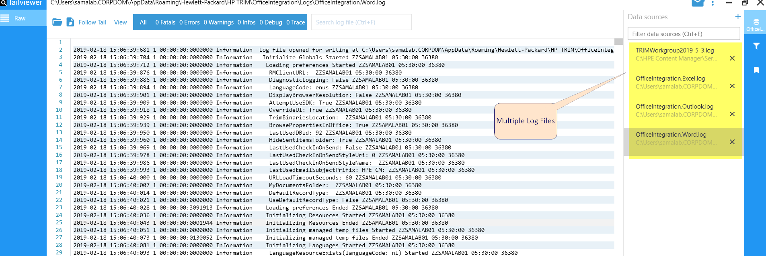

1. Can do quick search.

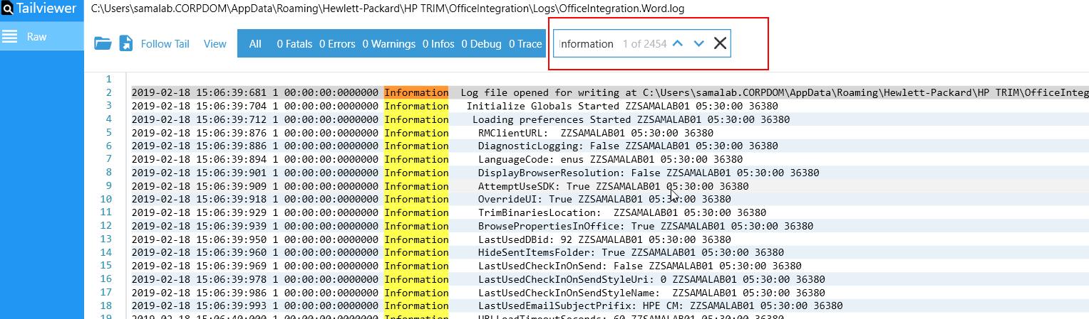

1. Can create quick filters to filter out specific data.

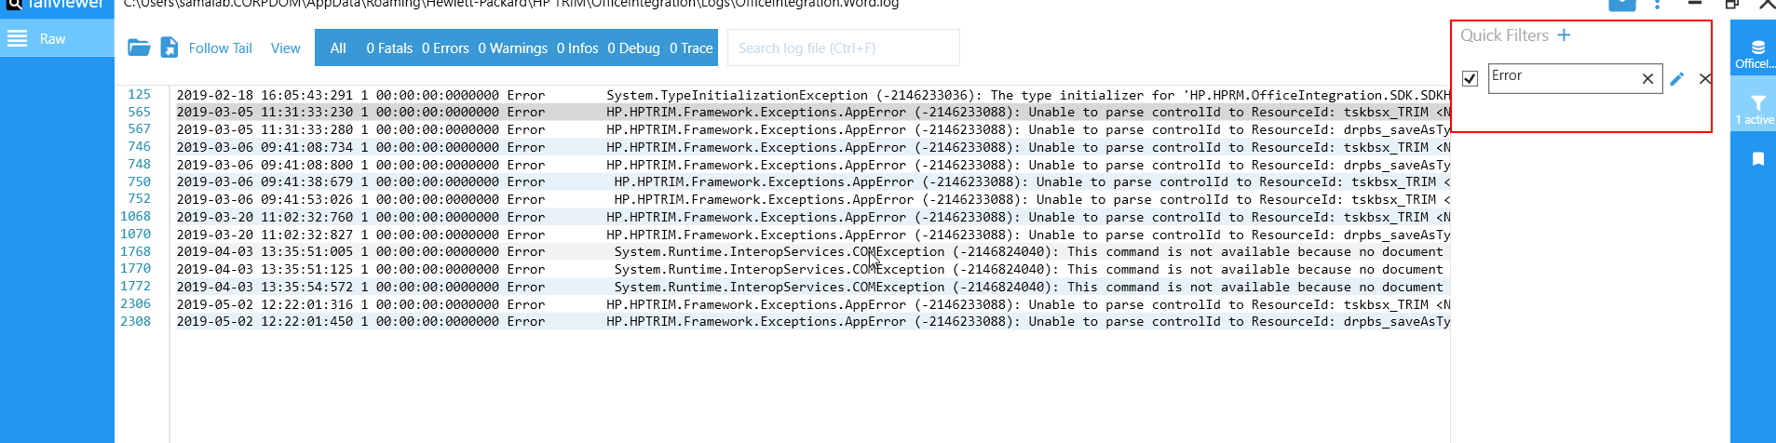

1. Different log files can be merged to analyse in a better way. Need to drag n drop one log file on other to merge. It will merge the log lines based on time stamp. If a log line doesn’t contain any timestamp it will skip those lines.

()

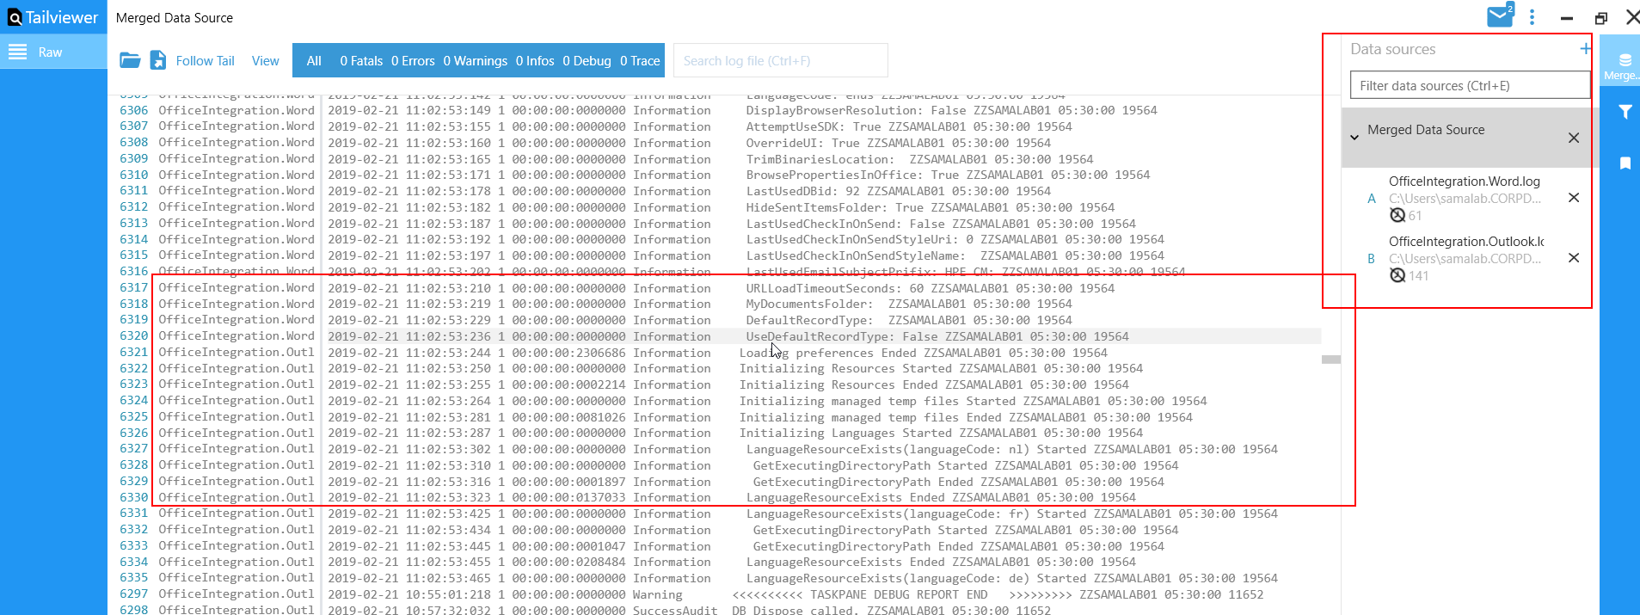

1. One can develop its own plugin and place it under installation directory/plugin folder to customize the log display.

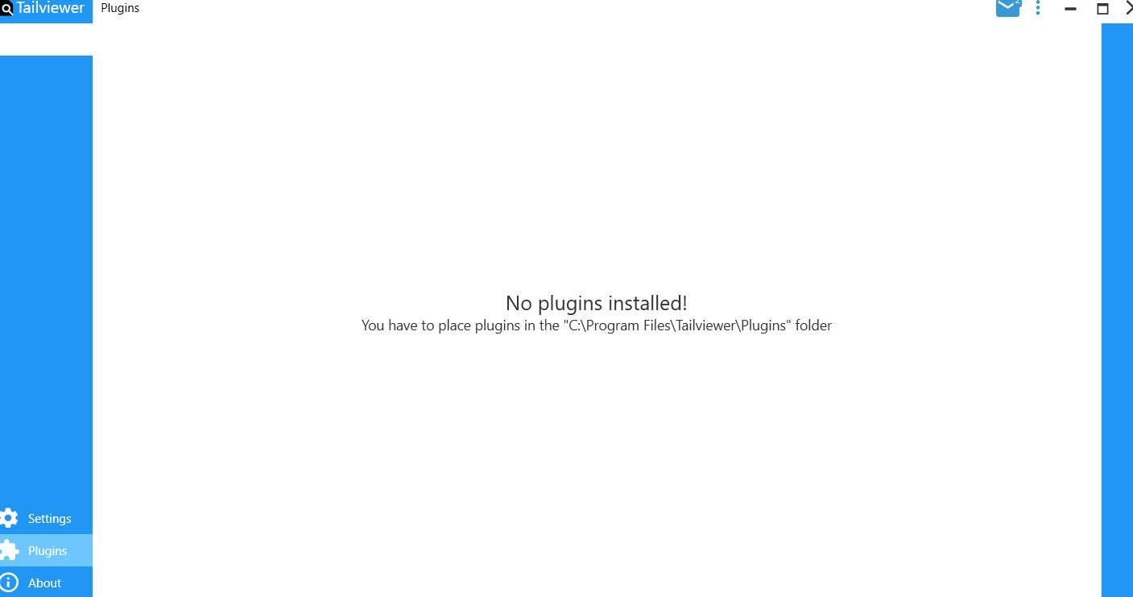

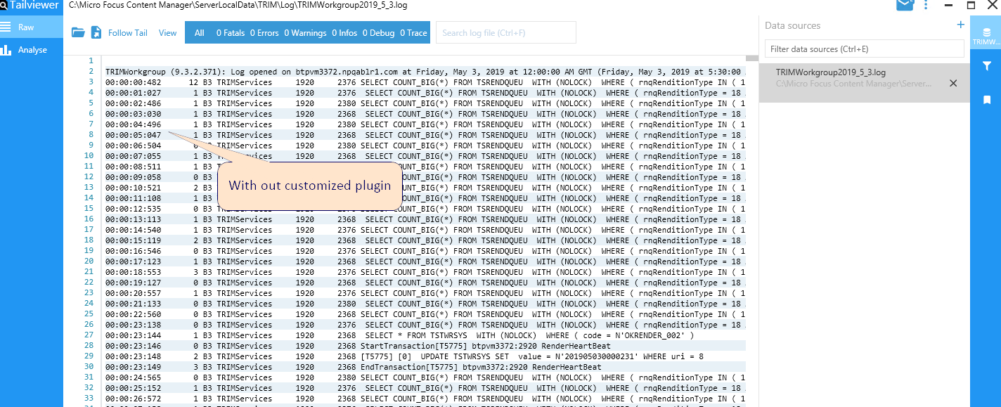

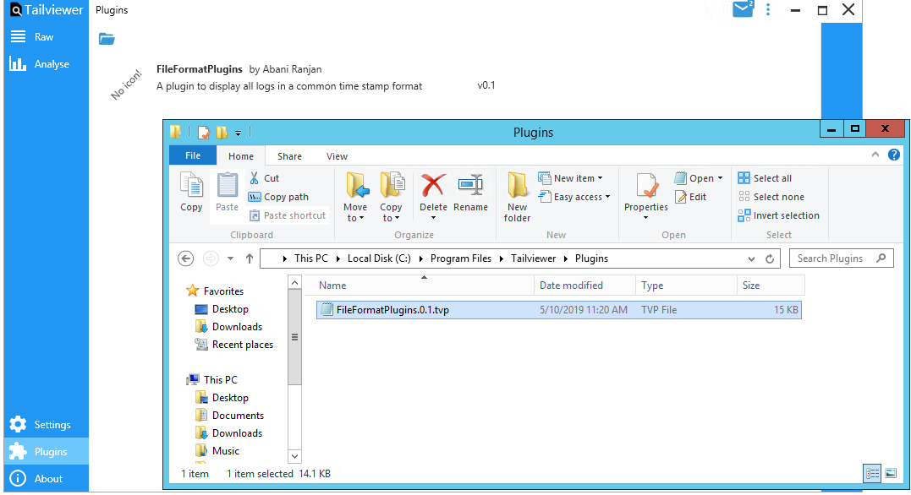

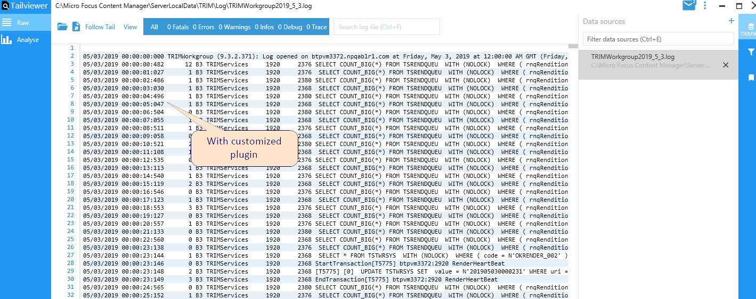

1. Documentations to develop plugins are available below.

<https://github.com/Kittyfisto/Tailviewer/blob/master/docs/DevelopingPlugins.md>

1. Log lines can be bookmarked as well.

