CHAPTER NO. 1

ORGANIZATIONAL STRUCTURE OF INDUSTRY & GENERAL LAYOUT
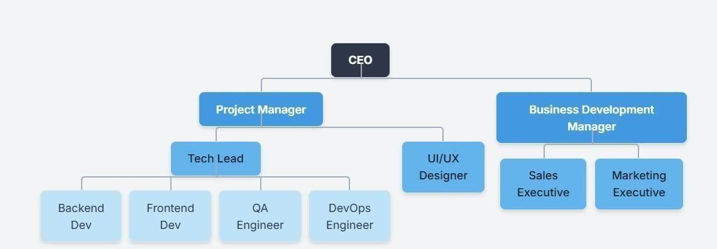
Fig 1.1 Hierarchy of Industry

CEO (Chief Executive Officer) :

- Responsibilities:

  - Defines company vision and strategic goals.
  - Makes high-level managerial decisions and over sees the entire company’s performance.
  - Builds partnerships, secures investments, and explores new markets.
  - Ensures organizational alignment and growth.

- Focus: Long-term business growth and leadership.

Project Manager :

- Responsibilities:

  - Plans and monitors projects from initiation to delivery.

  - Coordinates between teams (developers, designers, QA, etc.).

  - Conducts daily stand-ups, sprint planning, and retrospective meetings.

  - Ensures deadlines, scope, and budget are adhered to.
- Focus: Smooth execution of client projects and internal communication.

Tech Lead :

- Responsibilities:

  - Oversees technical implementation and architecture.
  - Assists developers in resolving complex coding or system issues.

  - Reviews code and maintains coding standards and documentation.

  - Acts as a bridge between developers and the project manager.
- Focus: Technical leadership and quality assurance.

UI/UX Designer :

- Responsibilities:
  - Designs the look and feel of applications using tools like Figma, Adobe XD, or Sketch.
  - Conducts user research and usability testing to enhance user experience.

  - Creates wireframes, mockups, and interactive prototypes.

- Focus: Visual design and user experience optimization.

Frontend Developer :

- Responsibilities:

  - Builds the client-side of web applications using React.js.
  - Works closely with the UI/UX designer to bring designs to life.
  - Implements responsive, interactive, and accessible interfaces.

  - May also work with React Native for mobile app development.
- Focus: User interface and user experience on the front-end.

Backend Developer : •
Responsibilities:

  - Develops RESTful APIs and microservices using Node.js and Express.js.
  - Integrates with databases (MongoDB), handles authentication, and manages server-side logic.
  - Ensures application performance and scalability.
- Focus: Server-side operations, API creation, and database management.

QA (Quality Assurance) Engineer :

- Responsibilities:

  - Writes and executes test plans (manual and automated).

  - Identifies bugs and performance issues before product release.
  - Works closely with developers to verify issue resolutions.
- Focus: Application quality and bug-free deployment.

DevOps Engineer :

- Responsibilities:

  - Automates development workflows (CI/CD pipelines).
  - Manages cloud infrastructure (AWS, Azure, etc.).

  - Oversees deployment, monitoring, and maintenance of applications.
- Focus: System stability, deployment automation, and scalability.

Business Development Manager :

- Responsibilities:

  - Identifies growth opportunities and potential clients.
  - Develops proposals, pricing models, and business plans.

  - Maintains client relationships and closes deals.
- Focus: Revenue growth and partnership development.

Sales Executive :

- Responsibilities:

  - Promotes services to potential customers.
  - Prepares presentations and demos for clients.

  - Negotiates terms and closes sales.
- Focus: Lead conversion and customer acquisition.

Marketing Executive :

- Responsibilities:
  - Promotes the company and services via digital marketing (SEO, SEM, SMM).
  - Runs ad campaigns, email newsletters, and manages website content.

  - Tracks analytics and optimizes marketing strategies.
- Focus: Brand visibility and inbound client generation.

CHAPTER NO. 2 INTRODUCTION TO INDUSTRY /ORGANIZATION

Introduction :-

Scalefull Technologies is a private limited liability partnership headquartered in Pune, Maharashtra, India. Incorporated on December 10, 2018, the company has established itself in the information technology sector by offering a comprehensive range of digital and business solutions. With an estimated team of 13 to 15 employees, Scalefull Technologies positions itself as a dedicated partner for businesses looking to enhance their digital presence and operational efficiency.

Company History and Vision:-

Founded in late 2018, Scalefull Technologies emerged in the bustling IT landscape of Pune with a clear mission: "Empowering Your Digital Presence." The company is dedicated to crafting exceptional digital experiences that drive business growth. Their approach is to work closely with clients to understand their unique objectives and deliver high-quality, tailored solutions.

Core Services and Products:-

Scalefull Technologies provides a diverse portfolio of services designed to meet a wide array of business needs. Here’s a more detailed look at their offerings:
- Custom Website Development: They specialize in creating visually appealing, user friendly, and responsive websites. Their goal is to build sites that not only look good but also captivate the target audience and function flawlessly across all devices.

- Web Application Design: The company develops robust, scalable, and customized web applications. These applications are designed to automate tasks, streamline business operations, and ultimately enhance productivity.
- E-commerce Solutions: Scalefull Technologies builds feature-rich, secure, and visually engaging e-commerce websites. Their focus is on creating online stores that drive conversions, boost revenue, and provide a seamless shopping experience for customers.
- Mobile Application Development: Recognizing the importance of mobile access, they offer development services for mobile applications, though specific platforms (iOS,
Android) are not detailed.
- IT and Business Consulting:
  - IT Consultancy: They provide expert guidance for both consumer-facing apps and complex enterprise-level solutions. o Business Consulting: They offer strategic advice to help businesses identify opportunities for growth and navigate the competitive landscape.
- Additional Services:

  - IT Training: To help bridge the skills gap, they provide training in various IT domains.
  - Recruitment and Staffing: They assist other companies with their talent acquisition needs, leveraging their expertise in the IT industry.

Business Process:-
Scalefull Technologies follows a structured 4-step process to ensure successful project delivery and client satisfaction It also focuses on maintaining quality, meeting project requirements, and providing effective solutions according to client needs:

- Discovery & Requirement Gathering: They begin by thoroughly understanding the client's objectives and gathering all necessary requirements for the project.
- Customized Strategy & Planning: Based on the initial discovery phase, they create a tailored strategy and a detailed project plan that aligns with the client's goals.
- Design & Development: Their team then designs and develops visually captivating and intuitive web-based solutions, bringing the project to life.
- Rigorous Testing & Deployment: Before launch, they conduct comprehensive testing to ensure a bug-free and seamless user experience, followed by a smooth deployment.

Company Information:-

  - Legal Name: Scalefull Technologies LLP

  - Incorporation Date: December 10, 2018

  - Location: Pune, Maharashtra, India

  - Number of Employees: 13-15

  - Directors (Designated Partners): As of late 2022, the company is led by Sushank Kishor Dahiwadkar and Swapneel Balasaheb Petkar, who joined the founding partner Sayali Kishor Dahiwadkar and Mohini Vasant Shukla

CHAPTER NO. 3
TYPES OF HARDWARE/SOFTWARE USED IN INDUSTRY

Hardware Infrastructure at Scalefull Technologies :

The hardware at Scalefull Technologies is centered around empowering their developers to build and test applications efficiently and ensuring reliable hosting for client projects.

Developer Workstations :

The primary tool for the development team at Scalefull Technologies is a high-performance laptop, allowing for flexibility and productivity.
  - Specifications:
    - Processor: Modern multi-core CPUs, typically from the Apple M-series (M2/M3) or Intel Core i7/i9 lines. o RAM: A standard of 16 GB, with senior developers and those working on larger projects using 32 GB to handle Docker and multiple concurrent processes smoothly.
    - Storage: Fast 512 GB or 1 TB NVMe SSDs are used to ensure rapid project loading, compilation, and boot times.
    - Setup: Each developer's workstation includes one or two high-resolution external monitors to maximize screen real estate and reduce eye strain.
  - Approximate Cost: The company invests between ₹90,000 and ₹3,00,000 per workstation, depending on the model and configuration.
  - Specific Use: This is where developers write code in VS Code, run local Node.js servers for testing, manage MongoDB instances, and collaborate with the team.

  - Routine Maintenance: Laptops undergo regular maintenance, including software updates, clearing of temporary files, and annual hardware diagnostic checks to ensure peak performance.

Cloud Server Infrastructure :

Scalefull Technologies operates on a cloud-first policy, leveraging leading providers to host development, staging, and production environments for their web and mobile applications.
  - Providers & Specifications:
- Primary Providers: Amazon Web Services (AWS) and Google Cloud Platform (GCP) are used for their scalability and comprehensive services.
- Server Configuration: A typical backend server is configured with 2-4 vCPUs, 4- 8 GB of RAM, and fast SSD storage.
- o Database Hosting: For databases, they rely on the managed service MongoDB Atlas, which automates scaling, backups, and maintenance, allowing the team to focus on development.
- Approximate Cost: Cloud spending is variable, typically ranging from ₹2,000 to ₹10,000 per month for a standard server, with database costs scaling based on usage.
- Specific Use: The cloud infrastructure is used to host live client applications, run backend APIs, and provide a staging environment for final testing before new features go live.
- Routine Maintenance: The technical team conducts continuous monitoring of server health, manages security through firewall rules and regular patching, and performs daily automated backups of all application data and server configurations.

Mobile Device Testing Lab :

To ensure their mobile applications (built with React Native) are flawless, the company maintains a library of physical devices for quality assurance.
  - Device Portfolio: The lab includes a range of popular iOS devices (various iPhone models) and Android devices from manufacturers like Samsung, OnePlus, and Google Pixel.
  - Approximate Cost: An initial investment of ₹2,00,000 - ₹5,00,000 is allocated for the device lab, with periodic updates.
  - Specific Use: The QA team uses these devices to rigorously test app performance, user interface responsiveness, and compatibility across different screen sizes, operating systems, and hardware capabilities.
  - Routine Maintenance: All test devices are kept fully charged, updated to the latest OS versions, and are regularly wiped to maintain a clean testing slate.

Software & Toolchain at Scalefull Technologies :
This suite of software forms the backbone of the development lifecycle, enabling efficient collaboration, coding, and deployment.

Development & Coding Tools

  - Code Editor: Visual Studio Code (VS Code) is the company-wide standard, customized with extensions for JavaScript, React, and Node.js development.
  - Runtime & Package Manager: They use Node.js as the server-side runtime, with npm to manage project libraries and dependencies.
  - Cost: These core tools are open-source and free.
  - Use & Maintenance: Used daily for writing and debugging code. The tools are kept updated, and developers regularly audit project dependencies for security vulnerabilities using npm audit.

Version Control & Collaboration :

  - System: Git is used for all source code version control.
  - Platform: GitHub is the central platform for hosting all project repositories. They use it for code reviews via pull requests and issue tracking.
  - Cost: They utilize GitHub's Team plan, which costs around ₹400 per developer per month, to enable private repositories and advanced collaboration features.
  - Use & Maintenance: GitHub is used to manage the entire codebase, track project progress, and facilitate team collaboration. Repositories are maintained with clear branching strategies and access controls.

API and Database Tools :

  - API Testing: Postman is the go-to tool for testing the Express.js backend APIs, ensuring they are robust and function correctly before frontend integration.
  - Database Management: MongoDB Compass is used to visually interact with and manage the data in their MongoDB databases.
  - Cost: Both tools offer powerful free versions that cover most of the team's needs.
  - Use & Maintenance: Postman is used to create and share collections of API tests for each project. MongoDB Compass is used for data validation and ad-hoc queries during development.

Project Management & Communication :

  - Project Management: Jira is used to manage development sprints, track tasks, and plan project roadmaps using Agile methodologies.Cost: Jira pricing is around ₹600 per user/month, while Slack also has similar teambased pricing.
  - Use & Maintenance: These tools ensure projects stay on track and that team communication is efficient and organized. The project manager maintains the Jira boards and sprint backlogs.

CHAPTER NO. 4

UNDERGOING PROJECT IN INDUSTRY

Development Department :

This is the core engineering engine of the company, responsible for building and maintaining all software applications. The department is home to developers with specialized and comprehensive skill sets.
  - Front-End Developers: These specialists are the architects of the user experience. They translate UI/UX designs into tangible, interactive web pages and application interfaces. Their primary focus is on client-side development, ensuring that every button, menu, and animation is responsive, intuitive, and visually appealing across all devices and browsers. They are experts in technologies like React, HTML5, CSS3, and modern JavaScript (ES6+).
  - Back-End Developers: These engineers build and maintain the server-side logic that powers the applications. They are responsible for creating robust APIs, managing the MongoDB database, and writing the business logic in Node.js using the Express.js framework. Their work is the invisible backbone of every project, handling data processing, user authentication, and ensuring the application is fast, scalable, and secure.
  - Full -Stack Developers: These versatile developers are proficient across the entire MERN stack. They can seamlessly switch between building a user interface on the frontend and designing a database schema on the back-end. Their comprehensive understanding of it.

Design Department :

This department is responsible for the overall look, feel, and usability of the products.
They ensure that every application is not only functional but also beautiful and easy to use.

  - UI/UX Designers: These professionals champion a human-centered design approach. Their process begins with user research to understand the target audience's needs and pain points. They then create wireframes to map out the application's structure, followed by interactive prototypes using tools like Figma or Adobe XD. Finally, they craft the highfidelity User Interface (UI), defining the color palettes, typography, and iconography that make the product engaging and on-brand.

Project Management Department :

  - This department steers the projects, ensuring they are completed efficiently and successfully, They are the primary point of contact for clients and the strategic leaders of a project.
  - They create detailed project plans, manage budgets, allocate resources, and mitigate risks.
  - They are responsible for ensuring clear communication among all stakeholders and guaranteeing that the final product is delivered on time.
  - Scrum Masters: In projects that follow the Agile methodology, the Scrum Master acts as a facilitator and coach. They don't manage the project but rather the process. They lead key scrum events like daily stand-ups, sprint planning, and retrospectives. Their goal is toremove any impediments blocking the development team and ensure that the principles of Agile are correctly implemented to maximize productivity and adaptability.

Quality Assurance (QA) Department:

The QA department acts as the final gatekeeper before a product reaches the user, ensuring everything is bug-free, stable, and meets the highest quality standards.
    - QA Engineers: These detail-oriented professionals are responsible for finding and documenting defects. They create comprehensive test plans and execute them through a combination of manual testing across various web browsers and mobile devices.
    - They also develop and maintain automated testing scripts using frameworks like Cypress or Jest to perform repetitive regression tests, ensuring new features don't break existing functionality.

Sales and Marketing Department :

This department drives business growth by building the company's brand, generating leads, and fostering strong client relationships.
  - Business Development Executives: They are the face of the company to potential clients.
  - Their responsibilities include identifying new business opportunities, nurturing leads, preparing and presenting project proposals, and negotiating contracts. They work to understand a client's needs and demonstrate how Scalefull's services can provide the perfect solution.
  - Digital Marketing Specialists: These experts manage the company's online presence to attract new clients. They handle Search Engine Optimization (SEO) for the companywebsite, manage social media channels like LinkedIn, create engaging content for blogs, and run targeted online advertising campaigns. Their efforts ensure a steady pipeline of inbound leads for the business development team.
  - website, manage social media channels like LinkedIn, create engaging content for blogs, and run targeted online advertising campaigns. Their efforts ensure a steady pipeline of inbound leads for the business development team.

HR and Administration Department :

This department is the backbone of the company's internal operations, managing its people and ensuring the office runs smoothly.
  - HR Managers: They oversee the entire employee lifecycle. Their duties include sourcing and recruiting new talent, onboarding new hires and interns, managing employee performance reviews, organizing training and development programs, and fostering a positive and engaging company culture.
  - Administrative Staff: This team ensures the efficient day-to-day functioning of the office. They manage logistics, procure office supplies, handle payroll and basic accounting, coordinate meetings and events, and provide crucial internal support to all other departments. Their work allows the technical and creative teams to focus .

a. Project Assigned During Internship: PathPilot-LMS Assistant

- Introduction and Purpose :

  - PathPilot is a student-focused academic management and productivity platform designed to provide students with a centralized place to organize their learning activities, study resources, goals, and progress. The primary purpose of the project is to simplify the learning process by bringing important academic and productivity features together in one platform was to develop a user-friendly and efficient digital learning platform that simplifies the learning process and helps students manage their academic activities in one place.
  - The main goals were to build a learning management system that could:

- Provide students with a centralized platform to manage their study notes and learning resources.
- Allow students to create, view, update, and delete their personal study notes.

- Help students organize their academic goals and learning activities.

- Provide an AI-powered learning and planning environment to assist students with their academic activities.
- Provide progress tracking through productivity scores, goal completion, streaks, skill progress, and reports.
- Provide secure user authentication and personalized data management, so that each student's information can be associated with their own account.
- Provide a Finance Hub to help students keep track of pocket money, expenses, savings goals, and spending

PathPilot is developed as a practical student productivity and learning platform that focuses on organization, personalization, productivity, and continuous learning. By combining academic management, goal planning, resource organization, AI-based assistance, progress tracking, and personal productivity features, PathPilot aims to reduce the need for students to use multiple separate platforms for managing their studies and provide a more organized learning experience.

Core Features and Functionality :

  - PathPilot is designed as a centralized student learning and productivity platform that helps students organize their academic activities, learning resources, goals, and progress. The major features of the system are:
    - Learning Hub: Provides students with tools for managing study notes, attendance, assignments, timetable, and study sessions in one place.
    - Notes Management: Students can create, view, update, and delete their personal study notes. Notes can contain information such as title, subject, content, and tags for better organization.
    - Goal Hub: Helps students define and manage their learning objectives through daily tasks, weekly tasks, monthly goals, and yearly goals.

    - AI Roadmap Generator: Generates a structured learning roadmap based on the student's selected career goal, skill, or learning objective, helping them understand what they should learn and in what order.
    - AI Hub: Provides AI-based features such as an AI Mentor, AI Chat, AI Planner, AI Video Analyzer, and AI Resource Recommender to support students in their learning and planning activities.
    - Progress Hub: Helps students monitor their overall development through productivity score, goal completion, streaks, skill progress, and weekly reports.
    - User Authentication: Provides secure user registration and login functionality using JWT-based authentication, allowing student data and notes to be associated with the authenticated user.
    - Smart Vault: Provides a centralized space for saving and organizing useful learning resources and URLs. Resources can be organized using AI categorization, tags, favorites, and search functionality.
    - Finance Hub: Allows students to manage their personal student finances, including pocket money, expenses, spending analysis, and savings goals.
    - Study Timer and Productivity Management: Provides a study timer to help students organize focused study sessions and maintain consistency in their daily learning activities.
    - Task and Activity Management: Allows students to organize pending and completed academic activities, helping them prioritize tasks and maintain a structured study routine.

Implemented Technology Stack :
The PathPilot web application was developed using the following technologies:

    - Front-End: React.js was used to develop the interactive and responsive user interface of PathPilot. It is used to create components and pages for the Learning Hub, Goal Hub, AI Hub, Finance Hub, Smart Vault, Progress Hub, dashboard, notes, tasks, and other modules.

    - Back-End: Python with the Django framework and Django REST Framework (DRF) was used to develop the backend. It handles application logic, user authentication, note management, task-related functionality, and communication between the fronted and database.
    - AI Integration: AI-based features are planned/integrated into PathPilot to provide students with assistance for learning, goal planning, roadmap generation, resource recommendations, and other learning-related activities.
    - Database: SQLite was used during development to store and manage user information, notes, tasks, goals, and other application data.
    - REST API: RESTful APIs were developed using Django REST Framework to enable communication between the React.js frontend and Django backend.
    - Authentication: JWT (JSON Web Token) based authentication was implemented to provide secure login and access to authorized PathPilot features. The authenticated user's data can be associated with their account.
    - Development Tools: Visual Studio Code was used as the primary development environment. Git and GitHub were used for source-code management and version .
    - ·Web Technologies: HTML, CSS, and JavaScript were used along with React.js to create the structure, styling, and interactive functionality of the PathPilot interface.
    - API Testing: Postman was used to test and verify REST API endpoints, including authentication and CRUD operations such as creating, retrieving, updating, and deleting notes.
    - Frontend Development Tool: Vite was used as the development and build tool for the React.js frontend, providing a fast development environment and local development server.

Project Workflow :

The student interacts with the PathPilot web interface through the React.js frontend.

- The user can log in, access the Learning Hub, manage study notes, create and manage goals and tasks, use learning resources, access the AI-related features, manage saved resources, track progress, and use other available modules.
- When the user performs an action, the React.js frontend sends an HTTP request to the Django REST API. The request contains the required information for the particular operation, such as note details, task information, goal data, authentication credentials, or other module-related information.
- Response Generation:
- The Django backend receives the request and processes it according to the requested functionality. It verifies the user's authentication, applies the required application logic, communicates with the SQLite database, and performs the appropriate operation.
- For authenticated operations, JWT authentication is used to identify the logged-in user and provide access to authorized resources.
- AI Assistant: If the request is an academic query, the AI Assistant processes the student's question and generates a suitable learning-related response to help explain the concept or resolve the student's doubt.
- .Displaying the Result:
The final response from the backend is sent back to the React.js frontend. The frontend then displays the requested course information, assignment status, quiz result, progress details, certificate information, or AI-generated response to the student through the appropriate PathPilot-LMS interface

CHAPTER NO. 5
TESTING OF HARDWARE AND SOFTWARE

Hardware Testing :

For the PathPilot-LMS project, hardware testing was performed to ensure that the LMS works reliably and efficiently on different devices.
- Development System Testing: The development computer was tested to ensure
that React.js, Django, Python, database services, and other required tools run.
- Performance Testing: The system was checked while running the frontend, backend, database, and browser simultaneously to ensure stable performance.
- Client Device Testing: PathPilot-LMS was tested on different desktop and laptop systems to ensure proper functionality and accessibility.
- Display Testing: Different screen sizes and resolutions were checked to ensure that the LMS interface, menus, buttons, courses, and other components are displayed correctly.
- Network Testing: The application was tested under different network conditions to ensure proper loading of courses, videos, study materials, assignments, and quizzes.
- Server Testing: The backend server was tested to ensure that APIs, database operations, authentication, and user requests are processed correctly and efficiently.

Software Testing :
Software testing is an important part of the PathPilot-LMS development process. It ensures that all modules and functionalities of the system work correctly.

Unit Testing (Foundation Level) -

This is the basic level of testing, performed to verify individual functions, components, and modules of the PathPilot-LMS.
- What it is: Testing individual units of code, such as React components, Django functions, API functions, and database operations, independently.
- Specific Use: For example, testing whether a login component accepts valid credentials, whether a CourseCard displays course information correctly, or whether an API returns the expected course data.
- Tools Used: Testing can be performed using tools such as Jest, React Testing Library, and Django testing framework.
- Maintenance: Unit tests are maintained along with the application code and can be executed whenever changes are made to individual features to ensure that existing functionality continues to work correctly.

Integration Testing (Middle Level) -

This layer ensures that different components of the PathPilot-LMS can communicate and work together correctly.
- What it is: Testing the interaction between two or more components, such as the React.js frontend, Django backend, REST APIs, and database.
- Specific Use: A test might simulate the React.js frontend sending an API request to the Django backend to retrieve course information and then verify that the correct course data is displayed on the frontend.
- Tools Used: Django Test Framework, React Testing Library, Jest, and Postman can be used to test API communication and integration between different modules.
- Example: Testing the complete login process by verifying that the React.js login form sends the user's credentials to the Django API, the backend authenticates the user, and the frontend correctly handles the response.

End-to-End (E2E) Testing (Top Level) -

E2E testing verifies the complete PathPilot-LMS application by simulating real user activities from start to finish. It ensures that all major modules work together correctly.
  - What it is: An automated test simulates a real student navigating through the PathPilot-LMS interface and performing complete tasks.
  - Specific Use: An E2E test can automate the following flow: open the LMS, log in, browse a course, open a lesson, watch a video, attempt a quiz, submit the quiz, view the result, and check the updated learning progress.
  - Tools Used: Selenium WebDriver, Cypress, or Playwright can be used to automate browser-based testing and verify complete user workflows.
  - Example: Testing the complete student learning journey from login to course completion and certificate generation ensures that the frontend, backend, APIs, database, and related LMS modules work together correctly.

Manual & Exploratory Testing

  - What it is: Manual and exploratory testing involves testing the PathPilot LMS manually to find functional errors, usability issues, and unexpected bugs.
  - Feature Testing: Important modules such as Login, Dashboard, Courses, Assignments, Quizzes, Certificates, StudyHub, and Store are tested manually.
  - Compatibility Testing: The LMS is tested on different web browsers such as Chrome, Firefox, and Edge to ensure proper functionality and appearance.
  - Usability Testing: Navigation, buttons, forms, responsiveness, and overall user experience are checked on different screen sizes and devices.

User Acceptance Testing (UAT) -

This is the final stage of testing performed to ensure that the specified requirements and is ready for actual use.
- What it is: The completed PathPilot is provided to the intended users for testing and evaluation from a real-user perspective.
- Specific Use: Users verify important features such as login, course access, video lessons, assignments, quizzes, Study Hub, AI Assistant, progress tracking, certificates, and other LMS functions.
- Requirement Verification: UAT confirms that the system functions according to the requirements and provides a simple and user-friendly learning experience.
- Final Approval: After successful completion of UAT and correction of identified issues, the PathPilot can be approved for deployment and actual use.

CHAPTER NO. 6
SAFETY PROCEDURE AND PRECAUTIONS

Physical & Environmental Safety -

This category covers the safety of the office environment itself, ensuring a secure and hazardfree workspace.
  - Electrical Safety:

    - Cable Management: All computer and power cables are neatly tied and routed through conduits or under desks to prevent tripping hazards.
    - Surge Protection: All workstations and servers are connected to high-quality surge protectors and Uninterruptible Power Supply (UPS) systems to protect against power fluctuations, which are common in Pune, especially during monsoon season. o No Overloading: Employees are trained not to overload power sockets by daisychaining extension cords.
  - Fire Safety & Prevention:

    - Equipment: The office is equipped with CarbonDioxide (CO2) fire extinguishers, which are safe for electrical fires. Smoke detectors are installed and tested semi-annually. o Evacuation Plan: A clear evacuation map is posted in common areas, showing primary and secondary exit routes and the designated safe assembly point outside the building.
    - Drills: A fire and evacuation drill is conducted at least twice a year to ensure everyone knows the procedure.

  - Office Security:

    - Access Control: Access to the office is restricted via a key card or biometric system to prevent unauthorized entry.
    - Visitor Protocol: All visitors are required to sign in at a reception desk and are escorted by an employee at all times.
    - CCTV Surveillance: Cameras are installed at entry/exit points and in common areas to monitor for security purposes.

  - Monsoon Preparedness (Pune-Specific):

    - Given Pune's heavy monsoon season, annual checks are performed for any potential roof or window leaks.
    - The UPS and power backup systems are fully tested before the season begins to handle potential power outages.

Occupational Health & Ergonomics -

This focuses on the well-being of employees who spend long hours working at a desk.

  - Ergonomic Workstations:
    - Chairs: All employees are provided with fully adjustable ergonomic chairs to support proper posture.
    - Monitor Placement: Developers are trained to position their monitors at eye level and an arm's length away to reduce neck and shoulder strain.
    - Keyboards & Mice: Ergonomic keyboards and mice are available upon request to prevent Repetitive Strain Injury (RSI).
  - Eye Strain Prevention (The 20-20-20 Rule):

    - Employees are actively encouraged to follow the 20-20-20 rule: every 20 minutes, look at something 20 feet away for 20 seconds to reduce digital eyestrain.
  - Mental Health and Well-being:

    - Break Culture: The company promotes a culture of taking regular short breaks away from the screen.
    - Work-Life Balance: While project deadlines are important, a sustainable work pace is encouraged to prevent burnout.
    - Open Communication: An open-door policy is maintained for employees to discuss work-related stress or other concerns without fear of reprisal.
  - First Aid:

    - A fully stocked and clearly labeled first-aid kit is maintained in a central, accessible location.
    - At least two employees are nominated and trained in basic first aid and CPR annually.

Cybersecurity & Data Safety -

For a software company, digital safety is as critical as physical safety. This involves protecting company and client data from breaches and loss.
  - Strong Access Control:

    - Password Policy: A strict password policy is enforced (minimum length, complexity, regular changes).
    - Multi-Factor Authentication (MFA): MFA is mandatory for accessing all critical systems, including email (Google Workspace/Microsoft 365), code repositories

  - Data Protection & Backup:

    - Regular Backups: All source code on GitHub and data on cloud servers are backed up automatically on a daily basis.
    - Encryption: All sensitive client data is encrypted both at rest (on the server's disk) and in transit (over the internet using TLS/SSL). o Clean Desk Policy: Employees are required to lock their computers when they step away from their desks and to avoid leaving sensitive documents out in the open.

  - Secure Development Practices:

- Awareness Training: Developers are regularly trained on secure coding practices, such as the OWASP Top 10, to prevent common vulnerabilities in their code.
- Code Reviews: Every piece of code is reviewed by at least one other developer before being merged into the main project. This process includes a check for potential security flaws.
- Phishing & Malware Prevention:

  - Regular awareness emails and brief training sessions are conducted to educate employees on how to spot and report phishing attempts.
  - All company workstations are equipped with enterprise-grade antivirus and antimalware software.

Emergency Preparedness & Response -

This outlines the plan for dealing with unforeseen incidents.

  - Emergency Contact List: A list containing numbers for the nearest hospital, police station, and fire brigade is prominently displayed on a notice board.
  - Medical Emergency: A clear protocol is in place for medical emergencies, outlining who to contact internally and the steps to assist the person until professional medical help arrives.
  - Data Breach Response Plan: A documented plan exists for what to do in the event of a data breach, including steps for identifying the breach, containing it, notifying affected clients, and reviewing security measures to prevent a recurrence.

CHAPTER NO. 7
PRACTICAL EXPERIENCES IN INDUSTRY/ORGANIZATION

Practical Experiences in Industry/Organization -

The practical experience gained during the internship was centered on the end-to-end development of a full-stack Task Management System. This project required the application of all the technologies learned, from front-end design to back-end database management. This section compiles two key work samples from this project that demonstrate the skills and responsibilities undertaken.

Work Sample 1: Back-End - Building a Secure REST API :

This work sample represents the foundational back-end development for the Task Management System, built using Python and Django.
  - Objective: To design and build a secure, robust, and scalable REST API that would serve as the backbone for the application. The API needed to handle all data operations (CRUD
- Create, Read, Update, Delete) for user tasks and manage user authentication.

  - Technologies Used: Python, Django, Django REST Framework (DRF), SQLite.

  - Key Responsibilities and Tasks:

    - Data Modeling: I designed the database schema by creating Django models for User and Task. The Task model included fields like title, description, due_date, priority, is_completed, and a ForeignKey relationship to the User model.
    - Serialization: I created serializers using DRF to efficiently convert the complex Task model data into a clean JSON format that could be easily consumed.

    - API View Logic: I built class-based API views to define the logic for each endpoint. This included endpoints for listing all tasks for a user, creating a new task, and updating or deleting an existing task. o Authentication & Permissions: A critical part of my work was securing the API. I implemented token-based authentication to ensure only logged-in users could access the system. Furthermore, I set up custom object-level permissions to guarantee that users could only view and modify their own tasks, preventing unauthorized data access.
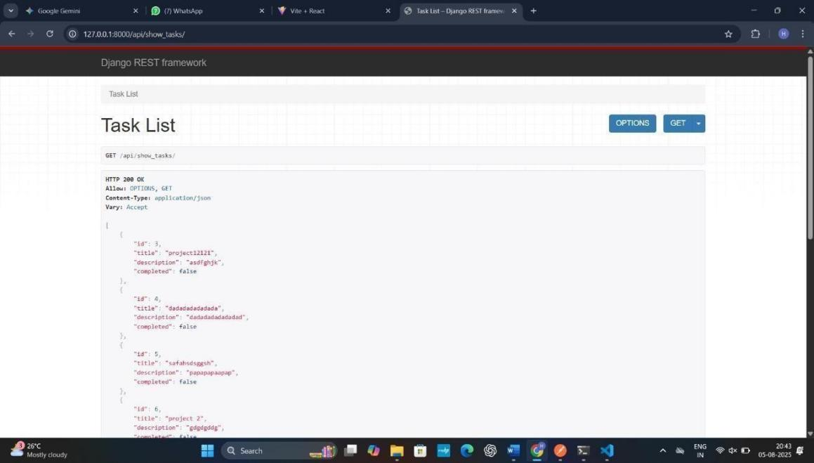
  - Outcome: The result was a fully functional and secure REST API. This provided a stable and reliable foundation for the front-end team to build upon, successfully separating the application's business logic from its presentation layer.

Fig 7.1 Api Creation (Backend)

Work Sample 2: Front-End -Weather App
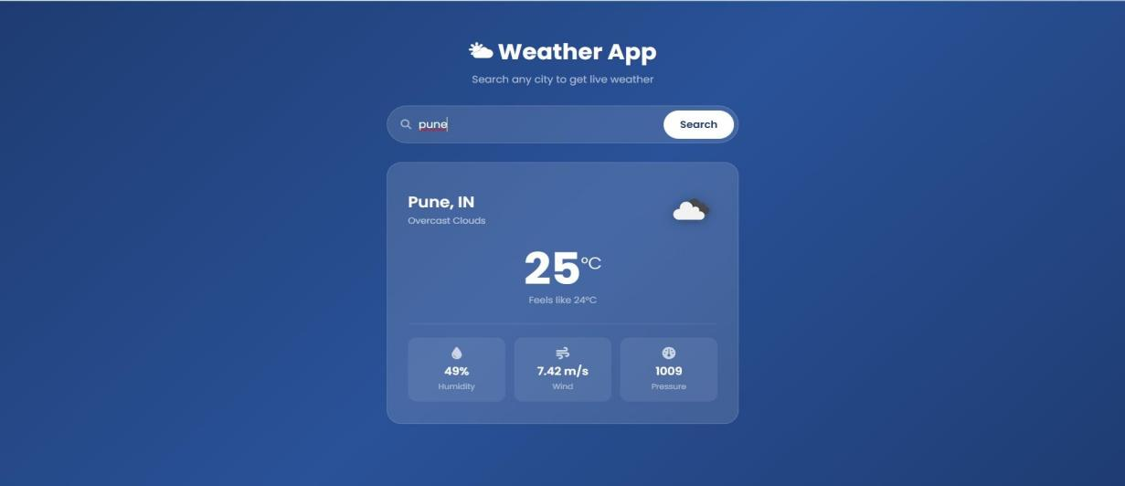
The Weather App is a web application that allows users to search for a city and view its current weather information. The application displays important weather details such as temperature, feels-like temperature, humidity, wind speed, atmospheric pressure, and weather conditions in a clean and responsive interface. Users can enter a city name in the search bar and retrieve the corresponding weather data dynamically. This project demonstrates the use of React.js, API integration, asynchronous data fetching, user input handling, and responsive UI design.
Work Sample 3 : React Mini Projects

Fig 7.2

This project is a collection of small React.js applications developed to understand and demonstrate different React concepts and component-based development. It includes features such as a Character Counter, Product Quantity controller, Color Picker, User Profile Card, and Feedback Collector. Each module focuses on a specific interactive functionality and demonstrates concepts such as React components, state management using useState, event handling, conditional rendering, and dynamic UI updates. The project helped in developing a practical understanding of building reusable and interactive frontend components using React.

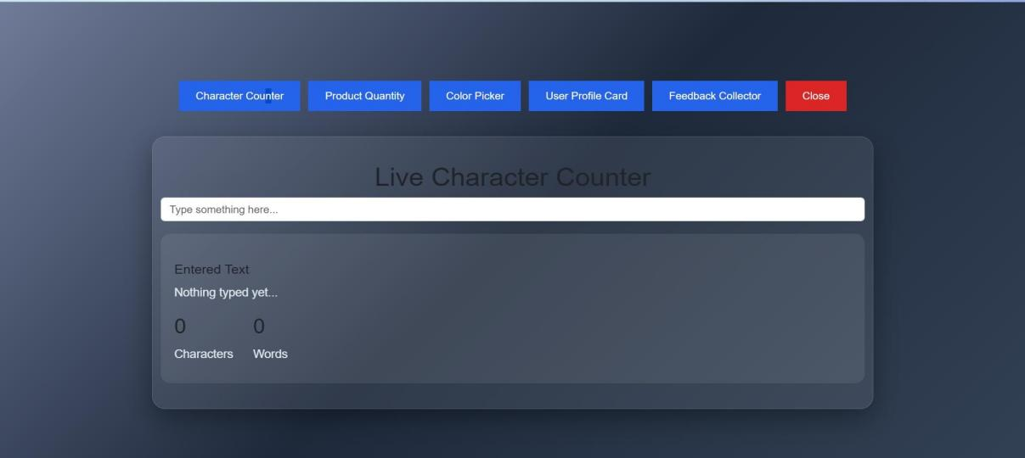

Fig 7.3
Work Sample 4 :Task Management
The Task Management module in PathPilot is designed to help students organize and manage their academic activities efficiently. It allows users to create, view, update, and manage tasks related to assignments, study sessions, projects, and other academic responsibilities. Tasks can be organized according to their priority, deadline, and completion status, helping students identify pending and completed activities. The module provides a centralized view of daily and upcoming tasks, making it easier for students to plan their workload, meet deadlines, and maintain consistent progress toward their academic

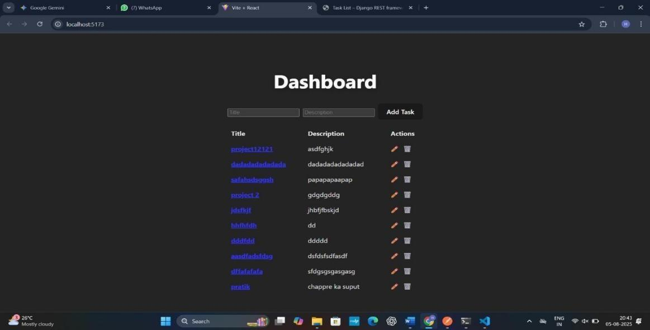

Fig 7.4

CHAPTER NO. 8 TASKS UNDERTAKEN

Internship Tasks and Learning Trajectory -

The internship was structured as a comprehensive, hands-on learning program designed to build a strong foundation in full-stack web development. The trajectory progressed from frontend fundamentals to advanced back-end concepts, culminating in the development of a complete web application.

Phase 1: Foundational Web Development :

The initial phase focused on mastering the core building blocks of the web, with an emphasis on creating static, responsive websites.
- HTML5: Learned to build well-structured and accessible web content using semantic tags.
- Tasks involved creating forms, embedding media, and structuring layouts for several single-page websites.
- CSS3 & Bootstrap: Styled pages using modern CSS3, including Flexbox and Grid, to create complex, responsive layouts. We then utilized the Bootstrap 5 framework to rapidly prototype a responsive layout for an internal dashboard template, learning its grid system and pre-styled components.

Phase 2: Dynamic Front-End Development :

This phase transitioned from static pages to creating dynamic, interactive user experiences using JavaScript and the React library.
- JavaScript (ES6+): Solidified core JavaScript concepts by building interactive features.This included DOM manipulation (e.g., creating a to-do list), handling user events, and making asynchronous API calls using the Fetch API to display data from a public source.

- React: Learned the fundamentals of component-based architecture. We practiced creating functional components, managing state with useState and useEffect hooks, and passing data via props. The primary task was to build a Single-Page Application (SPA), such as a movie search tool, which involved creating reusable components and managing application state.

Phase 3: Back-End Development :

The focus shifted to server-side development, learning how to build the logic and database infrastructure that powers web applications.
- Python: Began with learning the fundamentals of Python 3, covering data structures, control flow, functions, and the principles of Object-Oriented Programming (OOP).
- Django: We were introduced to the high-level Django web framework and its MVT (Model-View-Template) architecture. The main task in this module was to build a complete CRUD (Create, Read, Update, Delete) application. This involved defining Models, writing Views for business logic, and utilizing the Django REST Framework to build and test API endpoints.

Phase 4: Integrated Capstone Project - Task Management System :

In the final phase, all the learned skills were integrated to build a complete, full-stack Task Management System from the ground up. This project served as the capstone of the internship.
- Project Goal: To create a web application where users can register, log in, and manage their daily tasks. Users can create new tasks, set priorities and due dates, mark tasks as complete, and view their task list on a personal dashboard.
- Tasks and Implementation:
  - Back-End (Python/Django): We designed the database schema and built a secure REST API using Django REST Framework. This API handled all CRUD operations for tasks and included endpoints for user registration and authentication, ensuring that users could only access their own data.

  - Front-End (React): We developed a dynamic and interactive front-end using React. This involved building reusable components for the task list, a form for adding new tasks, and the main dashboard layout. We used React hooks to manage application state (like the user's task list and login status) and made asynchronous calls to our Django API to fetch and manipulate data.
  - Styling (Bootstrap): The entire application was styled using Bootstrap to ensure it was fully responsive and had a clean, professional user interface.
This capstone project provided invaluable experience in connecting a front-end application to a live back-end, reinforcing the full-stack development skills acquired throughout the internship.

CHAPTER NO. 9 CHALLENGES DURING TRAINING

Special and Challenging Experiences Encountered During Training -

The internship was a period of accelerated learning that, alongside technical training, provided a realistic introduction to the professional IT world. This immersive experience came with a unique set of challenges that fostered problem-solving skills, as well as special moments that solidified our passion for development.

Challenging Experiences -

While the training was well-structured, certain aspects presented significant but valuable hurdles that were crucial for our professional growth.
- The Full-Stack Integration Hurdle: The most demanding technical challenge was bridging the gap between the front-end and the back-end. While learning React and Django in isolation was manageable, making them communicate seamlessly for the capstone Task Management System was a major hurdle. Debugging Cross-Origin Resource Sharing (CORS) errors, ensuring API endpoints were correctly consumed by the React front-end, and managing user authentication state across both stacks required a steep learning curve and immense patience.
- Adapting to Professional Coding Standards: Moving from academic projects to a professional environment meant our code was subject to rigorous reviews by senior developers. The initial feedback on code quality, structure, and efficiency was challenging. Learning to write clean, maintainable, and documented code—not just code that "works"—was a significant mindset shift that required discipline and a willingness to refactor our work multiple times.
- Pace of Learning and Task Management: The internship curriculum was intensive, moving from HTML to a full-stack Django application in a short period. Balancing the time needed to grasp new theoretical concepts with the deadlines for practical assignments was a constant challenge. It taught us the critical importance of effective time management and prioritizing tasks in a fast-paced environment.

Special and Rewarding Experiences -

Alongside the challenges, the internship offered uniquely rewarding experiences that are often absent in a purely academic setting.
- Direct Mentorship and Guidance: One of the most significant benefits of interning at a smaller company like Scalefull Technologies was the direct access to senior developers. The one-on-one mentorship during code reviews and debugging sessions was invaluable. Having an expert guide us through a complex problem, rather than just giving us the answer, taught us how to think like experienced engineers.
- The "It Works!" Moment: After struggling with the integration challenges, the moment the React front-end successfully fetched, created, and updated tasks by communicating with our Django back-end was profoundly satisfying. Seeing the full application work end-to-end for the first time was a powerful validation of our efforts and a huge confidence booster.
- Collaborative Development Using Professional Tools: Working on a shared project using Git and GitHub was a new and essential experience. We learned the importance of version control, how to manage branches, create pull requests for code reviews, and resolve merge conflicts. This collaborative workflow, a standard in the industry, was a key practical skill took away from the internship.

Workplace Environment: Likes and Dislikes -
- Likes: The work environment was highly collaborative and supportive. There was a strong sense of teamwork, and senior members were always approachable and willing to help. We appreciated the focus on hands-on, practical learning over purely theoretical knowledge, as it made the experience engaging and relevant.
- Dislikes (Framed as Growth Opportunities): The fast-paced nature of the projects was initially overwhelming. However, this challenge ultimately became a positive, as it pushed us to learn quickly and adapt to real-world project pressures. Similarly, the direct and honest feedback during code reviews, while tough at first, was ultimately one of the most beneficial aspects for our long-term growth as developers.

CHAPTER NO. 10 CONCLUSION

Organizational Evaluation: A Critical and SWOT Analysis -

This section provides a comprehensive assessment of Scalefull Technologies LLP, evaluating its operational model, market positioning, and internal dynamics in the light of its strengths, weaknesses, and the external business environment.

Critical Analysis :

Scalefull Technologies operates as a lean and agile entity, a characteristic trait of a successful small IT service company. Its structure and processes appear well-suited to its size and the fastpaced nature of the tech industry.
- Human Capital as a Core Strength: The company's primary asset is its people. The strong emphasis on mentorship, continuous learning through a structured internship program, and a supportive culture indicates that management understands the value of investing in its talent. This approach likely leads to higher quality work and better employee retention compared to less people-centric organizations.
- Agile and Adaptive Operations: The company's small size is a significant advantage, allowing it to bypass the bureaucratic inertia common in larger corporations. This agility enables rapid decision-making, flexible adaptation to client needs, and the ability to pivot quickly with changing project requirements or market trends.
- Positioning Through Technology: In the highly competitive Pune IT market, Scalefull distinguishes itself by focusing on modern and in-demand technology stacks (MERN,

Python/Django). This specialization allows them to attract clients seeking cutting-edge solutions and talent passionate about working with current technologies.
- Potential Growth Bottlenecks: A critical challenge for the company is scalability. While the current model is effective, its heavy reliance on a small team of key personnel presents a risk. The capacity to handle multiple large-scale projects simultaneously is limited, and the departure of a senior team member could significantly impact project delivery. Future growth will depend heavily on its ability to attract, train, and retain more talent without diluting its strong company culture.

SWOT Analysis :

A SWOT analysis provides a structured view of the company's strategic position.

Strengths (Internal)

- Skilled & Agile Team: The development team is proficient in modern, high-demand technologies, and the company's small size facilitates quick, collaborative problem solving.
- Strong Company Culture: A positive and supportive environment focused on mentorship and hands-on learning fosters employee loyalty and attracts new talent.
- Cost-Effective Operations: Lower overhead compared to larger IT firms allows for more competitive pricing and greater financial flexibility.
- Comprehensive Training Program: The structured internship program acts as an effective pipeline for developing new talent that is already aligned with the company's culture and technical standards.

Weaknesses (Internal) :

- Limited Resources: A small team size restricts the number of projects that can be managed concurrently and may pose a challenge for very large, enterprise-scale contracts.
- Brand Recognition: As a relatively young company in a crowded market, it likely has lower brand visibility compared to established competitors.
- Dependency on Key Personnel: The smooth functioning of projects may rely heavily on a few senior members, making the organization vulnerable if they leave.
- Limited Marketing and Sales Bandwidth: A small business development team may struggle to generate a consistent and large-scale lead pipeline required for rapid growth.

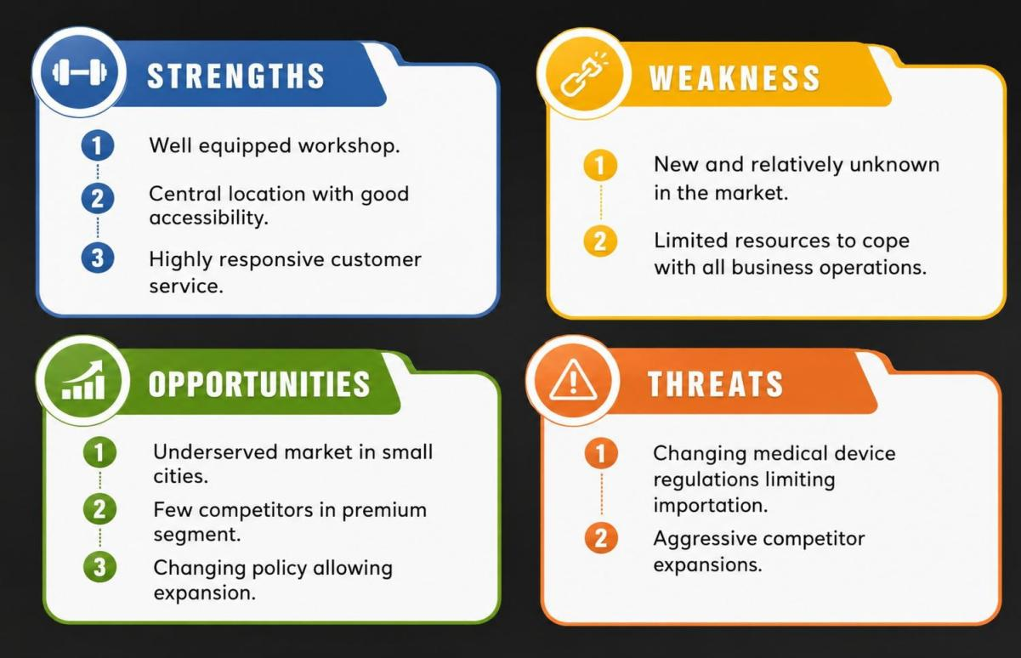
Fig 10.1 SWOT analysis

Opportunities (External) :

- Growing Demand for Digitalization: The global push for digital transformation means there is a consistently high demand for custom web and mobile application development.
- Niche Market Specialization: The company has the opportunity to become a recognized expert in a specific industry vertical (e.g., FinTech, EdTech, Healthcare IT) by leveraging its existing technical expertise.
- Global Client Base: They can offer cost-effective, high-quality development services to international clients, particularly in North America and Europe, capitalizing on the trend of remote work and global teams.
- Monetizing Training: The well-structured internship program could be refined and offered as a paid corporate training service to other companies, creating a new revenue stream.

Threats (External) :

- Intense Market Competition: The IT services market in Pune is saturated with freelancers, mid-sized agencies, and large multinational corporations, all competing for the same pool of clients and talent.
- Rapid Technological Change: The technologies that are popular today can become obsolete quickly. Continuous investment in training and R&D is necessary to stay relevant.
- Talent Poaching: Skilled developers are in high demand and are frequently targeted by larger companies offering higher salaries and more extensive benefits packages.
- Economic Instability: During economic downturns, businesses often cut spending on new IT projects, which could directly impact the company's revenue and project
pipeline.

CHAPTER NO. 11 REFERENCES

- https://en.wikipedia.org

- www.engineeringarticles.org

- http://www.thelibraryofmanufacturing.com/

- https://scalefull.com/

- https://in.linkedin.com/company/scalefull

- https://wisdomsprouts.in/

GROUP PHOTO WITH COMPANY PERSON AT COMPANY PREMISES.

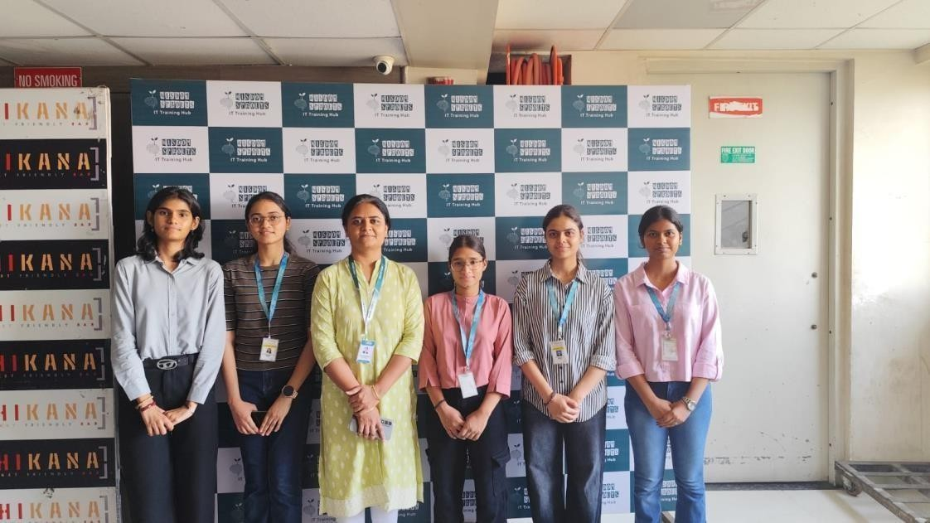
Fig.1 Group photo with Instructor

SNAPSHOTS OF PROJECT DONE

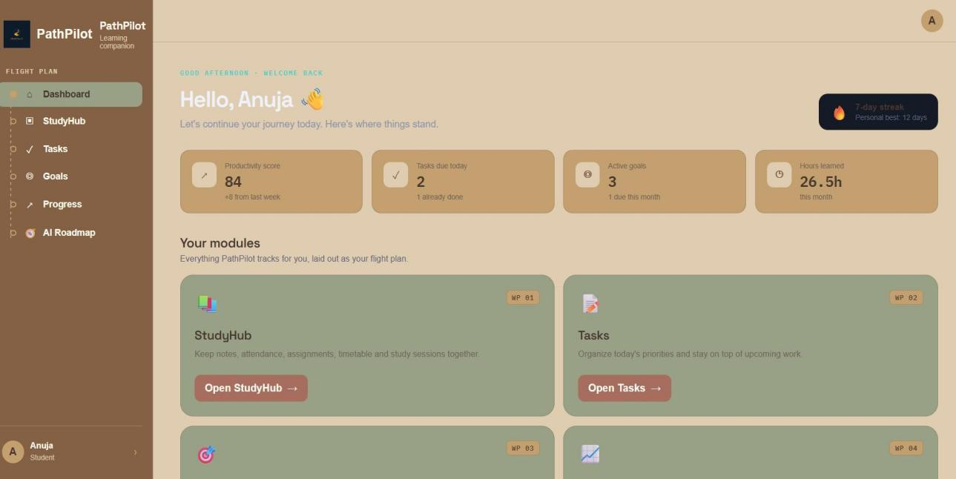
Fig.1 Dashboard

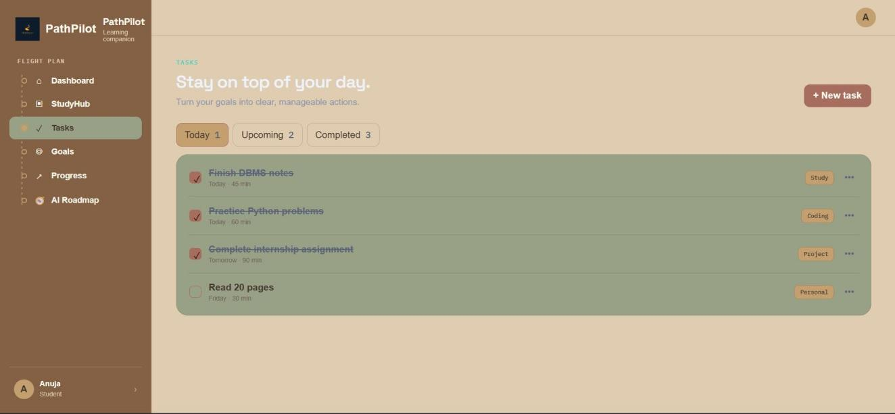
Fig.2. Tasks Board

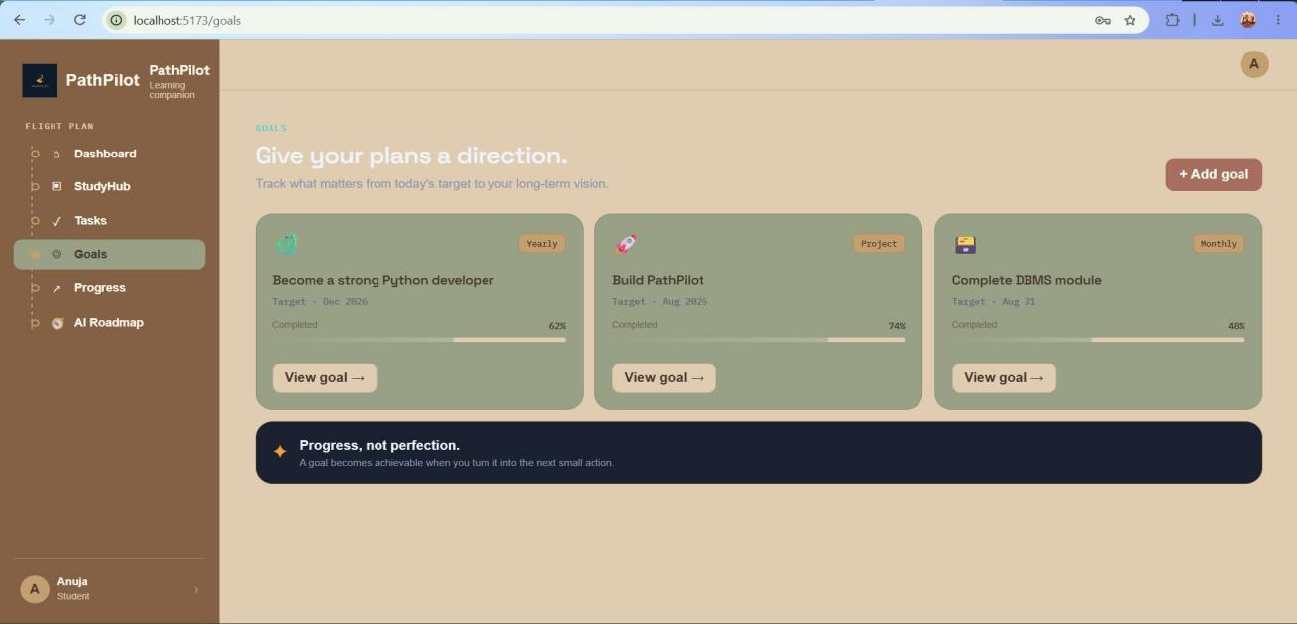

Fig.3.
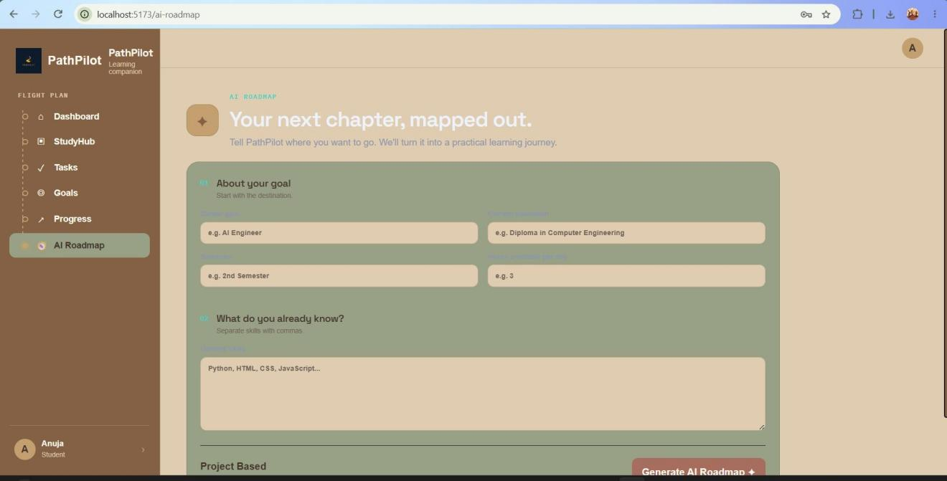
Fig.4.

INFOSYS SPRINGBOARD ONLINE CERTIFICATES WHICH ARE DONE DURING INTERNSHIP
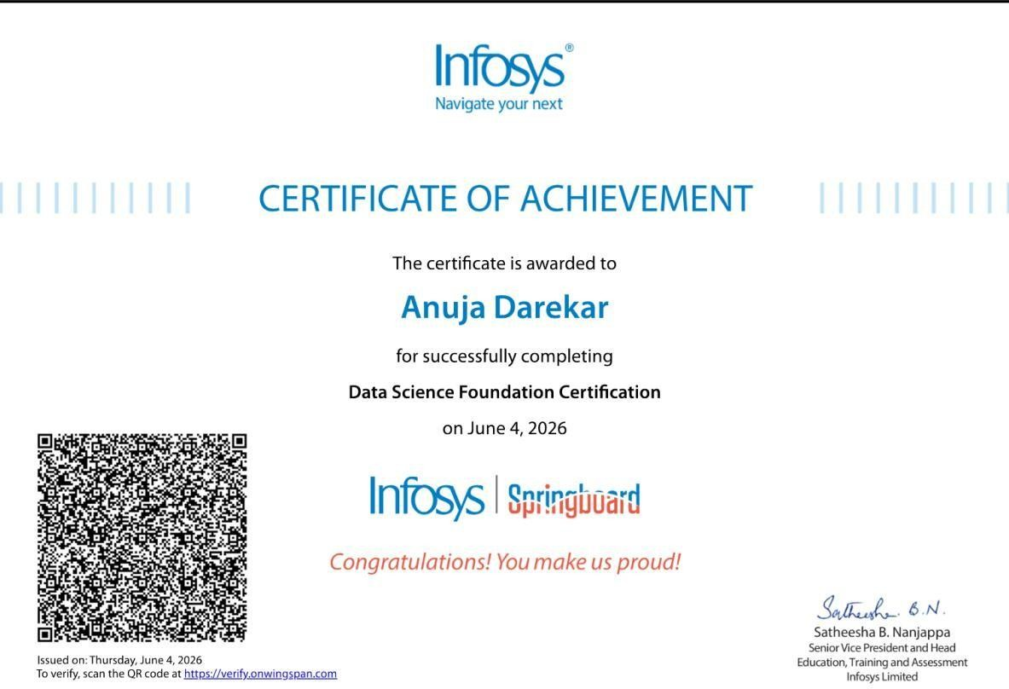

Fig.5 Certificate

