Show Users

SELECT User, Host FROM mysql.user;

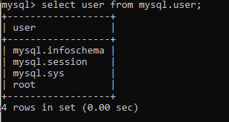

Create User

CREATE USER 'someuser'@'localhost' IDENTIFIED BY 'somepassword';



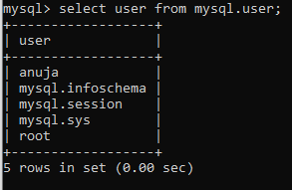

Grant All Priveleges On All Databases

GRANT ALL PRIVILEGES ON * . * TO 'someuser'@'localhost';



FLUSH PRIVILEGES;



Show Grants

SHOW GRANTS FOR 'someuser'@'localhost';

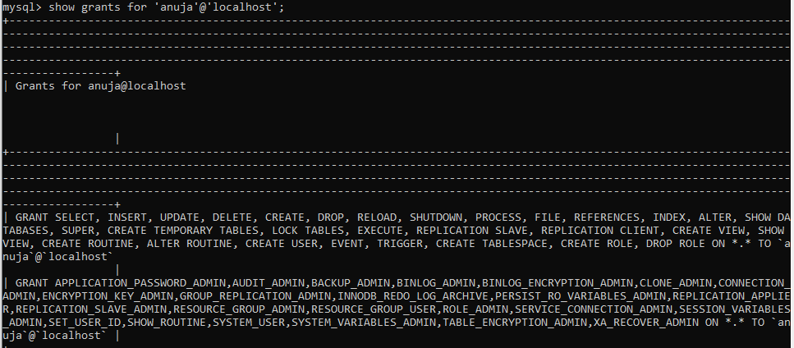

Remove Grants

REVOKE ALL PRIVILEGES, GRANT OPTION FROM 'someuser'@'localhost';

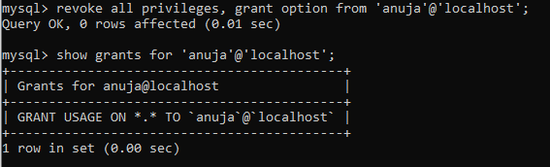

Delete User

DROP USER 'someuser'@'localhost';

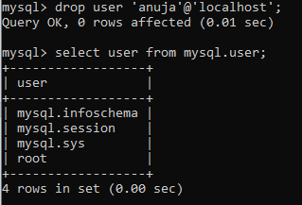

Exit

exit;

Show Databases

SHOW DATABASES

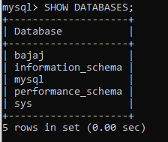

Create Database

CREATE DATABASE temp

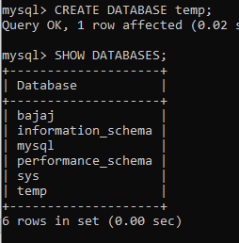

Delete Database

DROP DATABASE verzeo

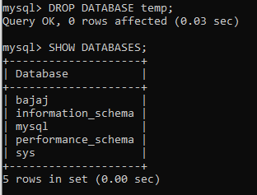

Select Database

USE bajaj;



Create Table

CREATE TABLE users(

id INT AUTO_INCREMENT,

first_name VARCHAR(100),

last_name VARCHAR(100),

email VARCHAR(50),

password VARCHAR(20),

location VARCHAR(100),

dept VARCHAR(100),

is_admin TINYINT(1),

register_date DATETIME,

PRIMARY KEY(id)

);

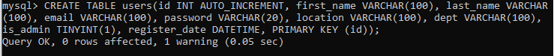

Delete / Drop Table

DROP TABLE tablename;

Show Tables

SHOW TABLES;

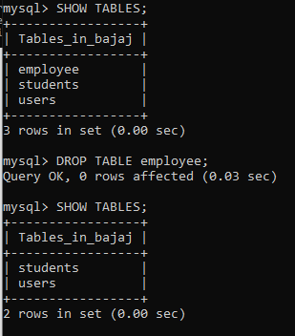

Insert Row / Record

INSERT INTO users (first_name, last_name, email, password, location, dept, is_admin, register_date) values ('venkat', 'bvs', 'venkat@gmail.com', '123456','bangalore', 'development', 1, now());

Insert Multiple Rows

INSERT INTO users (first_name, last_name, email, password, location, dept, is_admin, register_date) values ('archana', 'sunti', 'fred@gmail.com', '123456', 'New York', 'design', 0, now()), ('venkatone', 'bvs', 'venkatone@gmail.com', '123456', 'New York', 'design', 0, now()),('dhanvi', 'sagar', 'dhanvi@yahoo.com', '123456', 'Rhode Island', 'development', 1, now()),('Paula', 'Johnson', 'paula@yahoo.com', '123456', 'Massachusetts', 'sales', 0, now()),('Tom', 'Spears', 'tom@yahoo.com', '123456', 'Massachusetts', 'sales', 0, now());

Select

SELECT * FROM users;

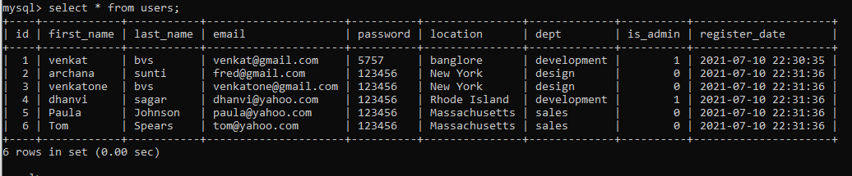

SELECT first_name, last_name FROM users;

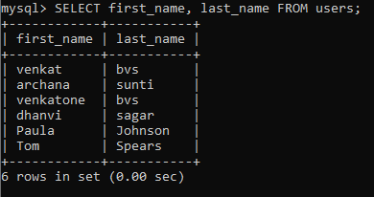

Where Clause

SELECT * FROM users WHERE location='Massachusetts';

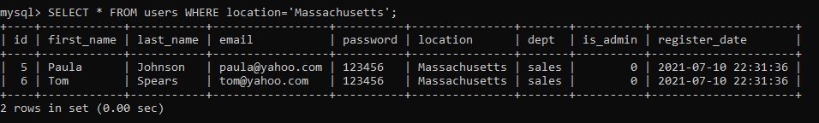

SELECT * FROM users WHERE location='Massachusetts' AND dept='sales';

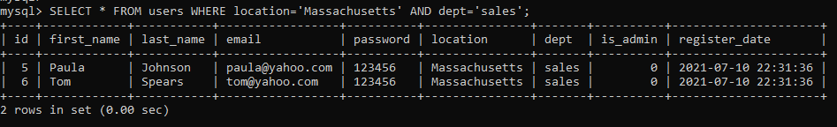

SELECT * FROM users WHERE is_admin = 1;

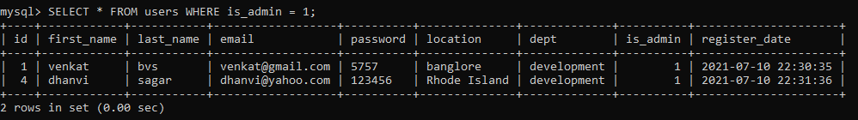

SELECT * FROM users WHERE is_admin > 0;

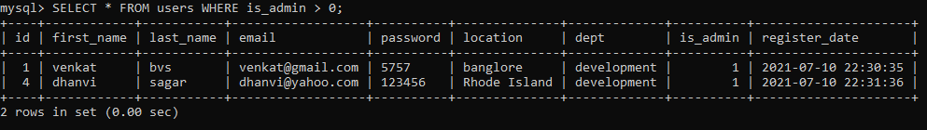

Delete Row

DELETE FROM users WHERE id = 6;

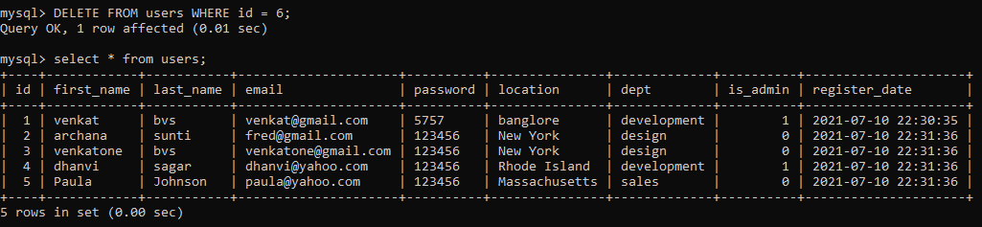

Update Row

UPDATE users SET email = 'freddy@gmail.com' WHERE id = 2;

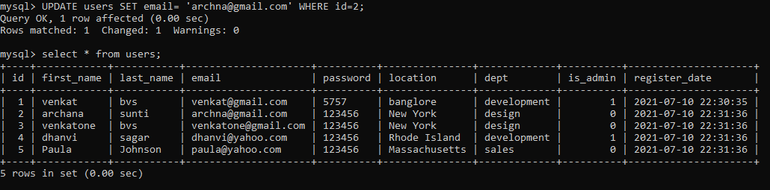

Add New Column

ALTER TABLE users ADD age VARCHAR(3);

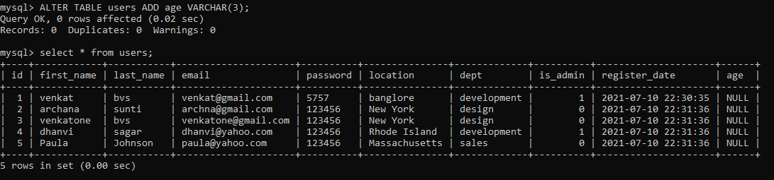

Modify Column

ALTER TABLE users MODIFY COLUMN age INT(3);

Order By (Sort)

SELECT * FROM users ORDER BY last_name ASC;

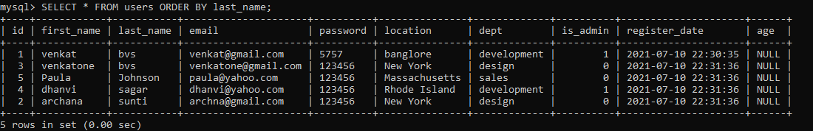

SELECT * FROM users ORDER BY last_name DESC;

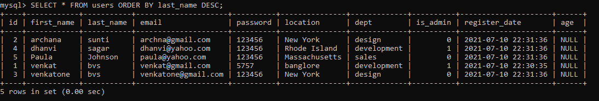

Concatenate Columns

SELECT CONCAT(first_name, ' ', last_name) AS 'Name', dept FROM users;

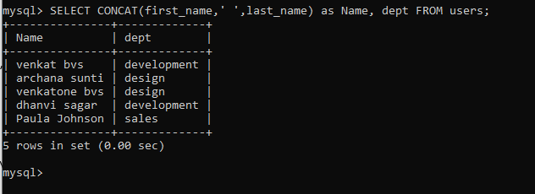

Select Distinct Rows

SELECT DISTINCT location FROM users;

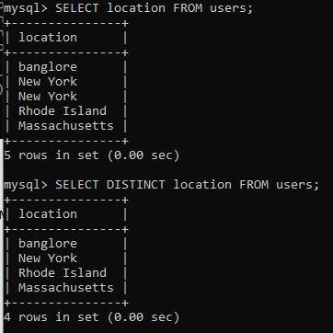

Between (Select Range)

SELECT * FROM users WHERE age BETWEEN 20 AND 25;

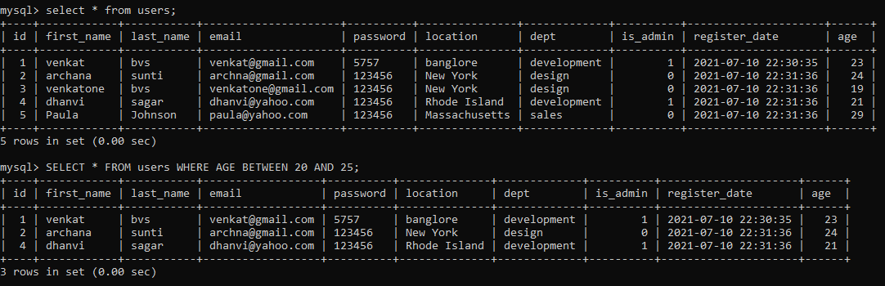

Like (Searching)

SELECT * FROM users WHERE dept LIKE 'd%';

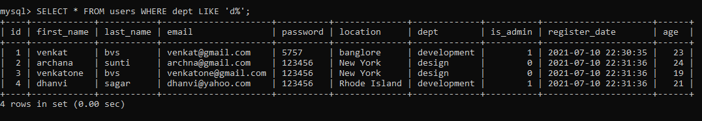

SELECT * FROM users WHERE dept LIKE 'dev%';

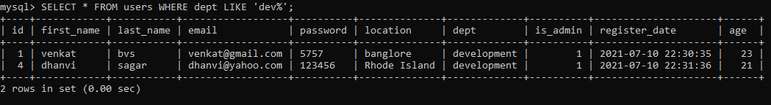

SELECT * FROM users WHERE dept LIKE '%t';

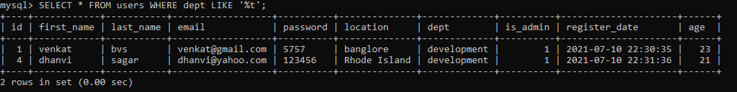

SELECT * FROM users WHERE dept LIKE '%e%';

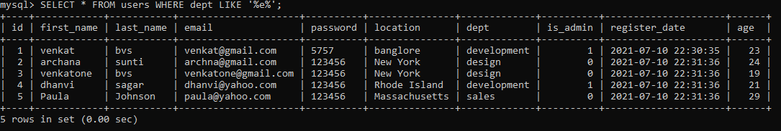

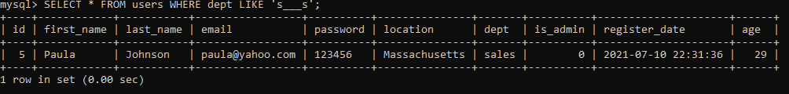

Not Like

SELECT * FROM users WHERE dept NOT LIKE 'd%';

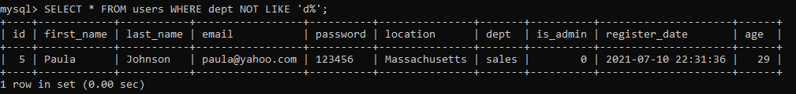

IN

SELECT * FROM users WHERE dept IN ('design', 'sales');

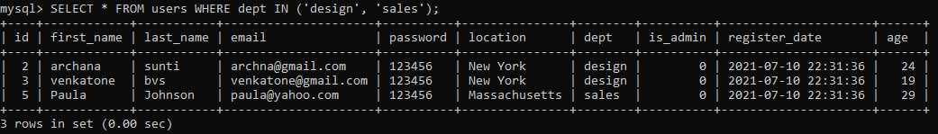

Create & Remove Index

CREATE INDEX LIndex On users(location);

DROP INDEX LIndex ON users;

New Table With Foreign Key (Posts)

CREATE TABLE posts(

id INT AUTO_INCREMENT,

user_id INT,

title VARCHAR(100),

body TEXT,

publish_date DATETIME DEFAULT CURRENT_TIMESTAMP,

PRIMARY KEY(id),

FOREIGN KEY (user_id) REFERENCES users(id)

);

Add Data to Posts Table

INSERT INTO posts(user_id, title, body) VALUES (1, 'Post One', 'This is post one'),(3, 'Post Two', 'This is post two'),(1, 'Post Three', 'This is post three'),(2, 'Post Four', 'This is post four'),(5, 'Post Five', 'This is post five'),(4, 'Post Six', 'This is post six'),(2, 'Post Seven', 'This is post seven'),(1, 'Post Eight', 'This is post eight'),(3, 'Post Nine', 'This is post none'),(4, 'Post Ten', 'This is post ten');

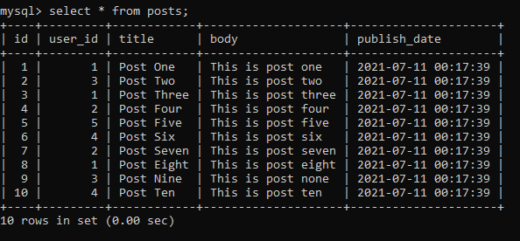

INNER JOIN

SELECT

users.first_name,

users.last_name,

posts.title,

posts.publish_date

FROM users

INNER JOIN posts

ON users.id = posts.user_id

ORDER BY posts.title;

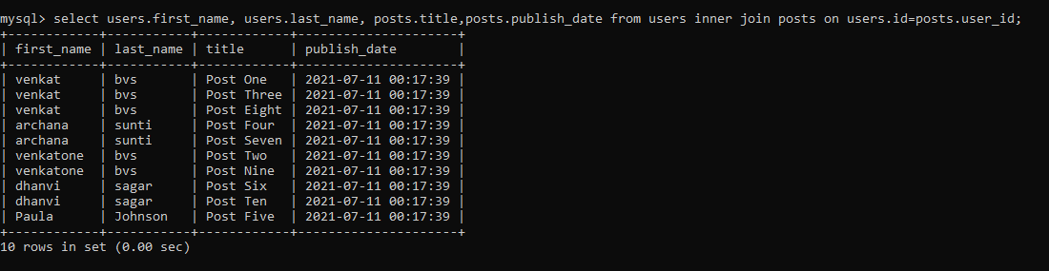

New Table With 2 Foriegn Keys

CREATE TABLE comments(

id INT AUTO_INCREMENT,

post_id INT,

user_id INT,

body TEXT,

publish_date DATETIME DEFAULT CURRENT_TIMESTAMP,

PRIMARY KEY(id),

FOREIGN KEY(user_id) references users(id),

FOREIGN KEY(post_id) references posts(id)

);

Add Data to Comments Table

INSERT INTO comments(post_id, user_id, body) VALUES (1, 3, 'This is comment one'),(2, 1, 'This is comment two'),(5, 3, 'This is comment three'),(2, 4, 'This is comment four'),(1, 2, 'This is comment five'),(3, 1, 'This is comment six'),(3, 2, 'This is comment six'),(5, 4, 'This is comment seven'),(2, 3, 'This is comment seven');

Left Join

SELECT

comments.body,

posts.title

FROM comments

LEFT JOIN posts ON posts.id = comments.post_id

ORDER BY posts.title;

Join Multiple Tables

SELECT

comments.body,

posts.title,

users.first_name,

users.last_name

FROM comments

INNER JOIN posts on posts.id = comments.post_id

INNER JOIN users on users.id = comments.user_id

ORDER BY posts.title;

Aggregate Functions

SELECT COUNT(id) FROM users;

SELECT MAX(age) FROM users;

SELECT MIN(age) FROM users;

SELECT SUM(age) FROM users;

SELECT UCASE(first_name), LCASE(last_name) FROM users;

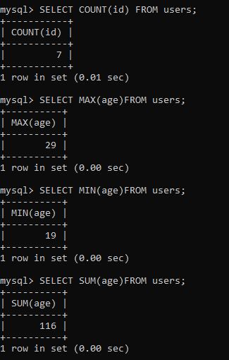

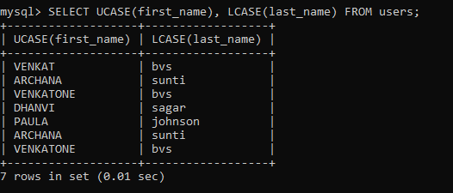

Group By

SELECT age, COUNT(age) FROM users GROUP BY age;

SELECT age, COUNT(age) FROM users WHERE age > 20 GROUP BY age;

SELECT age, COUNT(age) FROM users GROUP BY age HAVING count(age) >=2;

