Assignment on Docker compose
- Docker-compose is used for to run multiple containers at a time which are belong to same app
- steps to Use Docker-compose
- step1: Write docker compose yml file. If any build command is written to create an image then run the command
docker-compose build
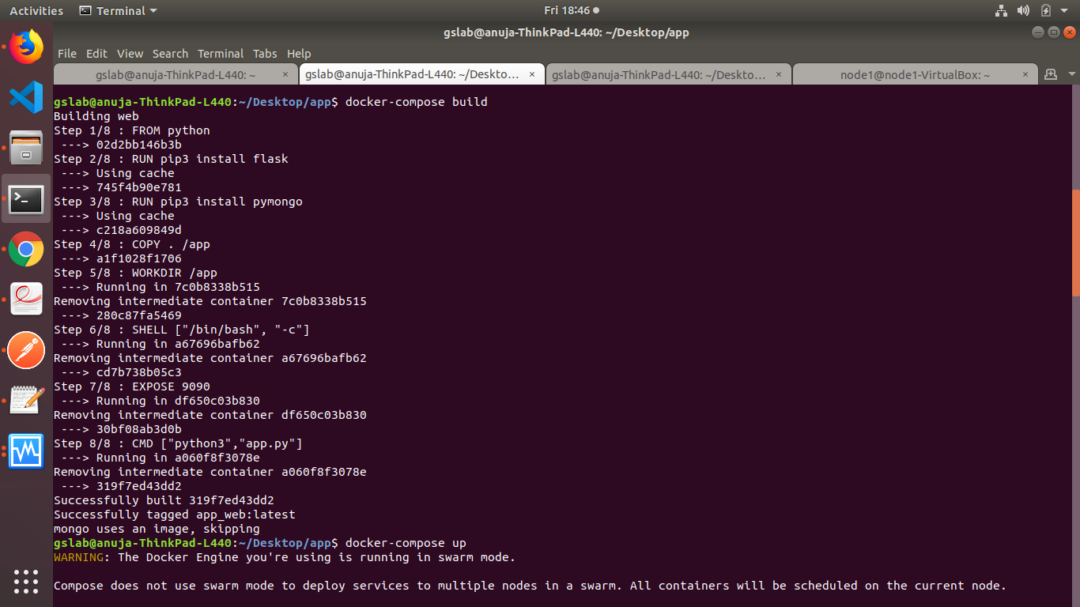
- Step2: For execute a docker-compose file use command
docker-compose up
It will execute a services i.e containers which you have mentioned in docker file

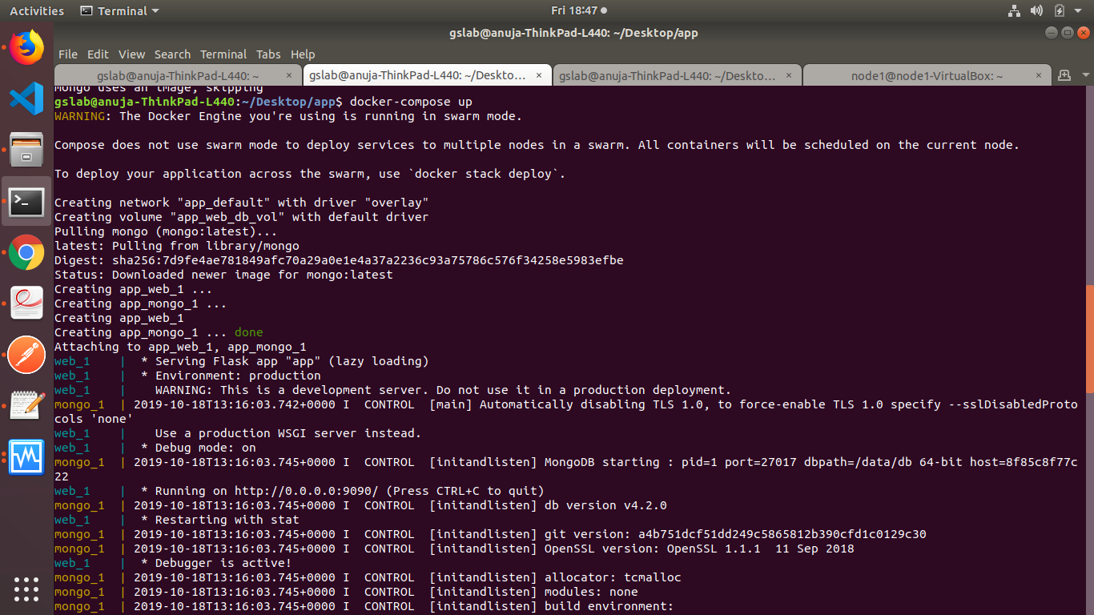
Check weather the services are running on exposed port
