Assignment

- Assignment On creating your own image ,pull on your repository and update an image with tag
steps:
- Build an image using your own docker file.
- Tag a image using user name and file name and version of it .Make sure you have already logged in to docker registery

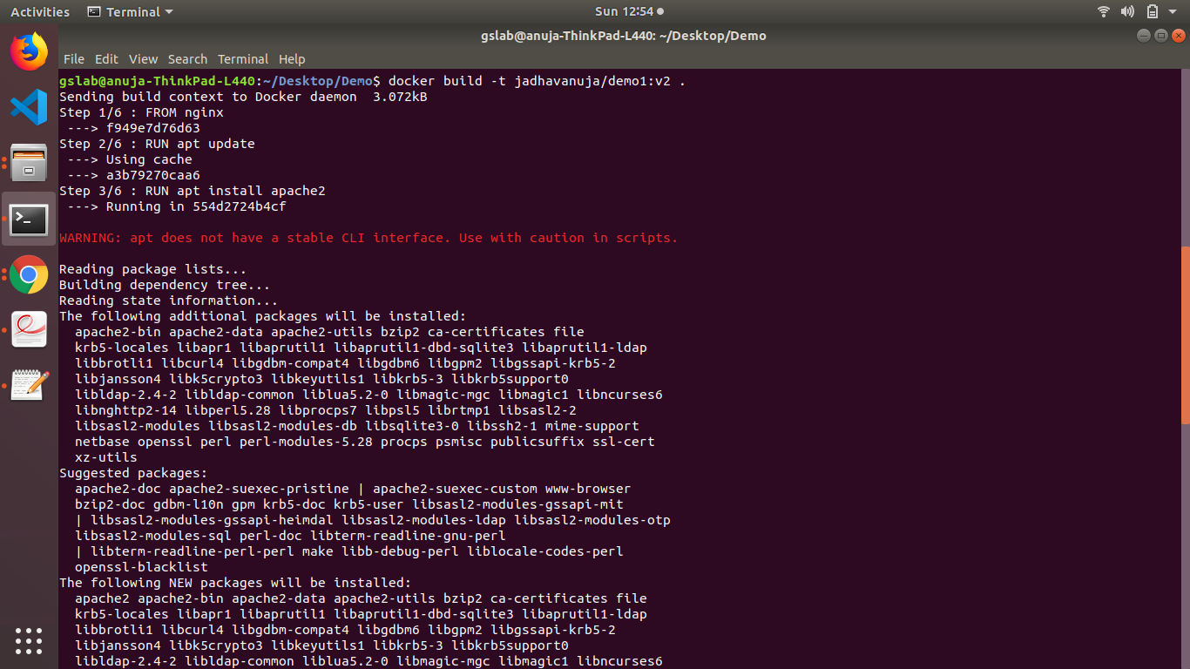

- Push an image to repository.Using below command

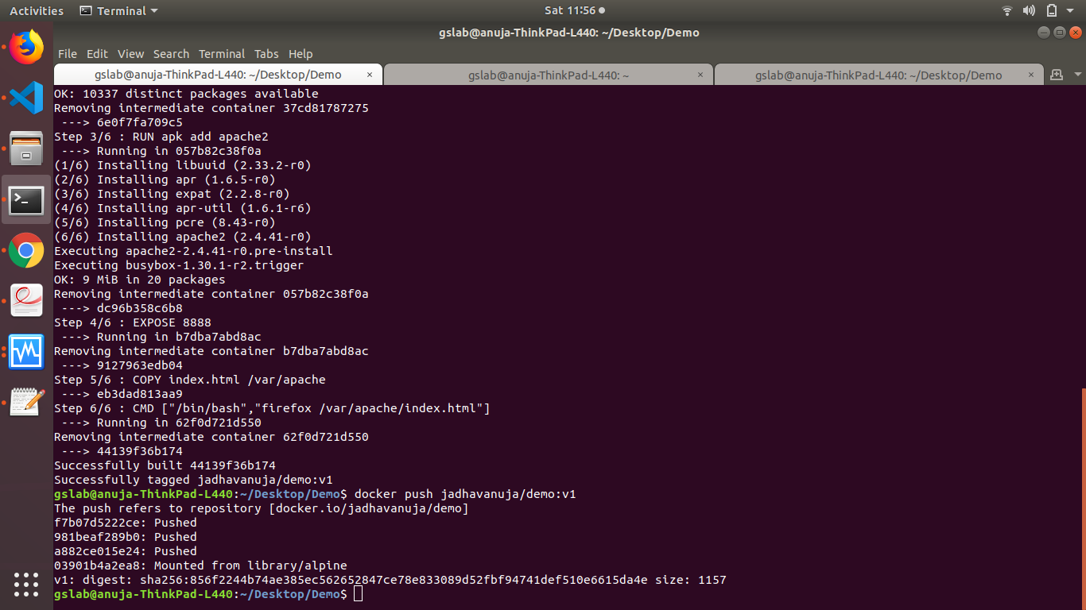
To update an existing image or put a latest release ,build an another image

change only the version of an image,and push it into same repository

using
docker push username/image_name:version
