Functional Requirements Document
AstraCart Ecommerce Platform
This FRD defines functional behavior for account access, shopping discovery, checkout, payment gateway integration, payment result pages, and order management. It is intentionally rich in tables, links, images, comments, footnotes, and endnotes to validate document extraction.
External reference: AstraCart API sandbox

Functional Scope
FR ID | Module | Function | Priority | Acceptance Criteria
FR-AUTH-001 | Registration | Register with email/mobile, password rules, duplicate detection | Must | Valid profile is created; duplicate returns existing-account guidance
FR-AUTH-009 | Login | Authenticate, remember device, and support risk-based MFA prompt | Must | Valid credentials create session; risky login prompts verification
FR-AUTH-014 | Logout | Explicit logout from header and account page | Must | Access/refresh tokens invalidated; cart remains anonymous
FR-AUTH-018 | Forgot Password | Generate reset link with expiry, resend, and audit | Must | Expired link shows safe message without account enumeration
FR-HOME-004 | Home | Render hero, category rails, recommendations, recently viewed | Should | Fallback rails appear when recommendation service is unavailable
FR-PLP-006 | Listing | Filter, sort, paginate, sponsored product slot | Must | URL state survives refresh and share
FR-PDP-011 | Product Detail | Variant selection, ETA, reviews, seller, add-to-cart | Must | Invalid variant cannot be added
FR-CHK-016 | Checkout | Cart review, address, shipping, coupon, tax, order quote | Must | Quote id is created and price lock applied
FR-PAY-021 | Payment | Gateway order, redirect/intent, webhook reconciliation | Must | Webhook result wins over redirect conflict
FR-ORD-029 | Orders | Order history, tracking, invoice, returns, refund timeline | Must | Latest shipment/payment status visible to customer

Key Screen Behavior
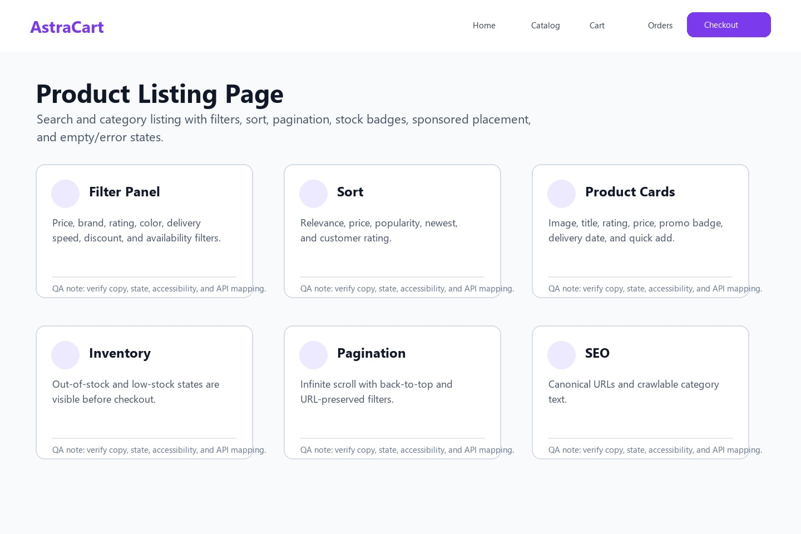
Figure: Product listing filters and inventory visibility.
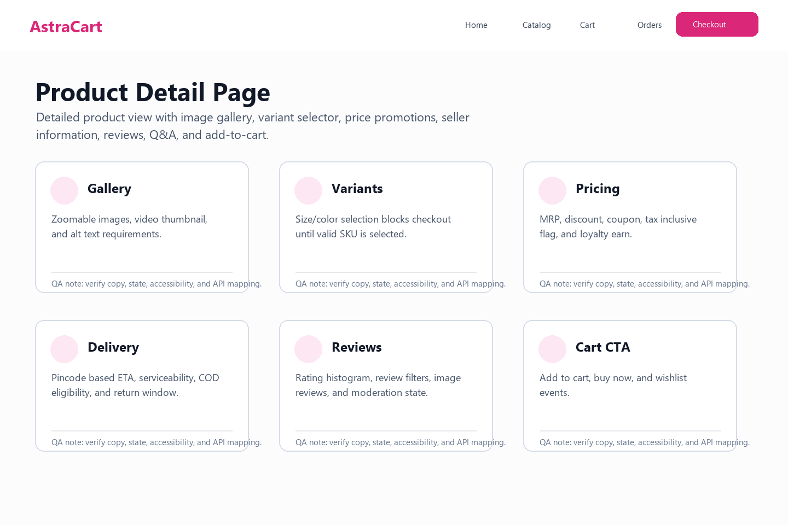
Figure: Product detail state and Add to Cart prerequisites.

Validation and Error Handling
Code | Trigger | Message | Expected UX
AUTH-VAL-001 | Invalid email | Enter a valid email address. | Inline under field
AUTH-SEC-004 | Too many attempts | Try again in 15 minutes or reset password. | Banner + reset link
CHECKOUT-STOCK-002 | SKU unavailable | This item is no longer available. | Cart item error
PAYMENT-PENDING-001 | Webhook pending | We are confirming your payment. | Pending page + polling
ORDER-TRACK-404 | Order not visible | We could not find an order for this account. | Safe empty state

Non-Functional Requirements
Accessibility: WCAG 2.2 AA for auth, listing, checkout, and order tracking pages.
Performance: PLP first meaningful content under 2.5 seconds at p75 on broadband.
Security: All payment initiation calls require CSRF/session validation and signed gateway webhooks.
Observability: Trace id must connect frontend action, checkout quote, payment order, gateway callback, and order id.

Workflow Notes
Checkout must preserve user context when the payment gateway redirects back to success, failure, or pending pages.
If a customer logs out while payment is pending, order confirmation should still be sent through registered email once webhook confirms payment.

