Low Level Design
AstraCart Ecommerce Platform
This LLD decomposes APIs, database entities, event contracts, validation rules, and integration details for checkout, payment, auth, catalog, and order tracking.
OpenAPI reference: AstraCart Checkout API

Service API Inventory
API | Method | Endpoint | Auth | Notes
Register | POST | /v1/auth/register | Public + captcha risk | Creates inactive profile until email/mobile verified
Login | POST | /v1/auth/login | Public | Returns session and refresh token
Logout | POST | /v1/auth/logout | Bearer | Revokes refresh token family
Reset Request | POST | /v1/auth/password-reset | Public | Always returns generic success
Search Products | GET | /v1/catalog/search | Optional | Supports filters, sort, pagination
Create Quote | POST | /v1/checkout/quote | Bearer or guest | Locks price and inventory snapshot
Create Payment | POST | /v1/payments/orders | Bearer | Gateway order id and redirect payload
Gateway Webhook | POST | /v1/payments/webhook | Signature | Authoritative payment result
Order Tracking | GET | /v1/orders/{id}/timeline | Bearer | Scoped to owner/support role

Data Model
Entity | Key Fields | Relationships | Retention/Audit
customer_account | id, email_hash, mobile_hash, status | 1:N sessions, addresses, orders | Audit login/reset events
catalog_product | sku, title, brand, price, inventory_state | N:1 seller, N:M category | Catalog change history 90 days
checkout_quote | quote_id, account_id, cart_hash, price_lock_until | 1:N quote_items | Retain 30 days
payment_order | payment_order_id, gateway_order_id, status | 1:1 order after authorization | Webhook event log retained 7 years
customer_order | order_id, payment_status, fulfillment_status | N:1 account, N order_events | Invoice and tax retention per policy

Payment State Machine
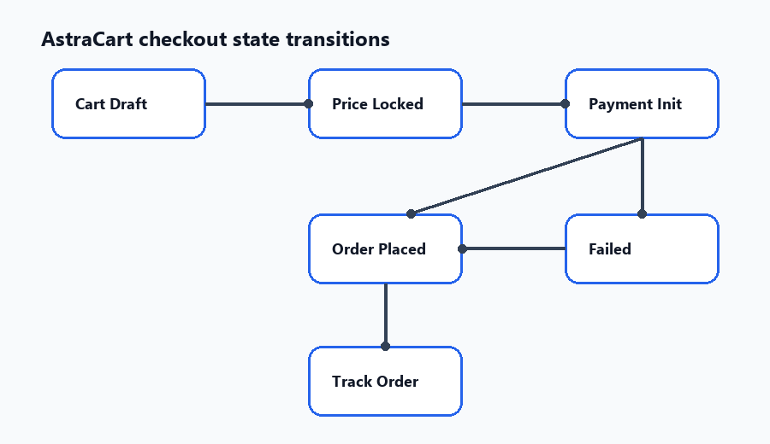
The retry path must reuse quote id and gateway idempotency key while preventing duplicate order creation.

Detailed Rules
Payment success page can show provisional confirmation only when redirect status is success and webhook is not yet received; final order state is updated after webhook.
Payment failure page must keep cart contents and price lock until quote expiry.
Product listing cache key includes category, query, filter values, sort key, page cursor, user segment, and inventory region.
Order history must hide orders not owned by the current user unless the requester has support role.
Password reset token hash is stored server-side; raw token appears only in the email link.

Exception Mapping
Exception | HTTP | Retryable | User Message
PAYMENT_GATEWAY_TIMEOUT | 202 | Yes | We are confirming your payment.
PAYMENT_SIGNATURE_INVALID | 400 | No | Payment could not be verified.
QUOTE_EXPIRED | 409 | Yes | Your cart price has changed. Review checkout again.
INVENTORY_UNAVAILABLE | 409 | No | One or more items are unavailable.
ORDER_NOT_FOUND_OR_UNAUTHORIZED | 404 | No | We could not find that order.

