Assignment no-1

index.html-

<!Doctype html>
<html>
<head>

<link rel="stylesheet" href="index.css">
<style>
table {
font-family: arial, sans-serif;
border-collapse: collapse;
width: 70%;
}

td, th {
border: 1px solid #dddddd;
text-align: left;
padding: 8px;
}

tr:nth-child(even) {
background-color: #dddddd;
}
</style>

</head>

<body>
<header>
<div class="titl">
<img src="logo.jpg" alt="background image" height="40" width="60">
<a><b>Bus Ticket System</b></a>
</div>
</header>
<!-- header tag -->
<div class="nav">
<a class ="active" href="#"><b>Home</b></a>
<a href="secondpage.html"><b>Buy</b></a>
<a href="about.html"><b>AboutUS</b></a>
<a href="contact.html"><b>Contact Us</b></a>
<button><b>LOGIN</b></button>
</div>
<div class="sidebar" ><marquee height="400px" width="175px"; direction = "up">
Pune To Mumbai <br>Rs200<br><br>
Pune To Nashik<br>Rs350<br><br>
Pune To Aurrangabad<br>Rs300<br><br>
Pune To beed<br>Rs260<br><br>
Pune To Latur<br>Rs290<br><br>
Pune To Amaravati<br>Rs450<br><br>
Pune To Ahemadnagar<br>Rs140<br><br>
Pune To Shirdi<br>Rs190<br><br>
Pune To ratanagiri<br>Rs240<br><br>
Pune To Dadar<br>Rs220<br><br>
Pune To Satara<br>Rs180<br><br>
Pune To kolhapur<br>Rs220

</marquee></div>
<h2>Available Buses</h2>
<div>
<table>
<tr>
<th>Bus Number</th>
<th>Bus Name</th>
<th>Tickets Available</th>
<th>Route</th>
<th>Price</th>
<th>Departure</th>
<th>From Station</th>
</tr>
<tr>
<td>101</td>
<td>Deccan Queen</td>
<td>19</td>
<td>Pune-Mumbai</td>
<td>250</td>
<td>11:00 am</td>
<td>Pune</td>
</tr>
<tr>
<td>102</td>
<td>Ordinary Express</td>
<td>32</td>
<td>Pune-Mumbai</td>
<td>200</td>
<td>12:00 pm</td>
<td>Shivajinagar</td>
</tr>
<tr>
<td>103</td>
<td>Marathwada Express</td>
<td>23</td>
<td>Pune-Aurangabad</td>
<td>350</td>
<td>10:00 am</td>
<td>Pune</td>
</tr>
<tr>
<td>104</td>
<td>Daulatabad Exp</td>
<td>27</td>
<td>Pune-Aurangabad</td>
<td>300</td>
<td>02:00 pm</td>
<td>Chinchwad</td>
</tr>
<tr>
<td>105</td>
<td>Ordinary Express</td>
<td>30</td>
<td>Pune-Aurangabad</td>
<td>300</td>
<td>05:00 pm</td>
<td>Shivajinagar</td>
</tr>
<tr>
<td>106</td>
<td>Nashik Exp</td>
<td>13</td>
<td>Pune-Nashik</td>
<td>350</td>
<td>11:00 am</td>
<td>Pune</td>
</tr>
<tr>
<td>107</td>
<td>Ordianry Exp</td>
<td>29</td>
<td>Pune-Nashik</td>
<td>350</td>
<td>02:00 pm</td>
<td>Chinchwad</td>
</tr>
<tr>
<td>108</td>
<td>Latur Queen</td>
<td>11</td>
<td>Pune-Latur</td>
<td>450</td>
<td>11:00 am</td>
<td>Pune</td>
</tr>
<tr>
<td>109</td>
<td>Ordinary Exp</td>
<td>37</td>
<td>Pune-Beed</td>
<td>650</td>
<td>11:30 am</td>
<td>Pune</td>
</tr>
<tr>
<td>110</td>
<td>Vidarbha Exp</td>
<td>13</td>
<td>Pune-Nagpur</td>
<td>950</td>
<td>09:00 am</td>
<td>Pune</td>
</tr>
<tr>
<td>111</td>
<td>Ordinary Exp</td>
<td>2001</td>
<td>Pune-Nagpur</td>
<td>850</td>
<td>11:00 am</td>
<td>Shivajinagar</td>
</tr>
<tr>
<td>112</td>
<td>Ambabai Exp</td>
<td>42</td>
<td>Pune-Ambejogai</td>
<td>750</td>
<td>11:00 am</td>
<td>Chinchwad</td>
</tr>
<tr>
<td>113</td>
<td>Ordinary Exp</td>
<td>33</td>
<td>Pune-Satara</td>
<td>250</td>
<td>01:00 pm</td>
<td>Pune</td>
</tr>

</table>
</div>
</body>

</div>
</html>

secondpage.html-
<!Doctype html>
<html>
<head>

<link rel="stylesheet" href="index.css">
<title>Form</title>
</head>

<body>
<header>
<div class="titl">
<img src="logo.jpg" alt="background image" height="40" width="60">
<a><b>Bus Ticket System</b></a>
</div>
</header>
<!-- header tag -->
<div class="nav">
<a href="index.html"><b>Home</b></a>
<a class ="active" href="#"><b>Buy</b></a>
<a href="about.html"><b>AboutUS </b></a>
<a href="contact.html"><b>ContactUs</b></a>
<button><b>LOGIN</b></button>
</div>
<div class="d2">
<div class="sidebar" ><marquee height="400px" width="175px"; direction = "up">
Pune To Mumbai <br>Rs200<br><br>
Pune To Nashik<br>Rs350<br><br>
Pune To Aurrangabad<br>Rs300<br><br>
Pune To beed<br>Rs260<br><br>
Pune To Latur<br>Rs290<br><br>
Pune To Amaravati<br>Rs450<br><br>
Pune To Ahemadnagar<br>Rs140<br><br>
Pune To Shirdi<br>Rs190<br><br>
Pune To ratanagiri<br>Rs240<br><br>
Pune To Dadar<br>Rs220<br><br>
Pune To Satara<br>Rs180<br><br>
Pune To kolhapur<br>Rs220

</marquee></div>
<div class="form1">
<form>
First name:
<input type="text" id="j1" name="firstname" placeholder="Enter firstname" size="10" required="true"><br>
Last name:
<input type="text" id="j1" name="lastname" placeholder="Enter lastname" size="10" required="true"><br>
Enter Email:
<input type="email" id="j1" name="Email" placeholder="@gmail.com" size="15" required="true"><br>
Enter Phone:
<input type="number" id="j1" name="number" pattern="[0-9]{10}" required="true"><br>
<input type="submit" id="sub" name="submit" value="submit"><br>
</form>
</div>
</div>
</body>

</div>
</html>

contact.html-

<!DOCTYPE html>
<html>
<head>
<meta charset="ISO-8859-1">
<link rel="stylesheet" href="index.css">
</head>
<body>
<header>
<div class="titl">
<img src="logo.jpg" alt="background image" height="40" width="60">
<a><b>Bus Ticket System</b></a>
</div>
</header>
<!-- header tag -->
<div class="nav">
<a class ="active" href="#"><b>Home</b></a>
<a href="secondpage.html"><b>Buy</b></a>
<a href="about.html"><b>AboutUS</b></a>
<a href="contact.html"><b>Contact Us</b></a>
<button><b>LOGIN</b></button>
</div>
<div class="sidebar" ><marquee height="400px" width="175px"; direction = "up">
Pune To Mumbai <br>Rs200<br><br>
Pune To Nashik<br>Rs350<br><br>
Pune To Aurrangabad<br>Rs300<br><br>
Pune To beed<br>Rs260<br><br>
Pune To Latur<br>Rs290<br><br>
Pune To Amaravati<br>Rs450<br><br>
Pune To Ahemadnagar<br>Rs140<br><br>
Pune To Shirdi<br>Rs190<br><br>
Pune To ratanagiri<br>Rs240<br><br>
Pune To Dadar<br>Rs220<br><br>
Pune To Satara<br>Rs180<br><br>
Pune To kolhapur<br>Rs220

</marquee></div>
<h1>GROUP MEMBERS:</h1>
<h2>1]aaaaaa<br>
2]bbbbb<br>
3]cccccc<br>
4]dddddd</h2>

</body>
</html>

about.html-

<!DOCTYPE html>
<html>
<head>
<meta charset="ISO-8859-1">

<link rel="stylesheet" href="index.css">
</head>
<body>
<header>
<div class="titl">
<img src="logo.jpg" alt="background image" height="40" width="60">
<a><b>Bus Ticket System</b></a>
</div>
</header>
<!-- header tag -->
<div class="nav">
<a href="index.html"><b>Home</b></a>
<a href="secondpage.html"><b>Buy</b></a>
<a class ="active" href="#"><b>AboutUS </b></a>
<a href="contact.html"><b>ContactUs</b></a>
<button><b>LOGIN</b></button>
</div>
<div class="sidebar" ><marquee height="400px" width="175px"; direction = "up">
Pune To Mumbai <br>Rs200<br><br>
Pune To Nashik<br>Rs350<br><br>
Pune To Aurrangabad<br>Rs300<br><br>
Pune To beed<br>Rs260<br><br>
Pune To Latur<br>Rs290<br><br>
Pune To Amaravati<br>Rs450<br><br>
Pune To Ahemadnagar<br>Rs140<br><br>
Pune To Shirdi<br>Rs190<br><br>
Pune To ratanagiri<br>Rs240<br><br>
Pune To Dadar<br>Rs220<br><br>
Pune To Satara<br>Rs180<br><br>
Pune To kolhapur<br>Rs220

</marquee></div>

<h3>About Us:</h3>
<h4>History:</h4>
<p >This oraganisation started in 2015 for the benefit of the customers who find difficulty
in booking the bus tickets.This oraganisation's main pillar is Mr.shubham who is has taken
the intiative to devlope this simle website which will be helpful to others. </p>
<h4>Description:</h4>
<p> As we can see this website has very simple look which will be helpful to many people
who finds booking thorugh many websites complicated.The left sidebar shows the buses to
various cities and the cost for that travel.The menubar shows the option to contact us as
well as the the login option and about us option.
</p>
<h4>Unique Bus Bokking Platform:</h4>
<p>
"SureGo.in is India's one of the largest online bus ticketing platform, trusted by over 3 million Indians.
With a sale of over 10,00,00 Bus tickets via web, mobile, and our bus agents, SureGostands
at the top of the game in bus ticketing. SureGo.in operates on over 3000 routes and is associated
with 2300 reputed bus operators. Try the SureGo experience today.";
</p>

</body>
</html>

index.css-

.titl{
padding: 16px;
background-color:#4b636e;
width: 100%;
font-size: 40px;
text-align: center;

}

.nav{
padding: 16px;
background-color:#78909c;
width: 100%;
}
.nav a{
padding: 13px 15px;
color:#E1F5FE;
font-size: 17px;
}
.nav a:hover {
background-color: #80DEEA;
color: black;
}
body{
background-color:#a7c0cd;
font-family: Arial, Helvetica, sans-serif;
height: 100%;
width: 96.95%;

}
.active{
background-color: #a7c0cd;
}
.nav button{
position: absolute;
right: 20px;
padding: 5px 7px;

}
.nav img{
width:80px;

}
.sidebar {
height:100% ;
font-size:20px;
width: 160px;
float:left;

}
.form1 {
height: 300px;
width: 350px;
margin: 0 auto;
background-color: #4b636e;
font-size: 20px;
padding: 10px;
border: 2px solid black;

}
#sub {
position: relative;
left: 100px;
background-color: #a7c0cd ;

}
input {

padding: 10px;
margin: 5px;
}
#j1 {

border: 2px solid black;
}

Assignment no-2

form1.html-

<html>
<head>
<title>
Form
</title>

<script src="https://ajax.googleapis.com/ajax/libs/jquery/3.3.1/jquery.min.js"></script>
<script src="https://cdnjs.cloudflare.com/ajax/libs/jquery-validate/1.17.0/jquery.validate.js"></script>
<script src="assg2.js"></script>
<link rel="stylesheet" href="assg2.css">
</head>
<body>
<div class="form2">
<form name="myform" id="form11" action="" method=post>
Name:<br><input type="text" name="name1" placeholder="Enter Name" ><br>
Password:<br><input type="password" name="pass12" id="pass12" placeholder="Enter password" required><br>
Confirm Password:<br><input type="password" name="pass2" id="pass2" placeholder="Confirm password" required><br>
Mobile No:<br><input type="number" name="mobnum" placeholder="Enter Mobile No" required><br>
Email Id:<br><input type="text" placeholder="Enter Mail" pattern="[A-Za-z0-9]+@[^@]+\.[a-zA-Z]{2,6}" name="email1" required><br>
Gender:male<input type="radio" name="gender" value="male">
female<input type="radio" name="gender" value="female" ><br>
Hobbies:<input type="checkbox" name="sport" value="sport"> sport
<input type="checkbox" name="music" value="music"> music
<input type="checkbox" name="other" value="other"> other<br>
state: <select>
<option value="Maharashtra">Maharashtra</option>
<option value="Punjab">Punjab</option>
<option value="Gujarat">Gujarat</option>
<option value="Other">Other</option>
</select><br>
pin:<input type="number" name="pin" required><br>
<input type="submit" value="Submit" id="submit1" >
</form>
<div>
</body>

</html>

assg2.js-

$(document).ready(function(){
$("#submit1").click(function(){
$("#form11").validate({
rules:
{
name1:"required",
pass12:
{
minlength: 6,
},
pass2:
{
equalTo: "#pass12",
minlength: 6,

},
mobnum:
{
minlength:10

}

},

messages:
{
name1:"Enter Name",
pass12:"pass should be atleast 6 char",
pass2:"pass should be same"
},

});

});
});
function validateEmail(sEmail) {
var filter = /^[\w\-\.\+]+\@[a-zA-Z0-9\.\-]+\.[a-zA-z0-9]{2,4}$/;
if (filter.test(sEmail)) {
return true;
}
else {
return false;
}
}

assg2.css-

.form2 {
height: 400px;
width:300px;
background-color: #D1C4E9 ;
position: relative;
left: 450px;
padding: 20px;
font-size: 20px;
margin: 70px;

}
.form2 input,select {
padding: 5px;
border: 2px solid black;

}
body {
height: 100%;
width:99.25%;
background-color: #F3E5F5;
}

Assignment 3

Aim: Add Dynamic web application essence in assignment 2 using Servlet,JSP and backend (MySQL Database Connectivity).

form1.html

<html>
<head>
<title>
Form
</title>

<script src="https://ajax.googleapis.com/ajax/libs/jquery/3.3.1/jquery.min.js"></script>
<script src="https://cdnjs.cloudflare.com/ajax/libs/jquery-validate/1.17.0/jquery.validate.js"></script>
<script src="assg2.js" type="text/javascript"></script>

<link rel="stylesheet" href="assg2.css">
</head>
<body>
<div class="form2">
<form name="myform" id="form11" action="http://localhost:8080/TEA120/Servlet" method=post> -->
<form name="myform" id="form11" action="Servlet.java" method="get">
Name:<br><input type="text" name="name1" placeholder="Enter Name" ><br>
Password:<br><input type="password" name="pass12" id="pass12" placeholder="Enter password" required><br>
Confirm Password:<br><input type="password" name="pass2" id="pass2" placeholder="Confirm password" required><br>
Mobile No:<br><input type="text" name="mobnum" pattern="[0-9]{10}" placeholder="Enter Mobile No" required><br>
Email Id:<br><input type="text" placeholder="Enter Mail" pattern="[A-Za-z0-9]+@[^@]+\.[a-zA-Z]{2,6}" name="email1" required><br>
Gender:male<input type="radio" name="gender" value="male">
female<input type="radio" name="gender" value="female" ><br>
Hobbies:<input type="checkbox" name="sport" value="sport"> sport
<input type="checkbox" name="music" value="music"> music
<input type="checkbox" name="other" value="other"> other<br>
state: <select>
<option value="Maharashtra">Maharashtra</option>
<option value="Punjab">Punjab</option>
<option value="Gujarat">Gujarat</option>
<option value="Other">Other</option>
</select><br>
pin:<input type="number" name="pin" required><br>
<input type="submit" value="Submit" id="submit1" >
</form>
</div>
</body>
</html>

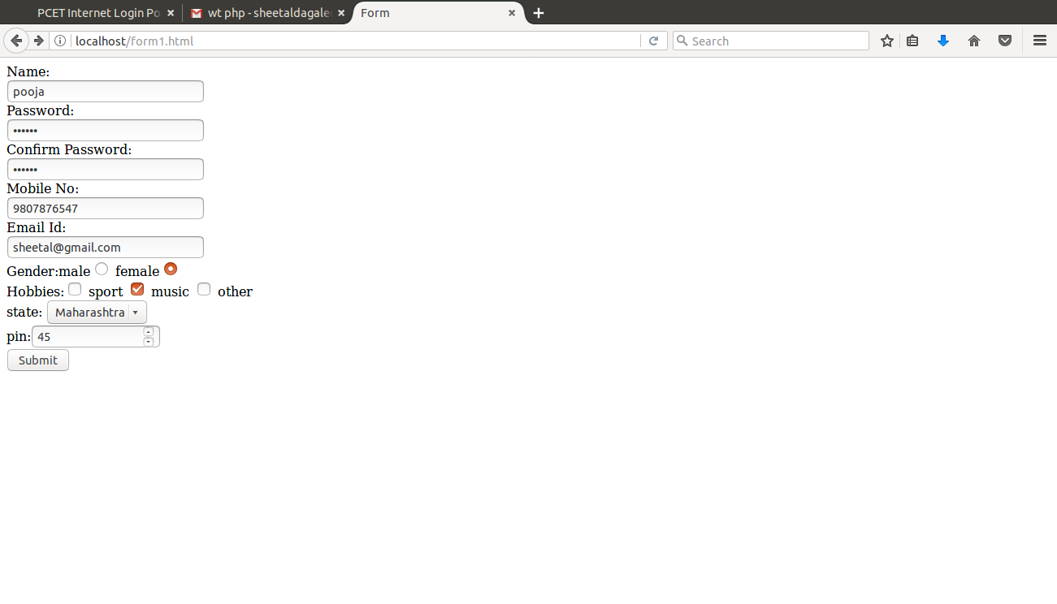

Servlet.java

import java.io.IOException;
import java.io.PrintWriter;
import java.sql.DriverManager;
import java.sql.Statement;

import javax.servlet.ServletException;
import javax.servlet.annotation.WebServlet;
import javax.servlet.http.HttpServlet;
import javax.servlet.http.HttpServletRequest;
import javax.servlet.http.HttpServletResponse;

import com.mysql.jdbc.Connection;

/**
* Servlet implementation class Servlet
*/
@WebServlet("/Servlet")
public class Servlet extends HttpServlet {
private static final long serialVersionUID = 1L;
public static final String url="jdbc:mysql://localhost:3306/student";
public static final String username="";
public static final String password="";

/**
* @see HttpServlet#HttpServlet()
*/
public Servlet() {
super();
// TODO Auto-generated constructor stub
}

/**
* @see HttpServlet#doGet(HttpServletRequest request, HttpServletResponse response)
*/
protected void doGet(HttpServletRequest request, HttpServletResponse response) throws ServletException, IOException {
// TODO Auto-generated method stub
response.getWriter().append("Served at: ").append(request.getContextPath());

PrintWriter out=response.getWriter();
response.setContentType("text/html"); //for reading obj from server and displaying client understandable format.
try
{
Class.forName("com.mysql.jdbc.Driver");
Connection conn=(Connection) DriverManager.getConnection(url, username, password);
//either cast or import java.sql.connection;
out.println("<h1>successful</h1>"); //if connection is successfully established.
String name=request.getParameter("name1");
String pass=request.getParameter("pass12");

Statement st=conn.createStatement();
int i=st.executeUpdate("insert into stud values('"+name+"','"+pass+"');");
if(i<0)
{
out.println("Failure");
}
else
{
out.println("Values Successfully inserted");
}

}
catch(Exception e)
{
out.println("<h2>Exception: +e+</h2>");
}
}

/**
* @see HttpServlet#doPost(HttpServletRequest request, HttpServletResponse response)
*/
protected void doPost(HttpServletRequest request, HttpServletResponse response) throws ServletException, IOException {
// TODO Auto-generated method stub
doGet(request, response);
}

}

s.jsp

<%@page import="com.mysql.jdbc.Connection"%>
<%@ page language="java" contentType="text/html; charset=UTF-8"
pageEncoding="UTF-8"%>
<!DOCTYPE html PUBLIC "-//W3C//DTD HTML 4.01 Transitional//EN" "http://www.w3.org/TR/html4/loose.dtd">

<%@page import="java.io.IOException"%>
<%@page import="java.io.PrintWriter" %>
<%@page import="java.sql.DriverManager" %>
<%@page import="java.sql.Statement"%>
<%@page import="javax.servlet.ServletException"%>
<%@page import="javax.servlet.annotation.WebServlet"%>
<%@page import="javax.servlet.http.HttpServlet"%>
<%@page import="javax.servlet.http.HttpServletRequest"%>
<%@page import="javax.servlet.http.HttpServletResponse"%>

<html>
<head>
<meta http-equiv="Content-Type" content="text/html; charset=UTF-8">
<title>Insert title here</title>
</head>
<body>
<% String url="jdbc:mysql://localhost:3306/svc";
String username="";
String password="";

try
{
Class.forName("com.mysql.jdbc.Driver");
Connection conn=(Connection) DriverManager.getConnection(url, username, password);
//either cast or import java.sql.connection;
out.println("<h1>successful</h1>"); //if connection is successfully established.
String name=request.getParameter("name1");
String pass=request.getParameter("pass12");

Statement st=conn.createStatement();
int i=st.executeUpdate("insert into student values('"+name+"','"+pass+"');");
if(i<0)
{
out.println("Failure");
}
else
{
out.println("Values Successfully inserted into database");
}

}
finally
{

}
%>
</body>
</html>

Assignment 4

Aim: Add Dynamic web application essence in assignment 2 using PHP, MySQL Database Connectivity and AJAX Control.

form1.html

<html>
<head>
<title>
Form
</title>

<script src="https://ajax.googleapis.com/ajax/libs/jquery/3.3.1/jquery.min.js"></script>
<script src="https://cdnjs.cloudflare.com/ajax/libs/jquery-validate/1.17.0/jquery.validate.js"></script>
<script src="assg2.js" type="text/javascript"></script>

<link rel="stylesheet" href="assg2.css">
</head>
<body>
<div class="form2">
<!-- <form name="myform" id="form11" action="http://localhost:8080/TEA120/Servlet" method=post> -->
<form name="myform" id="form11" action="h1.php" method=post>
Name:<br><input type="text" name="name1" placeholder="Enter Name" ><br>
Password:<br><input type="password" name="pass12" id="pass12" placeholder="Enter password" required><br>
Confirm Password:<br><input type="password" name="pass2" id="pass2" placeholder="Confirm password" required><br>
Mobile No:<br><input type="text" name="mobnum" pattern="[0-9]{10}" placeholder="Enter Mobile No" required><br>
Email Id:<br><input type="text" placeholder="Enter Mail" pattern="[A-Za-z0-9]+@[^@]+\.[a-zA-Z]{2,6}" name="email1" required><br>
Gender:male<input type="radio" name="gender" value="male">
female<input type="radio" name="gender" value="female" ><br>
Hobbies:<input type="checkbox" name="sport" value="sport"> sport
<input type="checkbox" name="music" value="music"> music
<input type="checkbox" name="other" value="other"> other<br>
state: <select>
<option value="Maharashtra">Maharashtra</option>
<option value="Punjab">Punjab</option>
<option value="Gujarat">Gujarat</option>
<option value="Other">Other</option>
</select><br>
pin:<input type="number" name="pin" required><br>
<input type="submit" value="Submit" id="submit1" >
</form>
</div>
</body>
</html>

h1.php

<?php
$servername="localhost";
$username="";
$password="";
$dbname="pccoe";

$conn=new mysqli($servername,$username,$password,$dbname);

if($conn->conn_error)
{
die("Connection failed: ".$conn->connect_error);
}
echo "connected successfully";

$name=$_POST["name1"];
$pass=$_POST["pass12"];

$sql = "INSERT INTO student VALUES('$name','$pass') ";

if ($conn->query($sql) === TRUE) {
echo "<br>New record created successfully<br>";
} else {
echo "Error: " . $sql . "<br>" . $conn->error;
}

$sql1="SELECT * FROM student";
$result = $conn->query($sql1);
if ($result->num_rows > 0) {
while($row = $result->fetch_assoc()) {
echo "<br> Name: " . $row["name"]. " " ."\tPass: ". $row["pass"]. "<br>";
}
} else {
echo "0 results";
}

$sql2 = "DELETE FROM student WHERE name='name1'";
if ($conn->query($sql2) === TRUE) {
echo "<br>Record deleted successfully";
} else {
echo "Error deleting record: " . $conn->error;
}

$sql3 = "UPDATE student SET pass='snehal' WHERE name='b'";

if ($conn->query($sql3) === TRUE) {
echo "<br>Record updated successfully";
} else {
echo "Error updating record: " . $conn->error;
}

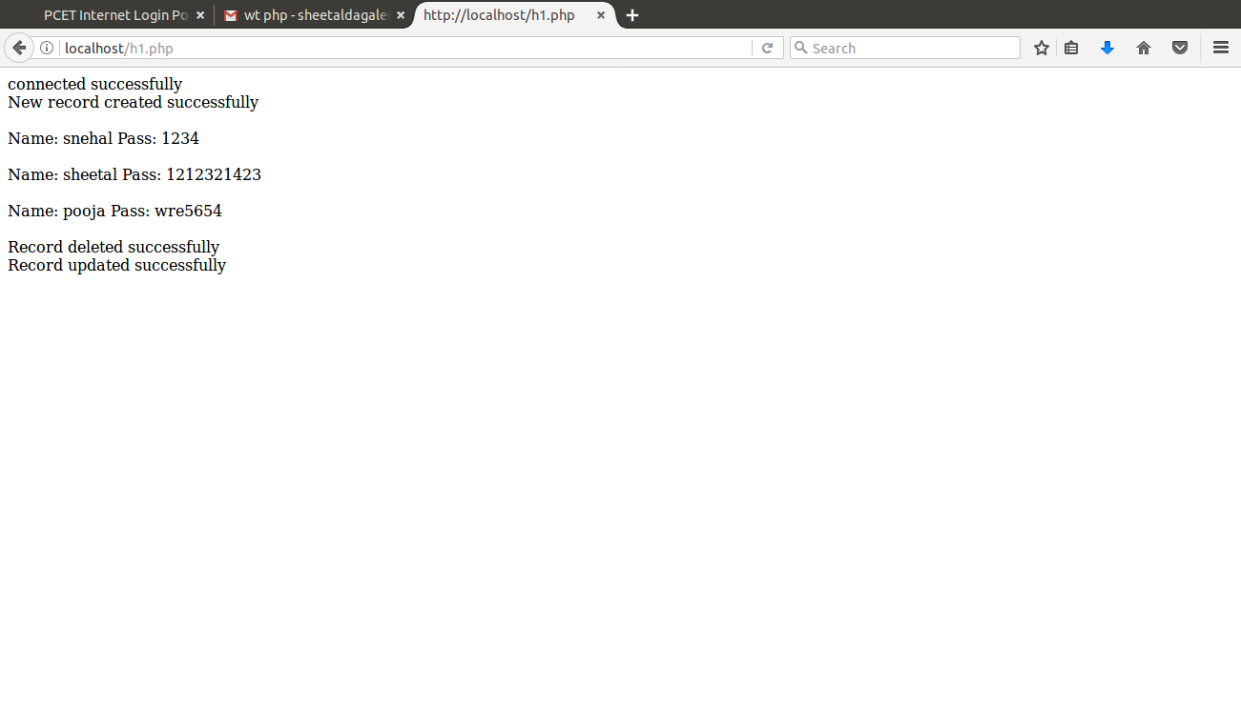
?>

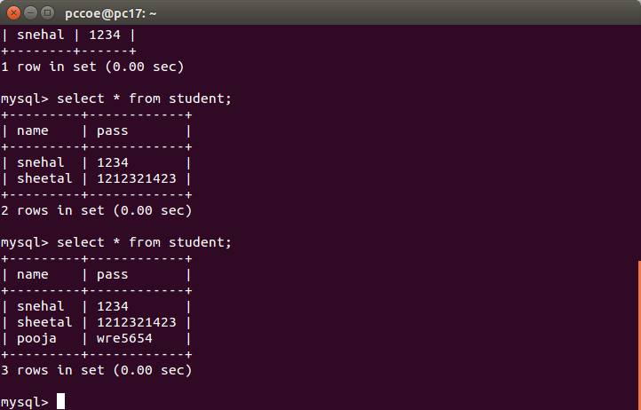

Assignment 5

Structs

LoginAction.java

import java.sql.Connection;
import java.sql.DriverManager;
import java.sql.PreparedStatement;
import java.sql.ResultSet;

import com.opensymphony.xwork2.ActionSupport;

public class LoginAction extends ActionSupport {

/**
*
*/
private static final long serialVersionUID = 1L;
private String user;
private String password;
private String name;

public String execute() {
String ret = ERROR;
Connection conn = null;

try {
String URL = "jdbc:mysql://localhost:3306/mysql";
Class.forName("com.mysql.jdbc.Driver");
conn = DriverManager.getConnection(URL+"?useSSL=false", "root", "S99709970");
String sql = "SELECT name FROM user1 WHERE";
sql+=" name = ? AND pass = ?";
PreparedStatement ps = conn.prepareStatement(sql);
ps.setString(1, user);
ps.setString(2, password);
ResultSet rs = ps.executeQuery();

while (rs.next()) {
name = rs.getString(1);
ret = SUCCESS;
}
} catch (Exception e) {
ret = ERROR;
} finally {
if (conn != null) {
try {
conn.close();
} catch (Exception e) {
}
}
}
return ret;
}

public String getUser() {
return user;
}

public void setUser(String user) {
this.user = user;
}

public String getPassword() {
return password;
}

public void setPassword(String password) {
this.password = password;
}

public String getName() {
return name;
}

public void setName(String name) {
this.name = name;
}
}

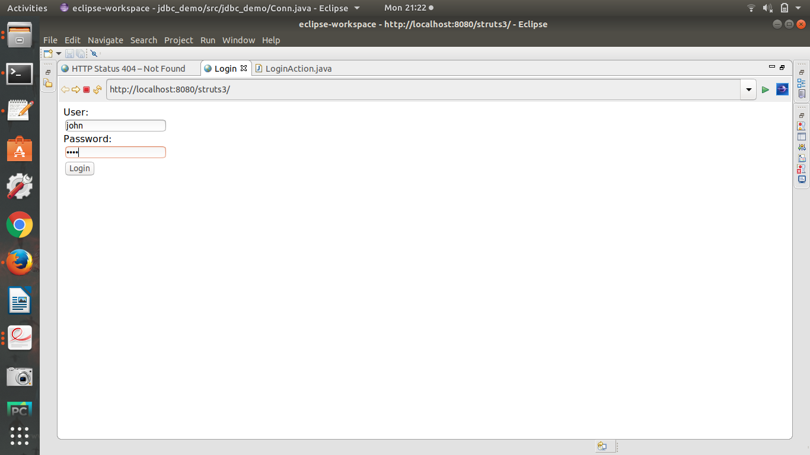
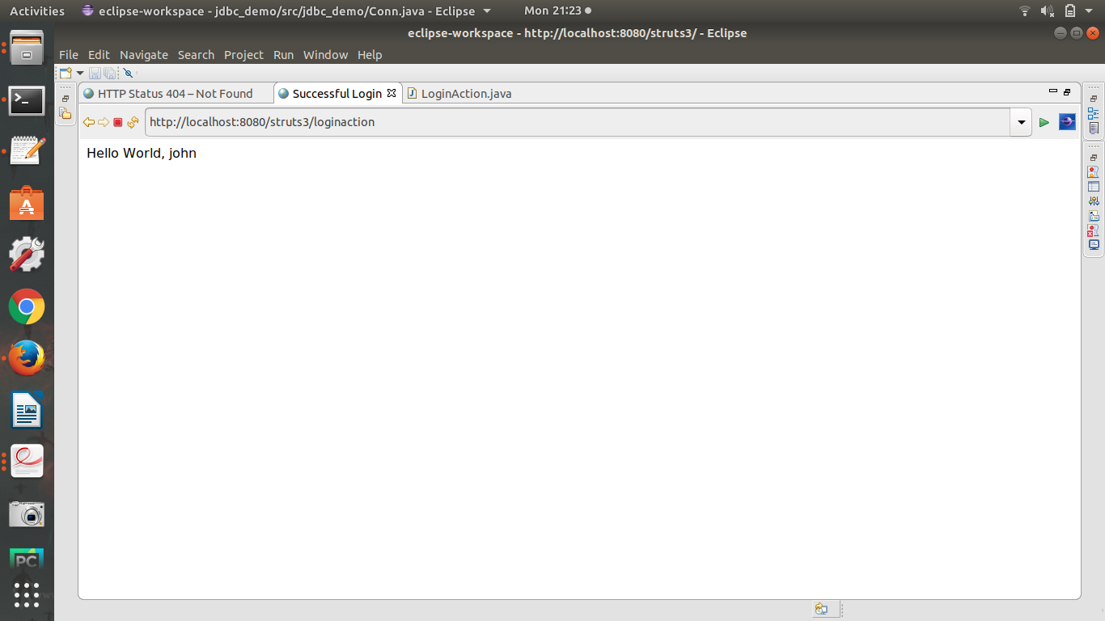
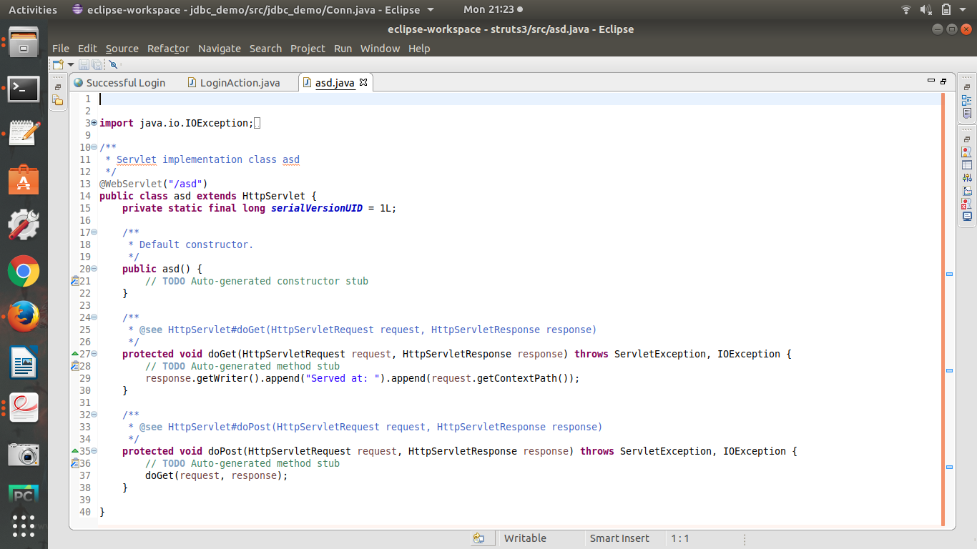
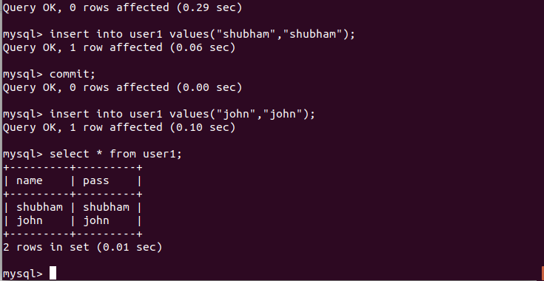

Assignment 6

AngularJS

aa.html

<!DOCTYPE html>
<html >
<style>
table, th , td {
border: 1px solid grey;
border-collapse: collapse;
padding: 5px;
}
table tr:nth-child(odd) {
background-color: #f1f1f1;
}
table tr:nth-child(even) {
background-color: #ffffff;
}
</style>
<script src="https://ajax.googleapis.com/ajax/libs/angularjs/1.6.4/angular.min.js"></script>
<body>

<div ng-app="myApp" ng-controller="customersCtrl">

<table>
<tr ng-repeat="x in names">
<td>name: {{ x.name }}</td>
<td>email: {{ x.email }}</td>
</tr>
</table>

</div>
</body>
<script>
var app = angular.module('myApp', []);
app.controller('customersCtrl', function($scope, $http) {
$http.get("a.php")
.then(function (response) {$scope.names = response.data.records;});
});
</script>

</html>

a.php

<?php

header("Access-Control-Allow-Origin: *");
header("Content-Type: application/json; charset=UTF-8");
$conn = new mysqli("localhost", "", "","pccoe");
$result = $conn->query("SELECT name, email FROM user");

//while ($row = mysqli_fetch_array($result)) {
//$data[] = array("Name"=>$row['name'],"EMail"=>$row['email']);
//}
//echo json_encode($data);

$outp = "";
while($rs = $result->fetch_array(MYSQLI_ASSOC)) {
if ($outp != "") {$outp .= ",";}
$outp .= '{"name":"' . $rs["name"] . '",';
$outp .= '"email":"'. $rs["email"] . '"}';
}
$outp ='{"records":['.$outp.']}';
$conn->close();

echo($outp);

?>

OUTPUT:

