**comprehensive test script to demonstrate the functionality of the secure file upload system**

->url : localhost/fileupload

It redirects to login page and if you are the new user then press signup link



In Register Page

i)Name must be an alphabet

ii) password must be an alphanumeric

iii) Name ,usename and password must be mandatory

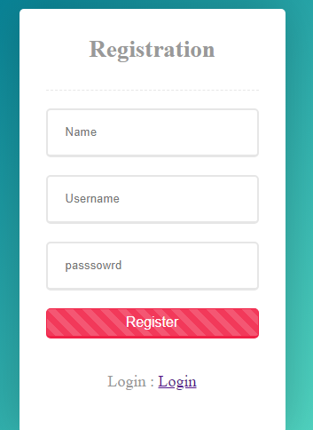

After successful registration page will redirect to login page and user login with registered username and password the file upload page will occurs.

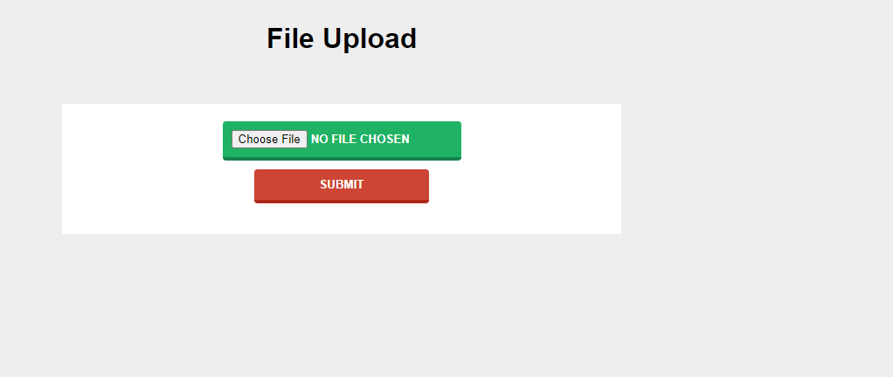

After successful file uploading it will redirect home page.

Validations

|  |  |  |
| --- | --- | --- |
|  | **Test Cases:** | **Expected Result** |
| Successful Upload | Valid File(jpg,pdf,docx etc) | File uploaded successfully, message indicating success, file accessible in the uploads directory with a unique name. |
| Rejected Upload | File: .exe file (e.g., test_app.exe) | Upload rejected, error message indicating invalid file type. |
| files with the same name (e.g., test_file.txt, test_file.txt) | Each file uploaded with a unique name (e.g., test_file_1.txt, test_file_2.txt). |
| Submit Save File Button without uploading a file | Results File cannot be empty |