Date of publication xxxx 00, 0000, date of current version xxxx 00, 0000.
Digital Object Identifier 10.1109/ACCESS.2017.Doi Number
Preparation of Papers for IEEE Access (February 2017)
First A. Author¹, Fellow, IEEE, Second B. Author², and Third C. Author, Jr.³, Member, IEEE
¹National Institute of Standards and Technology, Boulder, CO 80305 USA
²Department of Physics, Colorado State University, Fort Collins, CO 80523 USA
³Electrical Engineering Department, University of Colorado, Boulder, CO 80309 USA
Corresponding author: First A. Author (e-mail: author@ boulder.nist.gov).
This paragraph of the first footnote will contain support information, including sponsor and financial support acknowledgment. For example, “This work was supported in part by the U.S. Department of Commerce under Grant BS123456.”
ABSTRACT These instructions give you guidelines for preparing papers for IEEE Access. Use this document as a template if you are using Microsoft Word 6.0 or later. Otherwise, use this document as an instruction set. The electronic file of your paper will be formatted further at IEEE. Paper titles should be written in uppercase and lowercase letters, not all uppercase. Avoid writing long formulas with subscripts in the title; short formulas that identify the elements are fine (e.g., “Nd–Fe–B”). Do not write “(Invited)” in the title. Full names of authors are preferred in the author field, but are not required. Put a space between authors’ initials. The abstract must be a concise yet comprehensive reflection of what is in your article. In particular, the abstract must be self-contained, without abbreviations, footnotes, or references. It should be a microcosm of the full article. The abstract must be between 150–250 words. Be sure that you adhere to these limits; otherwise, you will need to edit your abstract accordingly. The abstract must be written as one paragraph, and should not contain displayed mathematical equations or tabular material. The abstract should include three or four different keywords or phrases, as this will help readers to find it. It is important to avoid over-repetition of such phrases as this can result in a page being rejected by search engines. Ensure that your abstract reads well and is grammatically correct.
INDEX TERMS Enter key words or phrases in alphabetical order, separated by commas. For a list of suggested keywords, send a blank e-mail to keywords@ieee.org or visit http://www.ieee.org/organizations/
pubs/ani_prod/keywrd98.txt

I. INTRODUCTION

II. GUIDELINES FOR MANUSCRIPT PREPARATION

III. MATH
IV. UNITS
V. SOME COMMON MISTAKES
VI. GUIDELINES FOR GRAPHICS PREPARATION
AND SUBMISSION

VII. CONCLUSION
APPENDIX
ACKNOWLEDGMENT
REFERENCES
- Lightw. Technol., vol. 29, no. 4, pp. 439–448, Sep. 2011.
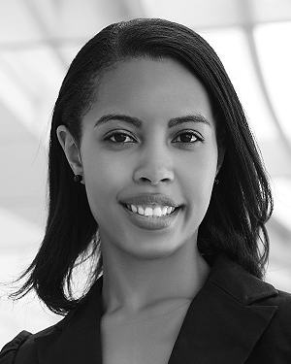
FIRST A. AUTHOR (M’76–SM’81–F’87) and all authors may include biographies. Biographies are often not included in conference-related papers. This author became a Member (M) of IEEE in 1976, a Senior Member (SM) in 1981, and a Fellow (F) in 1987. The first paragraph may contain a place and/or date of birth (list place, then date). Next, the author’s educational background is listed. The degrees should be listed with type of degree in what field, which institution, city, state, and country, and year the degree was earned. The author’s major field of study should be lower-cased.
The second paragraph uses the pronoun of the person (he or she) and not the author’s last name. It lists military and work experience, including summer and fellowship jobs. Job titles are capitalized. The current job must have a location; previous positions may be listed without one. Information concerning previous publications may be included. Try not to list more than three books or published articles. The format for listing publishers of a book within the biography is: title of book (publisher name, year) similar to a reference. Current and previous research interests end the paragraph.
The third paragraph begins with the author’s title and last name (e.g., Dr. Smith, Prof. Jones, Mr. Kajor, Ms. Hunter). List any memberships in professional societies other than the IEEE. Finally, list any awards and work for IEEE committees and publications. If a photograph is provided, it should be of good quality, and professional-looking. Following are two examples of an author’s biography.

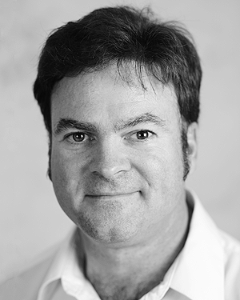
SECOND B. AUTHOR was born in Greenwich Village, New York, NY, USA in 1977. He received the B.S. and M.S. degrees in aerospace engineering from the University of Virginia, Charlottesville, in 2001 and the Ph.D. degree in mechanical engineering from Drexel University, Philadelphia, PA, in 2008.
From 2001 to 2004, he was a Research Assistant with the Princeton Plasma Physics Laboratory. Since 2009, he has been an Assistant Professor with the Mechanical Engineering Department, Texas A&M University, College Station. He is the author of three books, more than 150 articles, and more than 70 inventions. His research interests include high-pressure and high-density nonthermal plasma discharge processes and applications, microscale plasma discharges, discharges in liquids, spectroscopic diagnostics, plasma propulsion, and innovation plasma applications. He is an Associate Editor of the journal Earth, Moon, Planets, and holds two patents.
Dr. Author was a recipient of the International Association of Geomagnetism and Aeronomy Young Scientist Award for Excellence in 2008, and the IEEE Electromagnetic Compatibility Society Best Symposium Paper Award in 2011.

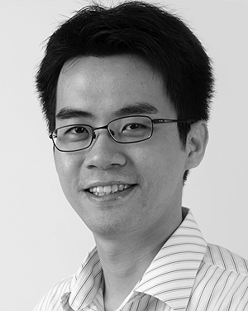
THIRD C. AUTHOR, JR. (M’87) received the B.S. degree in mechanical engineering from National Chung Cheng University, Chiayi, Taiwan, in 2004 and the M.S. degree in mechanical engineering from National Tsing Hua University, Hsinchu, Taiwan, in 2006. He is currently pursuing the Ph.D. degree in mechanical engineering at Texas A&M University, College Station, TX, USA.
From 2008 to 2009, he was a Research Assistant with the Institute of Physics, Academia Sinica, Tapei, Taiwan. His research interest includes the development of surface processing and biological/medical treatment techniques using nonthermal atmospheric pressure plasmas, fundamental study of plasma sources, and fabrication of micro- or nanostructured surfaces.
Mr. Author’s awards and honors include the Frew Fellowship (Australian Academy of Science), the I. I. Rabi Prize (APS), the European Frequency and Time Forum Award, the Carl Zeiss Research Award, the William F. Meggers Award and the Adolph Lomb Medal (OSA).

