**CSE 564 – VISUALIZATION**

**LAB 3 REPORT – IMAGEVIS3D (IMAGES SUBMITTED SEPARATELY TOO)**

**ANUJAY GHOSH (SBU ID: 115362293)**

***Problem 1: render 4 iso-surface images***

***two different datasets with different iso-surfaces shown***

Dataset 1: cropped Head.

Iso surfaces: First one shows the skeleton and bone surface while the second one shows the skin surface.

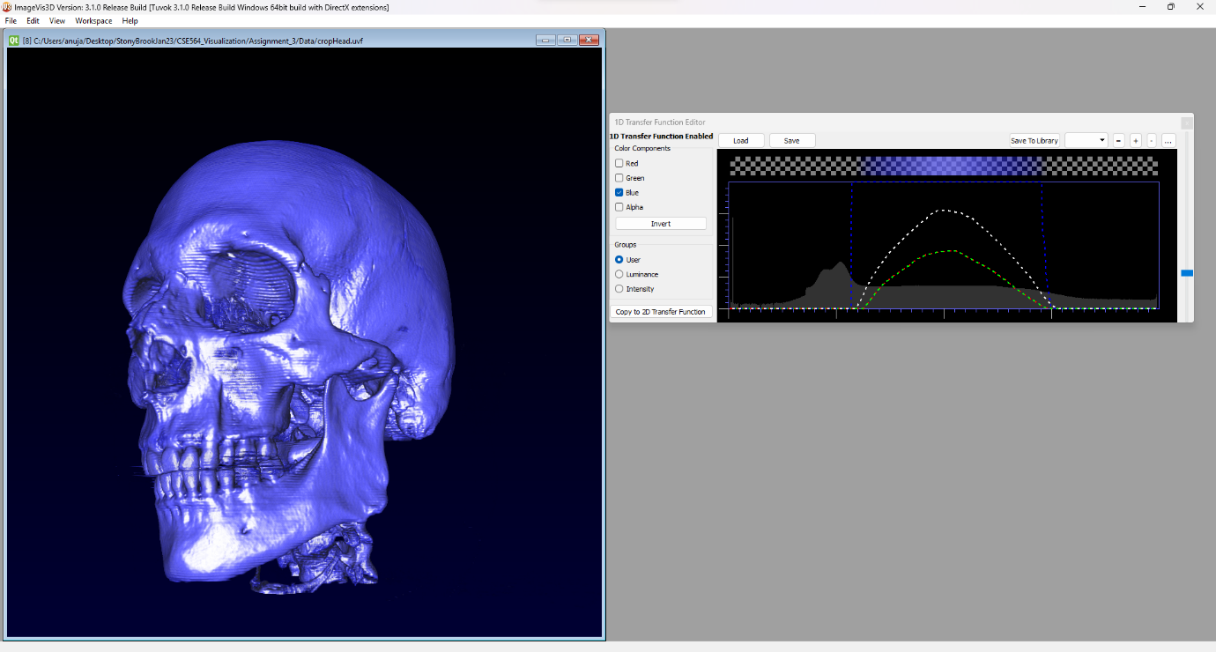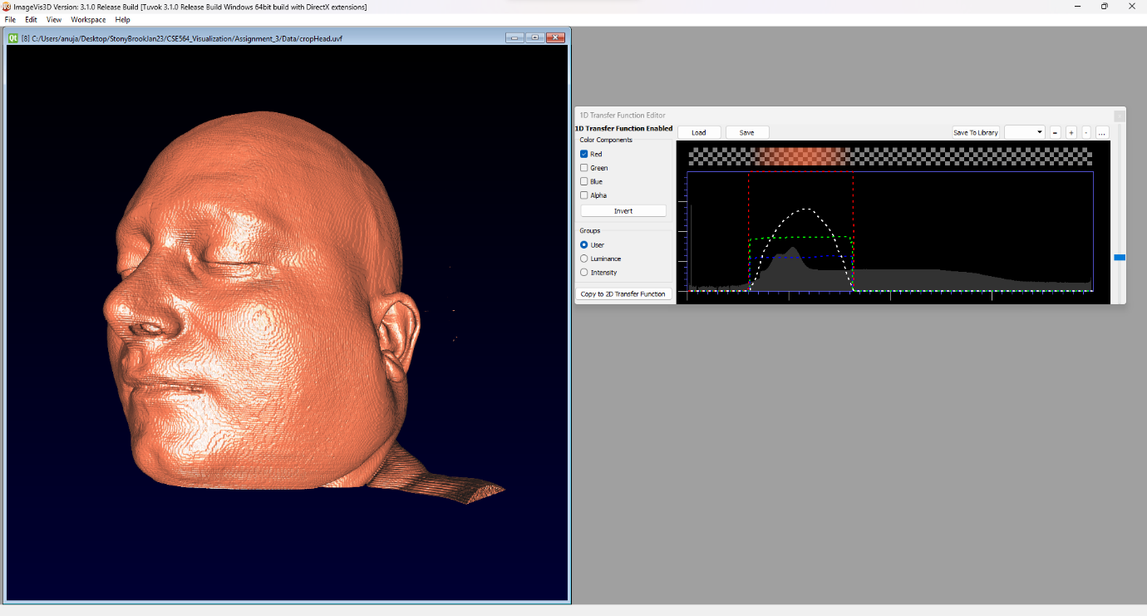

Dataset 2: Hand16

Iso-surfaces: First one shows the skeleton surface while the second one shows the skin surface and the lighting highlights the veins under the skin.

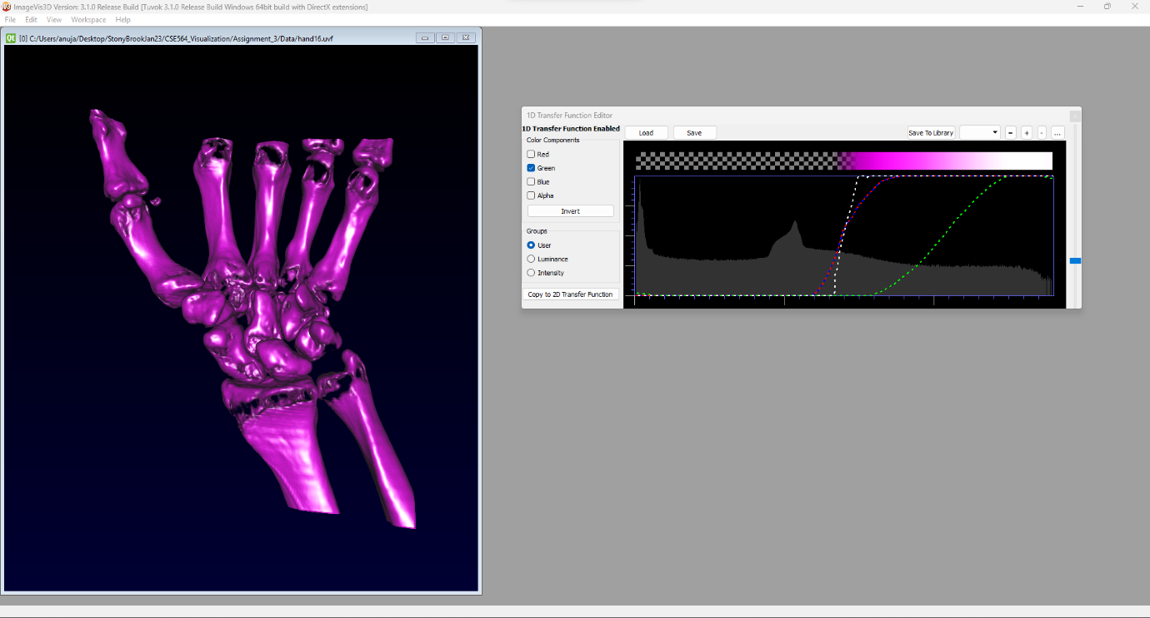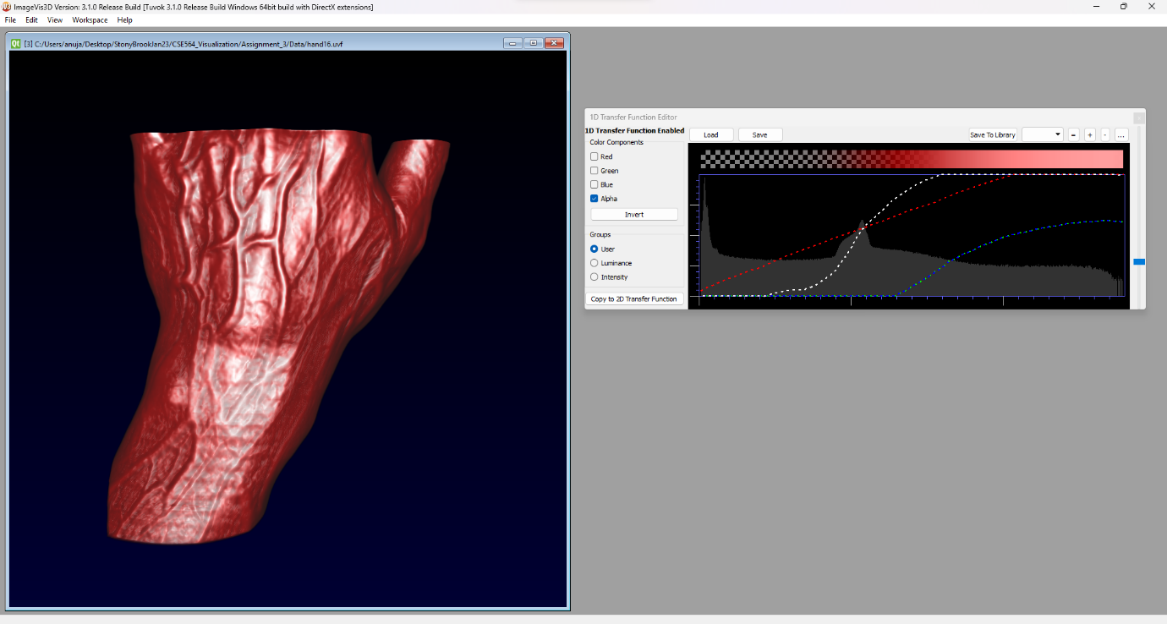

***Problem 2: render 2 images with multiple surfaces visible using semi-transparent rendering***

***pick from two different datasets***

***render the surfaces with different colors***

Dataset 1: Head512

Semi-transparent rendering shows the upper structure layer which has the nose, lips and ears along with organs like lungs seen as semi-transparent render whereas the skeletal structure underneath is also visible and is opaque.

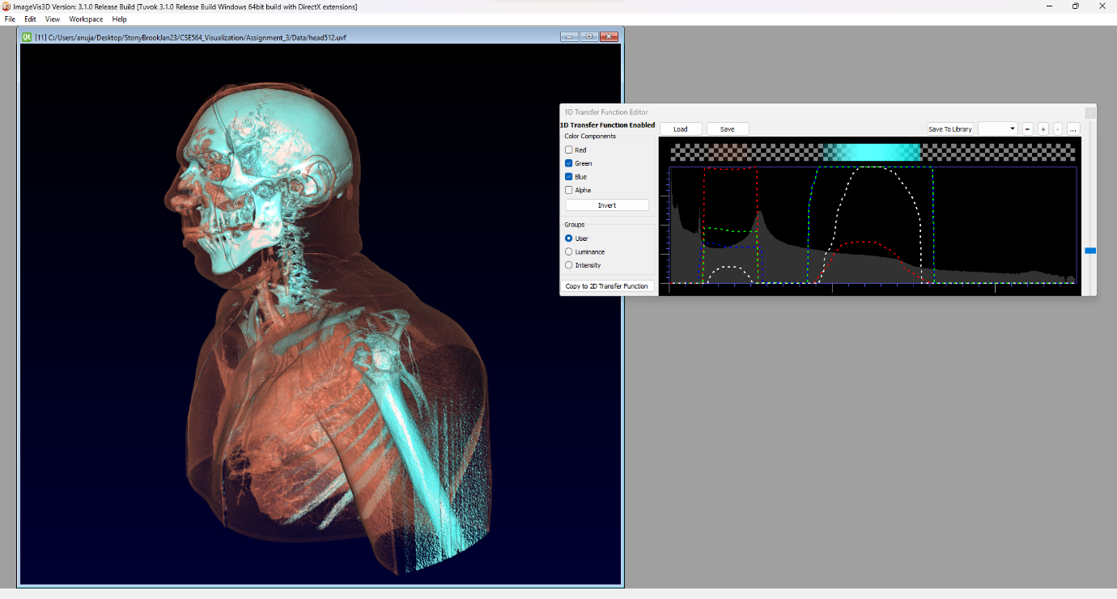

Dataset 2: Hand16

Semi-transparent rendering shows the upper structure layer which skin and veins seen as semi-transparent render whereas the skeletal structure underneath is also visible and is opaque

