Element 1: Logos
Element 2: Website banners (put a placeholder for now) (Pickup one from existing website)
Element 3: Impact and About us
https://docs.google.com/document/d/1ZCWYkFPqlHQSpW9-yyNhWpeIR81ci_79/edit?usp=drive_link&ouid=114108692427545121344&rtpof=true&sd=true
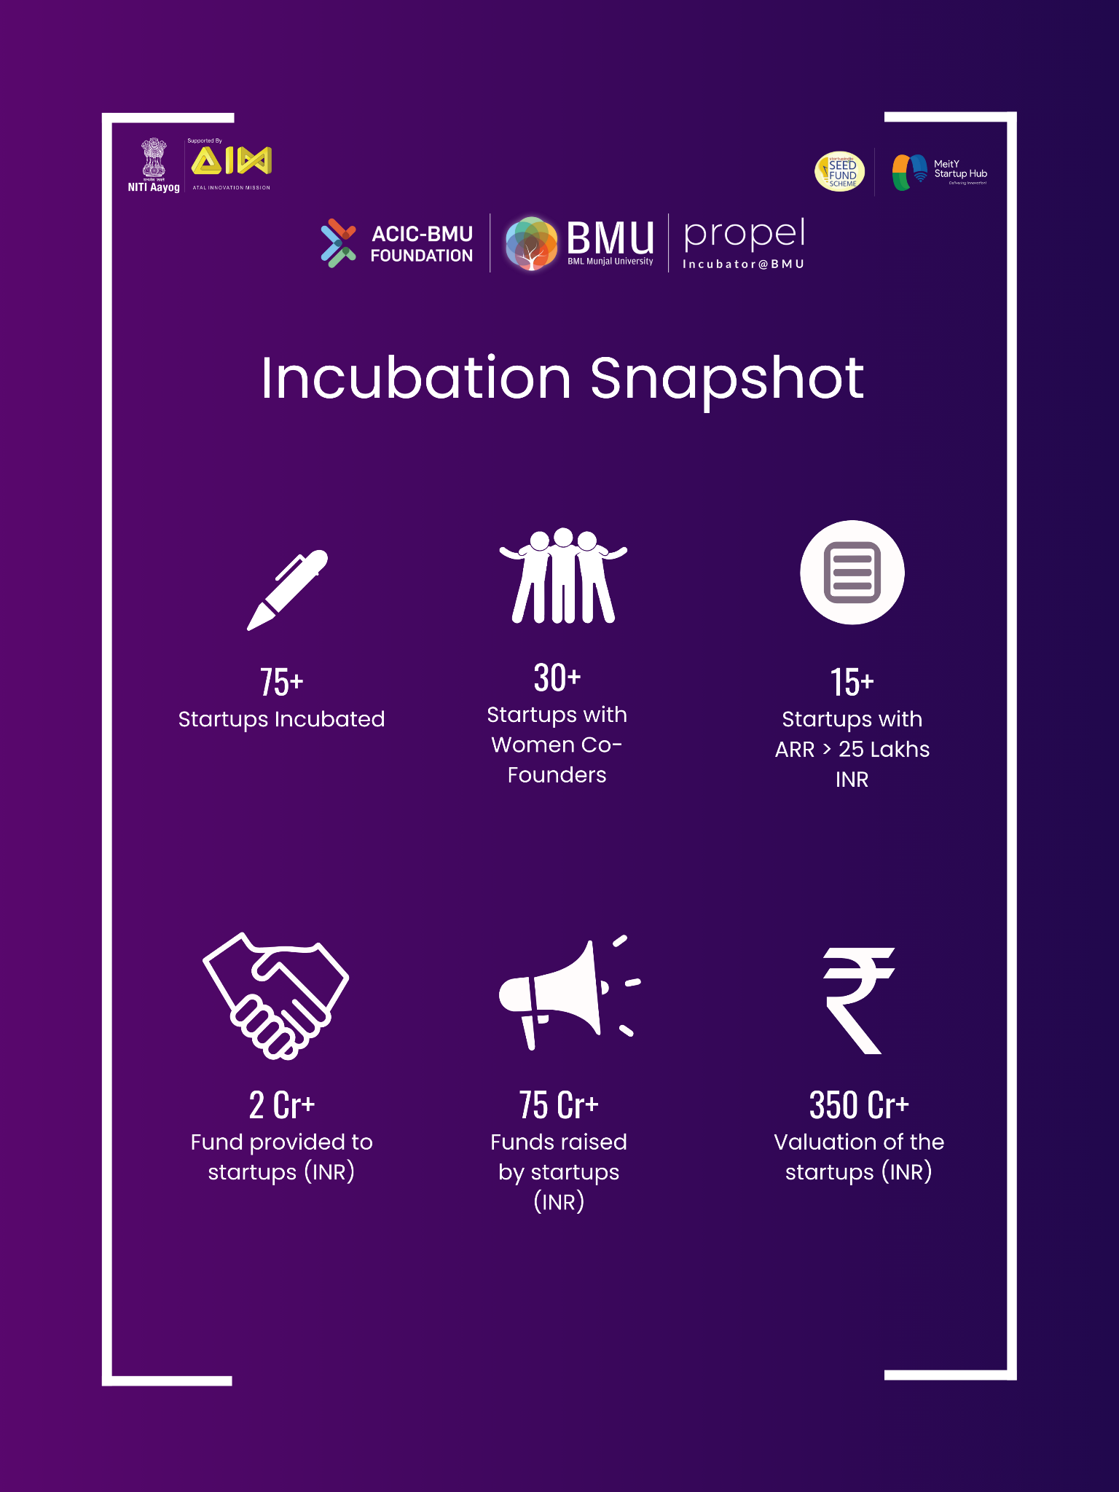

Element 4: Programs ( 3 verticals - photos with captions ) Know More CTA button Siraj KhanDivyaNeha -
- YUVA Udyami
- Startup Incubation
- Mera Business
Element 5: Success Stories our own startups (Startup logo, name, caption and website link) Siraj KhanDivya
Element 6: Events ( photo, 2-3 liners, date) Know more CTA
Element 7: Network Partners ( Logos ) This has to be presented in sliding Divya
Element 8 : Blogs
Element 9: Gallery
Element 10: Contact us( pick up from current website)

